|  |  |
| --- | --- |
| |  | | --- | | **MINISTRY OF EDUCATION AND TRAINING** | |
| Capstone Project Document |
| Japanese Dictionary For Vietnamese |
|  |
|  |
| |  |  |  |  | | --- | --- | --- | --- | | 日本語辞書・チーム | | | | | **Group Members** | Lê Đình Nam | SE02316 | Namldse02316 | |  | Phạm Thị Minh | SE02300 | Minhptse02300 | |  | Phạm Tiến Đạt | SE02336 | Datptse02336 | |  | Nguyễn Ngọc Tuấn | SE02189 | Tuannnse02189 | | **Supervisor** | Mr. Nguyễn Văn Sang | Lecture at FPT University | | | **Capstone Project code** | **UJD_VN** | | |   **Hanoi, 15th August, 2014** |

# Table of contents

Table of contents 2

Definition and Acronyms 6

1 Introduction 7

1.1 Project information 7

1.2 Project members 7

1.2.1 Supervisors 7

1.2.2 Team members 7

1.3 Purposes 7

1.4 Abstract 8

1.5 The existing system 8

1.5.1 Nhgo.net 8

1.5.2 Lớp học tiếng Nhật 9

1.5.3 RomajiDesu-Japanese dictionary and translator 10

1.6 Proposal 11

1.6.1 The idea 11

1.6.2 Objectives 11

1.6.3 Brief description about system 12

1.6.4 System features 12

1.7 Benefit From Project 13

1.7.1 For our group 13

1.7.2 For Community 14

1.8 Critical Assumption and Constraints 14

1.9 Potential Risk 14

2 Software Project Management 16

2.1 Project Overview 16

2.1.1 Project Description 16

2.1.2 Purposes of Project 16

2.1.3 Scope Statement 16

2.2 Project Organization 20

2.2.1 Organizational Structure 20

2.2.2 Project Process 21

2.3 Project Schedule 23

2.3.1 Milestone and Deliverables 23

2.3.2 Gantt chart 26

2.4 Risk Management 33

2.5 Communication Management 36

2.6 Tools and Infrastructure 38

2.7 Configuration Management Plan 39

3 Software Requirement Specification 40

3.1 Overview 40

3.1.1 Purpose 40

3.1.2 Scope 40

3.2 User Requirements Specification 40

3.2.1 Business Process Overview 40

3.2.2 Product Features 42

3.3 Sofware Requirements Specification 44

3.3.1 Overall Description 44

3.3.2 Entity Relation Model 49

3.3.3 Functional Specification 54

3.3.4 Non-Functional Specification Requirements 215

4 Software Design Description 217

4.1.1 SDD Overview 217

4.2 Architecture Design 217

4.2.1 MVC Model 217

4.2.2 Codeigniter 219

4.2.3 Architectural Representation 220

4.2.4 Architecture Goals and Constraints 221

4.2.5 Use-Case View 222

4.2.6 Logical View 231

4.2.7 Process View 236

4.2.8 Deployment view 237

4.3 Class Design 238

4.3.1 Packages 238

4.4 Screen Design 303

4.4.1 Screen Flow 303

4.5 Database design 330

4.5.1 Table diagram 330

4.5.2 User table 332

4.5.3 User_facebook table 333

4.5.4 Vocabulary table 334

4.5.5 Meaning table 334

4.5.6 Sentence table 335

4.5.7 Vocabularysentence table 336

4.5.8 Grammar table 336

4.5.9 Grammarsentence table 337

4.5.10 Video table 337

4.5.11 Kanji table 337

4.5.12 Conversation table 338

4.5.13 Conversationcontent table 338

4.5.14 Contact table 339

4.5.15 Traininglistening table 340

4.5.16 Sourcefile table 340

4.5.17 Readingdocument table 341

4.5.18 Readingvocabulary table 341

4.5.19 Test table 342

4.5.20 Question table 342

4.5.21 Readingarticle table 343

4.5.22 Trackingmark table 343

4.5.23 Answer table 344

5 Software Source Code 345

6 Software Test Documentation 346

6.1 INTRODUCTION 346

6.1.1 Purposes 346

6.2 TEST PLAN 346

6.2.1 Scope of Testing 346

6.2.2 Test Strategies 350

6.2.3 Resources 355

6.2.4 Test Milestones 356

6.3 TEST CASES 357

6.3.1 Component Test Case 357

6.3.2 Integration Test Case 359

6.3.3 System Test Case 361

6.4 CHECKLISTS 363

6.4.1 Test Checklist 363

6.4.2 GUI checklist 365

6.5 TEST LOGS 365

6.5.1 Defect Logs 365

6.5.2 Test Reports 366

7 Software User Manual 367

7.1 Installation guide 367

7.1.1 Introduction 367

7.1.2 Environment 367

7.1.3 Application Installation 367

7.2 User Guide 376

7.2.1 Overview 376

7.2.2 Details guidelines 376

7.3 PROJECT RESULT REPORT 498

7.3.1 Product Judging 498

7.3.2 Product Summary 499

7.3.3 Lessons Learnt 500

7.4 Reference 501

# Definition and Acronyms

|  |  |  |
| --- | --- | --- |
| **Acronym** | **Definition** | **Note** |
| UJD_VN | Japanese Dictionary For Vietnamese |  |
| JP | Japanese |  |
| EN | English |  |
| VI | Vietnamese |  |
| PM | Project Manager |  |
| PTL | Project Technical Leader |  |
| QA | Quality Assurance |  |
| RUP | Rational Unified Process |  |
| PMP | Project Management Plan |  |
| SRS | Software Requirement Specification |  |
| SAD | Software Architecture Design |  |
| SDD | Software Detail Design |  |
| STD | Software Test Documentation |  |
| UT | Unit Test |  |
| IT | Integration Test |  |
| ST | System Test |  |
| AT | Acceptance Test |  |
| UC | Use-case |  |
| SC | Screen |  |
| UI | User Interface |  |
| GUI | Graphical User Interface |  |
| ERD | Entity-Relationship diagram |  |
| MVC | Model-View-Controller |  |
| DB | Database |  |
| SUG | Software User Manual |  |

# Introduction

## Project information

* **Project Name:** Japanese Dictionary
* **Project Code:** UJD_VN
* **Project Type:** Web application
* **Duration:** From 12th May 2014 to 30th August 2014

## Project members

### Supervisors

|  |  |  |  |
| --- | --- | --- | --- |
| **Full name** | **Phone** | **E-Mail** | **Position** |
| Nguyễn Văn Sang | 0912210727 | sangnv@fpt.edu.vn | Supervisor |

### Team members

|  |  |  |  |  |
| --- | --- | --- | --- | --- |
| **Full name** | **Roll No.** | **Phone** | **E-mail** | **Position** |
| Lê Đình Nam | SE02316 | 01678 590905 | [Namldse02316@fpt.edu.vn](mailto:Namldse02316@fpt.edu.vn) | Leader |
| Phạm Thị Minh | SE02300 | 01677 690979 | [Minhptse02300@fpt.edu.vn](mailto:Minhptse02300@fpt.edu.vn) | Member |
| Phạm Tiến Đạt | SE02336 | 01667 404707 | [Datptse02336@fpt.edu.vn](mailto:Datptse02336@fpt.edu.vn) | Member |
| Nguyễn Ngọc Tuấn | SE02189 | 0976 218892 | [Tuannnse02189@fpt.edu.vn](mailto:Tuannnse02189@fpt.edu.vn) | Member |

Table 1‑1: 日本語辞書・team members

## Purposes

This document is created as the introduction for project Useful Japanese Dictionary for Vietnamese – our Capstone Project at FPT University. In this document, we will descript the overview of some existing systems, the initial idea for our project, a brief description about our expected system and some potential risks, critical assumptions, constrains. Moreover, this document also shows opportunities what it offers for users.

## Abstract

In Viet Nam, Information Technology are strongly growing and Japan is the largest market. People who want to learn Japanese to work for Japan also increase more. Thus Japanese training center were opened very much. But not everyone can enough time to learn Japanese at training center. So website and application which can help people learn Japanese was created. By this way, people can learn online at their house with lower cost. Although website learn Japanese have lots but following survey of people who used website, they see some website have too much Kanji, other websites have too few examples for new word, or have to upgrade to use more, etc... It makes user dissatisfaction. With the aim of helping user learn Japanese easy and full way, the website is expected to sold this limit and add some other features to fit desiderate of user. Our website were created to solve this problem.

## The existing system

Japan is know that the country has information technology very development. And have a lot of software engineers want to work in Japan. So, website and application were created a lots to help them study Japanese. Moreover Japanese is used in Vietnam very much. However still have not website or application which really perfect to help user. For example: nhgo.net, lophoctiengnhat.com, romajidesu.com…

### Nhgo.net

The website at <http://nhgo.net/> allows user search dictionary, kanji, grammar and post question. General, website is easy to use and search knowledge.

*Advantages:*

* Search with more option, it help user find expected result
* Kanji and grammar quite full
* Forum to post question, any member can comment to help each other

*Disadvantages:*

* Do not support search dictionary Viet – Nhat
* More words do not have mean with Vietnamese
* Example sentences do not have mean with Vietnamese
* Do not support listening, reading, conservation
* Support for JLPT not full

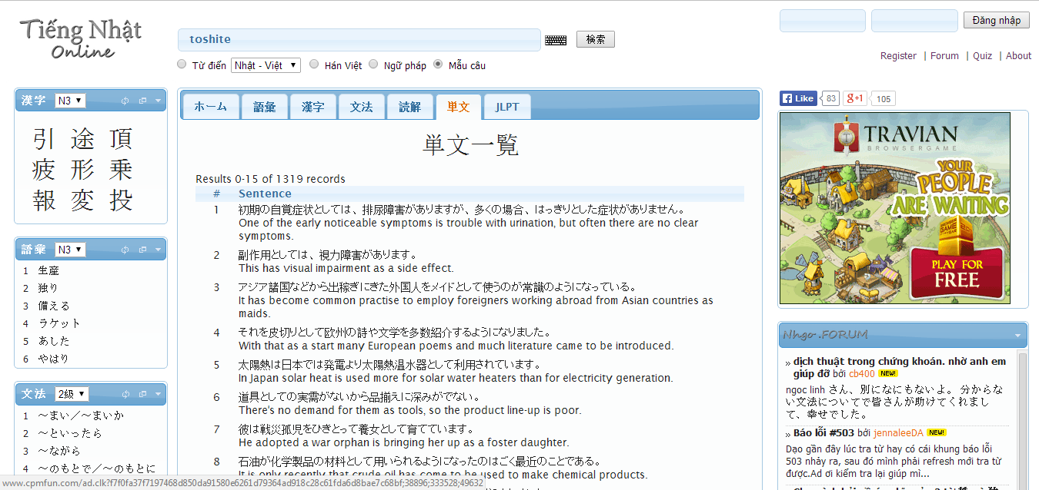

Figure 1-1: nhgo.net interface

Have a lot of words and example sentences do not mean with Vietnamese, it can make beginner hard to use or other users misunderstand. Website support very much option search but have not for Viet – Nhat, it will make user feel inconvenience.

### Lớp học tiếng Nhật

The website at <http://lophoctiengnhat.com/>, is not free, user have to log in to use resources, may be user have to upgrade account to study more. General, website help user learn JLPT with full listening, reading. It also support search.

*Advantages:*

* Support study JLPT full with level
* Support search

*Disadvantages:*

* User have to register, upgrade account
* Do not support more option for search, only search dictionary likes normal way

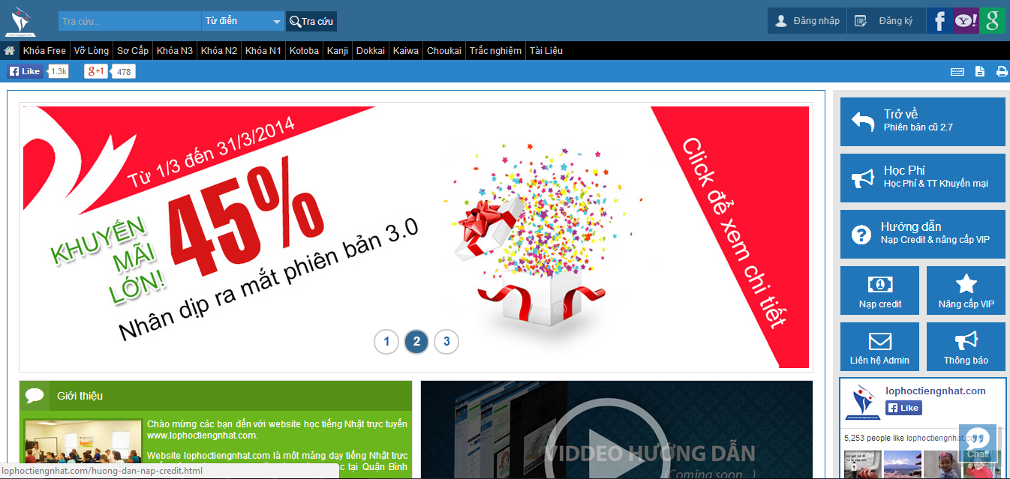

Figure 1-2: lophoctiengnhat.com interface

Because this is website of center, it will provide quite full document to user register and upgrade account to study. But if you do not register and upgrade, you can study more lesson. Moreover, search function is too simple, it can help user more while learning.

### RomajiDesu-Japanese dictionary and translator

In overview, the website at <http://www.romajidesu.com/> have main function is search. Converting romaji to katakana or hiragana for beginner.

*Advantages:*

* Search kanji with more result and example sentences
* Search dictionary
* Search lookup with how to write kanji

*Disadvantages:*

* Do not support more language, only Japanese – English
* Result search by English
* Search do not have more option

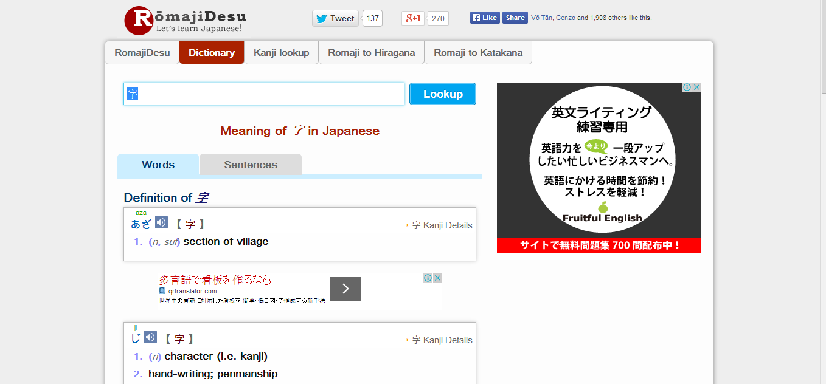

Figure 1-3: romajidesu.com interface

This website display by English, it is hard to user who do not know English, special beginner. Moreover it is not support test, JLPT. So users cannot study more such as listening, reading…

## Proposal

### The idea

Nowadays, there are many dictionaries which support Japanese. That can be a website or mobile application. All of them have been created for the purpose of helping users search vocabulary or studying Japanese more easily. But we found some disadvantages which existing in website which support users studying Japanese. So, our project – UJD_VN will include some main functions of existing dictionary website and add some special features such as showing examples by Vietnamese, supporting searching specialized vocabulary or users can contribute idea, good knowledge to make our database become larger. Moreover, we will provide freely website to users. Here, we toward provide website for Vietnamese who want to studying Japanese communication or who want to join Japanese certification exams.

### Objectives

This project is the Capstone Project in FPT University studying program. The first, this project is responsibility for all team member. So we must complete all requirements from teacher and FU. During the time doing project, we can learn how to develop a project, how to manage project, how to communicate better between team member, how to control time, how to perform teamwork effectively. Moreover, we also have experience about PHP, website design, test website… Therefore, we think this project is very necessary for us to improve skills, knowledge which we studied in FU. This project also make our CV more beautiful after graduating from FU. This is also an opportunity for us to prove capacity with recruiters.

The second, because we are in JS course. In studying’s progress, we realize some disadvantages of studying Japanese for Vietnamese. So we want to help users, especially Vietnamese users, to improve capacity Japanese of them, help them can communicate better with Japanese. The highlights of us are interface friendly, useful functions. Specially, website display completely in Vietnamese, so users can use functions easily, even though they do not know English.

### Brief description about system

This software is a web application. With friendly and simple interface, users can easily find out what they want without registration. This web help users to better understand about vocabulary, grammar, kanji, display the appropriate vocabulary and provide the other vocabulary have same meaning. Therefore, users can reference to make the best choice for themselves. It also help users review about skill reading, writing, speaking, listening. In addition, with a lot of exercise and small test, users can accurately assess their own capacity. And user also can send opinion to admin if there is anything that needs to be modified.

UJD_VN uses familiar technologies as: JavaScript, PHP… It is support operating systems such as windows and current browsers as CocCoc 35, Chrome 35 or above.

### System features

About the features of UJD_VN, we focus to provide for users main features as searching, doing test, listening conversation, reading document, contributing good opinions. Moreover, admin can manage members, manage database, manage contribute database and manage Q & A. In here, we focus on features which can help users can understand the best way what user want to have with features of UJD_VN.

There are the detailed features of UJD_VN:

* **Search**: User can search vocabulary and UJD_VN will display example sentences or conversation, grammar or Japanese video which include vocabulary which user searched. With searching features, user can understand visually, apply easily in communication, and how to use vocabulary in the situations. This is very new point and useful of UJD_VN when compare with other website which also provide user to study Japanese now. User have the following searching option:
* Searching with example sentences: user search a vocabulary and UJD_VN display example sentences which include these vocabulary.
* Searching with conversation: user search a vocabulary and UJD_VN display example conversation which include these vocabulary.
* Searching with grammar: user can search grammar of N2, N3, N4, N5 level. UJD_VN will explain these grammar and give to user example about these grammar.
* Searching Japanese video: user can search Japanese video.
* Searching specialized Japanese: user can search specialized Japanese in many fields as IT, economic, mechanical, traffic, financial …
* **Contributing opinion**: User can contribute opinion about UJD_VN website or contribute database as good sentences, good conversation, good video by using contributing feature. Admin of UJD_VN will approve correctness and add to database. This is feature which will help us make a larger database for system.
* **Listening conversation**: User can improve ability listening by listening available conversation on UJD_VN. Listening database of us is very diversity from everyday conversations, common conversational to conversations in a realistic situation. Especially, we provide conversations from elementary to intermediate for user can train to join Japanese certification exams.
* **Reading document**: User can find available Japanese document in UJD_VN as elementary grammar, intermediate grammar, list kanji, readings, Minnano Nihongo lesson.
* **Doing test**: User can do tests at N2, N3, N4, N5 level. Then UJD_VN will scored for user. This is an important feature of UJD_VN. We want to help users toward Japanese certification exams.
* **Login/Logout**: User can login to use more features of UJD_VN. User can register an account to login or login by using Facebook account.
* **Changing password/Forgetting password**: User can change new password or require new password if user forgot current password.
* **Managing account**: Registered user can add, edit information or track mark.
* **Managing member**: Admin can view list members, ban or unban member, delete member.
* **Managing contribute database**: Admin can approve opinion of member or delete opinion.
* **Managing Q & A**: Admin can view, reply, delete Q & A.
* **Managing Data**: Admin can add, update, delete data of UJD_VN.

## Benefit From Project

### For our group

After developing and implementing this project, our group will get some benefits:

● We have more experiences of managing a software project: how to manage plan, time, member and risk.

● Have more knowledge and skill about PHP programming.

● Know how to communicate with team members and how to teamwork more effective.

● Have more knowledge in Japan and improve Japanese proficiency.

● If this application is developed, we will get a good mark in Capstone Project. It makes our grade better.

### For Community

Just need to have a device that connect to the internet and any web browser, user can:

● Easy search for vocabulary, specialized vocabulary, kanji.

● Practice the skills: listening, reading, writing, speaking Japanese.

● Review the grammar, vocabulary, kanji.

● Do exam test N5, N4, N3, N2 and check point.

● Users do not need to pay money for using. It is completely free for all users.

## Critical Assumption and Constraints

We realize some critical assumption after analyzing this project. The first, that is about our team. We assumed that all developer can train PHP in a short time. Before starting this project, nobody in our team have knowledge about PHP, but with programming techniques which we studied at FU, we have to try the best to not missing any deadline in project plan. Besides that, we also assumed that all member in team have a good healthy to do their tasks.

We also have some constraints in progress. The first, about the time and deadline, we must complete task on time. We do not have more time for us to complete developing and deliver application to teachers. Besides, we have to submit report documents before deadline to teacher can review. The second, that is about the quality. Our website must be run well when users perform main functions in Google Chrome, CocCoc. Finally, we have problem about techniques. We is not in the high level in PHP. So, with the expected functions which we gave, we will try the best to complete our project successfully.

## Potential Risk

After studying about this project, we find out some problem that we may be encountered:

● It is the first time we manage a project like this , we have no experience in exchange information, managing and controlling work so we may be miss the deadline or out of scope

● We have not much knowledge in the framework and technique of PHP and web. Therefore, we have to study all of them from the beginning. This work takes a lot of times. The project team may face with the difficult technical problems that may requires long time to resolve so that causes the project be delayed.

● Knowledge of Japanese is extremely large, we have difficulty in providing sufficient information that users need to understand

● With the short duration - about 15 weeks - we cannot success to all functions and miss the deadline.

● In addition, we also have difficulty in using some tools such as Microsoft Project, Sublime Text, My SQL, Source code managing… Therefore, our work management may be not good.

● Sometime, because of careless, team members can lose data, source code… before uploading to server

# Software Project Management

## Project Overview

### Project Description

|  |  |  |  |
| --- | --- | --- | --- |
| **Project name:** | **Japanese Dictionary For Vietnamese** | | |
| **Project Code:** | **UJD_VN** | | |
| **Project manager:** | **Lê Đình Nam** | | |
| **Project category:** | **🗹 New development** | **🞎 Maintenance** | **🞎 Other** |
| **Application Type:** | **Website** | | |
| **Business domain:** | **Education** | | |
| **Project start date:** | **12/05/2014** | | |
| **Expected end date:** | **22/08/2014** | | |
| **Planned duration:** | **75 days** | | |

**Table 2‑1:** Project description

### Purposes of Project

This project is a capstone project of our group at FPT University. However we want to create a website not only we can pass capstone project but also we want it really useful for user. In study Japanese process we use Japanese website and see that have a lots inadequacy. So, our website is created with purpose to help user study Japanese by a fast and full way and it is absolute free. During 3 months of capstone project, we hope that all member can get more knowledge about processing of software development, skill do document, coding, testing. Moreover, soft skill also very important, we can get skill management time, working in group, skill communication… It is not long time for project but our group hope that can do this project successfully.

### Scope Statement

The scope of this project contains: Requirement Analysis, Design, Coding and Testing (Unit Test, Integration Test, System Test).

|  |  |  |  |
| --- | --- | --- | --- |
| **Use Case No.** | **Group of functions** | **Functions** | **Glossary** |
| **UJD_VN GUEST/MEMBER MODULE** | | | |
| **Common Module** | | | |
|  | Search | Search sentences | Search for example sentences |
|  | Search conversation | Search for conversations |
|  | Search grammar | Search for grammar |
|  | Search video | Search for video of Japanese |
|  | Search specialized Japanese | Search for Japanese specialized |
| **Account Management Module** | | | |
|  | Login | Login by Facebook account | Sign in with your Facebook account |
| Login by registered account | Sign in with you register account |
|  |  | Logout | Logout |
|  |  | Register | Register account for customers to use more features of the website |
|  |  | Edit Profile | Edit user’s profile |
|  |  | Forgot Password | Forgot password |
| **Contact Admin Module** | | | |
|  | Contact Admin | Contribute content | Contribute useful database for website |
|  | Contribute opinion | Feedback for website development |
|  | Send Q & A | Send any questions in the process of using Website |
| **Practice Management** | | | |
|  | Doing Test | Test | Doing test |
| Tracking mark | Tracking the learning process |
|  |  | Training Listening | Training listening level N2,N3,N4 |
|  |  | Listening conversation | Listening conversation |
|  |  | Reading Document | Reading document |
| **UJD_VN ADMIN MODULE** | | | |
|  | Admin’s account management | Add new admin | Add new admin |
|  | Edit profile | Edit admin’s profile |
|  | Delete admin | Delete admin |
|  | Management Member’s account | Search member | Search member |
|  | Ban/Unban Member’s account | Ban/Unban member’ account |
|  | Delete member | Delete member |
|  | Vocabulary Management | Search vocabulary | Search vocabulary |
|  | Add vocabulary | Add new vocabulary |
|  | Edit vocabulary | Edit vocabulary |
|  | Delete vocabulary | Delete vocabulary |
|  | Grammar Management | Search grammar | Search grammar |
|  | Add Grammar | Add Grammar |
|  | Edit grammar | Edit grammar |
|  | Delete Grammar | Delete Grammar |
|  | Reading Document Management | Search reading document | Search reading document |
|  | Add reading document | Add new reading document |
|  | Edit reading document | Edit reading document |
|  | Delete reading document | Delete reading document |
|  | Conversation management | Search conversation | Search conversation |
|  | Add conversation | Add new conversation |
|  | Edit conversation | Edit conversation |
|  | Delete conversation | Delete conversation |
|  | Video Management | Search Video | Search video by title |
|  | Add Video | Add new video |
|  | Edit Video | Edit video |
|  | Delete Video | Delete video |
|  | Listening Article Management | Search listening article | Search listening article |
|  | Add listening article | Add listening article |
|  | Edit listening article | Edit listening article |
|  | Delete listening article | Delete listening article |
|  | Doing test management | Search test | Search test |
|  | Add test | Add test |
|  | Edit test | Edit test |
|  | Delete test | Delete test |
| **Contact’s Content Management** | | | |
|  | Contributed content management | Search contribute content | Search contribute content |
| Approve content | Approve content |
| Reply user | Reply user |
| Delete content | Delete content |
|  | Contributed opinion management | Search contribute opinion | Search contribute opinion |
| Reply user | Reply user |
| Delete opinion | Delete opinion |
|  | Q & A Management | Search Q & A | Search Q & A |
| Reply Q & A | Reply Q & A |
| Delete Q & A | Delete Q & A |

Table 2-2: List function

## Project Organization

### Organizational Structure

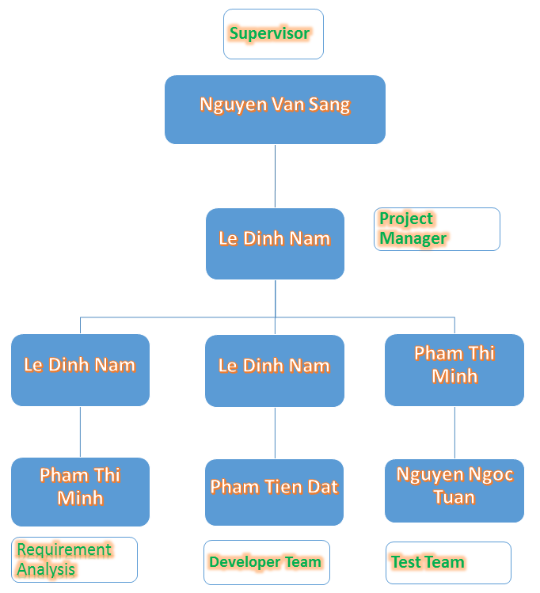

Figure ‑ Project organizational structure

### Project Process

#### Fsoft Process Model



Figure ‑2 Fsoft Process Model

The software lifecycle is broken into *cycles*, each cycle working on a new generation of the product. The Fsoft process divides one development cycle in six consecutive *phases*:

* Initiation phase
* Definition phase
* Solution phase
* Construction phase
* Transition
* Termination

#### Project Life Cycle

Basing on Fsoft process and real-world project, we decided to divide the project into four phases: Initiation, Solution, Construction, Termination:

**- Initiation Phase:** This is the explanatory phase of the project. Project objective and description is described at this stage. The purpose of this phase is to collect and understand business requirements, detail the project plan and agree upon a high level statement of work. Our primary objectives are complete project identification and project plan. After these are completed, the project is checked against the following criteria:

* + Identify business functions of the system
  + Determining the scope, conditions and limitations of the project
  + List the main functions of the system
  + List one or more suitable architecture for the system
  + Identify project risks
  + Complete Report 1, and Report 2

**- Solution Phase:**

* + In this phase, the architecture of the system is designed. The goal is to translate requirements and specification into a technical solution to produce Technical Design. Our primary objectives are complete requirement specification, architecture design and database design.
  + Finally, the plan must provide (including estimates of cost and time) for the construction phase. The plan must ensure proper and accurate based on experience.
  + Complete Report 3 and Report 4

**- Construction Phase:**

* + This is the longest phase of a project life cycle.
  + In this phase, all functions of the system will be installed. The installation will be divided into small stages, each stage of the installation a few functions. The results of each phase will be the release of the module function can be executed.
  + Construction and improvement of products until the final product is ready to deliver to the user. During this phase, all the components and other features of the application is developed and integrated into the product.
  + This phase emphasizes the resource management and control operations to optimize cost, time and quality.
  + Complete software packages and Report 5, Report 6

**- Termination Phase:**

* + This is the final phase in the life cycle of a project.
  + Their products will be deployed to the client. The feedback received during the transfer process will be recorded and put on the new functional requirements or functionality enhancements in the next version of the product.
  + Phase transfer switch also includes the training system and the new system for the user.

## Project Schedule

The Effort estimation is documented in the table below.

|  |  |  |  |  |  |
| --- | --- | --- | --- | --- | --- |
|  | Initiation | Solution | Construction | Termination | Total |
| Effort(person/day) | 72.5 | 104 | 89.5 | 34 | 300 |
| Total % budgeted Effort Usage (%) | 100 | 100 | 100 | 100 |  |

Table 2-3: Effort Estimate

### Milestone and Deliverables

| No | Stage | Committed Delivery date | Actual Delivery Date | | Description of Deliverable | Delivery media |
| --- | --- | --- | --- | --- | --- | --- |
| Initiation | |  | |  | Requirements agreed, Report 1 reviewed | |
| 1 | Develop project idea | 12-05-2014 | | 12-05-2014 | Project goals and scope defined, milestone description defined, resource committed | Commit to SVN Server |
| 2 | Q&A Management Sheet | 13-05-2014 | | 13-05-2014 | Criteria: Documentation reviewed | Commit to SVN Server |
| 3 | Submit report no.1 final | 20-5-2014 | | 20-5-2014 | Completed report no.1 | Commit to SVN Server |
| 4 | Project Plan | 28-05-2014 | | 28-05-2014 | Criteria: Documentation reviewed | Commit to SVN Server |
| 5 | Submit report no.2 final | 30-05-2014 | | 30-05-2014 | Completed report no.2 | Commit to SVN Server |
| Solution | |  | |  |  | |
| 1 | Screen Prototype | 10-06-2014 | | 10-06-2014 | Criteria: Documentation reviewed | Commit to SVN Server |
| 2 | Architecture Design | 12-6-2014 | | 12-6-2014 | Criteria: Documentation reviewed | Commit to SVN Server |
| 3 | Screen Design | 10-06-2014 | | 10-06-2014 | Criteria: Documentation reviewed | Commit to SVN Server |
| 4 | Class Design | 11-06-2014 | | 11-06-2014 | Criteria: Documentation reviewed | Commit to SVN Server |
| 5 | Detail Data Design | 11-6-2014 | | 11-6-2014 | Criteria: Documentation reviewed | Commit to SVN Server |
| 6 | SRS | 20-06-2014 | | 20-06-2014 | Criteria: Documentation reviewed | Commit to SVN Server |
| 7 | Submit Report no.3 Final | 20-06-2014 | | 20-06-2014 | Completed report no.3 | Commit to SVN Server |
| 8 | Submit Test Plan Final | 23-06-2014 | | 23-06-2014 | Criteria: Documentation reviewed | Commit to SVN Server |
| 9 | Create Unit Test Case | 28-06-2014 | | 28-06-2014 | Criteria: Documentation reviewed | Commit to SVN Server |
| 10 | Submit Report no.4 Final | 30-06-2014 | | 30-06-2014 | Completed report no.4 | Commit to SVN Server |
| Construction | |  | |  | Product developed & tested and released to supervisor, documentation reviewed. | |
| 1 | Review Test Document | 09-07-2014 | | 09-07-2014 | Criteria: Documentation reviewed | Commit to SVN Server |
| 2 | Submit report no.5 Final | 16-07-2014 | | 16-07-2014 | Completed report no.5 | Commit to SVN Server |
| 3 | Complete Coding and Unit Test | 24-07-2014 | | 24-07-2014 | Source code  Acceptance criteria: Product unit tested | Commit to SVN Server |
| 4 | Complete Testing | 31-07-2014 | | 31-07-2014 | Completed Test | Commit to SVN Server |
| 5 | Submit report no.6 Final | 04-08-2014 | | 11-08-2014 | Completed report no.6 | Commit to SVN Server |
| 6 | Submit the last document and CD source code | 11-08-2014 | | 21-08-2014 | Final Documents and Source Code | Print document and copy to CD |
| Termination | |  | |  | Project post-mortem is conducted, Project assets archived and released to supervisor | |
| 1 | Lesson learned | 12-8-2014 | | 18-8-2014 | Criteria: Completed | Group Meeting |
| 2 | Complete Presentation Slide | 14-8-2014 | | 19-8-2014 | Criteria: Completed | Commit to SVN Server |
| 3 | Represent capstone project | 20-08-2014 | | 30-08-2014 | Criteria: Completed | Present |
| 4 | Project Complete | 22-8-2014 | | 30-8-2014 | Criteria: Completed |  |

**Table 2‑4:** Milestone and Deliverables

### Gantt chart

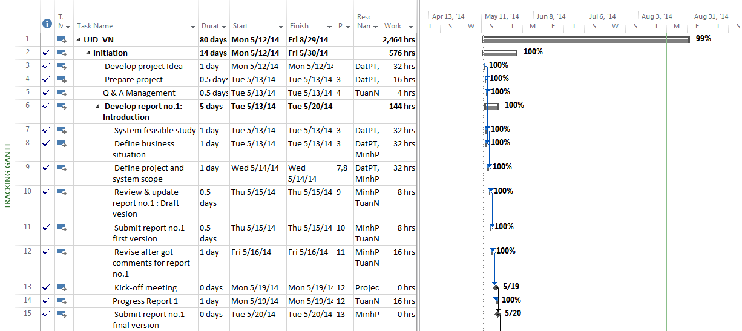

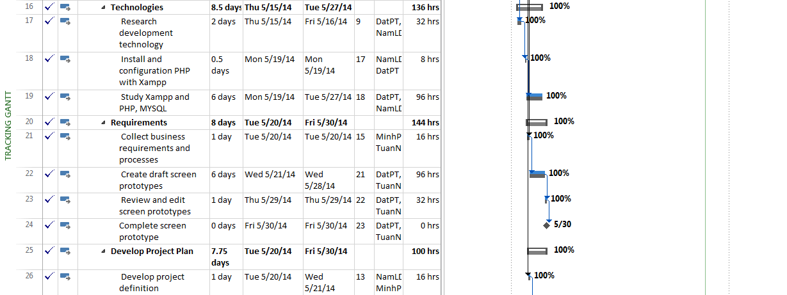

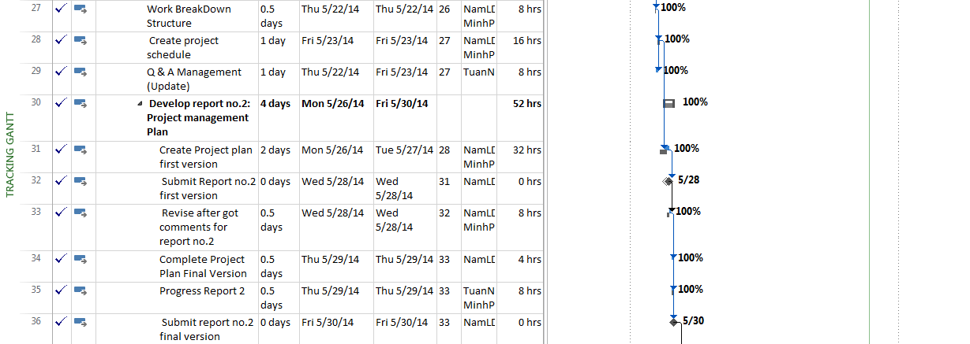

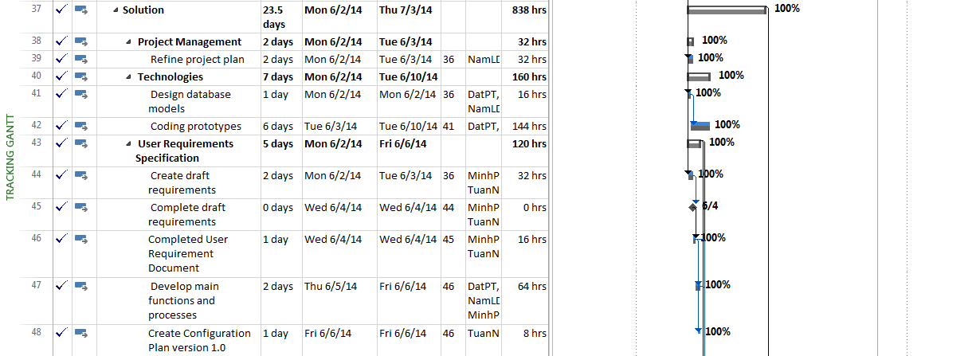

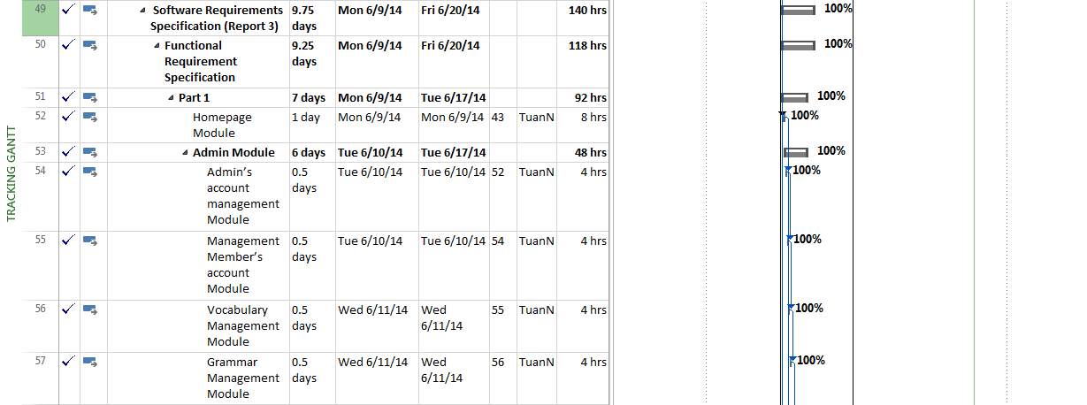

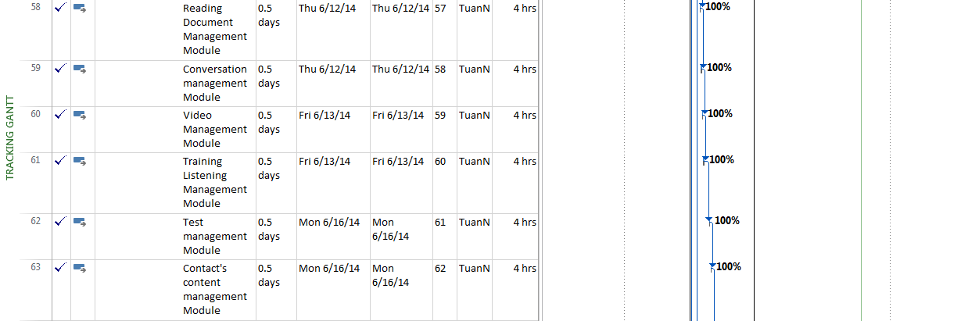

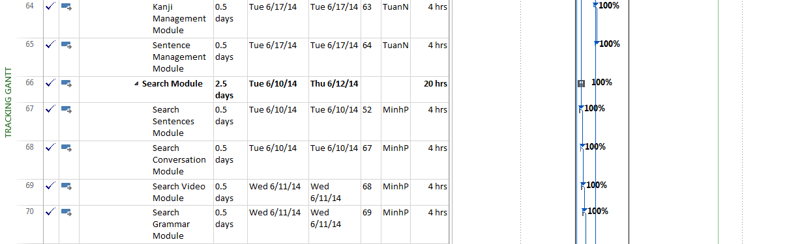

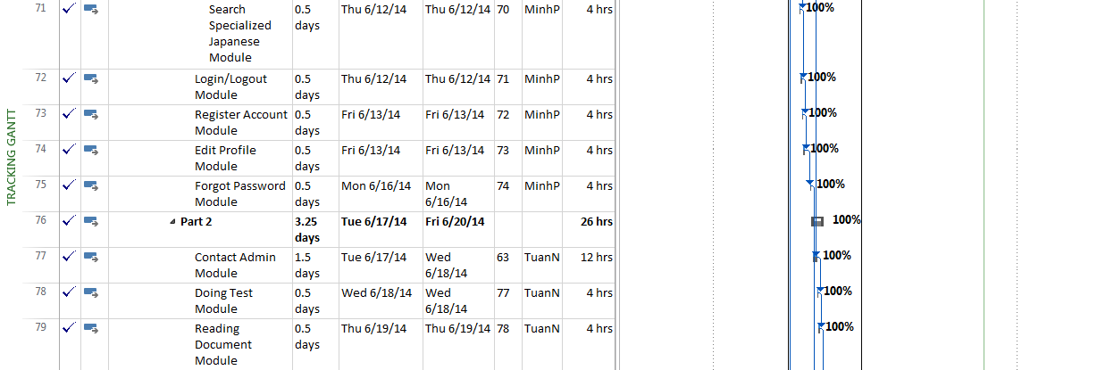

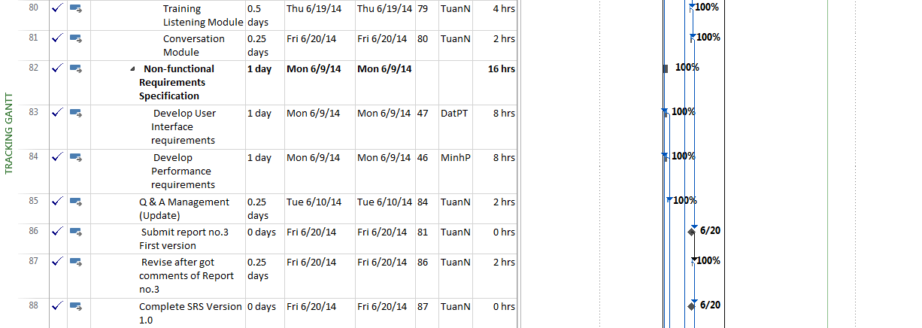

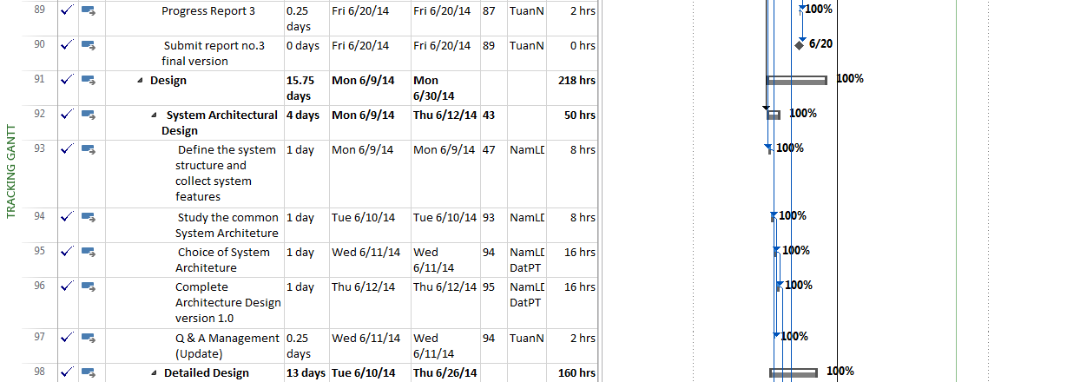

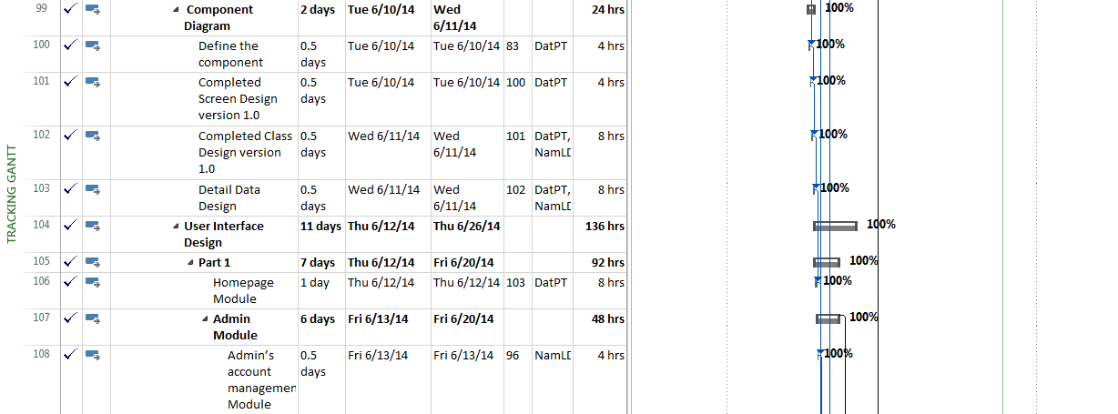

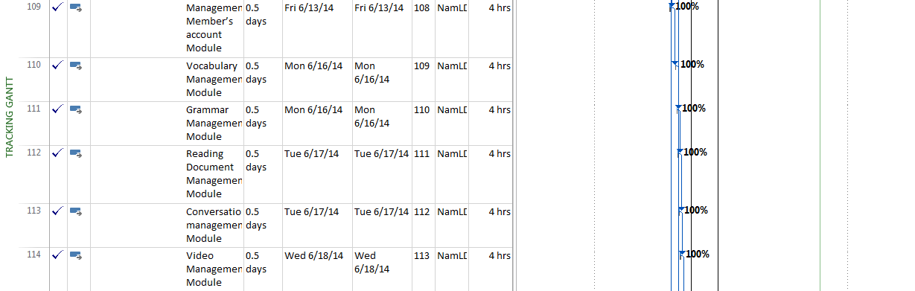

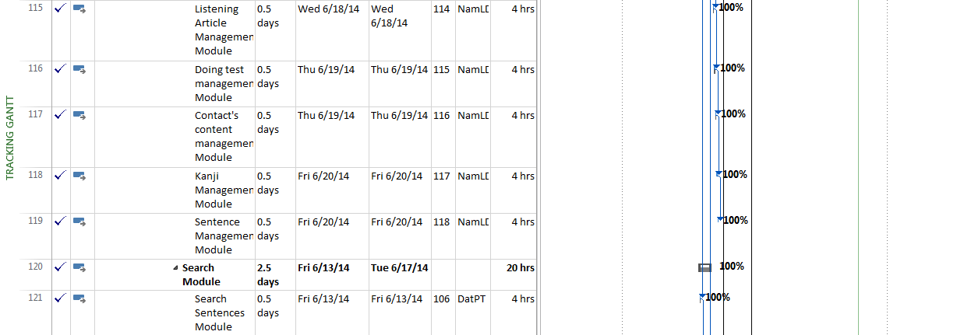

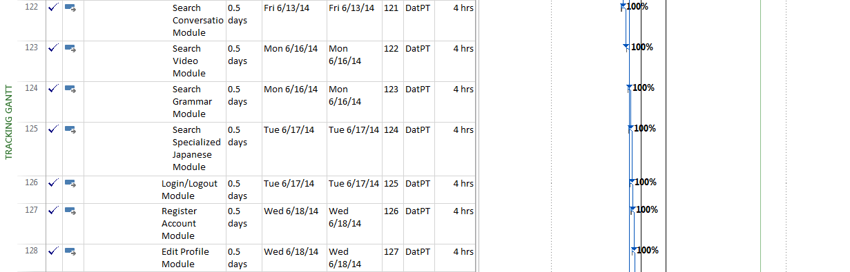

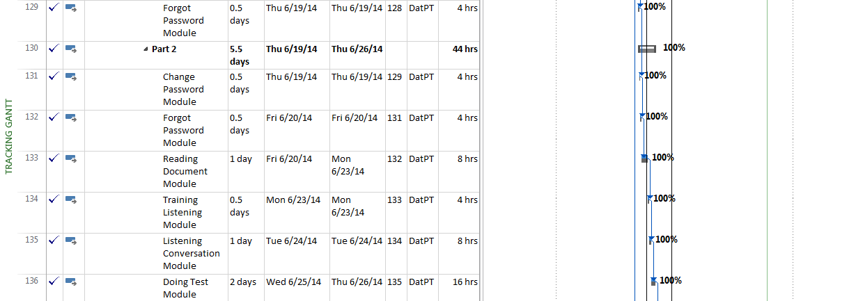

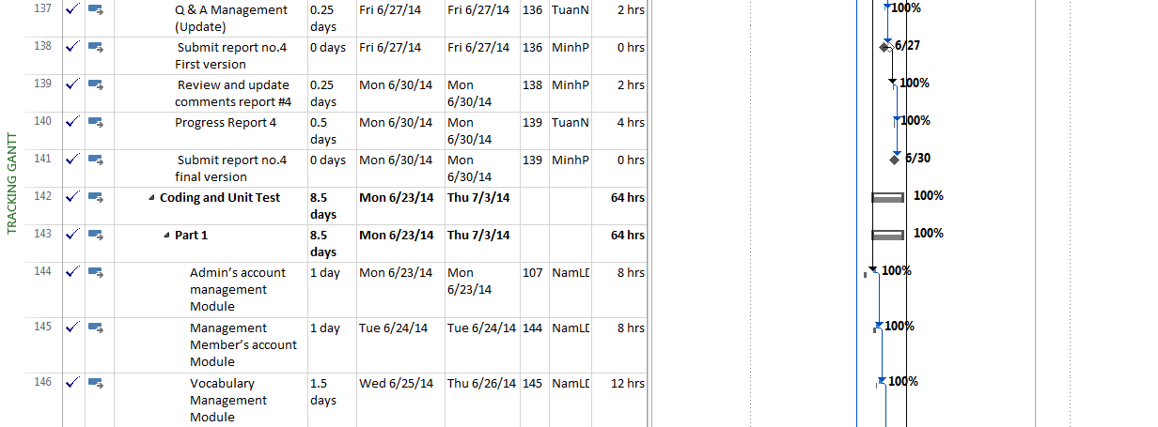

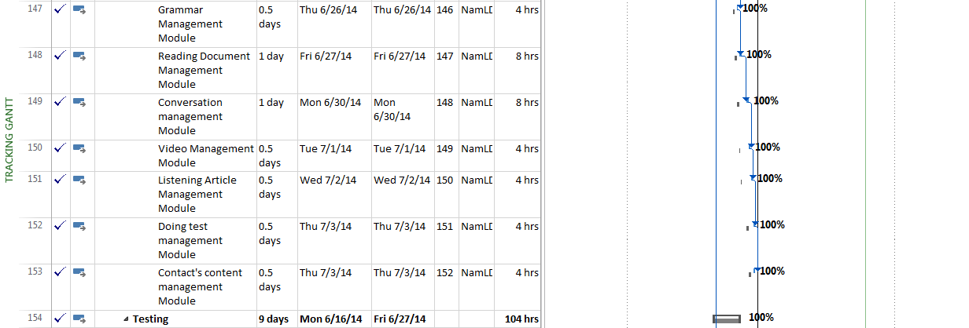

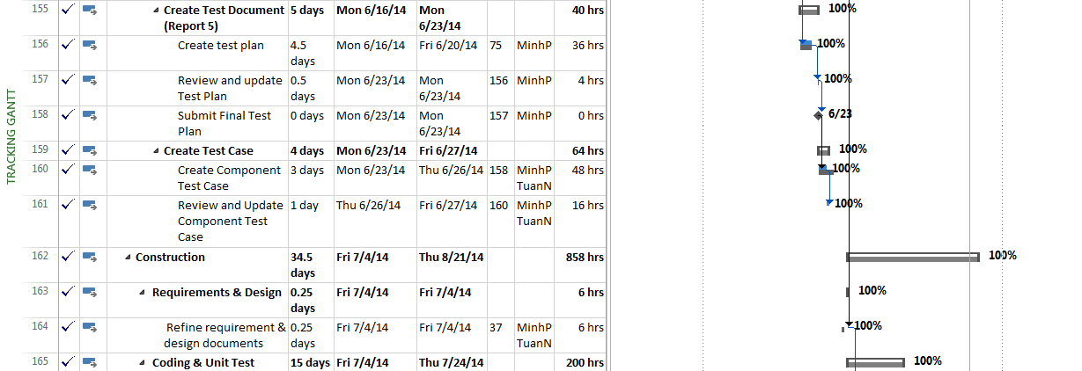

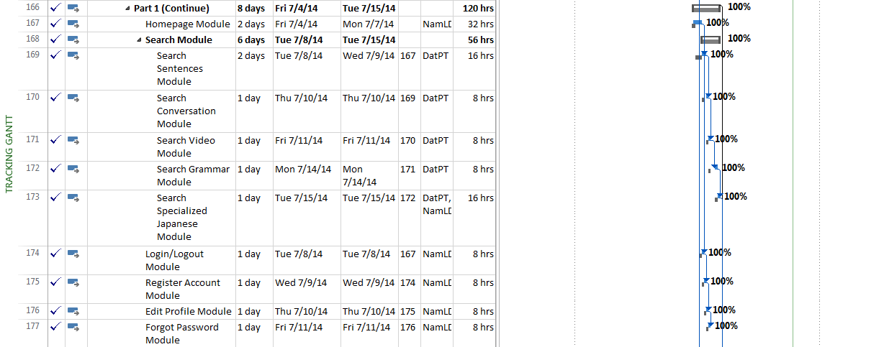

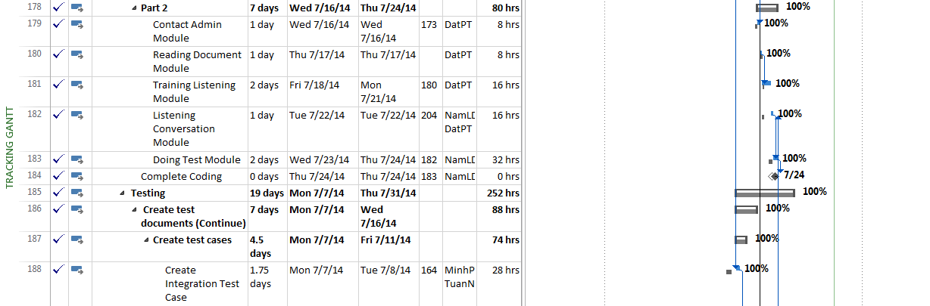

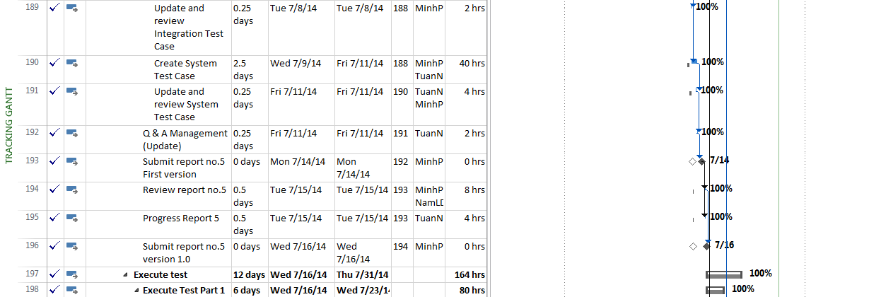

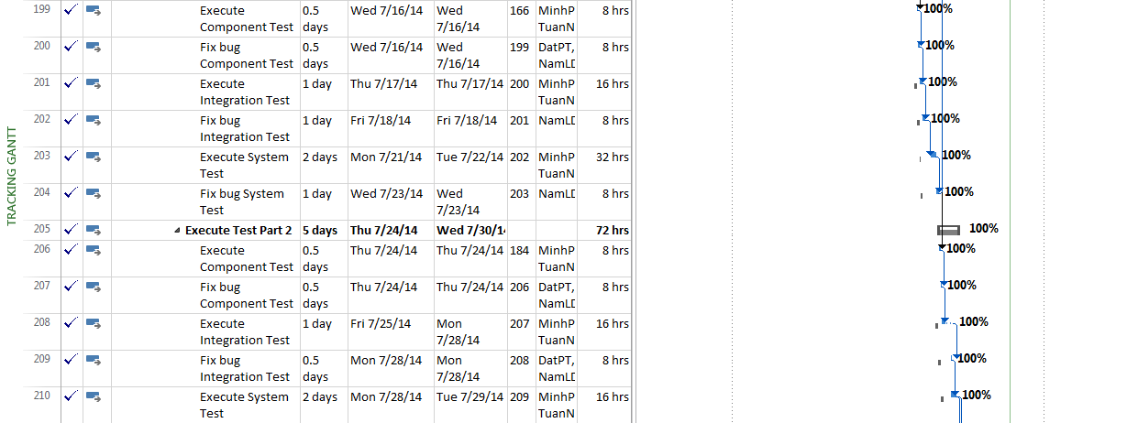

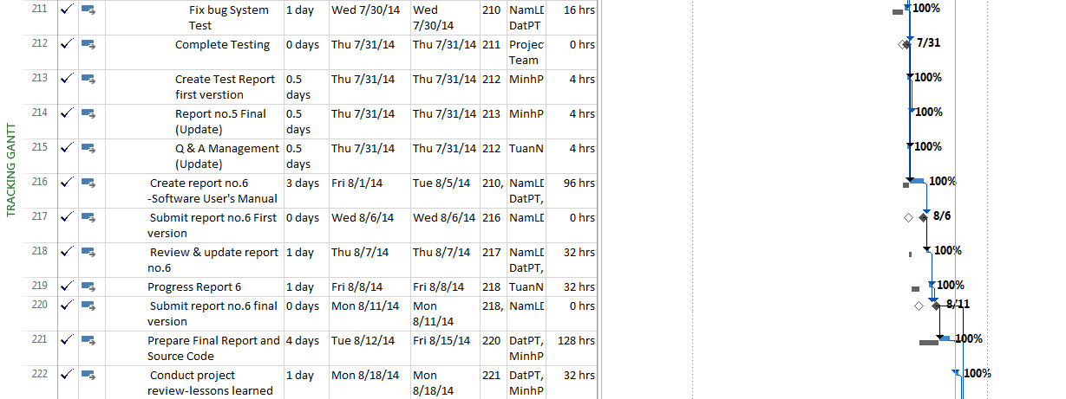

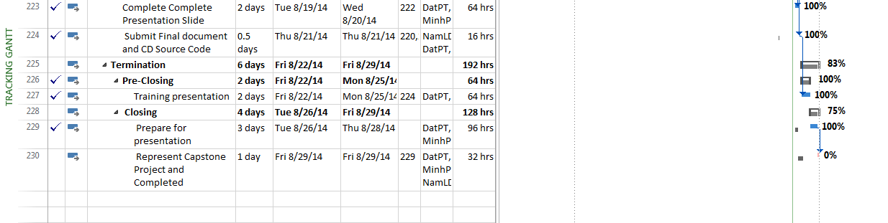

Figure 2-3: UJD_VN Gantt chart

## Risk Management

|  |  |  |  |  |  |  |  |  |  |  |  |  |
| --- | --- | --- | --- | --- | --- | --- | --- | --- | --- | --- | --- | --- |
| **Risk ID** | **Risk Source** | **Risk Category** | **Risk Description** | **Probability** | **Impact** | **Exposure** | **Priority** | **Trigger** | **Risk Status** | **Mitigation** | **Contigency** | **Person in charge** |
| R01 | Project Requirement | Not meeting performance requirements | Quality of document which is wrote by Japanese maybe not good | 0.3 | 2 | 0.6 | 4 | Member don’t know more Japanese. | Open | 1. Create plan to training Japanese for member from beginning of project. |  | Team member |
| 2. Using English instead of Japanese (if can). |  | Team member |
| 3. When deliver documents to customer can write by two languages: English and Japanese. |  | Team member |
| R02 | Human resource | Shortage of Human resource | Member leave team while running project. | 0.2 | 8 | 1.6 | 3 | Member being absent at the meeting minues and cannot contact |  |  | If risk occurs, PM assigns work to other member. | Team member |
| Open |  |  |  |
|  |  |  |  |
| R03 | Project Management | Insufficient PM Experience | PM may not follow the process because lacks of project management skill. | 0.5 | 5 | 2.5 | 1 | Project is not follow the process |  | 1. PM ask for helping from Supervisor when need. |  | NamLD |
| Open | 2.PM self-study about Project Management Skill |  | NamLD |
|  |  |  |  |
| R04 | Technical | Process risk | Delivery report day is delay. | 0.6 | 4 | 2.4 | 2 | Schedule is unclearly and member don't know about delevery report day | Open | PM must make schedule clearly and take care specially to delivery day. |  | Team member |
| R05 | Project Requirement | Not meeting performance requirements | Change requirement | 0.4 | 6 | 2.4 | 2 | Requirement is changed when designing/ coding or testing | Open | Change design, code, test case |  | Team member |
| R06 | Project Management | Structure risk | Not suitable schedule | 0.5 | 6 | 3 | 3 | Schedule is not suitable, duration is too long or too short | Open | Change schedule |  | Team member |
| R07 | Project Requirement | Not meeting performance requirements | Miss requirement | 0.4 | 7 | 2.8 | 2 | The product of project cannot meet fully requirements | Open | PM must make schedule clearly and take care specially to delivery day. |  | Team member |
| R08 | Human resource | Shortage of Human resource | Developer of project doesn't have any experience about PHP language and unit test for PHP. | 0.3 | 6 | 1.8 | 4 | Developer has not worked or studied with PHP language before. | Open | - Have plan for developer to study and code demo by PHP language before the project start.  - Refer unit test of Fsoft's project. |  | Team member |
| R09 | Human resource | Shortage of Human resource | Tester of project may can't join with project full time. | 0.6 | 6 | 3.6 | 3 | - Website may not be tested clearly and fully | Open | Other member will join full time in project when it is necessary. |  | Team member |
| R10 | Human resource | Shortage of Human resource | During the time doing project, member of project may have problem and can't do their job fully. | 0.6 | 9 | 5.4 | 5 | - Their job may be late and affect project schedule. | Open | - Always have the people to support for another when it is necessary |  | Team member |

Table 2-5: Risk Management

## 

## Communication Management

| Communication Type | Method / Tool | When | Information | Participants / Responsible | |
| --- | --- | --- | --- | --- | --- |
| Project Task Tracking | | | | | |
| Task scheduling | MS Project Professional 2013 | At the beginning of every stage, and weekly  Refinement and rescheduling as necessary |  | PM | |
| Task assignment | MS Project Professional 2013 | Weekly |  | PTL | |
| Task status reporting | Daily Report | Daily |  | Project Team Members | |
| Project Meeting | | | | | |
| Kick-off Meeting | Face to face | Initiation stage | Project introduction; Project plan review; Risk identification; stakeholders identify. | PM, Project Team Members | |
| Project Progress Review Meetings | Face to face | Weekly and on event | Communicate project status  Communicate and resolve any open issue, risks, and changes  Discuss any suggested improvement | PM, Project Team Members | |
| Milestone Meetings | Face to face | 5 days After the completion of stages: Definition, Solution & Construction | Project objective review, evaluate project performance (quality, schedule, effort), Causal analysis, update project plan for next stage | PM, Project Team Members, QA, Supervisor | |
| Transfer/Sharing of project documentation/information | Tortoise SVN | When available | All project documentation and information | PM, Project Team Members, QA | |
| Supervisor Communication and Reporting: | | | | | |
| Project Report | Agreed Fsoft and FU standard format | 5pm Monday, Weekly | Project status report, Issue requiring clarifications, escalation, if any | | PM |
| Project Meetings with supervisor | Face to face | 12h45 Friday, Weekly | As above | | PM |
| Requirement gathering/clarification | Face to face meeting | During requirement analysis phase | As in Q&A list | | PM |
| Communication with Supervisor | | | | | |
| Review Project Plan & Project schedule | By attend project meeting | Significant changes to WO, PP and Project schedule (scope, objectives Organization, HR, major milestone, deliverables ) |  | | PM |
| Project Progress Review | By email and/or via Operation meeting at Group/Division level | Weekly | Project status report, Issue requiring clarifications, escalation, if any | | PM |
| Project Milestone Review | By email and via project milestone review meeting | End of every stage | Project objective review, evaluate project performance (quality, schedule, effort), Causal analysis, update project plan for next stage | | PM |

Table 2-6: Communication Management

## Tools and Infrastructure

Below is the list of tools and infrastructure requirements needed for development environment.

| Item | Description | Expected Availability by | Note |
| --- | --- | --- | --- |
| Development Environment | | | |
| Operating System | Window 7 (32 bit, 64 bit), Window 8 | 12-05-2014 |  |
| Browser | Google Chrome, CocCoc(all version) | 12-05-2014 |  |
| Development language | PHP | 12-05-2014 | for Web interface |
| Technology | | | |
| Development language | PHP, MVC Model | 12-05-2014 |  |
| Server | Xampp 1.8.2 (server localhost) | 12-05-2014 |  |
| Hardware Requirement | | | |
| Hardware Configuration | 2GB workspaces on server | 12-05-2014 |  |
| Equipment & Tools | | | |
| Source Version Control | TortoiseSVN | 12-05-2014 |  |
| Task Tracking | MS Project Professional 2013 | 12-05-2014 |  |
| SRS | Microsoft Office Word, Microsoft Office Excel, Microsoft Office Visio | 12-05-2014 |  |

Table 2-7: Tools and Infrastructure

## Configuration Management Plan

Reference to UJD_VN_CMPlan_v1.0_EN to more detail.

# Software Requirement Specification

## Overview

### Purpose

This document is created as the introduction for project Useful Japanese Dictionary for Vietnamese – our Capstone Project at FPT University. In this document, we will descript the overview of function list, use case of our software, a brief description about function's screen. This document help user understand more about our system.

### Scope

The scope of this project contains Requirement Analysis, Design, Coding and Testing (Unit Test, Integration Test, and System Test).

## User Requirements Specification

### Business Process Overview

#### Search workflow

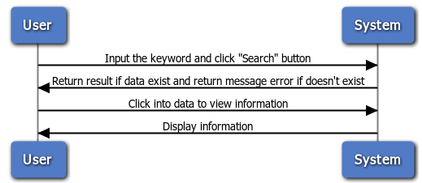

Figure 3-1: Search workflow

**Brief description**: Everyone can do that search process. It is divided into these steps:

**Step 1**: User choose the type of search and input the key word into text box.

**Step 2**: After user click on search button, system will return result match with key word if it exists, and return error message if it does not exist.

**Step 3**: User can click on result to view information of key word.

#### Doing Test Workflow

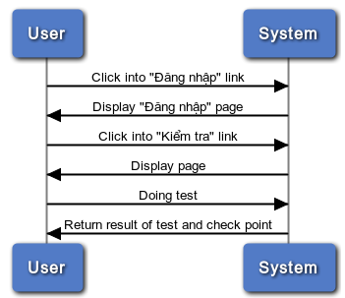

Figure 3-2: Doing Test

**Brief description**: Only member can do test. It divided into these steps:

**Step 1**: Member click on the “Kiểm tra” link

**Step 2**: After member click on link, system will display all test on the website

**Step 3**: User click on any test link and doing test

**Step 4**: After member successful the test, system will return result of test and check point

#### Register workflow

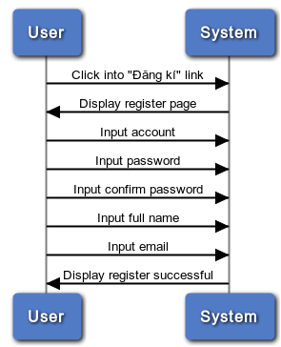

Figure 3-3: Register

**Brief description**: Only guest can register. It divided into these steps:

**Step 1**: User (Guest) click on register link

**Step 2**: System will display register page

**Step 3**: User insert into all required fields then click on register button. System will check the validation of all inserted fields. If it is invalid, display error message beside wrong fields. If ok, display successful message.

#### Contact Admin

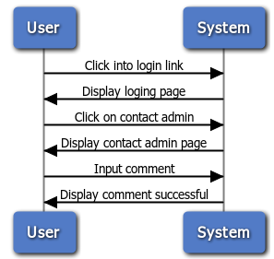

Figure 3-4: Contact admin

**Brief description**: Only member can contact admin. It is divided into these steps:

**Step 1**: Member click on contact admin link

**Step 2**: System will display contact page

**Step 3**: User input comment

**Step 4**: System will receive comments and display successful message

### Product Features

UJD_VN is an online system, user only connect to internet to use website. System provides these main functions:

* + **Manage admin account**

System just allows user who logins as Administrator have permission to manage admin account. So that they can add new admin, edit profile, delete admin as they want.

* + **Manage member account**

System just allows user who logins as Administrator have permission to manage member account. So that they can search member, ban/ unban member, delete member as they want.

* + **Manage vocabulary**

System just allows user who logins as Administrator have permission to manage vocabulary. So that they can search, add, edit, delete vocabulary as they want.

* + **Manage grammar**

System just allows user who logins as Administrator have permission to manage grammar. So that they can search, add, edit, delete grammar as they want.

* + **Manage reading document**

System just allows user who logins as Administrator have permission to manage reading document. So that they can search, add, edit, delete reading document as they want.

* + **Manage conversation**

System just allows user who logins as Administrator have permission to manage conversation. So that they can search, add, edit, delete conversation when they want.

* + **Manage video**

System just allows user who logins as Administrator have permission to manage video. So that they can search, add, edit, delete video as they want.

* + **Manage listening article**

System just allows user who logins as Administrator have permission to manage listening article. So that they can search, add, edit, delete listening article as they want.

* + **Manage doing test**

System just allows user who logins as Administrator have permission to manage doing test. So that they can search, add, edit, delete doing test as they want.

* + **Manage contributed content**

System just allows user who logins as Administrator have permission to manage contributed content. So that they can search, approve, reply, delete contributed content as they want.

* + **Manage contributed opinion**

System just allows user who logins as Administrator have permission to manage contributed opinion. So that they can search, reply, delete contributed opinion as they want.

* + **Manage Q&A**

System just allows user who logins as Administrator have permission to manage Q&A. So that they can search, reply, delete Q&A as they want.

* + **Search**

Everyone who uses that system can make search with five options: search sentences, search conversation, search grammar, search video, search specialized Japanese.

* + **Training listening**

Everyone who uses that system can make training listening.

* + **Listening conversation**

Everyone who uses that system can make listening conversation.

* + **Reading document**

Everyone who uses that system can make reading document such as: Fundamental Japanese document, Intermediate Japanese document, review Japanese document.

* + **Doing test**

When user registered successfully, user can make doing test then tracking their mark.

* + **Contact admin**

When user registered successfully, user can make contact admin such as: contribute content, contribute opinion and send any question to admin.

* + **Log in/ Log out**

When user registered successfully, user can make log in.

* + **Edit Profile**

When user registered successfully, user can make log in, when logged in, user can edit their profile, change password and track their mark.

* + **Forgot password**

If user forgot password, user can retake new password.

* + **Register**

If user do not have account on system, user can use make register.

## Sofware Requirements Specification

### Overall Description

#### System overview

Nowadays, there are many dictionaries which support Japanese. That can be a website or mobile application. All of them have been created for the purpose of helping users search vocabulary or studying Japanese more easily. But we found some disadvantages which existing in website which support users studying Japanese. So, our project – UJD_VN will include some main functions of existing dictionary website and add some special features such as showing examples by Vietnamese, supporting searching specialized vocabulary or users can contribute idea, good knowledge to make our database become larger. Moreover, we will provide freely website to users. Here, we toward provide website for Vietnamese who want to studying Japanese communication or who want to join Japanese certification exams.

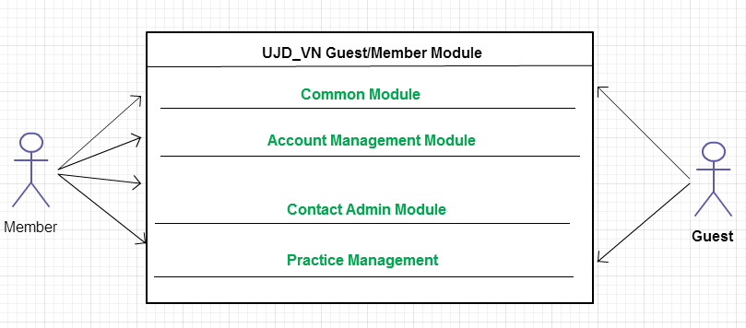

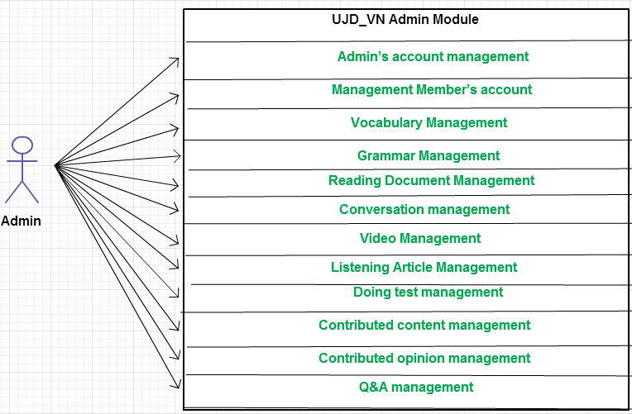

Figure 3-5: System overview

#### Product Features

|  |  |  |  |
| --- | --- | --- | --- |
| **Use Case No.** | **Group of functions** | **Functions** | **Glossary** |
| **UJD_VN GUEST/MEMBER MODULE** | | | |
| **Common Module** | | | |
|  | Search | Search sentences | Search for example sentences |
|  | Search conversation | Search for conversations |
|  | Search grammar | Search for grammar |
|  | Search video | Search for video of Japanese |
|  | Search specialized Japanese | Search for Japanese specialized |
| **Account Management Module** | | | |
|  | Login | Login by Facebook account | Sign in with your Facebook account |
| Login by registered account | Sign in with you register account |
|  |  | Logout | Logout |
|  |  | Register | Register account for customers to use more features of the website |
|  |  | Edit Profile | Edit user’s profile |
|  |  | Forgot Password | Forgot password |
| **Contact Admin Module** | | | |
|  | Contact Admin | Contribute content | Contribute useful database for website |
|  | Contribute opinion | Feedback for website development |
|  | Send Q & A | Send any questions in the process of using Website |
| **Practice Management** | | | |
|  | Doing Test | Test | Doing test |
| Tracking mark | Tracking the learning process |
|  |  | Training Listening | Training listening level N2,N3,N4 |
|  |  | Listening conversation | Listening conversation |
|  |  | Reading Document | Reading document |
| **UJD_VN ADMIN MODULE** | | | |
|  | Admin’s account management | Add new admin | Add new admin |
|  | Edit profile | Edit admin’s profile |
|  | Delete admin | Delete admin |
|  | Management Member’s account | Search member | Search member |
|  | Ban/Unban Member’s account | Ban/Unban member’ account |
|  | Delete member | Delete member |
|  | Vocabulary Management | Search vocabulary | Search vocabulary |
|  | Add vocabulary | Add new vocabulary |
|  | Edit vocabulary | Edit vocabulary |
|  | Delete vocabulary | Delete vocabulary |
|  | Grammar Management | Search grammar | Search grammar |
|  | Add Grammar | Add Grammar |
|  | Edit grammar | Edit grammar |
|  | Delete Grammar | Delete Grammar |
|  | Reading Document Management | Search reading document | Search reading document |
|  | Add reading document | Add new reading document |
|  | Edit reading document | Edit reading document |
|  | Delete reading document | Delete reading document |
|  | Conversation management | Search conversation | Search conversation |
|  | Add conversation | Add new conversation |
|  | Edit conversation | Edit conversation |
|  | Delete conversation | Delete conversation |
|  | Video Management | Search Video | Search video by title |
|  | Add Video | Add new video |
|  | Edit Video | Edit video |
|  | Delete Video | Delete video |
|  | Listening Article Management | Search listening article | Search listening article |
|  | Add listening article | Add listening article |
|  | Edit listening article | Edit listening article |
|  | Delete listening article | Delete listening article |
|  | Doing test management | Search test | Search test |
|  | Add test | Add test |
|  | Edit test | Edit test |
|  | Delete test | Delete test |
| **Contact Management** | | | |
|  |  | Search Question | Search Opinion or Q&A |
|  |  | Reply Question | Answer question to member |
|  |  | Delete Question | Delete question from database if the question is not neccessary |
|  |  | Approve contributed content | Check contributed content form member, if it is exactly, admin will approve it and add to database, if not exactly, admin can reject it. |
|  |  | Delete contributed content | If contributed content is not exactly, admin can delete content. |

Table 3-1: Product features

#### User Characteristics

This website developed towards those who have achieved elementary level Japanese and want to improve intermediate level. The website requires users to have the ability to use a browser with an internet connection. Use can easy use the functions in website, but if they want to use all function, they must be login.

#### User Documentation

List of document when delivering this application is in the table below:

|  |  |
| --- | --- |
| Name | Description |
| User Manual | Provide detailed explanation about the system, screens and guide users how to use all features of UJD_VN website. |

#### Assumption

* Receive the guidance and good support of teacher.
* No one of member got sick in the software development process.
* In the development process, no device got fail.
* Every report meets the deadline.
* Team member do not conflict in the work process.

### Entity Relation Model

#### Entity-Relationship Diagram

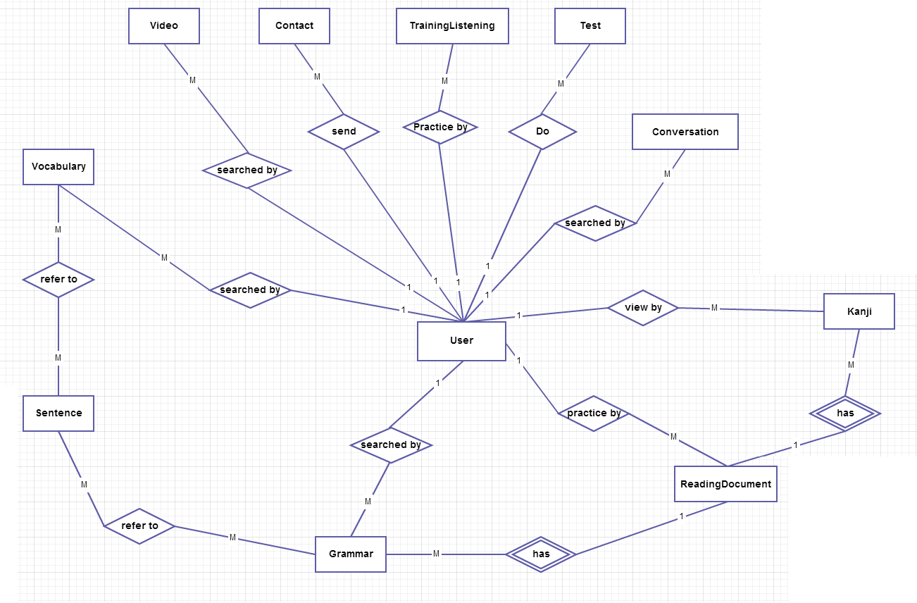

Figure 3-6: Entity Relationship Diagram

#### Entity Detail

##### Vocabulary

|  |  |  |  |  |
| --- | --- | --- | --- | --- |
| No | Field Name | Type | Mandatory | Description |
|  | id | Number | Y | Vocabulary’s id |
|  | Hiragana | String | Y | Vocabulary’s hiragana |
|  | Romaji | String | Y | Vocabulary’s romaji |
|  | Meaning | String | Y | Vocabulary’s meaning |
|  | Category | String | Y | Vocabulary’s category |
|  | Kanji | String |  | Vocabulary’s kanji |
|  | Specialized | String |  | Vocabulary’s specialized |
|  | Status | Number | Y | Vocabulary’s status |

##### Sentence

|  |  |  |  |  |
| --- | --- | --- | --- | --- |
| No | Field Name | Type | Mandatory | Description |
|  | ID | Number | Y | Sentence’s id |
|  | Hiragana | String | Y | Sentence’s hiragana |
|  | Romaji | String | Y | Sentence’s romaji |
|  | Meaning | String | Y | Sentence’s meaning |
|  | Kanji | String | Y | Sentence’s kanji |

##### Grammar

|  |  |  |  |  |
| --- | --- | --- | --- | --- |
| No | Field Name | Type | Mandatory | Description |
|  | ID | Number | Y | Grammar’s id |
|  | Hiragana | String | Y | Grammar’s hiragana |
|  | Romaji | String | Y | Grammar’s romaji |
|  | Level | String | Y | Grammar’s level |
|  | Meaning | String | Y | Grammar’s meaning |
|  | Use | String | Y | Grammar’s use |
|  | Lesson | String |  | Grammar’s lesson |
|  | Status | Number | Y | Grammar’s status |

##### Video

|  |  |  |  |  |
| --- | --- | --- | --- | --- |
| No | Field Name | Type | Mandatory | Description |
|  | ID | Number | Y | Video’s id |
|  | Title | String | Y | Video’s title |
|  | Link | String | Y | Video’s link |

##### Kanji

|  |  |  |  |  |
| --- | --- | --- | --- | --- |
| No | Field Name | Type | Mandatory | Description |
|  | ID | Number | Y | Kanji’s id |
|  | Kanji | String | Y | Kanji in Japanese |
|  | Hanviet | String | Y | Kanji’s Vietnamese-Han |
|  | Onyomi | String | Y | Kanji’s onyomi |
|  | Kunyomi | String |  | Kanji’s kunyomi |
|  | Meaning | String | Y | Kanji’s meaning |
|  | Level | String | Y | Kanji’s level |
|  | Lesson | String |  | Kanji’s lesson |
|  | Status | Number | Y | Kanji’s status |

##### Conversation

|  |  |  |  |  |
| --- | --- | --- | --- | --- |
| No | Field Name | Type | Mandatory | Description |
|  | ID | Number | Y | Conversation’s id |
|  | Titel | String | Y | Conversation’s level |
|  | Level | String | Y | Conversation’s title |
|  | Content | String | Y | Conversation’s content |
|  | Audio | String | Y | Conversation’s audio |
|  | Image | String |  | Conversation’s image |

##### User

|  |  |  |  |  |
| --- | --- | --- | --- | --- |
| No | Field Name | Type | Mandatory | Description |
|  | ID | Number | Y | User’s id |
|  | Username | String | Y | Username login |
|  | Password | String | Y | Store password login of user.  Using md5 algorithm. |
|  | Role | Number | Y | Admin can assign permission for user |
|  | Full name | String |  | User’s name display |
|  | Email | String | Y | User’s email |
|  | Register date | Date | Y | Date register |
|  | Status | Number | Y | Active or deactive |

##### Test

|  |  |  |  |  |
| --- | --- | --- | --- | --- |
| No | Field Name | Type | Default | Description |
|  | ID | Number | Y | Test’s id |
|  | Title | String | Y | Test’s category |
|  | Level | String | Y | Test’s level |
|  | Category | String | Y | Test’s category |
|  | Content | String |  | Test’s content |
|  | Question | String | Y | Test’s question |
|  | Answer | String | Y | Question’s answer |

##### Contact

|  |  |  |  |  |
| --- | --- | --- | --- | --- |
| No | Field Name | Type | Mandatory | Description |
|  | ID | Number | Y | Contact’s id |
|  | Email | String | Y | Contact’s email |
|  | Content | String | Y | Contact’s content |
|  | Type | String | Y | Contact’s type |
|  | Reply | String |  | Contact’s reply |
|  | Status | Number | Y | Contact’s status |

##### Training Listening

|  |  |  |  |  |
| --- | --- | --- | --- | --- |
| No | Field Name | Type | Mandatory | Description |
|  | ID | Number | Y | Listening’s id |
|  | Title | String | Y | Listening’s title |
|  | Level | String | Y | Listening’s level |
|  | File | String | Y | Listening’s file |
|  | Question | String | Y | Listening’s question |
|  | Script | String | Y | Listening’s script |
|  | Meaning | String | Y | Listening’s meaning |
|  | Answer | String | Y | Listening’s answer |

##### Reading document

|  |  |  |  |  |
| --- | --- | --- | --- | --- |
| No | Field Name | Type | Mandatory | Description |
|  | ID | Number | Y | Reading’s id |
|  | Title | String | Y | Reading’s title |
|  | Level | String | Y | Reading’s level |
|  | Vocabulary | String | Y | Reading’s vocabulary |
|  | Grammar | String | Y | Reading’s grammar |
|  | Kanji | String | Y | Reading’s kanji |
|  | Article | String | Y | Reading’s article |

### Functional Specification

#### Common Module

##### Use Case Diagram

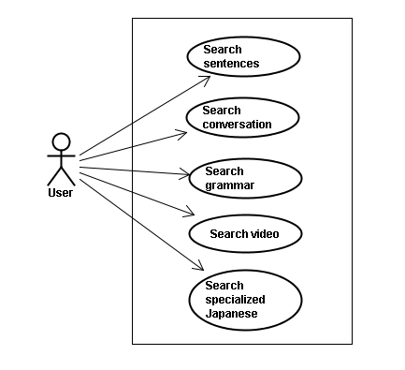

Figure 3-7: Search Use Case Diagram

##### Screen description

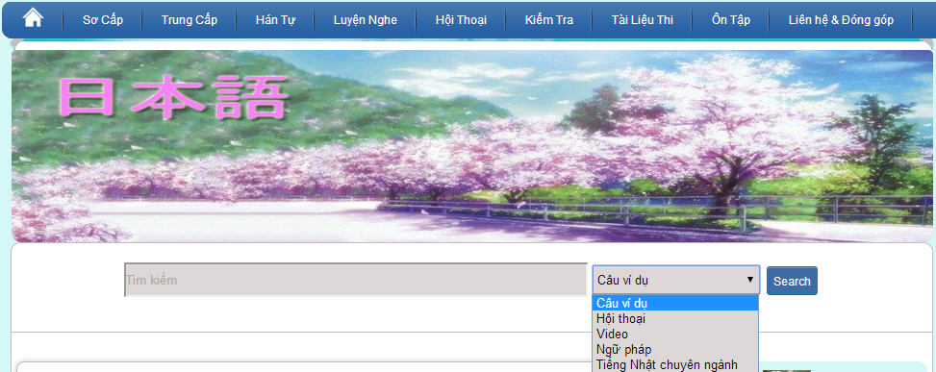

Figure 3-8: Search’s screen description

|  |  |  |  |  |  |  |  |
| --- | --- | --- | --- | --- | --- | --- | --- |
| No | Field name | Field name in Vietnamese | Type | Require | Mandatory | Length | Description |
| 1 | Searcharea | Tìm kiếm | Text | Text | Y | 255 | User input a new word with length less than 255 characters |
| 2 | SearchOption | Kiểu tìm kiếm | Drop-down list | Click | Y |  | User choose type of search |
| 2 | Search | Search | Button | Click | Y |  | User click on search button |

Table 3-2: Search’s screen description

##### Use Case Specification

###### UC001: Search sentences

|  |  |  |  |  |
| --- | --- | --- | --- | --- |
| **UC001 – Search sentences** | | | | |
| **Use-case No.** | <UC001> | **Use-case Version** | | <1.0> |
| **Use-case Name** | Search sentences | | | |
| **Author** | Tuan NN | | | |
| **Date** | 09/06/2014 | **Priority** | <High > | |
| **Actor:**  Guest, Member, Administrator  **Summary:**  When Guest, Member, Administrator want to search by sentences in database successfully if it is existed  **Triggers**  Click on search area , input sentences in the text area, choose type of search and then click “Search” button  **Preconditions:**   * Website is available * User have to input data in search area   **Post Conditions:**  Display detail information of sentences  **Main Success Scenario:**   |  |  |  | | --- | --- | --- | | **Step** | **User** | **System** | | 1 | Enter website link on web browser | Display Home page screen | | 2 | Input data in search area and choose “Câu ví dụ” type then click button Search | Display “sentences information” screen that contains the information of chosen sentences with these elements:   * Serial number * Name of sentences by hiragana * Name of sentences by romaji * Meaning of sentences |     **Alternative Scenario:**   |  |  |  | | --- | --- | --- | | **At Step** | **User** | **System** | | 2 | Input data in search area and choose “Câu ví dụ” type then click on another link | Switch to selected page |   **Exceptions:**   |  |  |  | | --- | --- | --- | | **At Step** | **User** | **System** | | 2 | Fill data that they want to find (that do not exist in database) into these fields then click “Search” button | Return Error message to inorm that sentences cannot be found | | | | | |

###### UC002: Search conversation

|  |  |  |  |  |
| --- | --- | --- | --- | --- |
| **UC002 – Search conversation** | | | | |
| **Use-case No.** | <UC002> | **Use-case Version** | | <1.0> |
| **Use-case Name** | Search conversation | | | |
| **Author** | Tuan NN | | | |
| **Date** | 09/06/2014 | **Priority** | <High > | |
| **Actor:**  Guest, Member, Administrator  **Summary:**  When Guest, Member, Administrator want to search by conversation in database successfully if it is existed  **Triggers**  Click on search area , input conversation in the text area, choose type of search and then click “Search” button  **Preconditions:**   * Website is available * User have to input data in search area   **Post Conditions:**  Display detail information of conversation  **Main Success Scenario:**   |  |  |  | | --- | --- | --- | | **Step** | **User** | **System** | | 1 | Enter website link on web browser | Display Home page screen | | 2 | Input data in search area and choose “Hội thoại” type then click button Search | Display “conversation information” screen that contains the information of chosen conversation with these elements:   * Serial number * Name of conversation by hiragana * Name of conversation by romaji * Meaning of conversation |     **Alternative Scenario:**   |  |  |  | | --- | --- | --- | | **At Step** | **User** | **System** | | 2 | Input data in search area and choose “Hội thoại” type then click on another link | Switch to selected page |   **Exceptions:**   |  |  |  | | --- | --- | --- | | **At Step** | **User** | **System** | | 2 | Fill data that they want to find (that do not exist in database) into these fields then click “Search” button | Return Error message to inform that conversation cannot be found | | | | | |

###### UC003: Search grammar

|  |  |  |  |  |
| --- | --- | --- | --- | --- |
| **UC003 – Search grammar** | | | | |
| **Use-case No.** | <UC003> | **Use-case Version** | | <1.0> |
| **Use-case Name** | Search grammar | | | |
| **Author** | Tuan NN | | | |
| **Date** | 09/06/2014 | **Priority** | <High > | |
| **Actor:**  Guest, Member, Administrator  **Summary:**  When Guest, Member, Administrator want to search by grammar in database successfully if it is existed  **Triggers**  Click on search area , input grammar in the text area, choose type of search and then click “Search” button  **Preconditions:**   * Website is available * User have to input data in search area   **Post Conditions:**  Display detail information of grammar  **Main Success Scenario:**   |  |  |  | | --- | --- | --- | | **Step** | **User** | **System** | | 1 | Enter website link on web browser | Display Home page screen | | 2 | Input data in search area and choose “Ngữ pháp” type then click button Search | Display “grammar information” screen that contains the information of chosen grammar with these elements:   * Serial number * Name of grammar by hiragana * Name of grammar by romaji * Meaning of grammar |     **Alternative Scenario:**   |  |  |  | | --- | --- | --- | | **At Step** | **User** | **System** | | 2 | Input data in search area and choose “Ngữ pháp” type then click on another link | Switch to selected page |   **Exceptions:**   |  |  |  | | --- | --- | --- | | **At Step** | **User** | **System** | | 2 | Fill data that they want to find (that do not exist in database) into these fields then click “Search” button | Return Error message to inform that grammar cannot be found | | | | | |

###### UC004: Search video

|  |  |  |  |  |
| --- | --- | --- | --- | --- |
| **UC004 – Search video** | | | | |
| **Use-case No.** | <UC004> | **Use-case Version** | | <1.0> |
| **Use-case Name** | Search video | | | |
| **Author** | Tuan NN | | | |
| **Date** | 09/06/2014 | **Priority** | <High > | |
| **Actor:**  Guest, Member, Administrator  **Summary:**  When Guest, Member, Administrator want to search by video in database successfully if it is existed  **Triggers**  Click on search area , input video in the text area, choose type of search and then click “Search” button  **Preconditions:**   * Website is available * User have to input data in search area   **Post Conditions:**  Display detail information of video  **Main Success Scenario:**   |  |  |  | | --- | --- | --- | | **Step** | **User** | **System** | | 1 | Enter website link on web browser | Display Home page screen | | 2 | Input data in search area and choose “Video” type then click button Search | Display “video information” screen that contains the information of chosen video with these elements:   * Serial number * Name of video by hiragana * Name of video by romaji * Meaning of video |     **Alternative Scenario:**   |  |  |  | | --- | --- | --- | | **At Step** | **User** | **System** | | 2 | Input data in search area and choose “Video” type then click on another link | Switch to selected page |   **Exceptions:**   |  |  |  | | --- | --- | --- | | **At Step** | **User** | **System** | | 2 | Fill data that they want to find (that do not exist in database) into these fields then click “Search” button | Return Error message to inform that video cannot be found | | | | | |

###### UC005: Search specialized Japanese

|  |  |  |  |  |
| --- | --- | --- | --- | --- |
| **UC005 – Search specialized Japanese** | | | | |
| **Use-case No.** | <UC005> | **Use-case Version** | | <1.0> |
| **Use-case Name** | Search specialized Japanese | | | |
| **Author** | Tuan NN | | | |
| **Date** | 09/06/2014 | **Priority** | <High > | |
| **Actor:**  Guest, Member, Administrator  **Summary:**  When Guest, Member, Administrator want to search by specialized Japanese in database successfully if it is existed  **Triggers**  Click on search area , input specialized Japanese in the text area, choose type of search and then click “Search” button  **Preconditions:**   * Website is available * User have to input data in search area   **Post Conditions:**  Display detail information of video  **Main Success Scenario:**   |  |  |  | | --- | --- | --- | | **Step** | **User** | **System** | | 1 | Enter website link on web browser | Display Home page screen | | 2 | Input data in search area and choose “Tiếng Nhật chuyên ngành” type then click button Search | Display “specialized Japanese information” screen that contains the information of chosen specialized Japanese with these elements:   * Serial number * Name of specialized Japanese by hiragana * Name of specialized Japanese by romaji * Meaning of specialized Japanese |     **Alternative Scenario:**   |  |  |  | | --- | --- | --- | | **At Step** | **User** | **System** | | 2 | Input data in search area and choose “Tiếng Nhật chuyên ngành” type then click on another link | Switch to selected page |   **Exceptions:**   |  |  |  | | --- | --- | --- | | **At Step** | **User** | **System** | | 2 | Fill data that they want to find (that do not exist in database) into these fields then click “Search” button | Return Error message to inform that specialized Japanese cannot be found | | | | | |

#### Account management Module

##### Use Case Diagram

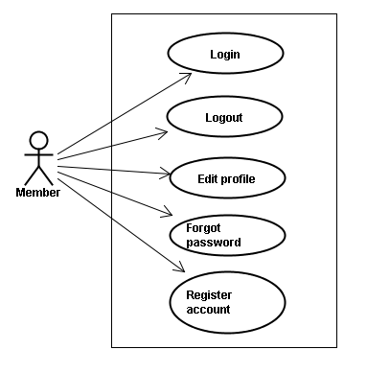

Figure 3-9: Account Use Case Diagram

##### Use Case Specification

###### UC006: Login



Figure 3-10: Login Screen

|  |  |  |  |  |  |  |  |
| --- | --- | --- | --- | --- | --- | --- | --- |
| **No** | **Field name** | **Field name in Vietnamese** | **Type** | **Require** | **Mandatory** | **Max-Length** | **Description** |
| 1 | Username | Tên đăng nhập | Text | Text | Y | 32 | User input username with length less than 32 character |
| 2 | Password | Mật khẩu | Password | Text | Y | 32 | User input their password with length less than 32 characters |
| 3 | Login | Đăng nhập | Button | Click | Y |  | User click on Login button |

Table 3-3: Login’s screen description

|  |  |  |  |  |
| --- | --- | --- | --- | --- |
| **UC006 – Login** | | | | |
| **Use-case No.** | <UC006> | **Use-case Version** | | <1.0> |
| **Use-case Name** | Login | | | |
| **Author** | Tuan NN | | | |
| **Date** | 09/06/2014 | **Priority** | <High > | |
| **Actor:**  Member, Administrator  **Summary:**  When Member, Administrator want to login by Facebook/Register account to use more functions in website  **Triggers**  User choose the login method, input data and click on login button  **Preconditions:**   * Website is available * Account Facebook/Register must be exist and correctly   **Post Conditions:**  Login successfully and redirect user to previous page.  **Main Success Scenario:**   |  |  |  | | --- | --- | --- | | **Step** | **User** | **System** | | 1 | Enter website link on web browser | Display Homepage screen | | 2 | Choose login method ( login by Facebook/register account), input account and password and then click “Đăng nhập” button | Validate information and log user into system. |     **Alternative Scenario:**   |  |  |  | | --- | --- | --- | | **At Step** | **User** | **System** | | 2 | Input data in username and password area then click on another link | Switch to selected page |   **Exceptions:**   |  |  |  | | --- | --- | --- | | **At Step** | **User** | **System** | | 3 | Fill incorrect or missing information “Tên đăng nhập”/ “Mật khẩu” field | Return Error message beside “Tên đăng nhập”/ “Mật khẩu” field. | | | | | |

###### UC007: Logout



Figure 3-11: Logout Screen

|  |  |  |  |  |  |  |
| --- | --- | --- | --- | --- | --- | --- |
| **No** | **Field name** | **Type** | **Require** | **Mandatory** | **Max-Length** | **Description** |
| 1 | Logout | Button | Click | Y |  | User click on Logout button |

Table 3-4: Logout’s screen description

|  |  |  |  |  |
| --- | --- | --- | --- | --- |
| **UC007 – Logout** | | | | |
| **Use-case No.** | <UC007> | **Use-case Version** | | <1.0> |
| **Use-case Name** | Logout | | | |
| **Author** | Tuan NN | | | |
| **Date** | 09/06/2014 | **Priority** | <High > | |
| **Actor:**  Member, Admin  **Summary:**  When Member, Admin want to logout their account  **Triggers**  Click on logout button  **Preconditions:**   * Website is available * Member, Admin must be login   **Post Conditions:**  Redirect user to previous page.  **Main Success Scenario:**   |  |  |  | | --- | --- | --- | | **Step** | **User** | **System** | | 1 | Click on logout button | Redirect to homepage | | | | | |

###### UC008: Register account

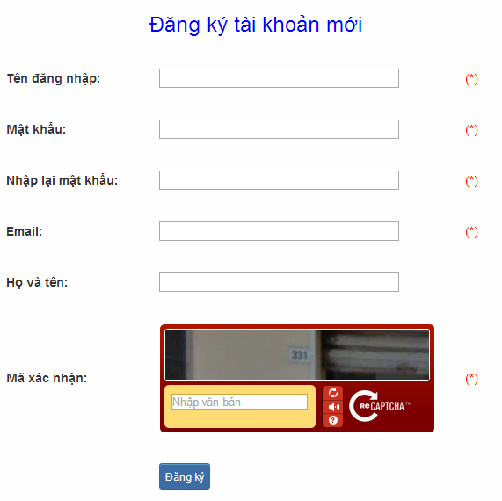

Figure 3-12: Register screen description

|  |  |  |  |  |  |  |  |
| --- | --- | --- | --- | --- | --- | --- | --- |
| **No** | **Field name** | **Field name in Vietnamese** | **Type** | **Require** | **Mandatory** | **Max-Length** | **Description** |
| 1 | Username | Tên đăng nhập | Text | Text | Y | 32 | User input username with length less than 32 characters |
| 2 | Password | Mật khẩu | Password | Text | Y | 32 | User input their password with length less than 32 characters |
| 3 | Re-password | Nhập lại mật khẩu | Password | Text | Y | 32 | User re-input password with length less than 32 characters |
| 4 | Name | Họ và tên | Text | Text | Y | 50 | User input their name with length less than 50 characters |
| 5 | Email | Email | Text | Text | Y | 100 | User input email with length less than 32 characters |
| 6 | Capcha | Mã xác nhận | Text | Text | Y | 100 | User input the verification code |
| 7 | Register | Đăng ký | Button | Click | Y |  | User click Register button |

Table 3-5: Register’s screen description

|  |  |  |  |  |
| --- | --- | --- | --- | --- |
| **UC008 – Register account** | | | | |
| **Use-case No.** | <UC008> | **Use-case Version** | | <1.0> |
| **Use-case Name** | Register | | | |
| **Author** | Tuan NN | | | |
| **Date** | 09/06/2014 | **Priority** | <High > | |
| **Actor:**  Guest  **Summary:**  Visitor can create new account to use more function as a register user  **Triggers:**  Click on register link on the website  **Preconditions:**   * Website is available   **Post Conditions:**  Create account for guest  **Main Success Scenario:**   |  |  |  | | --- | --- | --- | | **Step** | **User** | **System** | | 1 | Enter website link on web browser | Display Homepage screen | | 2 | Click on register link | Display register form | | 3 | Enter necessary and mandatory information and click "Đăng kí" button. | Display message to register successfully and redirect to homepage |     **Alternative Scenario:**   |  |  |  | | --- | --- | --- | | **At Step** | **User** | **System** | | 3 | Enter necessary and mandatory information and click another link | Switch to selected page |   **Exceptions:**   |  |  |  | | --- | --- | --- | | **At Step** | **User** | **System** | | 3 | Missing “Tên đăng nhập” field and click “Đăng kí” button | Display error message beside “Tên đăng nhập” field. | | 3 | Enter incorrect information or missing “Mật khẩu” field and click “Đăng kí” button | Display error message beside “Mật khẩu” field. | | 3 | Missing “Họ và tên” field and click “Đăng kí” button | Display error message beside “Họ và tên” field. | | 3 | Missing “Email” field and click “Đăng kí” button | Display error message beside “Email” field. | | 3 | Enter incorrect information or missing “Mã xác nhận” field and click “Đăng kí” button | Display error message beside “Mã xác nhận” field. | | | | | |

###### UC009: Edit profile

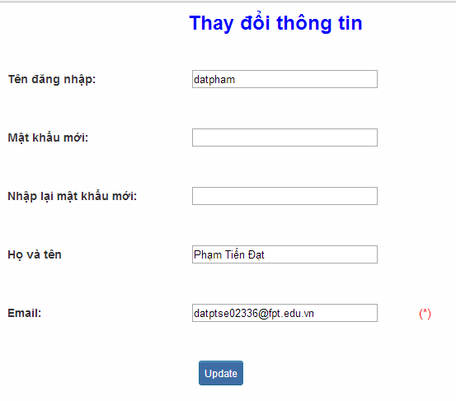

Figure 3-13: Edit profile

|  |  |  |  |  |  |  |  |
| --- | --- | --- | --- | --- | --- | --- | --- |
| **No** | **Field name** | **Field name in Vietnamese** | **Type** | **Require** | **Mandatory** | **Max-Length** | **Description** |
| 1 | Name | Họ và tên | Text | Text | Y | 32 | User input their name with length less than 32 characters |
| 2 | Old-Password | Mật khẩu cũ | Password | Text | Y | 32 | User input their old password with length less than 32 characters |
| 3 | New-password | Mật khẩu mới | Password | Text | Y | 32 | User input new password with length less than 32 characters |
| 4 | Re-password | Nhập lại mật khẩu mới | Password | Text | Y | 32 | User re-input password with length less than 32 characters |
| 5 | Email | Email | Text | Text | Y | 100 | User input email to with length less than 100 characters |
| 6 | Edit | Thay đổi thông tin | Button | Click | Y |  | User click on Edit button |

Table 3-6: Edit profile’s screen description

|  |  |  |  |  |
| --- | --- | --- | --- | --- |
| **UC009 – Edit profile** | | | | |
| **Use-case No.** | <UC009> | **Use-case Version** | | <1.0> |
| **Use-case Name** | Edit profile | | | |
| **Author** | Tuan NN | | | |
| **Date** | 09/06/2014 | **Priority** | <High > | |
| **Actor:**  Member  **Summary:**  When member want to change their profile  **Triggers:**  Login the website and click on the edit profile link  **Preconditions:**   * Website is available * Member login the website   **Post Conditions:**  Edit profile successful and redirect user to edited profile page  **Main Success Scenario:**   |  |  |  | | --- | --- | --- | | **Step** | **User** | **System** | | 1 | Enter website link on web browser | Display Homepage screen | | 2 | Enter necessary and mandatory information and click "Login” | Redirect to previous page and logged user into system. | | 3 | Click on "Trang cá nhân" link. | Display “Trang cá nhân” page | | 4 | User changes profile and click “Lưu” button | Update new profile |     **Alternative Scenario:**   |  |  |  | | --- | --- | --- | | **At Step** | **User** | **System** | | 4 | Enter necessary and mandatory information and click another link | Switch to selected page |   **Exceptions:**   |  |  |  | | --- | --- | --- | | **At Step** | **User** | **System** | | 4 | Enter new password that incorrect form or missing information and click “Lưu” button | Display error message | | 4 | Enter new email that incorrect form or missing information and click “Lưu” button | Display error message | | | | | |

###### UC010: Forgot password

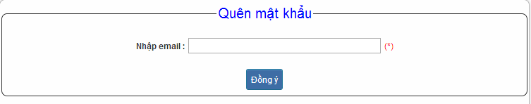

Figure 3-14: Forgot password

|  |  |  |  |  |  |  |  |
| --- | --- | --- | --- | --- | --- | --- | --- |
| **No** | **Field name** | **Field name in Vietnamese** | **Type** | **Require** | **Mandatory** | **Max-Length** | **Description** |
| 1 | Email | Email | Text | Text | Y | 32 | User input email with length less than 100 characters |
| 2 | Send | Đồng ý | Button | Click | Y |  | Click to receive password |

Table 3-7: Forgot password’s screen description

|  |  |  |  |  |
| --- | --- | --- | --- | --- |
| **UC010 – Forgot password** | | | | |
| **Use-case No.** | <UC010> | **Use-case Version** | | <1.0> |
| **Use-case Name** | Forgot password | | | |
| **Author** | Tuan NN | | | |
| **Date** | 09/06/2014 | **Priority** | <High > | |
| **Actor:**  Member, Admin  **Summary:**  When Member, Admin forgot their password to login the system, this function will receiving their password to email  **Triggers:**  Click on forgot password link on the website  **Preconditions:**   * Website is available   **Post Conditions:**  Receiving their password to their email  **Main Success Scenario:**   |  |  |  | | --- | --- | --- | | **Step** | **User** | **System** | | 1 | Enter website link on web browser | Display Homepage screen | | 2 | Click on “Quên mật khẩu” link. | Display “Quên mật khẩu” page | | 3 | Enter necessary and mandatory information in the “Quên mật khẩu” form and click "Gửi yêu cầu" button. | System will send the password into your email. |     **Alternative Scenario:**   |  |  |  | | --- | --- | --- | | **At Step** | **User** | **Syste** | | 3 | Enter necessary and mandatory information and click another link | Switch to selected page |   **Exceptions:**   |  |  |  | | --- | --- | --- | | **At Step** | **User** | **System** | | 3 | Enter email incorrect with email that use to register account | Display error message and request to re-enter email | | | | | |

#### Contact admin Module

##### Use case diagram

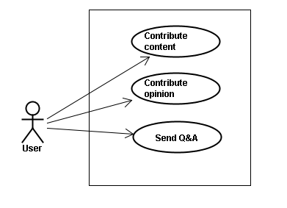

Figure 3-15: Contact Admin - Use Case Diagram

##### Use Case Specification

###### UC011: Contribute content

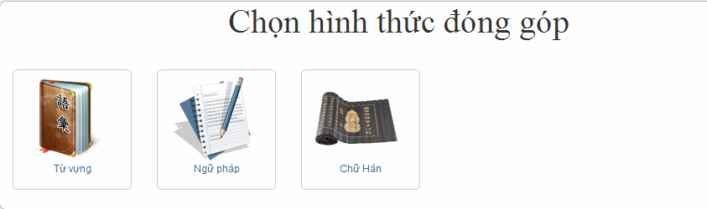

Figure 3.16: Contribute content

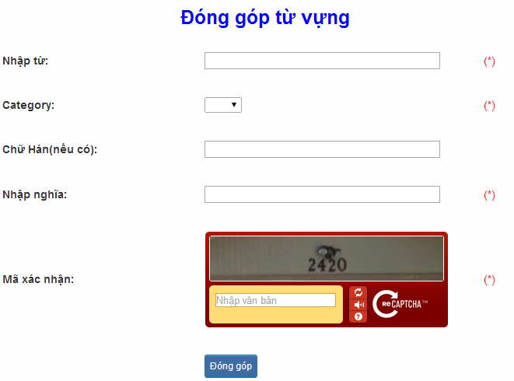

Figure 3-17: Contribute vocabulary

|  |  |  |  |  |  |  |  |
| --- | --- | --- | --- | --- | --- | --- | --- |
| **No** | **Field name** | **Field name in Vietnamese** | **Type** | **Require** | **Mandatory** | **Max-Length** | **Description** |
| 1 | Vocabulary | Từ | Text | Text | Y | 200 | User input vocabulary with length less than 200 characters |
| 2 | Category | Loại từ | Drop-down list | Click | Y |  | User choose type of category |
| 3 | Kanji | Chữ Hán | Text | Text | Y | 10 | User input kanji of vocabulary (if exist) with length less than 10 characters |
| 4 | Mean | Nhập nghĩa | Text | Text | Y | 500 | User input mean of vocabulary with length less than 500 characters |
| 5 | Capcha | Mã xác nhận | Text | Text | Y |  | User input the verification code |
| 6 | Contribute | Đóng góp | Button | Click | Y |  | User click on contribute button |

Table 3-8: Contribute vocabulary’s screen description

|  |  |  |  |  |
| --- | --- | --- | --- | --- |
| **UC011 – Contribute content** | | | | |
| **Use-case No.** | <UC011> | **Use-case Version** | | <1.0> |
| **Use-case Name** | Contribute content | | | |
| **Author** | Tuan NN | | | |
| **Date** | 09/06/2014 | **Priority** | <High > | |
| **Actor:**  Member  **Summary:**  When Member want to contribute content for website  **Triggers:**  User enter website link and click on “Liên hệ” link on the website  **Preconditions:**   * Website is available * User must be login to the website   **Post Conditions:**  Receive opinions and redirect user to contact page  **Main Success Scenario:**   |  |  |  | | --- | --- | --- | | **Step** | **User** | **System** | | 1 | Enter website link on web browser | Display Homepage screen | | 2 | Enter necessary and mandatory information and click "Login” | Redirect to previous page and logged user into system. | | 3 | Click on “Liên hệ”->”Đóng góp database” section | Display “Đóng góp database” page | | 4 | Enter information that member want to contribute for the website then click “Đóng góp” | System will receive contributions |     **Alternative Scenario:**   |  |  |  | | --- | --- | --- | | **At Step** | **User** | **System** | | 4 | Enter necessary and mandatory information and click another link | Switch to selected page |   **Exceptions:**   |  |  |  | | --- | --- | --- | | **At Step** | **User** | **System** | | 4 | Missing “Nhập từ” field and click “Đóng góp” button | Display error message beside “Nhập từ” field. | | 4 | Missing “Loại từ” field and click “Đóng góp” button | Display error message beside “Loại từ” field. | | 4 | Missing “Nhập nghĩa” field and click “Đóng góp” button | Display error message beside “Nhập nghĩa” field. | | 4 | Enter incorrect information or missing “Mã xác nhận” field and click “Đóng góp” button | Display error message beside “Mã xác nhận” field. | | | | | |

###### UC012: Contribute opinion

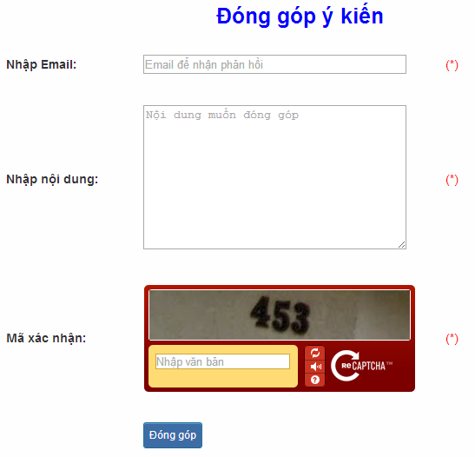

Figure 3-18: Contribute opinion

|  |  |  |  |  |  |  |  |
| --- | --- | --- | --- | --- | --- | --- | --- |
| **No** | **Field name** | **Field name in Vietnamese** | **Type** | **Require** | **Mandatory** | **Max-Length** | **Description** |
| 1 | Email | Email | Text | Text | Y | 100 | User input email with length less than100 characters |
| 2 | Content | Nhập nội dung | Text | Text | Y | 1000 | User input content with length less than1000 characters |
| 3 | Capcha | Mã xác nhận | Text | Text | Y |  | User input the verification code |
| 4 | Contribute | Đóng góp | Button | Click | Y |  | User click on contribute button |

Table 3-9: Contribute opinion’s screen description

|  |  |  |  |  |
| --- | --- | --- | --- | --- |
| **UC012 – Contribute opinion** | | | | |
| **Use-case No.** | <UC012> | **Use-case Version** | | <1.0> |
| **Use-case Name** | Contribute opinion | | | |
| **Author** | Tuan NN | | | |
| **Date** | 09/06/2014 | **Priority** | <High > | |
| **Actor:**  Member  **Summary:**  When Member want to contribute opinion for website  **Triggers**  User enter website link and click on “Liên hệ” link on the website  **Preconditions:**   * Website is available * User must be login to the website   **Post Conditions:**  Receive opinions and redirect user to contact page  **Main Success Scenario:**   |  |  |  | | --- | --- | --- | | **Step** | **Use** | **System** | | 1 | Enter website link on web browser | Display Homepage screen | | 2 | Enter necessary and mandatory information and click "Login” | Redirect to previous page and logged user into system. | | 3 | Click on “Liên hệ”->”Đóng góp ý kiến” tab | Display “Đóng góp ý kiến” page | | 4 | Enter information that member want to contribute for the website then click “Đóng góp” | System will receive contributions |   **Alternative Scenario:**   |  |  |  | | --- | --- | --- | | **At Step** | **User** | **System** | | 4 | Enter necessary and mandatory information and click another link | Switch to selected page |   **Exceptions:**   |  |  |  | | --- | --- | --- | | **At Step** | **User** | **System** | | 4 | Missing “Nhập email” field and click “Đóng góp” button | Display error message beside “Nhập email” field. | | 4 | Missing “Nhập nội dung:” field and click “Đóng góp” button | Display error message beside “Nhập nội dung:” field. | | 4 | Enter incorrect information or missing “Mã xác nhận” field and click “Đóng góp” button | Display error message beside “Mã xác nhận” field. | | | | | |

###### UC013: Send Q&A

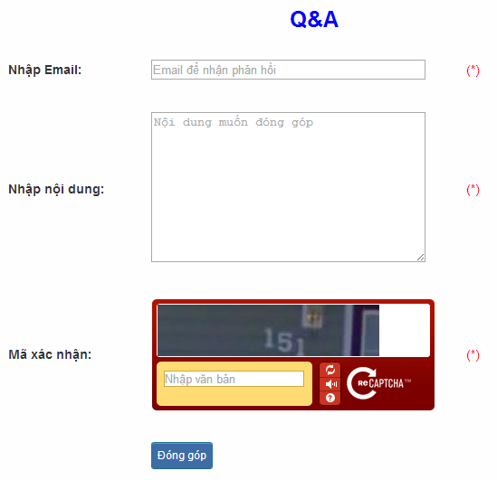

Figure 3-19: Send Q&A

|  |  |  |  |  |  |  |  |
| --- | --- | --- | --- | --- | --- | --- | --- |
| **No** | **Field name** | **Field name in Vietnamese** | **Type** | **Require** | **Mandatory** | **Max-Length** | **Description** |
| 1 | QA | Q&A | Text | Text | Y | 1000 | User input Q&A with length less than 1000 characters |
| 2 | Email | Email | Text | Text | Y | 100 | User input email with length less than 100 characters |
| 3 | Capcha | Mã xác nhận | Text | Text | Y |  | User input the verification code |
| 4 | Contribute | Đóng góp | Button | Click | Y |  | User click on contribute button |

Table 3-10: Send Q&A’s screen description

|  |  |  |  |  |
| --- | --- | --- | --- | --- |
| **UC013 – Send Q&A** | | | | |
| **Use-case No.** | <UC013> | **Use-case Version** | | <1.0> |
| **Use-case Name** | Send Q&A | | | |
| **Author** | Tuan NN | | | |
| **Date** | 09/06/2014 | **Priority** | <High > | |
| **Actor:**  Member  **Summary:**  When Member have the question, they can create Q&A  **Triggers:**  Click on “Liên hệ” link on the website  **Preconditions:**   * Website is available * User must be login to the website   **Post Conditions:**  Add new Q&A into the website  **Main Success Scenario:**   |  |  |  | | --- | --- | --- | | **Step** | **User** | **System** | | 1 | Enter website link on web browser | Display Homepage screen | | 2 | Enter necessary and mandatory information and click "Login” | Redirect to previous page and logged user into system. | | 3 | Click on “Q&A” tab | Display “Q&A” page | | 4 | Enter necessary and mandatory information in the “Q&A” form and click "Gửi" button. | Display this Q&A in the “Q&A”section. |     **Alternative Scenario:**   |  |  |  | | --- | --- | --- | | **At Step** | **User** | **System** | | 4 | Enter necessary and mandatory information and click another link | Switch to selected page |   **Exceptions:**   |  |  |  | | --- | --- | --- | | **At Step** | **User** | **System** | | 4 | Missing “Nhập email” field and click “Đóng góp” button | Display error message beside “Nhập email” field. | | 4 | Missing “Q&A” field and click “Đóng góp” button | Display error message beside “Q&A” field. | | 4 | Enter incorrect information or missing “Mã xác nhận” field and click “Đóng góp” button | Display error message beside “Mã xác nhận” field. | | | | | |

#### Practice management Module

##### Use case diagram

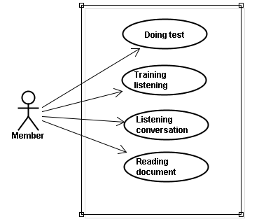

Figure 3-20: Practice – Use Case Diagram

##### Use case specification

###### UC014: Doing test

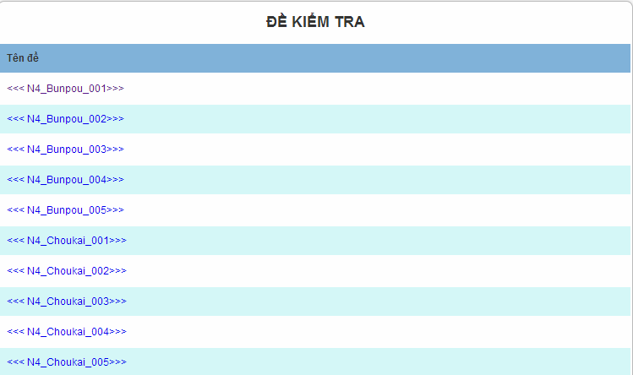

Figure 3-21: Doing test

|  |  |  |  |  |
| --- | --- | --- | --- | --- |
| **UC014 – Doing test** | | | | |
| **Use-case No.** | <UC014> | **Use-case Version** | | <1.0> |
| **Use-case Name** | Doing test | | | |
| **Author** | Tuan NN | | | |
| **Date** | 09/06/2014 | **Priority** | <High > | |
| **Actor:**  Member  **Summary:**  This function will help users do the online quiz and check the answers, grading and evaluation capabilities  **Triggers**  User going to website, login and then click on “Kiểm tra” link on the website  **Preconditions:**   * Website is available * User must be login to the website   **Post Conditions:**  Doing test in the website  **Main Success Scenario:**   |  |  |  | | --- | --- | --- | | **Step** | **User** | **System** | | 1 | Enter website link on web browser | Display Homepage screen | | 2 | Enter necessary and mandatory information and click "Login” | Redirect to previous page and logged user into system. | | 3 | Click on “Kiểm tra” section | Display “Kiểm tra” page | | 4 | Choose one of items that you want to doing test | Display that item’s page | | 5 | Doing test | Check the answer, grading after finish |     **Alternative Scenario:**   |  |  |  | | --- | --- | --- | | **At Step** | **User** | **System** | | 5 | While doing test, click another link | Switch to selected page | | | | | |

###### UC015: Training listening

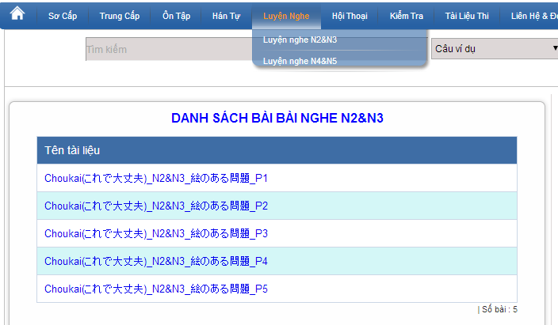

Figure 3-22: Training listening

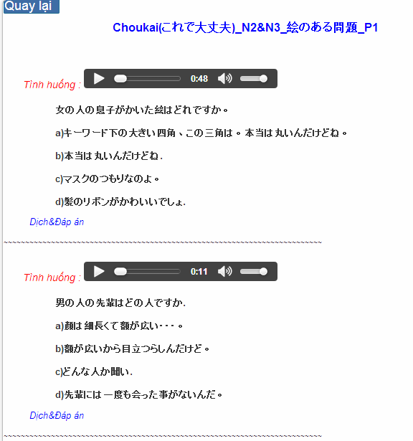

Figure 3-23: Training listening content

|  |  |  |  |  |  |  |
| --- | --- | --- | --- | --- | --- | --- |
| **No** | **Field name** | **Field name in Vietnamese** | **Type** | **Require** | **Mandatory** | **Description** |
| 1 | Audio | Audio | Audio | Click | Y | User click play button |
| 2 | Translation and Answer | Dịch và đáp án | Link | Click | Y | User click to display translation and answer |

Table 3-11: Training listening content’s screen description

|  |  |  |  |  |
| --- | --- | --- | --- | --- |
| **UC015 – Training listening** | | | | |
| **Use-case No.** | <UC015> | **Use-case Version** | | <1.0> |
| **Use-case Name** | Training listening | | | |
| **Author** | Tuan NN | | | |
| **Date** | 09/06/2014 | **Priority** | <High > | |
| **Actor:**  Guest, Member  **Summary:**  This function provide users some the listening of level N2, N3, N4 to help users training listening skill  **Triggers:**  User going to website and click on “Luyện nghe” link on the website  **Preconditions:**   * Website is available   **Post Conditions:**  Training listening in the website  **Main Success Scenario:**   |  |  |  | | --- | --- | --- | | **Step** | **User** | **System** | | 1 | Enter website link on web browser | Display Homepage screen | | 2 | Click on “Luyện nghe” section | Display “Luyện nghe” page |     **Alternative Scenario:**   |  |  |  | | --- | --- | --- | | **At Stp** | **User** | **System** | | 4 | While listening, click another link | Switch to selected page | | | | | |

###### UC016: Listening conversation

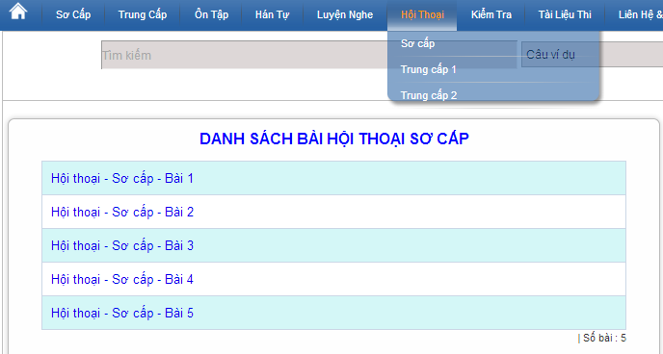

Figure 3-24: Listening conversation

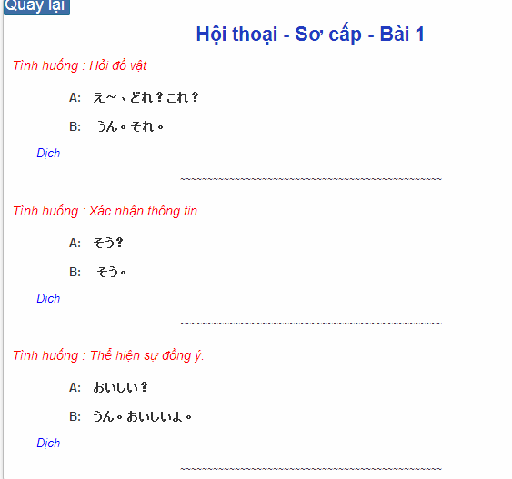

Figure 3-25: Conversation content

|  |  |  |  |  |  |  |
| --- | --- | --- | --- | --- | --- | --- |
| **No** | **Field name** | **Field name in Vietnamese** | **Type** | **Require** | **Mandatory** | **Description** |
| 1 | Translation | Dịch | Link | Click | Y | User click to display translation |

Table 3-12: Training listening content’s screen description

|  |  |  |  |  |
| --- | --- | --- | --- | --- |
| **UC016 – Listening conversation** | | | | |
| **Use-case No.** | <UC016> | **Use-case Version** | | <1.0> |
| **Use-case Name** | Listening conversation | | | |
| **Author** | Tuan NN | | | |
| **Date** | 09/06/2014 | **Priority** | <High > | |
| **Actor:**  Guest, Member  **Summary:**  This function provide users some the conversation in everyday life and common situations (eg: restaurants, shopping, in hospital …)  **Triggers:**  Click on “Hội thoại” link on the website  **Preconditions:**   * Website is available   **Post Conditions:**  Listening conversation in the website  **Main Success Scenario:**   |  |  |  | | --- | --- | --- | | **Step** | **User** | **System** | | 1 | Enter website link on web browser | Display Homepage screen | | 2 | Click on “Hội thoại” section | Display “Hội thoại” page |     **Alternative Scenario:**   |  |  |  | | --- | --- | --- | | **At Step** | **User** | **System** | | 4 | While listening, click another link | Switch to selected page | | | | | |

###### UC017: Reading document

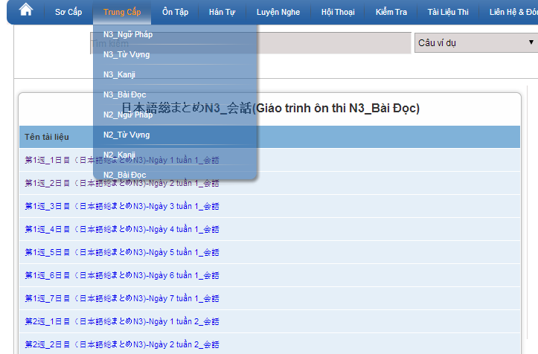

Figure 3-26: Reading document

|  |  |  |  |  |
| --- | --- | --- | --- | --- |
| **UC017 – Reading document** | | | | |
| **Use-case No.** | <UC017> | **Use-case Version** | | <1.0> |
| **Use-case Name** | Reading document | | | |
| **Author** | Tuan NN | | | |
| **Date** | 09/06/2014 | **Priority** | <High > | |
| **Actor:**  Guest, Member  **Summary:**  This function provides users some document: elementary, intermediate and review.  **Triggers**  Click on “N3/N2 Bài đọc” link on the website  **Preconditions:**   * Website is available   **Post Conditions:**  Reading document in the website  **Main Success Scenario:**   |  |  |  | | --- | --- | --- | | **Step** | **User** | **System** | | 1 | Enter website link on web browser | Display Homepage screen | | 2 | Click on “Bài đọc” section | Display “Bài đọc” page |     **Alternative Scenario:**   |  |  |  | | --- | --- | --- | | **At Step** | **User** | **System** | | 4 | While reading, click another link | Switch to selected page | | | | | |

#### Admin’s account management

##### Use case diagram

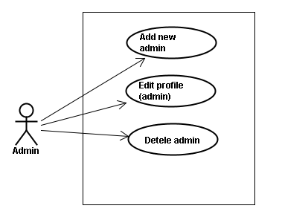

Figure 3-27: Admin’s account – Use Case Diagram

##### Use case specifications

###### UC018: Add new admin

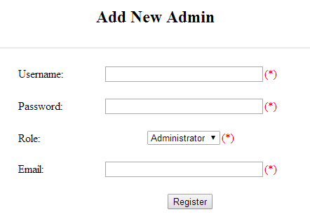

Figure 3-28: Add new admin

|  |  |  |  |  |  |  |
| --- | --- | --- | --- | --- | --- | --- |
| **No** | **Field name** | **Type** | **Require** | **Mandatory** | **Max-Length** | **Description** |
| 1 | Username | Text | Text | Y | 32 | Admin input username of admin’s account with length less than 32 characters |
| 2 | Password | Text | Text | Y | 100 | Admin input password of admin’s account with length less than 32 characters |
| 3 | Roll | Drop-down list | Choose | Y |  | Admin choose the roll of account |
| 4 | Email | Text | Text | Y | 100 | Admin input email of admin’s account with length less than 100 characters |
| 5 | Register | Button | Click | Y |  | Admin add new admin |

Table 3-13: Add new admin’s screen description

|  |  |  |  |  |
| --- | --- | --- | --- | --- |
| **UC018 – Add new admin** | | | | |
| **Use-case No.** | <UC018> | **Use-case Version** | | <1.0> |
| **Use-case Name** | Add new admin | | | |
| **Author** | Tuan NN | | | |
| **Date** | 09/06/2014 | **Priority** | <High > | |
| **Actor:**  Admin  **Summary:**  Administrator can add new admin  **Triggers:**  Admin login the website and click on add new admin link on the website  **Preconditions:**   * Website is available * Admin login to the website   **Post Conditions:**  New admin be added successfully  **Main Success Scenario:**   |  |  |  | | --- | --- | --- | | **Step** | **User** | **System** | | 1 | Enter website link on web browser | Display Homepage screen | | 2 | Enter necessary and mandatory information and click "Login” | Redirect to previous page and logged admin into system. | | 3 | Click on add new admin button | Display “Add New Admin” screen that contains these elements:   * Username * Password * Roll * Email | | 4 | Fill test information into all necessary or mandatory fields and click “Add” button | The system validates the input data and then save new test data into database |     **Alternative Scenario:**   |  |  |  | | --- | --- | --- | | **At Step** | **User** | **System** | | 4 | Input data in account area then click on another link | Switch to selected page |   **Exceptions:**   |  |  |  | | --- | --- | --- | | **At Step** | **User** | **System** | | 4 | Fill incorrect account name | Return Error message | | | | | |

###### UC019: Edit profile (admin)

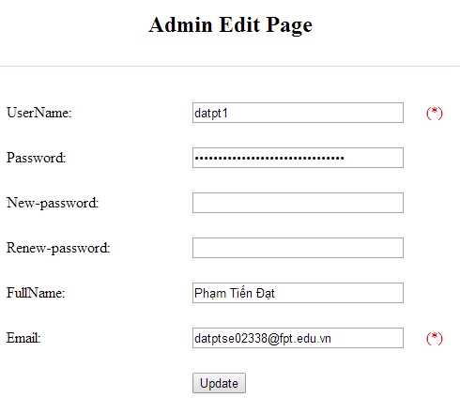

Figure 3-29: Edit profile admin

|  |  |  |  |  |  |  |
| --- | --- | --- | --- | --- | --- | --- |
| **No** | **Field name** | **Type** | **Require** | **Mandatory** | **Max-Length** | **Description** |
| 1 | Username | Text | Text | N |  | Username of admin’s account |
| 2 | New-password | Text | Text | Y | 32 | Admin input new password with length less than 32 characters |
| 3 | Renew-password | Text | Text | Y | 32 | Admin re-input new password with length less than 32 characters |
| 4 | Fullname | Text | Text | Y | 100 | Admin input full name with length less than 100 characters |
| 5 | Email | Text | Text | Y | 100 | Admin input email with length less than 100 characters |
| 6 | Update | Button | Click | Y |  | User click to edit vocabulary |

Table 3-14: Edit profile admin’s screen description

|  |  |  |  |  |
| --- | --- | --- | --- | --- |
| **UC019 – Edit profile(admin)** | | | | |
| **Use-case No.** | <UC019> | **Use-case Version** | | <1.0> |
| **Use-case Name** | Edit profile admin | | | |
| **Author** | Tuan NN | | | |
| **Date** | 09/06/2014 | **Priority** | <High > | |
| **Actor:**  Administrator  **Summary:**  Administrator want to change their profile  **Triggers:**  Administrator login the website and click on the edit profile link  **Preconditions:**   * Website is available * Administrator login the website   **Post Conditions:**  Edit admin profile and redirect to edited profile page  **Main Success Scenario:**   |  |  |  | | --- | --- | --- | | **Step** | **User** | **System** | | 1 | Enter website link on web browser | Display Homepage screen | | 2 | Enter necessary and mandatory information and click "Login” | Redirect to previous page and logged admin into system. | | 3 | Click on edit profile tab | Display “Edit profile” screen that contains these elements:   * Username * Password * New-Password * Renew-Password * Full name * Email | | 4 | Fill test information into all necessary or mandatory fields and click “Add” button | The system validates the input data and then save new test data into database |   **Alternative Scenario:**   |  |  |  | | --- | --- | --- | | **At Step** | **User** | **System** | | 4 | Enter necessary and mandatory information and click another link | Switch to selected page |   **Exceptions:**   |  |  |  | | --- | --- | --- | | **At Step** | **User** | **System** | | 4 | Enter new password that incorrect form or missing information and click “Lưu” button | Display error message | | 4 | Enter new email that incorrect form or missing information and click “Lưu” button | Display error message | | | | | |

###### UC020: Delete admin

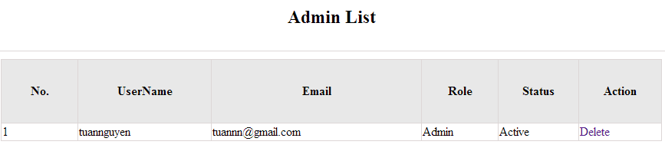

Figure 3-30: Delete admin

|  |  |  |  |  |
| --- | --- | --- | --- | --- |
| **UC020 – Delete admin** | | | | |
| **Use-case No.** | <UC020> | **Use-case Version** | | <1.0> |
| **Use-case Name** | Delete admin | | | |
| **Author** | Tuan NN | | | |
| **Date** | 09/06/2014 | **Priority** | <High > | |
| **Actor:**  Administrator  **Summary:**  Administrators can remove administrator rights of other admin  **Triggers:**  Login the website and click on the delete admin link  **Preconditions:**   * Website is available * Admin login the website   **Post Conditions:**  Admin will be remove administrator rights  **Main Success Scenario:**   |  |  |  | | --- | --- | --- | | **Step** | **User** | **System** | | 1 | Enter website link on web browser | Display Homepage screen | | 2 | Enter necessary and mandatory information and click "Login” | Redirect to previous page and logged admin into system. | | 3 | Click on delete admin link. | Display delete admin page | | 4 | Enter the account that you want to remove administrator rights | Remove administrator rights of account and display message to remove successfully |     **Alternative Scenario:**   |  |  |  | | --- | --- | --- | | **At Step** | **User** | **System** | | 4 | Input data in account area then click on another link | Switch to selected page |   **Exceptions:**   |  |  |  | | --- | --- | --- | | **At Step** | **User** | **System** | | 4 | Fill incorrect account name | Return Error message | | | | | |

#### Management Member’s account

##### Use case diagram

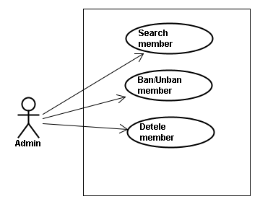

Figure 3-31: Management Member – Use Case Diagram

##### Screen description

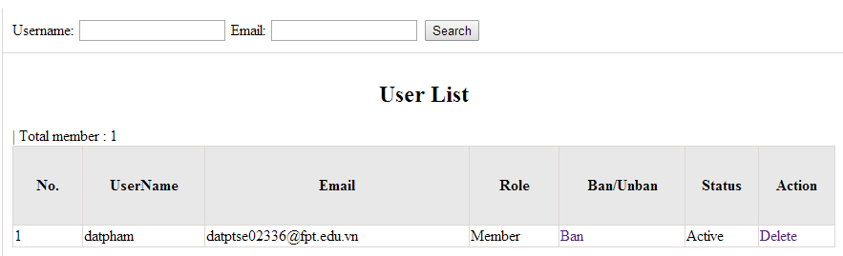

Figure 3-32: Management Member

|  |  |  |  |  |  |  |
| --- | --- | --- | --- | --- | --- | --- |
| **No** | **Field name** | **Type** | **Require** | **Mandatory** | **Max-Length** | **Description** |
| 1 | Username | Text | Text | Y | 32 | Admin input username to search member by username |
| 2 | Email | Text | Text | Y | 100 | Admin input email to search member by email |
| 3 | Ban/Unban | Button | Click | N |  | Admin click ban/unban member |
| 4 | Delete | Button | Click | N |  | Admin click delete member |

Table 3-15: Management member’s screen description

##### Use case specifications

###### UC021: Search member

Search member screen:

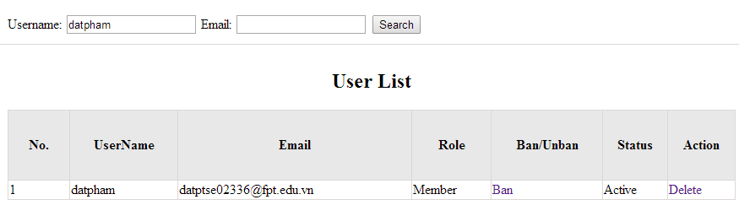

Figure 3-33: Search member screen description

|  |  |  |  |  |
| --- | --- | --- | --- | --- |
| **UC021 – Search member** | | | | |
| **Use-case No.** | <UC021> | **Use-case Version** | | <1.0> |
| **Use-case Name** | Search member | | | |
| **Author** | Tuan NN | | | |
| **Date** | 09/06/2014 | **Priority** | <High > | |
| **Actor:**  Admin  **Summary:**  When admin want to search by member’s account in database successfully if it is existed  **Triggers:**  Admin login the website and click on search member , input member’s account in the right text box then click “Search” button  **Preconditions:**   * Website is available * Admin must be login * Input data must be correctly   **Post Conditions:**  Display detail information of member  **Main Success Scenario:**   |  |  |  | | --- | --- | --- | | **Step** | **User** | **System** | | 1 | Enter website link on web browser | Display Homepage screen | | 2 | Enter necessary and mandatory information and click "Login” | Redirect to previous page and logged admin into system. | | 3 | Click on "Search member" button and input member’s account or email | Display “member information” screen that contains the information :   * No * User Name * Email * Roll * Ban/Unban * Status * Delete |     **Alternative Scenario:**   |  |  |  | | --- | --- | --- | | **At Step** | **User** | **System** | | 3 | Fill information of the member that they want to find into these fields then click on another link | Switch to selected page |   **Exceptions:**   |  |  |  | | --- | --- | --- | | **At Step** | **User** | **System** | | 3 | Fill information of the member that they want to find (that do not exist in database) into these fields then click “Search” button | Return Error message to inform that member cannot be found | | | | | |

###### UC022: Ban/Unban member

|  |  |  |  |  |
| --- | --- | --- | --- | --- |
| **UC022 – Search member** | | | | |
| **Use-case No.** | <UC022> | **Use-case Version** | | <1.0> |
| **Use-case Name** | Ban/Unban member | | | |
| **Author** | Tuan NN | | | |
| **Date** | 09/06/2014 | **Priority** | <High > | |
| **Actor:**  Admin  **Summary:**  When admin can ban user who violated rule of website and unban member  **Triggers**  Admin login the website and click on member’s account and then click “Ban/Unban” button  **Preconditions:**   * Website is available * Admin must be login * Input data must be correctly   **Post Conditions:**  Member’s account will be ban/unban by administrator  **Main Success Scenario:**   |  |  |  | | --- | --- | --- | | **Step** | **User** | **System** | | 1 | Enter website link on web browser | Display Homepage screen | | 2 | Enter necessary and mandatory information and click "Login” | Redirect to previous page and logged admin into system. | | 3 | Click on "Search member" button and input member’s account or email | Display “member information” screen that contains the information | | 4 | Click “Ban/Unban” link | Ban/Unban member |   **Alternative Scenario:**   |  |  |  | | --- | --- | --- | | **At Step** | **User** | **System** | | 3 | Fill information of the member that they want to find into these fields then click on another link | Switch to selected page |   **Exceptions:**   |  |  |  | | --- | --- | --- | | **At Step** | **User** | **System** | | 3 | Fill information of the member that they want to find (that do not exist in database) into these fields then click “Search” button | Return Error message to inform that member cannot be found | | | | | |

###### UC023: Delete member

|  |  |  |  |  |
| --- | --- | --- | --- | --- |
| **UC023 – Delete member** | | | | |
| **Use-case No.** | <UC023> | **Use-case Version** | | <1.0> |
| **Use-case Name** | Delete member | | | |
| **Author** | Tuan NN | | | |
| **Date** | 09/06/2014 | **Priority** | <High > | |
| **Actor:**  Admin  **Summary:**  Administrators can delete member who violated rule of website  **Triggers**  Admin login the website and click on the delete member link  **Preconditions:**   * Website is available * Admin must be login * Input data must be correctly   **Post Conditions:**  Member’s account will be removed from system  **Main Success Scenario:**   |  |  |  | | --- | --- | --- | | **Step** | **User** | **System** | | 1 | Enter website link on web browser | Display Homepage screen | | 2 | Enter necessary and mandatory information and click "Login” | Redirect to previous page and logged admin into system. | | 3 | Click on "Search member" button and input member’s account or email | Display information of member | | 4 | Click on delete link corresponding with member want to delete | Remove member from list |     **Alternative Scenario:**   |  |  |  | | --- | --- | --- | | **At Step** | **User** | **System** | | 3 | Fill information of the member that they want to find into these fields then click on another link | Switch to selected page |   **Exceptions:**   |  |  |  | | --- | --- | --- | | **At Step** | **User** | **System** | | 3 | Fill information of the member that they want to find (that do not exist in database) into these fields then click “Search” button | Return Error message to inform that member cannot be found | | | | | |

#### Vocabulary Management

##### Use case diagram

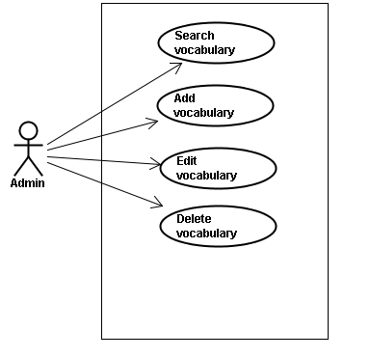

Figure 3-34: Vocabulary Management – Use Case Diagram

##### Screen description

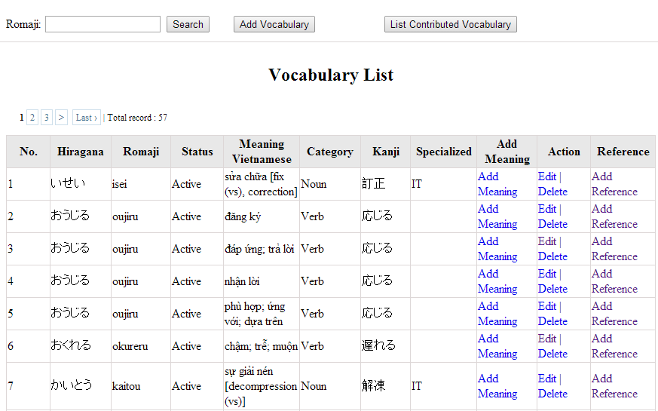

Figure 3-35: Vocabulary management

|  |  |  |  |  |  |  |
| --- | --- | --- | --- | --- | --- | --- |
| **No** | **Field name** | **Type** | **Require** | **Mandatory** | **Max-Length** | **Description** |
| 1 | Romaji | Text | Text | Y | 100 | Admin input romaji with length less than 100 character |
| 2 | Search | Button | Click | Y |  | Admin click to search vocabulary |
| 2 | Add-new | Button | Click | N |  | Admin add new vocabulary into database |
| 3 | Add meaning | Button | Click | Y |  | Admin add meaning of vocabulary |
| 4 | Edit | Button | Click | N |  | Admin click edit vocabulary |
| 5 | Delete | Button | Click | N |  | Admin click delete vocabulary |
| 6 | Add-reference | Button | Click | N |  | Admin add reference of vocabulary if reference exist |
| 7 | List-contribute | Button | Click | N |  | Admin click to view list contribute |

Table 3-16: Vocabulary management’s screen description

##### Use case specifications

###### UC024: Search vocabulary

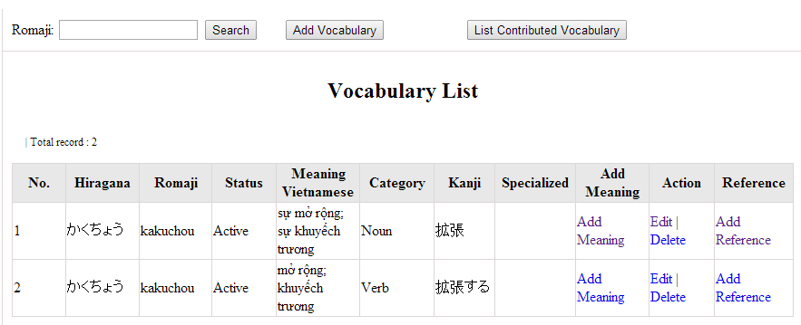

Figure 3-36: Search vocabulary

|  |  |  |  |  |
| --- | --- | --- | --- | --- |
| **UC0024 – Specification** | | | | |
| **Use-case No.** | <UC0024> | **Use-case Version** | | <1.0> |
| **Use-case Name** | Search vocabulary | | | |
| **Author** | TuanNN | | | |
| **Date** | 09/06/2014 | **Priority** | <High > | |
| **Actor:**  Admin  **Summary:**  When Administrator want to search a vocabulary on database  **Goal:**  Administrator can search vocabulary in database successfully if it is existed  **Triggers**  Admin login the website and click on “Vocabulary management” tab, input vocabulary in the right text box then click “Search” button  **Preconditions:**   * Website is available * Admin must be login * Input data must be correctly   **Post Conditions:**  Display detail information of vocabulary  **Main Success Scenario:**   |  |  |  | | --- | --- | --- | | **Step** | **User** | **System** | | 1 | Enter website link on web browser | Display Homepage screen | | 2 | Enter necessary and mandatory information and click "Login” | Redirect to previous page and logged admin into system. | | 4 | Click on “vocabulary management” tab | Displays criteria search screen | | 5 | Fill information of the vocabulary that they want to find into these fields then click “Search” button | Displays search result as a table with these elements:   * No * Hiragana * Romaji * Status * Meaning * Category * Kanji * Specialized * Add meaning * Edit * Delete * Add reference |     **Alternative Scenario:**   |  |  |  | | --- | --- | --- | | **At Step** | **User** | **System** | | 5 | Fill information of the vocabulary that they want to find into these fields then click on another link | Switch to selected page |   **Exceptions:**   |  |  |  | | --- | --- | --- | | **At Step** | **User** | **System** | | 5 | Fill information of the vocabulary that they want to find (that do not exited in database) into these fields then click “Search” button | Return Error message to inform that vocabulary structure cannot be found | | | | | |

###### UC025: Add vocabulary

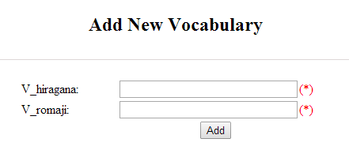

Figure 3-37: Add new vocabulary

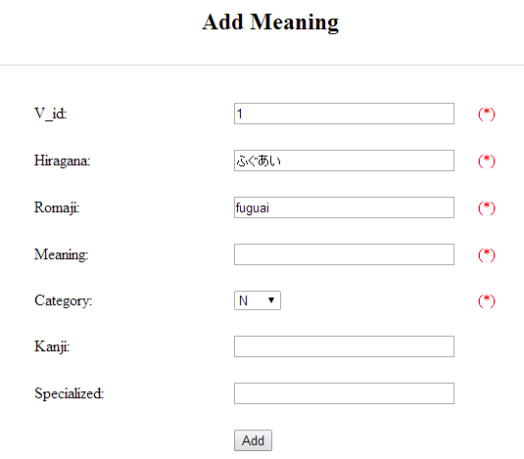

Figure 3-38: Add vocabulary meaning

|  |  |  |  |  |  |  |
| --- | --- | --- | --- | --- | --- | --- |
| **No** | **Field name** | **Type** | **Require** | **Mandatory** | **Max-Length** | **Description** |
| 1 | Hiragana | Text | Text | Y | 200 | Admin input vocabulary by hiragana with length less than 200 characters |
| 2 | Romaji | Text | Text | Y | 200 | Admin input vocabulary by romaji with length less than 200 characters |
| 3 | Meaning | Text | Text | Y | 500 | Admin input mean of vocabulary with length less than 500 characters |
| 4 | Category | Drop-down list | Click | Y |  | Admin choose category of vocabulary |
| 5 | Kanji | Text | Text | Y | 10 | Admin input vocabulary by kanji with length less than 10 characters |
| 6 | Specialized | Text | Text | Y | 200 | Admin input specialized of vocabulary with length less than 200 characters |
| 7 | Add | Button | Click | Y |  | Admin add new vocabulary |

Table 3-17: Add new vocabulary & meaning’s screen description

|  |  |  |  |  |
| --- | --- | --- | --- | --- |
| **UC0025 - Specification** | | | | |
| **Use-case No.** | <UC0025> | **Use-case Version** | | <1.0> |
| **Use-case Name** | Add vocabulary | | | |
| **Author** | Tuan NN | | | |
| **Date** | 09/06/2014 | **Priority** | <High > | |
| **Actor:**  Admin  **Summary:**  When Administrator want to add a vocabulary into database. They have to insert all necessary data of vocabulary into “Add new vocabulary” screen  **Goal:**  Administrator can add new vocabulary information in database successfully  **Triggers**  User must click on “Vocabulary management/ Add new” tab and input all necessary information of vocabulary into the right fields then click on “Add new” button  **Preconditions:**   * Website is available * User have logged into system as an admin. * All mandatory fields have been filled * All input data must be valid and have not existed in system   **Post Conditions:**  New vocabulary has been saved into system database successfully  **Main Success Scenario:**   |  |  |  | | --- | --- | --- | | **Step** | **User** | **System** | | 1 | Enter website link on web browser | Display Homepage screen | | 2 | Enter necessary and mandatory information and click "Login” | Redirect to previous page and logged admin into system. | | 3 | Click on “Vocabulary management/Add new” tab | Display “Add New Vocabulary” screen that contains these elements:   * Hiragana * Romaji | | 4 | Fill information into all necessary or mandatory fields and click “Add” button | The system validates the input data and then save new vocabulary data into database | | 5 | Click on “Vocabulary management/Add meaning” tab | Display “Add meaning” screen that contains these elements:   * Hiragana * Romaji * Meaning * Category * Kanji * Specialized | | 6 | Fill information into all necessary or mandatory fields and click “Add” button | The system validates the input data and then save new vocabulary data into database | | 7 | Click on “Vocabulary management/Add reference” tab | Display “Add meaning” screen that contains these elements:   * Vocabulary * Meaning * Sentence | | 8 | Choose sentence and click “Add” button | The system validates the input data and then save new vocabulary data into database |     **Alternative Scenario:**   |  |  |  | | --- | --- | --- | | **At Step** | **User** | **System** | | 4 | Click on another link | Do not save new vocabulary data into database then redirect to selected page | | 6 | Click on another link | Do not save meaning data into database then redirect to selected page | | 8 | Click on another link | Do not save reference into database then redirect to selected page |   **Exceptions:**   |  |  |  | | --- | --- | --- | | **At Step** | **User** | **System** | | 4 | Do not fill full information into fields then click “Add” button | Return Error message beside empty field and ask if user want to add with empty field. | | 6 | Do not fill full information into fields then click “Add” button | Return Error message beside empty field and ask if user want to add with empty field. | | 8 | Do not fill full information into fields then click “Add” button | Return Error message beside empty field and ask if user want to add with empty field. | | | | | |

###### UC026: Edit vocabulary

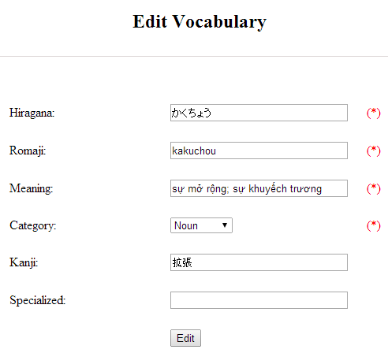

Figure 3-39: Edit vocabulary

|  |  |  |  |  |  |  |
| --- | --- | --- | --- | --- | --- | --- |
| **No** | **Field name** | **Type** | **Require** | **Mandatory** | **Max-Length** | **Description** |
| 1 | Hiragana | Text | Text | Y | 200 | Admin input vocabulary by hiragana with length less than 200 characters |
| 2 | Romaji | Text | Text | Y | 200 | Admin input vocabulary by romaji with length less than 200 characters |
| 3 | Meaning | Text | Text | Y | 500 | Admin input mean of vocabulary with length less than 500 characters |
| 4 | Category | Drop-down list | Click | Y |  | Admin choose category of vocabulary |
| 5 | Kanji | Text | Text | Y | 10 | Admin input vocabulary by kanji with length less than 10 characters |
| 6 | Specialized | Text | Text | Y | 200 | Admin input specialized of vocabulary with leng less than 200 characters |
| 7 | Edit | Button | Click | Y |  | Admin edit vocabulary |

Table 3-18: Edit vocabulary’s screen description

|  |  |  |  |  |
| --- | --- | --- | --- | --- |
| **UC0026 - Specification** | | | | |
| **Use-case No.** | <UC0026> | **Use-case Version** | | <1.0> |
| **Use-case Name** | Edit vocabulary | | | |
| **Author** | TuanNN | | | |
| **Date** | 09/06/2014 | **Priority** | <High > | |
| **Actor:**  Admin  **Summary:**  When Administrator want to edit a vocabulary on database which has some new meanings or errors  **Goal:**  Administrator can edit vocabulary information in database successfully  **Triggers**  User must click on “Vocabulary management” then search for the vocabulary. User click on “Edit” link on corresponding vocabulary. They edit necessary information in the right fields then click on “Edit” button.  **Preconditions:**   * Website is available * User have logged into system as an admin. * All mandatory fields have been filled * All input data must be valid and have not existed in system   **Post Conditions:**  Changed information of vocabulary has been saved into system database successfully  **Main Success Scenario:**   |  |  |  | | --- | --- | --- | | **Step** | **User** | **System** | | 1 | Enter website link on web browser | Display Homepage screen | | 2 | Enter necessary and mandatory information and click "Login” | Redirect to previous page and logged admin into system. | | 3 | Click on “Vocabulary management ” then search for the vocabulary that they want to edit | Displays search result as a table | | 4 | Click on “Edit” link | Display “Edit Vocabulary” screen that contains the information of chosen vocabulary with these elements:   * Hiragana * Romaji * Meaning * Category * Kanji * Specialized | | 5 | Edit vocabulary information and click “Edit” button | The system validates the input data and then save data into database |     **Alternative Scenario:**   |  |  |  | | --- | --- | --- | | **At Step** | **User** | **System** | | 4 | Edit vocabulary information then click to another link | Do not save edited data then redirect to selected page |   **Exceptions:**   |  |  |  | | --- | --- | --- | | **At Step** | **User** | **System** | | 4 | Edit vocabulary information to be similar to another existed grammar and click “Edit” button | The system validates the input data and return Error message and do not save edited data into database |   **Reference:**  UC0024 - Search Vocabulary | | | | |

###### UC027: Delete vocabulary

|  |  |  |  |  |
| --- | --- | --- | --- | --- |
| **UC0027 - Specification** | | | | |
| **Use-case No.** | <UC0027> | **Use-case Version** | | <1.0> |
| **Use-case Name** | Delete vocabulary | | | |
| **Author** | TuanNN | | | |
| **Date** | 09/06/2014 | **Priority** | <High > | |
| **Actor:**  Admin  **Summary:**  When Administrator want to delete a vocabulary on database  **Goal:**  Administrator can delete selected vocabulary in database successfully  **Triggers**  User must click on “Vocabulary management” then search for the vocabulary. User click on “Delete” link on corresponding vocabulary.  **Preconditions:**   * Website is available * User have logged into system as an admin. * All mandatory fields have been filled * All input data must be valid and have existed in system   **Post Conditions:**  Vocabulary has been deleted from system database successfully  **Main Success Scenario:**   |  |  |  | | --- | --- | --- | | **Step** | **User** | **System** | | 1 | Enter website link on web browser | Display Homepage screen | | 2 | Enter necessary and mandatory information and click "Login” | Redirect to previous page and logged admin into system. | | 3 | Click on “Vocabulary management ” then search for the vocabulary that they want to delete | Displays search result as a table | | 4 | Click on “Delete” link beside that vocabulary row | Remove that vocabulary from list |   **Exceptions:**   |  |  |  | | --- | --- | --- | | **At Step** | **User** | **System** | |  |  |  |   **Reference:**  UC0024 - Search vocabulary | | | | |
|  | | | | |

#### Grammar Management

##### Use case diagram

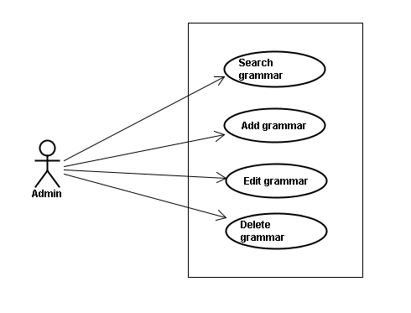

Figure 3-40: Grammar Mangement – Use Case Diagram

##### Screen description

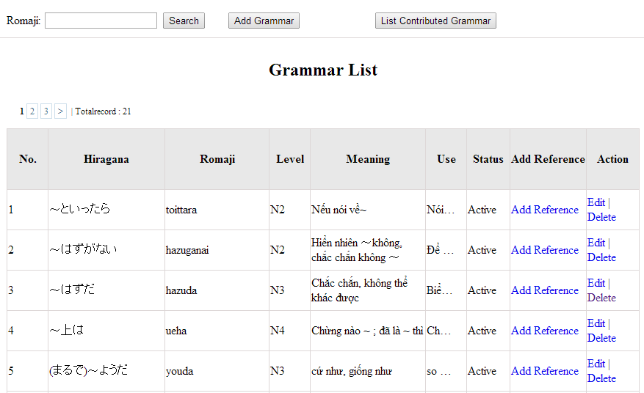

Figure 3-41: Grammar management

|  |  |  |  |  |  |  |
| --- | --- | --- | --- | --- | --- | --- |
| **No** | **Field name** | **Type** | **Require** | **Mandatory** | **Max-Length** | **Description** |
| 1 | Romaji | Text | Text | Y | 100 | Admin input romaji with length less than 100 character |
| 2 | Add-new | Button | Click | N |  | Admin add new grammar into database |
| 3 | Edit | Button | Click | N |  | Admin click edit grammar |
| 4 | Delete | Button | Click | N |  | Admin click delete grammar |
| 5 | Add-reference | Button | Click | N |  | Admin add reference of grammar |
| 6 | List-contribute | Button | Click | N |  | Admin click to view list contribute |
| Table 3-19: Grammar management’s screen description | | | | | | |
|  | | | | | | |
|  | | | | | | |
|  | | | | | | |

##### Use case specifications

###### UC0028: Search grammar

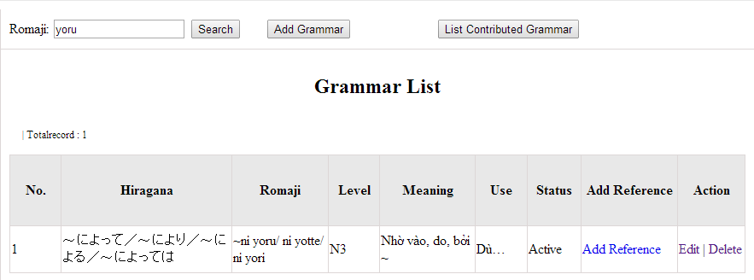

Figure 3-42: Search grammar

|  |  |  |  |  |
| --- | --- | --- | --- | --- |
| **UC0028 - Specification** | | | | |
| **Use-case No.** | <UC0028> | **Use-case Version** | | <1.0> |
| **Use-case Name** | Search grammar | | | |
| **Author** | Minh PT | | | |
| **Date** | 09/06/2014 | **Priority** | <High > | |
| **Actor:**  Admin  **Summary:**  When Administrator wants to search a grammatical structure in database, Admin can input a grammatical structure by “romaji” letter then click button “Search”. If that grammatical structure is existed, system will return meaning.  **Triggers**  Click on “Grammar management” tab, input grammatical structure in the right text box then click “Search” button  **Preconditions:**   * Website is available * User has to login as Administrator * User has to input data in search area   **Post Conditions:**  Display detail information of grammatical structure  **Main Success Scenario:**   |  |  |  | | --- | --- | --- | | **Step** | **User** | **System** | | 1 | Have logged into system as an admin |  | | 2 | Click on “Grammar management” tab | Displays criteria search screen | | 3 | Fill information of the grammatical structure that they want to find into these fields then click “Search” button | Displays search result as a table with these elements:   * No * Hiragana * Romaji * Level * Meaning * Use * Status * Add reference * Edit * Delete |     **Alternative Scenario:**   |  |  |  | | --- | --- | --- | | **At Step** | **User** | **System** | | 3 | Fill information of the grammatical structure that they want to find into these fields then click on another link | Switch to selected page |   **Exceptions:**   |  |  |  | | --- | --- | --- | | **At Step** | **User** | **System** | | 3 | Fill information of the grammatical structure that they want to find (that do not exited in database) into these fields then click “Search” button | Return Error message to inform that grammatical structure cannot be found | | | | | |

###### UC0029: Add grammar

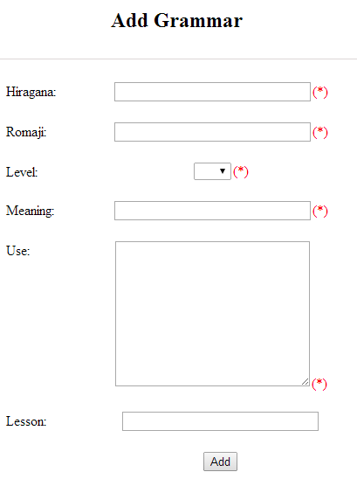

Figure 3-43: Add grammar

|  |  |  |  |  |  |  |
| --- | --- | --- | --- | --- | --- | --- |
| **No** | **Field name** | **Type** | **Require** | **Mandatory** | **Max-Length** | **Description** |
| 1 | Hiragana | Text | Text | Y | 200 | Admin input grammar by hiragana with length less than 200 characters |
| 2 | Romaji | Text | Text | Y | 200 | Admin input grammar by romaji with length less than 200 characters |
| 3 | Meaning | Text | Text | Y | 200 | Admin input mean of grammar with length less than 200 characters |
| 4 | Use | Text | Text | Y | 1000 | Admin input use of grammar with length less than 1000 characters |
| 5 | Level | Drop-down list | Choose | Y |  | Admin choose level of grammar |
| 6 | Lesson | Text | Text | Y | 20 | Admin input lesson |
| 7 | Add | Button | Click | Y |  | Admin add new grammar |

Table 3-20: Add grammar’s screen description

|  |  |  |  |  |
| --- | --- | --- | --- | --- |
| **UC0029 - Specification** | | | | |
| **Use-case No.** | <UC0029> | **Use-case Version** | | <1.0> |
| **Use-case Name** | Add grammar | | | |
| **Author** | Minh PT | | | |
| **Date** | 09/06/2014 | **Priority** | <High > | |
| **Actor:**  Admin  **Summary:**  When Administrator wants to add a grammar into database. They have to insert all necessary data of grammar into “Add Grammar” screen then click “Add” button  **Triggers**  User must click on “Grammar management/ Add New” and input all necessary information of grammar into the right fields then click on “Add” button  **Preconditions:**   * Website is available * User has to login as Administrator * All mandatory fields have been filled * All input data must be valid and have not existed in system   **Post Conditions:**  New grammatical structure has been saved into system database successfully  **Main Success Scenario:**   |  |  |  | | --- | --- | --- | | **Step** | **User** | **System** | | 1 | Have logged into system as an admin |  | | 2 | Click on “Grammar management/Add New” | Display “Add Grammar” screen that contains these elements:   * Hiragana * Romaji * Level * Meaning * Use * Lesson | | 3 | Fill grammar information into all necessary or mandatory fields and click “Add” button | The system validates the input data and then save new grammar data into database | | 4 | Click on “Grammar management/Add Reference” | Display “Add Grammar” screen that contains these elements:   * Grammar * Meaning * Reference | | 5 | Fill grammar information into all necessary or mandatory fields and click “Add” button | The system validates the input data and then save new grammar data into database |     **Alternative Scenario:**   |  |  |  | | --- | --- | --- | | **At Step** | **User** | **System** | | 3 | Click on another link | Do not save new grammar data into database then redirect to selected page | | 5 | Click on another link | Do not save new reference data into database then redirect to selected page |   **Exceptions:**   |  |  |  | | --- | --- | --- | | **At Step** | **User** | **System** | | 3 | Do not fill full information into fields then click “Add” button | Return Error message and request user input data into all fields | | 5 | Do not fill full information into fields then click “Add” button | Return Error message and request user input data into all fields | | | | | |

###### UC0030: Edit grammar

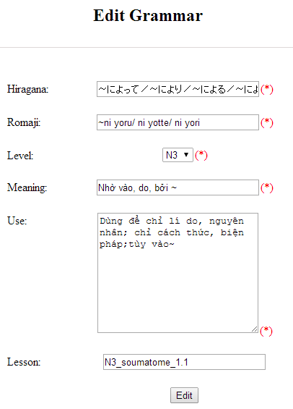

Figure 3-44: Edit grammar

|  |  |  |  |  |  |  |
| --- | --- | --- | --- | --- | --- | --- |
| **No** | **Field name** | **Type** | **Require** | **Mandatory** | **Max-Length** | **Description** |
| 1 | Hiragana | Text | Text | Y | 200 | Admin input grammar by hiragana with length less than 200 characters |
| 2 | Romaji | Text | Text | Y | 200 | Admin input grammar by romaji with length less than 200 characters |
| 3 | Meaning | Text | Text | Y | 200 | Admin input mean of grammar with length less than 200 characters |
| 4 | Use | Text | Text | Y | 1000 | Admin input use of grammar with length less than 1000 characters |
| 5 | Level | Drop-down list | Choose | Y |  | Admin choose level of grammar |
| 6 | Lesson | Text | Text | Y | 20 | Admin input lesson |
| 7 | Add | Button | Click | Y |  | Admin add new grammar |

Table 3-21: Edit vocabulary’s screen description

|  |  |  |  |  |
| --- | --- | --- | --- | --- |
| **UC0030 - Specification** | | | | |
| **Use-case No.** | <UC0030> | **Use-case Version** | | <1.0> |
| **Use-case Name** | Edit grammar | | | |
| **Author** | Minh PT | | | |
| **Date** | 09/06/2014 | **Priority** | <High > | |
| **Actor:**  Admin  **Summary:**  When Administrator want to edit a grammatical structure in database which has some new meanings or errors. Admin will search that grammar then click “Edit” link. When edit finished, new meaning of that grammar will be updated.  **Triggers**  User must click on “Grammar management” then search for the grammatical structure. User click on “Edit” link corresponding with grammar which want to edit. Users edit necessary information of grammar in the right fields then click on “Edit” button.  **Preconditions:**   * Website is available * User has to login as Administrator * All mandatory fields have been filled * All input data must be valid and have not existed in system   **Post Conditions:**  Changed information of grammar has been saved into system database successfully  **Main Success Scenario:**   |  |  |  | | --- | --- | --- | | **Step** | **User** | **System** | | 1 | Have logged into system as an admin |  | | 2 | Click on “Management grammar ” then search for the grammatical structure that they want to edit | Displays search result as a table | | 3 | Click on “Edit” link corresponding with grammar | Display “Edit Grammar” screen that contains the information of chosen grammar with these elements:   * Hiragana * Romaji * Level * Meaning * Use * Lesson | | 4 | Edit grammar information and click “Edit” button | The system validates the input data and then save data into database |     **Alternative Scenario:**   |  |  |  | | --- | --- | --- | | **At Step** | **User** | **System** | | 4 | Edit grammar information then click to another link | Do not save edited data then redirect to selected page |   **Exceptions:**   |  |  |  | | --- | --- | --- | | **At Step** | **User** | **System** | | 4 | Edit grammar information to be similar to another existed grammar and click “Edit” button | The system validates the input data and return Error message and do not save edited data into database |   **Reference:**  UC0028 - <Admin> Search Grammar | | | | |

###### UC0031: Delete grammar

|  |  |  |  |  |
| --- | --- | --- | --- | --- |
| **UC0031 - Specification** | | | | |
| **Use-case No.** | <UC0031> | **Use-case Version** | | <1.0> |
| **Use-case Name** | Delete grammar | | | |
| **Author** | Minh PT | | | |
| **Date** | 09/06/2014 | **Priority** | <High > | |
| **Actor:**  Admin  **Summary:**  When Administrator want to delete a grammar in database. Admin will search that grammar then click “Delete” link. When deleted finished, that grammar no longer exist in database.  **Triggers**  User must click on “Grammar management” then search for the grammatical structure. User click on “Delete” link corresponding with grammar which want to delete.  **Preconditions:**   * Website is available * User has to login as Administrator   **Post Conditions:**  Grammar has been deleted from system database successfully  **Main Success Scenario:**   |  |  |  | | --- | --- | --- | | **Step** | **User** | **System** | | 1 | Have logged into system as an admin |  | | 2 | Click on “Grammar management ” then search for the grammar that they want to delete | Displays search result as a table | | 3 | Click on “Delete” link corresponding with grammar | Remove that grammar in database |   **Reference:** UC0028 - <Admin> Search grammar | | | | |
|  | | | | |

#### Reading Document Management

##### Use case diagram

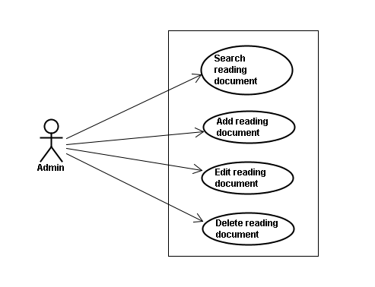

Figure 3-45: Reading Document – Use Case Diagram

##### Screen description

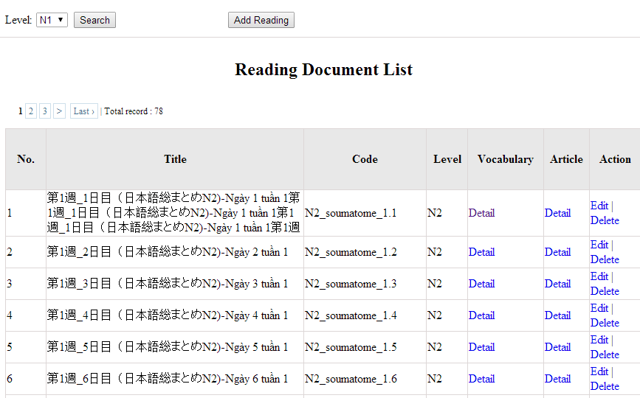

Figure 3-46: Reading document

|  |  |  |  |  |  |  |
| --- | --- | --- | --- | --- | --- | --- |
| **No** | **Field name** | **Type** | **Require** | **Mandatory** | **Max-Length** | **Description** |
| 1 | Level | Drop-down list | Click | Y |  | Admin choose the level |
| 2 | Search | Button | Click | Y |  | Admin click to search |
| 3 | Add-new | Button | Click | N |  | Admin add new into database |
| 4 | Edit | Button | Click | N |  | Admin click edit grammar |
| 5 | Delete | Button | Click | N |  | Admin click delete grammar |
| 6 | Detail-Vocab | Hyperlink | Click | N |  | Details of vocabulary |
| 7 | Detail-Article | Hyperlink | Click | N |  | Details of article |
| Table 3-22: Reading document’s screen description | | | | | | |

##### Use case specifications

###### UC0032: Search reading document

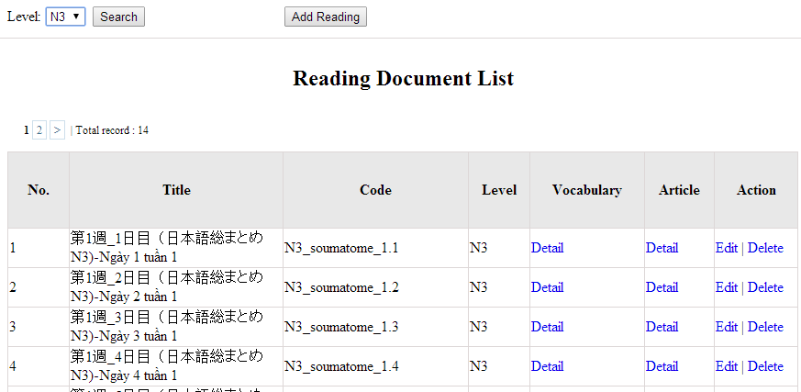

Figure 3-47: Search reading document

|  |  |  |  |  |
| --- | --- | --- | --- | --- |
| **UC0032 - Specification** | | | | |
| **Use-case No.** | <UC0032> | **Use-case Version** | | <1.0> |
| **Use-case Name** | Search document | | | |
| **Author** | Minh PT | | | |
| **Date** | 09/06/2014 | **Priority** | <High > | |
| **Actor:**  Admin  **Summary:**  When Administrator want to search reading document in database and Administrator can search reading document in database successfully if it is existed  **Triggers**  Click on “Reading management” tab, choose level of reading document in the right text box then click “Search” button  **Preconditions:**  User has to login as Administrator user  **Post Conditions:**  Display detail information of reading document  **Main Success Scenario:**   |  |  |  | | --- | --- | --- | | **Step** | **User** | **System** | | 1 | Have logged into system as an admin |  | | 2 | Click on “Reading management” tab | Displays criteria search screen | | 3 | Choose level of the reading document that they want to find then click “Search” button | Displays search result as a table with these elements:   * No * Title * Code * Level * Vocabulary * Article * Edit * Delete |     **Alternative Scenario:**   |  |  |  | | --- | --- | --- | | **At Step** | **User** | **System** | | 3 | Choose level of the reading document that they want to find into these fields then click on another link | Switch to selected page |   **Exceptions:**   |  |  |  | | --- | --- | --- | | **At Step** | **User** | **System** | | 3 | Choose level of the reading document that they want to find (that do not exited in database) into these fields then click “Search” button | Return Error message to inform that reading document cannot be found | | | | | |

###### UC0033: Add reading document

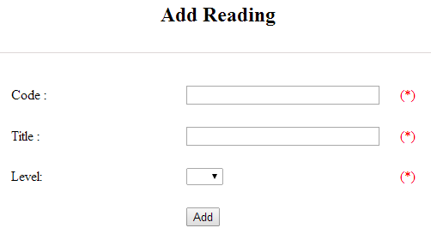

Figure 3-48: Add reading document

|  |  |  |  |  |  |  |
| --- | --- | --- | --- | --- | --- | --- |
| **No** | **Field name** | **Type** | **Require** | **Mandatory** | **Max-Length** | **Description** |
| 1 | Code | Text | Text | Y | 50 | Admin input code with length less than 50 character |
| 2 | Title | Text | Text | Y | 100 | Admin input title with length less than 100 characters |
| 3 | Level | Drop-down list | Click | Y |  | Admin choose the level |
| 4 | Add | Button | Click | Y |  | Admin click to add reading |

Table 3-23: Add reading document’s screen description

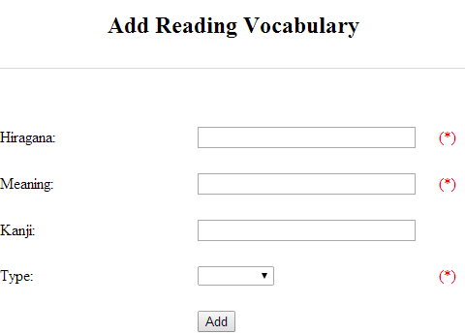

Figure 3-49: Add reading vocabulary

|  |  |  |  |  |  |  |
| --- | --- | --- | --- | --- | --- | --- |
| **No** | **Field name** | **Type** | **Require** | **Mandatory** | **Max-Length** | **Description** |
| 1 | Hiragana | Text | Text | Y | 100 | Admin input hiragana with length less than 100 character |
| 2 | Meaning | Text | Text | Y | 100 | Admin input meaning with length less than 100 characters |
| 3 | Kanji | Text | Text | N | 10 | Admin input kanji with length less than 10 characters |
| 4 | Type | Drop-down list | Click | Y |  | Admin choose the type |
| 5 | Add | Button | Click | Y |  | Admin click to add reading vocabulary |

Table 3-24: Add reading vocabulary’s screen description

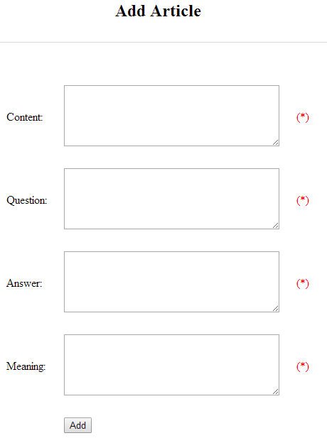

Figure 3-50: Add article

|  |  |  |  |  |  |  |
| --- | --- | --- | --- | --- | --- | --- |
| **No** | **Field name** | **Type** | **Require** | **Mandatory** | **Max-Length** | **Description** |
| 1 | Content | Text | Text | Y | 5000 | Admin input content with length less than 5000 character |
| 2 | Question | Text | Text | Y | 5000 | Admin input question with length less than 5000 characters |
| 3 | Answer | Text | Text | Y | 5000 | Admin input answer with length less than 5000 characters |
| 4 | Meaning | Text | Text | Y | 5000 | Admin input meaning with length less than 5000 characters |
| 5 | Add | Button | Click | Y |  | Admin click to add article |

Table 3-25: Add article’s screen description

|  |  |  |  |  |
| --- | --- | --- | --- | --- |
| **UC0030 - Specification** | | | | |
| **Use-case No.** | <UC0030> | **Use-case Version** | | <1.0> |
| **Use-case Name** | Add document | | | |
| **Author** | Minh PT | | | |
| **Date** | 09/06/2014 | **Priority** | <High > | |
| **Actor:**  Admin  **Summary:**  When Administrator want to add new reading document into database. They have to insert all necessary data of reading document into “Add new reading” screen  **Triggers**  User must click on “Reading management/ Add new” tab and input all necessary information of grammar into the right fields then click on “Add new” button  **Preconditions:**   * User have logged into system as an admin. * All mandatory fields have been filled * All input data must be valid and have not existed in system   **Post Conditions:**  New reading document has been saved into system database successfully  **Main Success Scenario:**   |  |  |  | | --- | --- | --- | | **Step** | **User** | **System** | | 1 | Have logged into system as an admin |  | | 2 | Click on “Reading management/Add new” tab | Display “Add New Reading” screen that contains these elements:   * Code * Title * Level | | 3 | Fill reading document information into all necessary or mandatory fields and click “Add ” button | The system validates the input data and then save new reading document data into database | | 4 | Click on “Reading management/Vocabulary Details” | Display “Vocabulary Details” screen that contains these elements:   * Hiragana * Meaning * Kanji * Type | | 5 | Fill reading document information into all necessary or mandatory fields and click “Add ” button | The system validates the input data and then save new reading document data into database | | 6 | Click on “Reading management/Article Details” | Display “Article Details” screen that contains these elements:   * Content * Question * Answer * Meaning | | 7 | Fill reading document information into all necessary or mandatory fields and click “Add ” button | The system validates the input data and then save new reading document data into database |     **Alternative Scenario:**   |  |  |  | | --- | --- | --- | | **At Step** | **User** | **System** | | 3 | Click on another link | Do not save new reading document data into database then redirect to selected page | | 5 | Click on another link | Do not save vocabulary details data into database then redirect to selected page | | 7 | Click on another link | Do not save article details data into database then redirect to selected page |   **Exceptions:**   |  |  |  | | --- | --- | --- | | **At Step** | **User** | **System** | | 3 | Do not fill full information into fields then click “Add new” button | Return Error message beside empty field and ask if user want to add with empty field. | | 5 | Do not fill full information into fields then click “Add new” button | Return Error message beside empty field and ask if user want to add with empty field. | | 7 | Do not fill full information into fields then click “Add new” button | Return Error message beside empty field and ask if user want to add with empty field. | | | | | |

###### UC0034: Edit reading document

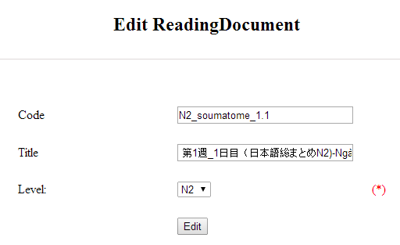

Figure 3-51: Edit reading document

|  |  |  |  |  |  |  |
| --- | --- | --- | --- | --- | --- | --- |
| **No** | **Field name** | **Type** | **Require** | **Mandatory** | **Max-Length** | **Description** |
| 1 | Code | Text | Text | Y | 50 | Admin input code with length less than 50 character |
| 2 | Title | Text | Text | Y | 100 | Admin input title with length less than 100 characters |
| 3 | Level | Drop-down list | Click | Y |  | Admin choose the level |
| 4 | Edit | Button | Click | Y |  | Admin click to edit reading |

Table 3-26: Edit reading document’s screen description

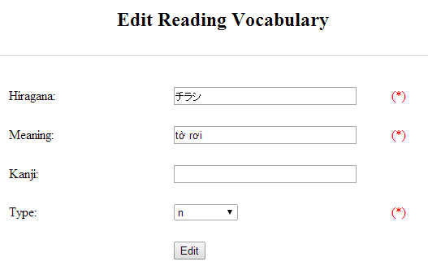

Figure 3-52: Add reading vocabulary

|  |  |  |  |  |  |  |
| --- | --- | --- | --- | --- | --- | --- |
| **No** | **Field name** | **Type** | **Require** | **Mandatory** | **Max-Length** | **Description** |
| 1 | Hiragana | Text | Text | Y | 100 | Admin input hiragana with length less than 100 character |
| 2 | Meaning | Text | Text | Y | 100 | Admin input meaning with length less than 100 characters |
| 3 | Kanji | Text | Text | N | 10 | Admin input kanji with length less than 10 characters |
| 4 | Type | Drop-down list | Click | Y |  | Admin choose the type |
| 5 | Edit | Button | Click | Y |  | Admin click to edit reading vocabulary |

Table 3-27: Add reading vocabulary’s screen description

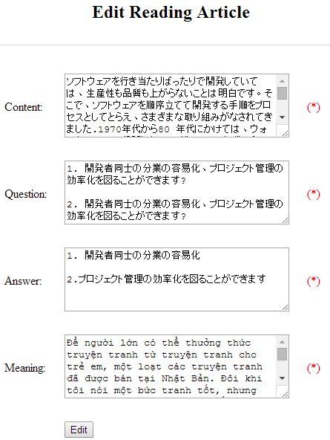

Figure 3-53: Add article

|  |  |  |  |  |  |  |
| --- | --- | --- | --- | --- | --- | --- |
| **No** | **Field name** | **Type** | **Require** | **Mandatory** | **Max-Length** | **Description** |
| 1 | Content | Text | Text | Y | 5000 | Admin input content with length less than 5000 character |
| 2 | Question | Text | Text | Y | 5000 | Admin input question with length less than 5000 characters |
| 3 | Answer | Text | Text | Y | 5000 | Admin input answer with length less than 5000 characters |
| 4 | Meaning | Text | Text | Y | 5000 | Admin input meaning with length less than 5000 characters |
| 5 | Edit | Button | Click | Y |  | Admin click to edit article |

Table 3-28: Add article’s screen description

|  |  |  |  |  |
| --- | --- | --- | --- | --- |
| **UC0034 - Specification** | | | | |
| **Use-case No.** | <UC0034> | **Use-case Version** | | <1.0> |
| **Use-case Name** | Edit reading document | | | |
| **Author** | Minh PT | | | |
| **Date** | 09/06/2014 | **Priority** | <High > | |
| **Actor:**  Admin  **Summary:**  When Administrator want to edit reading document on database which has some new meanings or errors  **Triggers**  User must click on “Reading management” then search for the reading document. User click on “Edit” link to corresponding reading document. They edit necessary information of reading document in the right fields then click on “Edit” button.  **Preconditions:**   * User have logged into system as an admin. * All mandatory fields have been filled * All input data must be valid and have not existed in system   **Post Conditions:**  Changed information of reading document has been saved into system database successfully  **Main Success Scenario:**   |  |  |  | | --- | --- | --- | | **Step** | **User** | **System** | | 1 | Have logged into system as an admin |  | | 2 | Click on “Reading management ” then search for the reading document that they want to edit | Displays search result as a table | | 3 | Click on “Edit” link | Display “Edit reading” screen that contains the information of chosen reading with these elements:   * Code * Title * Level | | 4 | Edit reading document information and click “Edit” button | The system validates the input data and then save data into database | | 5 | Click on “VocabularyEdit” link | Display “Edit vocabulary” screen that contains the information of chosen reading with these elements:   * Hiragana * Meaning * Kanji * Type | | 6 | Edit reading document information and click “Edit” button | The system validates the input data and then save data into database | | 7 | Click on “ArticleEdit” link | Display “Edit article” screen that contains the information of chosen reading with these elements:   * Content * Question * Answer * Meaning | | 8 | Edit reading document information and click “Edit” button | The system validates the input data and then save data into database |     **Alternative Scenario:**   |  |  |  | | --- | --- | --- | | **At Step** | **User** | **System** | | 4 | Edit reading information then click to another link | Do not save edited data then redirect to selected page | | 6 | Edit reading information then click to another link | Do not save edited data then redirect to selected page | | 8 | Edit reading information then click to another link | Do not save edited data then redirect to selected page |   **Exceptions:**   |  |  |  | | --- | --- | --- | | **At Step** | **User** | **System** | | 4 | Edit reading information to be similar to another existed reading and click “Edit” button | The system validates the input data and return Error message and do not save edited data into database | | 6 | Edit reading information to be similar to another existed reading and click “Edit” button | The system validates the input data and return Error message and do not save edited data into database | | 8 | Edit reading information to be similar to another existed reading and click “Edit” button | The system validates the input data and return Error message and do not save edited data into database |   **Reference:**  UC0032- <Admin> Search reading document | | | | |

###### UC0035: Delete reading document

|  |  |  |  |  |
| --- | --- | --- | --- | --- |
| **UC0035 - Specification** | | | | |
| **Use-case No.** | <UC0035> | **Use-case Version** | | <1.0> |
| **Use-case Name** | Delete reading document | | | |
| **Author** | Minh PT | | | |
| **Date** | 09/06/2014 | **Priority** | <High > | |
| **Actor:**  Admin  **Summary:**  When Administrator want to delete reading document on database  **Triggers**  User must click on “Reading management” then search for the reading document. User click on “Delete” link on corresponding reading document.  **Preconditions:**   * User have logged into system as an admin. * All mandatory fields have been filled * All input data must be valid and have existed in system   **Post Conditions:**  Reading document has been deleted from system database successfully  **Main Success Scenario:**   |  |  |  | | --- | --- | --- | | **Step** | **User** | **System** | | 1 | Have logged into system as an admin |  | | 2 | Click on “Reading management ” then search for the reading document that they want to delete | Displays search result as a table | | 3 | Click on “Delete” link beside that reading document row | Displays pop up to confirm if they really want to remove that reading document | | 4 | Click “Yes” button on popup | Closes the popup then remove that reading document name from reading list |     **Alternative Scenario:**   |  |  |  | | --- | --- | --- | | **At Step** | **User** | **System** | | 4 | Click close icon of the popup | Only closes the popup, does not remove that reading document |   **Exceptions:**   |  |  |  | | --- | --- | --- | | **At Step** | **User** | **System** | | 4 | Click “Cancel” button on popup | Only closes the popup, does not remove that reading document |   **Reference:**  UC0032 - <Admin> Search reading document | | | | |
|  | | | | |

#### Conversation management

##### Use case diagram

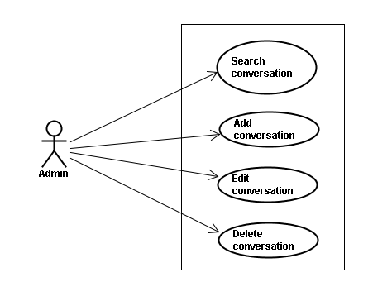

Figure 3-54: Conversation – Use Case Diagram

##### Screen description

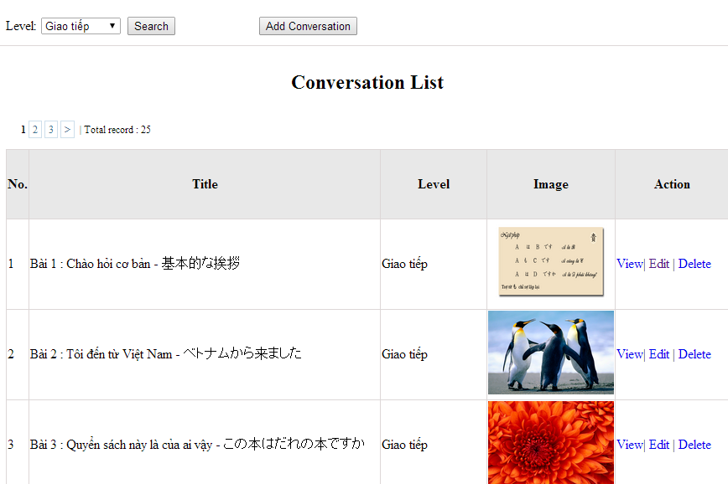

Figure 3-55: Conversation management

|  |  |  |  |  |  |  |
| --- | --- | --- | --- | --- | --- | --- |
| **No** | **Field name** | **Type** | **Require** | **Mandatory** | **Max-Length** | **Description** |
| 1 | Level | Drop-down list | Click | N |  | Admin choose the level |
| 2 | Search | Button | Click | N |  | Admin click to search conversation |
| 3 | Add-new | Button | Click | N |  | Admin click to add new conversation |
| 4 | View | Hyperlink | Click | N |  | Admin click to view content |
| 5 | Edit | Hyperlink | Click | N |  | Admin click edit conversation |
| 6 | Delete | Hyperlink | Click | N |  | Admin click delete conversation |

Table 3-29: Conversation management’s screen description

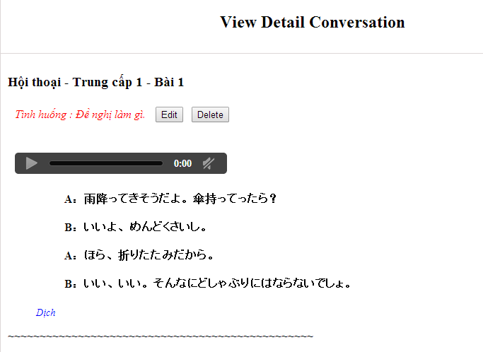

Figure 3-56: View Detail Conversation Screen

##### Use case specifications

###### UC0036: Search conversation

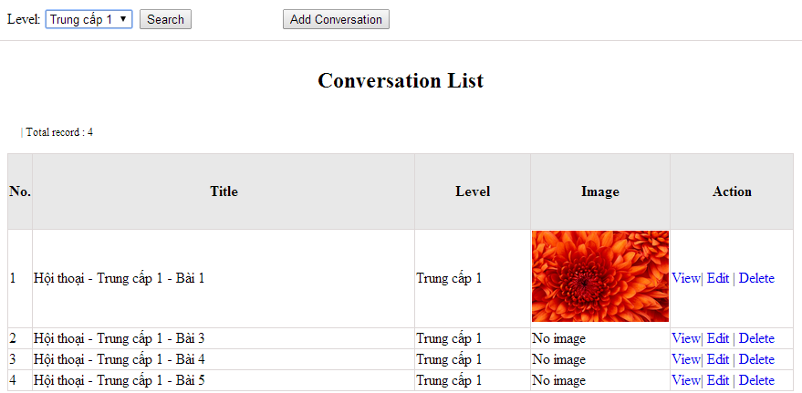

Figure 3-57: Search conversation

|  |  |  |  |  |
| --- | --- | --- | --- | --- |
| **UC0036 - Specification** | | | | |
| **Use-case No.** | <UC0036> | **Use-case Version** | | <1.0> |
| **Use-case Name** | Search conversation | | | |
| **Author** | Minh PT | | | |
| **Date** | 09/06/2014 | **Priority** | <High > | |
| **Actor:**  Admin  **Summary:**  When Administrator wants to search conversation in database. User choose level of conversation or level then click “Search” button  **Triggers**  Click on “Conversation management” tab, choose level of conversation in the right text box then click “Search” button  **Preconditions:**   * Website is available * User has to login as Administrator * User has to input data in search area   **Post Conditions:**  Display detail information of conversation  **Main Success Scenario:**   |  |  |  | | --- | --- | --- | | **Step** | **User** | **System** | | 1 | Have logged into system as an admin |  | | 2 | Click on “Conversation management” tab | Displays criteria search screen | | 3 | Choose level of the conversation that they want to find then click “Search” button | Displays search result as a table with these elements:   * No * Title * Level * Image * View * Edit * Delete |     **Alternative Scenario:**   |  |  |  | | --- | --- | --- | | **At Step** | **User** | **System** | | 3 | Choose level of the conversation that they want to find into these fields then click on another link | Switch to selected page |   **Exceptions:**   |  |  |  | | --- | --- | --- | | **At Step** | **User** | **System** | | 3 | Choose level of the conversation that they want to find (that do not exited in database) into these fields then click “Search” button | Return Error message to inform that conversation cannot be found | | | | | |

###### UC0037: Add conversation

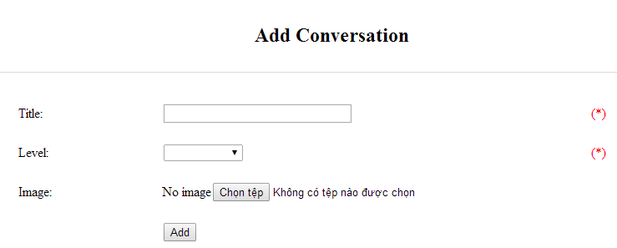

Figure 3-58: Add conversation

|  |  |  |  |  |  |  |
| --- | --- | --- | --- | --- | --- | --- |
| **No** | **Field name** | **Type** | **Require** | **Mandatory** | **Max-Length** | **Description** |
| 1 | Title | Text | Text | Y | 100 | Admin input title of conversation with length less than 100 characters |
| 3 | Level | Drop-down list | Text | Y |  | Admin choose the level |
| 4 | Image | Button | Click | N |  | Admin choose the image |
| 5 | Add | Button | Click | Y |  | Admin add new conversation |

Table 3-30: Add conversation’s screen description

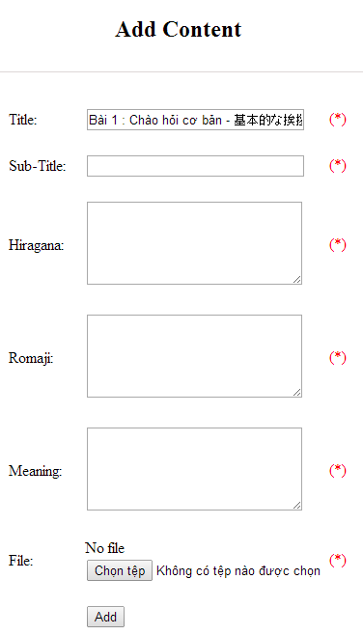

Figure 3-59: Add new conversation content

|  |  |  |  |  |  |  |
| --- | --- | --- | --- | --- | --- | --- |
| **No** | **Field name** | **Type** | **Require** | **Mandatory** | **Max-Length** | **Description** |
| 1 | Title |  |  |  |  |  |
| 2 | Sub-title | Text | Text | Y | 200 | Admin input subtitle with length less than 200 characters |
| 3 | Hiragana | Text | Text | Y | 5000 | Admin input hiragana with length less than 5000 characters |
| 4 | Romaji | Text | Text | Y | 5000 | Admin input conversation by romaji with length less than 5000 characters |
| 5 | Meaning | Text | Text | Y | 5000 | Admin input conversation’s meaning with length less than 5000 characters |
| 6 | File | Button | Click | Y |  | Admin choose the file |
| 7 | Add | Button | Click | Y |  | Admin add new content |

Table 3-31: Add conversation content’s screen description

|  |  |  |  |  |
| --- | --- | --- | --- | --- |
| **UC0037 - Specification** | | | | |
| **Use-case No.** | <UC0037> | **Use-case Version** | | <1.0> |
| **Use-case Name** | Add conversation | | | |
| **Author** | Minh PT | | | |
| **Date** | 09/06/2014 | **Priority** | <High > | |
| **Actor:**  Admin  **Summary:**  When Administrator wants to add new conversation into database. They have to insert all necessary data of conversation into “Add Conversation” screen  **Triggers**  User must click on “Conversation management/ Add New” and input all necessary information of conversation into the right fields then click on “Add” button  **Preconditions:**   * Website is available * User have logged into system as an admin. * All mandatory fields have been filled * All input data must be valid and have not existed in system   **Post Conditions:**  New conversation has been saved into system database successfully  **Main Success Scenario:**   |  |  |  | | --- | --- | --- | | **Step** | **User** | **System** | | 1 | Have logged into system as an admin |  | | 2 | Click on “Conversation management/Add New” | Display “Add Conversation” screen that contains these elements:   * Title * Level * Image | | 3 | Fill conversation information into all necessary or mandatory fields and click “Add” button | The system validates the input data and then save new conversation data into database | | 4 | Click on “Conversation management/View/Add new content” | Display “Add Content” screen that contains these elements:   * Title * Subtitle * Hiragana * Romaji * Meaning * File | | 5 | Fill conversation information into all necessary or mandatory fields and click “Add” button | The system validates the input data and then save new conversation data into database |     **Alternative Scenario:**   |  |  |  | | --- | --- | --- | | **At Step** | **User** | **System** | | 3 | Click on another link | Do not save new conversation data into database then redirect to selected page | | 5 | Click on another link | Do not save new content conversation data into database then redirect to selected page |   **Exceptions:**   |  |  |  | | --- | --- | --- | | **At Step** | **User** | **System** | | 3 | Do not fill full information into fields then click “Add” button | Return Error message and request user input data into all fields | | 5 | Do not fill full information into fields then click “Add” button | Return Error message and request user input data into all fields | | | | | |

###### UC0038: Edit conversation

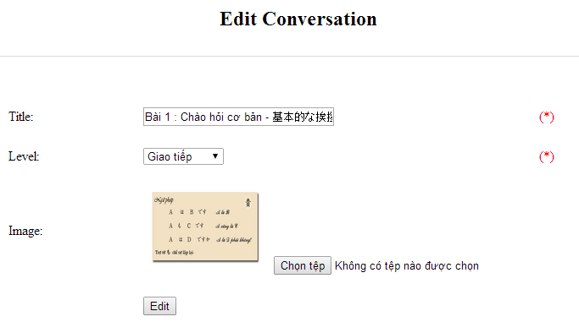

Figure 3-60: Edit conversation

|  |  |  |  |  |  |  |
| --- | --- | --- | --- | --- | --- | --- |
| **No** | **Field name** | **Type** | **Require** | **Mandatory** | **Max-Length** | **Description** |
| 1 | Title | Text | Text | Y | 100 | Admin input title of conversation with length less than 100 characters |
| 3 | Level | Drop-down list | Text | Y |  | Admin choose the level |
| 4 | Image | Button | Click | N |  | Admin choose the image |
| 5 | Edit | Button | Click | Y |  | Admin add edit conversation |

Table 3-32: Edit conversation’s screen description

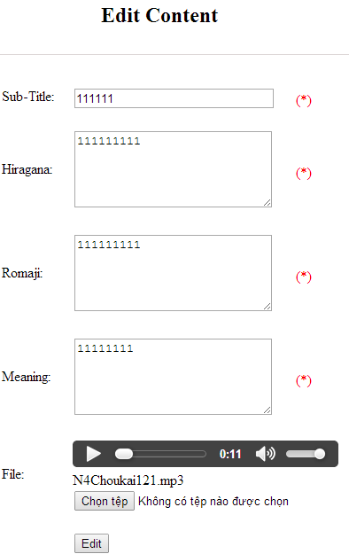

Figure 3-61: Edit new conversation content

|  |  |  |  |  |  |  |
| --- | --- | --- | --- | --- | --- | --- |
| **No** | **Field name** | **Type** | **Require** | **Mandatory** | **Max-Length** | **Description** |
| 1 | Sub-title | Text | Text | Y | 200 | Admin input subtitle with length less than 200 characters |
| 2 | Hiragana | Text | Text | Y | 5000 | Admin input hiragana with length less than 5000 characters |
| 3 | Romaji | Text | Text | Y | 5000 | Admin input conversation by romaji with length less than 5000 characters |
| 4 | Meaning | Text | Text | Y | 5000 | Admin input conversation’s meaning with length less than 5000 characters |
| 5 | File | Button | Click | Y |  | Admin choose the file |
| 6 | Edit | Button | Click | Y |  | Admin edit conversation |

Table 3-33: Edit conversation content’s screen description

|  |  |  |  |  |
| --- | --- | --- | --- | --- |
| **UC0038 - Specification** | | | | |
| **Use-case No.** | <UC0038> | **Use-case Version** | | <1.0> |
| **Use-case Name** | Edit conversation | | | |
| **Author** | Minh PT | | | |
| **Date** | 09/06/2014 | **Priority** | <High > | |
| **Actor:**  Admin  **Summary:**  When Administrator want to edit conversation in database which has some new meanings or errors. When edit finished, new meaning will be updated  **Triggers**  User must click on “Conversation management” then search for the conversation. User click on “Edit” link on corresponding conversation. They edit necessary information of conversation in the right fields then click on “Edit” button.  **Preconditions:**   * Website is available * User have logged into system as an admin. * All mandatory fields have been filled * All input data must be valid and have not existed in system   **Post Conditions:**  Changed information of conversation has been saved into system database successfully  **Main Success Scenario:**   |  |  |  | | --- | --- | --- | | **Step** | **User** | **System** | | 1 | Have logged into system as an admin |  | | 2 | Click on “Conversation management ” then search for the conversation that they want to edit | Displays search result as a table | | 3 | Click on “Edit” link corresponding | Display “Edit conversation” screen that contains the information of chosen conversation with these elements:   * Title * Level * Image | | 4 | Edit conversation information and click “Edit” button | The system validates the input data and then save data into database | | 5 | Click “View/Edit content” | Display “Edit Conversation Content” screen that contains the information of chosen conversation with these elements:   * Sub-title * Hiragana * Romaji * Meaning * File | | 6 | Edit conversation content information and click “Edit” button | The system validates the input data and then save data into database |     **Alternative Scenario:**   |  |  |  | | --- | --- | --- | | **At Step** | **User** | **System** | | 4 | Edit conversation then click to another link | Do not save edited data then redirect to selected page | | 6 | Edit conversation content then click to another link | Do not save edited data then redirect to selected page |   **Exceptions:**   |  |  |  | | --- | --- | --- | | **At Step** | **User** | **System** | | 4 | Edit conversation to be similar to another existed conversation |  | | 6 | Click “Edit” button | The system validates the input data and return Error message and do not save edited data into database |   **Reference:**  UC0036- <Admin> Search conversation | | | | |

###### UC0039: Delete conversation

|  |  |  |  |  |
| --- | --- | --- | --- | --- |
| **UC0039 - Specification** | | | | |
| **Use-case No.** | <UC0039> | **Use-case Version** | | <1.0> |
| **Use-case Name** | Delete conversation | | | |
| **Author** | Minh PT | | | |
| **Date** | 09/06/2014 | **Priority** | <High > | |
| **Actor:**  Admin  **Summary:**  When Administrator want to delete conversation in database  **Triggers**  User must click on “Conversation management” then search for the conversation. User click on “Delete” link on corresponding conversation.  **Preconditions:**   * Website is available * User have logged into system as an admin.   **Post Conditions:**  Conversation has been deleted from system database successfully  **Main Success Scenario:**   |  |  |  | | --- | --- | --- | | **Step** | **User** | **System** | | 1 | Have logged into system as an admin |  | | 2 | Click on “Conversation management ” then search for the conversation that they want to delete | Displays search result as a table | | 3 | Click on “Delete” link corresponding with conversation | Remove that conversation in database |   **Exceptions:**   |  |  |  | | --- | --- | --- | | **At Step** | **User** | **System** | | 3 | Click on “Delete” link corresponding with conversation (conversation content is existing) | Return Error message and request user remove conversation content first |   **Reference:**  UC0036 - <Admin> Search conversation | | | | |
|  | | | | |

#### Video Management

##### Use case diagram

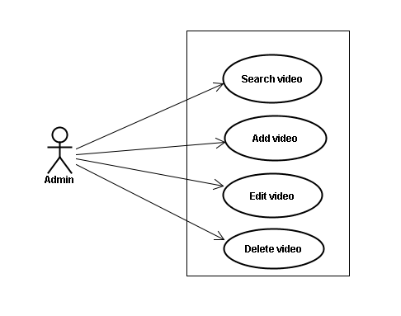

Figure 3-62: Video Management – Use Case Diagram

##### Screen description

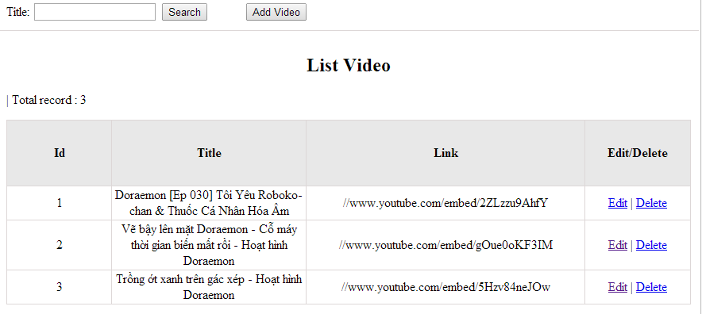

Figure 3-63: Video management

|  |  |  |  |  |  |  |
| --- | --- | --- | --- | --- | --- | --- |
| **No** | **Field name** | **Type** | **Require** | **Mandatory** | **Max-Length** | **Description** |
| 1 | Title | Text | Text | Y | 100 | Admin input title with length less than 100 character |
| 2 | Add new | Button | Click | N |  | Admin add new video into database |
| 3 | Edit | Button | Click | N |  | Admin click edit video |
| 4 | Delete | Button | Click | N |  | Admin click delete video |

Table 3-34: Video management’s screen description

##### Use case specifications

###### UC040: Search video

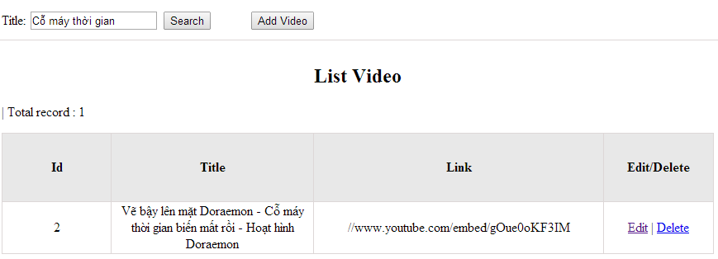

Figure 3-64: Search video

|  |  |  |  |  |
| --- | --- | --- | --- | --- |
| **UC0040 - Specification** | | | | |
| **Use-case No.** | <UC0040> | **Use-case Version** | | <1.0> |
| **Use-case Name** | Search video | | | |
| **Author** | Minh PT | | | |
| **Date** | 09/06/2014 | **Priority** | <High > | |
| **Actor:**  Admin  **Summary:**  When Administrator wants to search video in database. User input title of video then click “Search” button  **Triggers**  Click on “Video management” tab, input title of video in the right text box then click “Search” button  **Preconditions:**   * Website is available * User has to login as Administrator * User has to input data in search area   **Post Conditions:**  Display detail information of video  **Main Success Scenario:**   |  |  |  | | --- | --- | --- | | **Step** | **User** | **System** | | 1 | Have logged into system as an admin |  | | 2 | Click on “Video management” tab | Displays criteria search screen | | 3 | Fill information of the video that they want to find into these fields then click “Search” button | Displays search result as a table with these elements:   * No * Title * Link * Edit * Delete |     **Alternative Scenario:**   |  |  |  | | --- | --- | --- | | **At Step** | **User** | **System** | | 3 | Fill information of the video that they want to find into these fields then click on another link | Switch to selected page |   **Exceptions:**   |  |  |  | | --- | --- | --- | | **At Step** | **User** | **System** | | 3 | Fill information of the video that they want to find (that do not exited in database) into these fields then click “Search” button | Return Error message to inform that video cannot be found | | | | | |

###### UC041: Add video

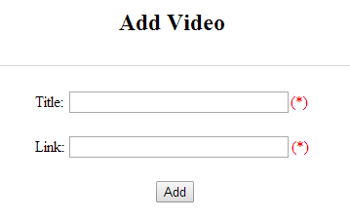

Figure 3-65: Add video

|  |  |  |  |  |  |  |
| --- | --- | --- | --- | --- | --- | --- |
| **No** | **Field name** | **Type** | **Require** | **Mandatory** | **Max-Length** | **Description** |
| 1 | Title | Text | Text | Y | 200 | Admin input title with length less than 200 characters |
| 2 | Link | Text | Text | Y |  | Admin input hyperlink |
| 3 | Add | Button | Click | Y |  | Admin add new video |
| 4 | Reset | Button | Click | N |  | Admin reset information |

Table 3-35: Add video’s screen description

|  |  |  |  |  |
| --- | --- | --- | --- | --- |
| **UC0041 - Specification** | | | | |
| **Use-case No.** | <UC0041> | **Use-case Version** | | <1.0> |
| **Use-case Name** | Add video | | | |
| **Author** | Minh PT | | | |
| **Date** | 09/06/2014 | **Priority** | <High > | |
| **Actor:**  Admin  **Summary:**  When Administrator wants to add new video into database. They have to insert all necessary data of video into “Add Video” screen  **Triggers**  User must click on “Video management/ Add New” tab and input all necessary information of video into the right fields then click on “Add” button  **Preconditions:**   * Website is available * User have logged into system as an admin. * All mandatory fields have been filled * All input data must be valid and have not existed in system   **Post Conditions:**  New video has been saved into system database successfully  **Main Success Scenario:**   |  |  |  | | --- | --- | --- | | **Step** | **User** | **System** | | 1 | Have logged into system as an admin |  | | 2 | Click on “Video management/Add New” tab | Display “Add Video” screen that contains these elements:   * Title * Link | | 3 | Fill video information into all necessary or mandatory fields and click “Add” button | The system validates the input data and then save new video data into database |     **Alternative Scenario:**   |  |  |  | | --- | --- | --- | | **At Step** | **User** | **System** | | 3 | Click on another link | Do not save new video data into database then redirect to selected page |   **Exceptions:**   |  |  |  | | --- | --- | --- | | **At Step** | **User** | **System** | | 3 | Do not fill full information into fields then click “Add” button | Return Error message and request user input data into all fields | | | | | |

###### UC042: Edit video

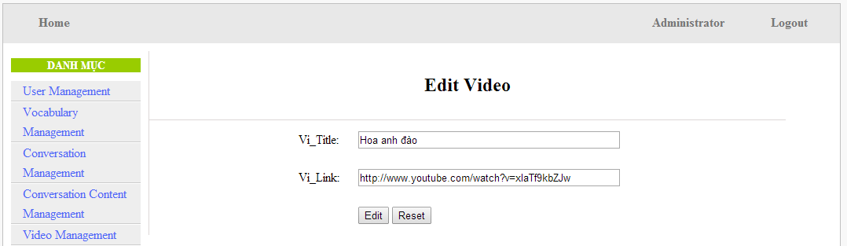

Figure 3-66: Edit video

|  |  |  |  |  |  |  |
| --- | --- | --- | --- | --- | --- | --- |
| **No** | **Field name** | **Type** | **Require** | **Mandatory** | **Max-Length** | **Description** |
| 1 | Title | Text | Text | Y | 200 | Admin input title with length less than 200 characters |
| 2 | Link | Text | Text | Y | 1000 | Admin input hyperlink |
| 3 | Add | Button | Click | Y |  | Admin edit video |

Table 3-36: Edit video’s screen description

|  |  |  |  |  |
| --- | --- | --- | --- | --- |
| **UC0042 - Specification** | | | | |
| **Use-case No.** | <UC0042> | **Use-case Version** | | <1.0> |
| **Use-case Name** | Edit video | | | |
| **Author** | Minh PT | | | |
| **Date** | 09/06/2014 | **Priority** | <High > | |
| **Actor:**  Admin  **Summary:**  When Administrator wants to edit video in database which has some new meanings or errors. When edit finished, new meaning will be updated  **Triggers**  User must click on “Video management” then search for the video. User click on “Edit” link corresponding with video. User edits necessary information of video in the right fields then click on “Edit” button.  **Preconditions:**   * Website is available * User have logged into system as an admin. * All mandatory fields have been filled * All input data must be valid and have not existed in system   **Post Conditions:**  Changed information of video has been saved into system database successfully  **Main Success Scenario:**   |  |  |  | | --- | --- | --- | | **Step** | **User** | **System** | | 1 | Have logged into system as an admin |  | | 2 | Click on “Video management ” then search for the video that they want to edit | Displays search result as a table | | 3 | Click on “Edit” link corresponding | Display “Edit video” screen that contains the information of chosen video with these elements:   * Title * Link | | 4 | Edit video information and click “Edit” button | The system validates the input data and then save data into database |     **Alternative Scenario:**   |  |  |  | | --- | --- | --- | | **At Step** | **User** | **System** | | 4 | Edit video then click to another link | Do not save edited data then redirect to selected page |   **Exceptions:**   |  |  |  | | --- | --- | --- | | **At Step** | **User** | **System** | | 4 | Edit video to be similar to another existed video and click “Edit” button | The system validates the input data and return Error message and do not save edited data into database |   **Reference:**  UC0040- <Admin> Search video | | | | |

###### UC043: Delete video

|  |  |  |  |  |
| --- | --- | --- | --- | --- |
| **UC0043 - Specification** | | | | |
| **Use-case No.** | <UC0043> | **Use-case Version** | | <1.0> |
| **Use-case Name** | Delete video | | | |
| **Author** | Minh PT | | | |
| **Date** | 09/06/2014 | **Priority** | <High > | |
| **Actor:**  Admin  **Summary:**  When Administrator wants to delete video in database  **Triggers**  User must click on “Video management” then search for the video. User click on “Delete” link on corresponding video.  **Preconditions:**   * Website is available * User have logged into system as an admin.   **Post Conditions:**  Video has been deleted from system database successfully  **Main Success Scenario:**   |  |  |  | | --- | --- | --- | | **Step** | **User** | **System** | | 1 | Have logged into system as an admin |  | | 2 | Click on “Video management ” then search for the video that they want to delete | Displays search result as a table | | 3 | Click on “Delete” link corresponding with conversation | Remove that video in database |     **Reference:**  UC0040 - <Admin> Search video | | | | |
|  | | | | |

#### Training Listening Management

##### Use case diagram

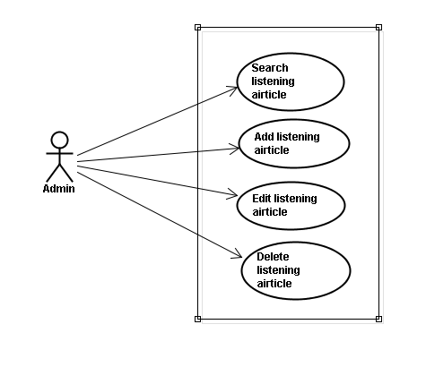

Figure 3-67: Training Listening – Use Case Diagram

##### Screen description

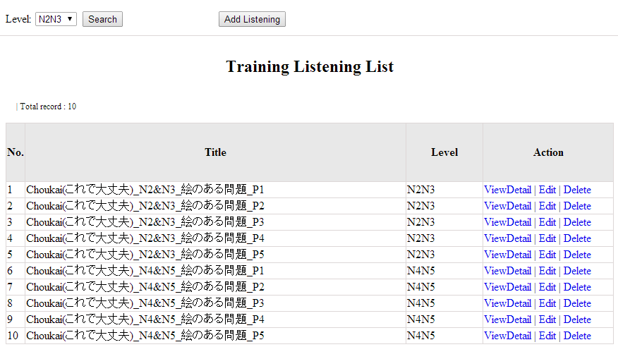

Figure 3-68: Listening article management

|  |  |  |  |  |  |  |
| --- | --- | --- | --- | --- | --- | --- |
| **No** | **Field name** | **Type** | **Require** | **Mandatory** | **Max-Length** | **Description** |
| 1 | Level | Drop-down list | Click | Y |  | Admin choose the level |
| 2 | Search | Button | Click | Y |  | Admin click to search |
| 3 | Addnew | Button | Click | N |  | Admin add new listening into database |
| 4 | ViewDetail | Hyperlink | Click | N |  | Admin click to view details of listening |
| 5 | Edit | Button | Click | N |  | Admin click edit listening article |
| 6 | Delete | Button | Click | N |  | Admin click delete article |

Table 3-37: Conversation management’s screen description

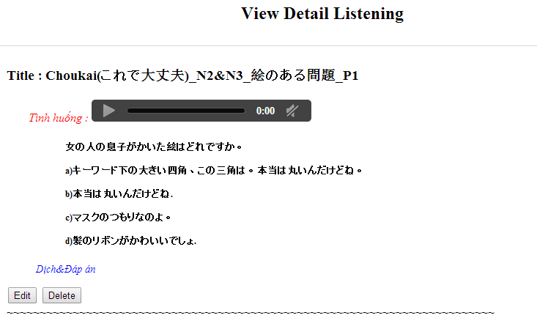

Figure 3-69: View Detail Listening Screen

##### Use case specifications

###### UC044: Search listening article

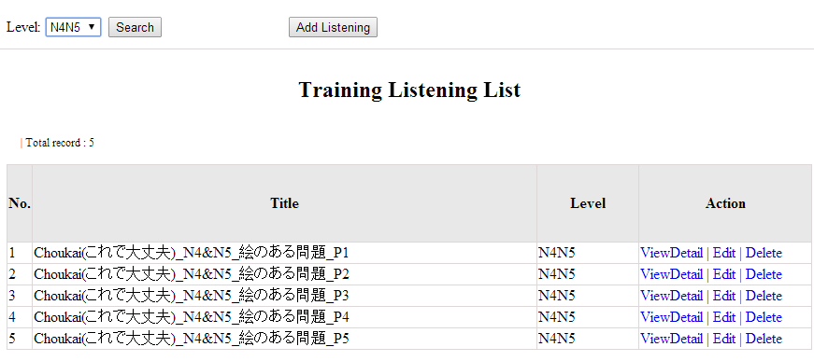

Figure 3-70: Search listening article

|  |  |  |  |  |
| --- | --- | --- | --- | --- |
| **UC0044 - Specification** | | | | |
| **Use-case No.** | <UC0044> | **Use-case Version** | | <1.0> |
| **Use-case Name** | Search listening article | | | |
| **Author** | Minh PT | | | |
| **Date** | 09/06/2014 | **Priority** | <High > | |
| **Actor:**  Admin  **Summary:**  When Administrator wants to search listening article in database. User choose level of listening level then click “Search” button  **Triggers**  Click on “Listening practice management” tab, choose level in the right text box then click “Search” button  **Preconditions:**   * Website is available * User has to login as Administrator * User has to input data in search area   **Post Conditions:**  Display detail information of listening article  **Main Success Scenario:**   |  |  |  | | --- | --- | --- | | **Step** | **User** | **System** | | 1 | Have logged into system as an admin |  | | 2 | Click on “Listening article management” tab | Displays criteria search screen | | 3 | Choose level of the listening article that they want to find then click “Search” button | Displays search result as a table with these elements:   * No * Title * Level * View details * Edit * Delete |     **Alternative Scenario:**   |  |  |  | | --- | --- | --- | | **At Step** | **User** | **System** | | 3 | Choose level of the listening article that they want to find into these fields then click on another link | Switch to selected page |   **Exceptions:**   |  |  |  | | --- | --- | --- | | **At Step** | **User** | **System** | | 3 | Choose level of the listening article that they want to find (that do not exited in database) into these fields then click “Search” button | Return Error message to inform that listening article cannot be found | | | | | |

###### UC045: Add listening article

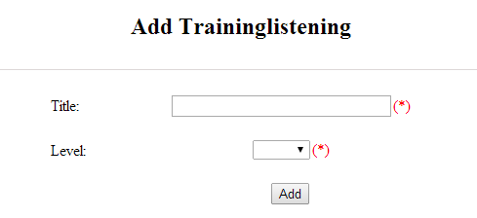

Figure 3-71: Add listening

|  |  |  |  |  |  |  |
| --- | --- | --- | --- | --- | --- | --- |
| **No** | **Field name** | **Type** | **Require** | **Mandatory** | **Max-Length** | **Description** |
| 1 | Title | Text | Text | Y | 500 | Admin input id with length less than 500 characters |
| 2 | Level | Drop-down list | Choose | Y |  | Admin choose level |
| 3 | Add | Button | Click | Y |  | Admin add new listening |

Table 3-38: Add listening’s screen description

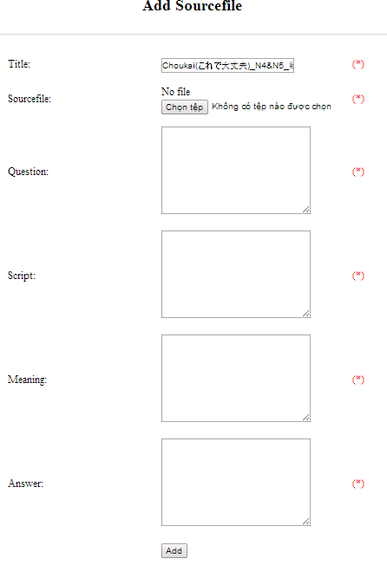

Figure 3-72: Add listening source file

|  |  |  |  |  |  |  |
| --- | --- | --- | --- | --- | --- | --- |
| **No** | **Field name** | **Type** | **Require** | **Mandatory** | **Max-Length** | **Description** |
| 1 | Source_file | Button | Click | Y |  | Admin choose the file |
| 2 | Question | Text | Text | Y | 5000 | Admin input question of listening with length less than 5000 characters |
| 3 | Script | Text | Text | Y | 5000 | Admin input script of listening with length less than 5000 characters |
| 4 | Meaning | Text | Text | Y | 5000 | Admin input meaning of listening with length less than 5000 characters |
| 5 | Answer | Text | Text | Y | 5000 | Admin input answer of listening with length less than 5000 characters |
| 6 | Add | Button | Click | Y |  | Admin add source file |

Table 3-39: Add listening source file’s screen description

|  |  |  |  |  |
| --- | --- | --- | --- | --- |
| **UC0045 - Specification** | | | | |
| **Use-case No.** | <UC0045> | **Use-case Version** | | <1.0> |
| **Use-case Name** | Add listening article | | | |
| **Author** | Minh PT | | | |
| **Date** | 09/06/2014 | **Priority** | <High > | |
| **Actor:**  Admin  **Summary:**  When Administrator wants to add new listening article into database. They have to insert all necessary data of listening article into “Add new listening” screen  **Triggers**  User must click on “Listening management/ Add New” and input all necessary information of listening article into the right fields then click on “Add” button  **Preconditions:**   * Website is available * User have logged into system as an admin. * All mandatory fields have been filled * All input data must be valid and have not existed in system   **Post Conditions:**  New listening article has been saved into system database successfully  **Main Success Scenario:**   |  |  |  | | --- | --- | --- | | **Step** | **User** | **System** | | 1 | Have logged into system as an admin |  | | 2 | Click on “Listening article management/Add New” | Display “Add New Listening” screen that contains these elements:   * Title * Level | | 3 | Fill listening article information into all necessary or mandatory fields click “Add” button | The system validates the input data and then save new listening article data into database | | 4 | Click on “Listening article management/View details/ Add source file” | Display “Add source file” screen that contains these elements:   * Title * Source file * Question * Script * Meaning * Answer | | 5 | Fill listening article information into all necessary or mandatory fields click “Add” button | The system validates the input data and then save new listening article data into database |     **Alternative Scenario:**   |  |  |  | | --- | --- | --- | | **At Step** | **User** | **System** | | 3 | Click on another link | Do not save new listening article data into database then redirect to selected page | | 5 | Click on another link | Do not save new source file data into database then redirect to selected page |   **Exceptions:**   |  |  |  | | --- | --- | --- | | **At Step** | **User** | **System** | | 3 | Do not fill full information into fields then click “Add” button | Return Error message and request user input data into all fields | | 5 | Do not fill full information into fields then click “Add” button | Return Error message and request user input data into all fields | | | | | |

###### UC046: Edit listening article

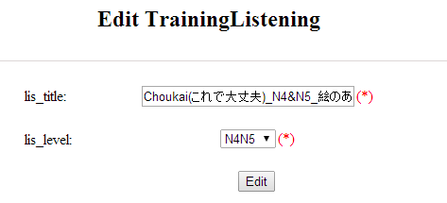

Figure 3-73: Edit listening

|  |  |  |  |  |  |  |
| --- | --- | --- | --- | --- | --- | --- |
| **No** | **Field name** | **Type** | **Require** | **Mandatory** | **Max-Length** | **Description** |
| 1 | Title | Text | Text | Y | 500 | Admin input id with length less than 500 characters |
| 2 | Level | Drop-down list | Choose | Y |  | Admin choose level |
| 3 | Edit | Button | Click | Y |  | Admin edit listening |

Table 3-40: Edit listening’s screen description

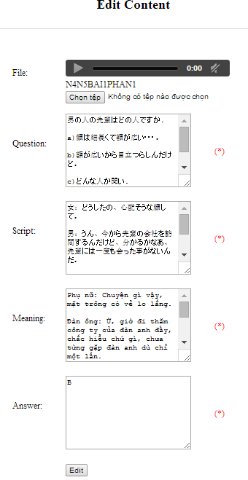

Figure 3-74: Edit listening source file

|  |  |  |  |  |  |  |
| --- | --- | --- | --- | --- | --- | --- |
| **No** | **Field name** | **Type** | **Require** | **Mandatory** | **Max-Length** | **Description** |
| 1 | Source_file | Button | Click | Y |  | Admin choose the file |
| 2 | Question | Text | Text | Y | 5000 | Admin input question of listening with length less than 5000 characters |
| 3 | Script | Text | Text | Y | 5000 | Admin input script of listening with length less than 5000 characters |
| 4 | Meaning | Text | Text | Y | 5000 | Admin input meaning of listening with length less than 5000 characters |
| 5 | Answer | Text | Text | Y | 5000 | Admin input answer of listening with length less than 5000 characters |
| 6 | Edit | Button | Click | Y |  | Admin edit source file |

Table 3-41: Edit listening source file’s screen description

|  |  |  |  |  |
| --- | --- | --- | --- | --- |
| **UC0046 - Specification** | | | | |
| **Use-case No.** | <UC0046> | **Use-case Version** | | <1.0> |
| **Use-case Name** | Edit listening article | | | |
| **Author** | Minh PT | | | |
| **Date** | 09/06/2014 | **Priority** | <High > | |
| **Actor:**  Admin  **Summary:**  When Administrator wants to edit listening article in database which has some new meanings or errors. When edit finished, new meaning will be updated  **Triggers**  User must click on “Listening management” then search for the listening article. User click on “Edit” link corresponding with listening article. They edit necessary information of listening article in the right fields then click on “Edit” button.  **Preconditions:**   * Website is available * User have logged into system as an admin. * All mandatory fields have been filled * All input data must be valid and have not existed in system   **Post Conditions:**  Changed information of listening article has been saved into system database successfully  **Main Success Scenario:**   |  |  |  | | --- | --- | --- | | **Step** | **User** | **System** | | 1 | Have logged into system as an admin |  | | 2 | Click on “Training listening” then search for the listening article that they want to edit | Displays search result as a table | | 3 | Click on “Edit” link corresponding | Display “Edit listening” screen that contains the information of chosen listening article with these elements:   * Title * Level | | 4 | Edit listening article information and click “Edit” button | The system validates the input data and then save data into database | | 5 | Click on “View details/ Edit” link corresponding | Display “Edit listening” screen that contains the information of chosen listening article with these elements:   * File * Question * Script * Meaning * Answer | | 6 | Edit listening article information and click “Edit” button | The system validates the input data and then save data into database |     **Alternative Scenario:**   |  |  |  | | --- | --- | --- | | **At Step** | **User** | **System** | | 4 | Edit listening article then click to another link | Do not save edited data then redirect to selected page | | 6 | Edit listening article then click to another link | Do not save edited data then redirect to selected page |   **Exceptions:**   |  |  |  | | --- | --- | --- | | **At Step** | **User** | **System** | | 4 | Edit listening article to be similar to another existed listening article click “Edit” button | The system validates the input data and return Error message and do not save edited data into database | | 6 | Edit listening article to be similar to another existed listening article click “Edit” button | The system validates the input data and return Error message and do not save edited data into database |   **Reference:**  UC0044- <Admin> Search listening article | | | | |

###### UC047: Delete listening article

|  |  |  |  |  |
| --- | --- | --- | --- | --- |
| **UC0047 - Specification** | | | | |
| **Use-case No.** | <UC0047> | **Use-case Version** | | <1.0> |
| **Use-case Name** | Delete listening article | | | |
| **Author** | Minh PT | | | |
| **Date** | 09/06/2014 | **Priority** | <High > | |
| **Actor:**  Admin  **Summary:**  When Administrator want to delete listening article inn database  **Triggers**  User must click on “Listening article management” then search for the listening article. User click on “Delete” link corresponding with listening article.  **Preconditions:**   * Website is available * User have logged into system as an admin.   **Post Conditions:**  Listening article has been deleted from system database successfully  **Main Success Scenario:**   |  |  |  | | --- | --- | --- | | **Step** | **User** | **System** | | 1 | Have logged into system as an admin |  | | 2 | Click on “Listening article management ” then search for the listening article that they want to delete | Displays search result as a table | | 3 | Click on “Delete” link corresponding | Remove that listening article in database |     **Reference:**  UC0044 - <Admin> Search listening article | | | | |
|  | | | | |

#### Test management

##### Use case diagram

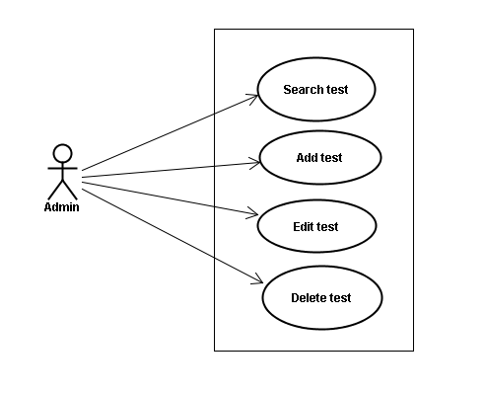

Figure 3-75: Test – Use Case Diagram

##### Screen description

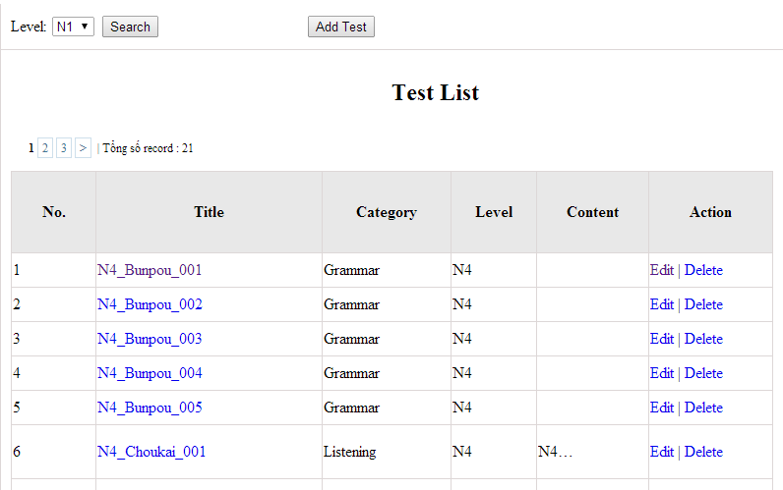

Figure 3-76: Doing test management

|  |  |  |  |  |  |  |
| --- | --- | --- | --- | --- | --- | --- |
| **No** | **Field name** | **Type** | **Require** | **Mandatory** | **Max-Length** | **Description** |
| 1 | Level | Drop-down list | Click | N |  | Admin choose the level |
| 2 | Search | Button | Click | N |  | Admin click to search |
| 3 | List | Hyperlink | Click | N |  | Admin click to view details |
| 4 | Edit | Button | Click | N |  | Admin click edit test |
| 5 | Delete | Button | Click | N |  | Admin click delete test |
| Table 3-42: Doing test management’s screen description | | | | | | |

##### Use case specifications

###### UC048: Search test

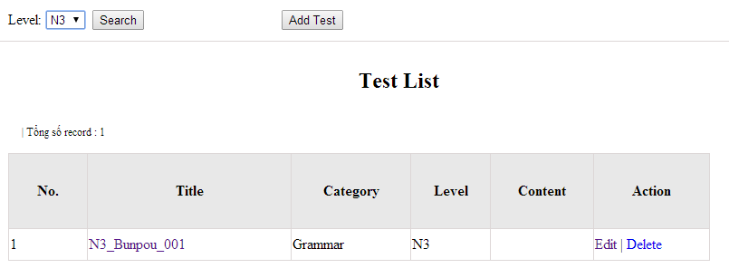

Figure 3-77: Search test

|  |  |  |  |  |
| --- | --- | --- | --- | --- |
| **UC0048 - Specification** | | | | |
| **Use-case No.** | <UC0048> | **Use-case Version** | | <1.0> |
| **Use-case Name** | Search test | | | |
| **Author** | Minh PT | | | |
| **Date** | 09/06/2014 | **Priority** | <High > | |
| **Actor:**  Admin  **Summary:**  When Administrator wants to search test article in database. User choose test level then click “Search” button.  **Triggers**  Click on “Test management” tab, choose level in the right text box then click “Search” button  **Preconditions:**   * Website is available * User has to login as Administrator * User has to input data in search area   **Post Conditions:**  Display detail information of that test  **Main Success Scenario:**   |  |  |  | | --- | --- | --- | | **Step** | **User** | **System** | | 1 | Have logged into system as an admin |  | | 2 | Click on “Test management” tab | Displays criteria search screen | | 3 | Choose level of the test that they want to find then click “Search” button | Displays search result as a table with these elements:   * No * Title * Category * Level * Content * Edit * Delete |     **Alternative Scenario:**   |  |  |  | | --- | --- | --- | | **At Step** | **User** | **System** | | 3 | Choose level of the test that they want to find into these fields then click on another link | Switch to selected page |   **Exceptions:**   |  |  |  | | --- | --- | --- | | **At Step** | **User** | **System** | | 3 | Choose level of the test that they want to find (that do not exited in database) into these fields then click “Search” button | Return Error message to inform that test cannot be found | | | | | |

###### UC049: Add test

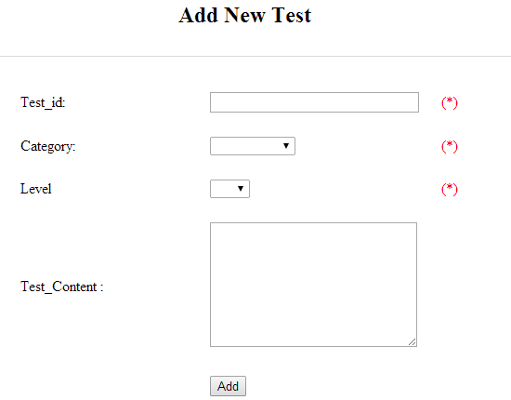

Figure 3-78: Add test

|  |  |  |  |  |  |  |
| --- | --- | --- | --- | --- | --- | --- |
| **No** | **Field name** | **Type** | **Require** | **Mandatory** | **Max-Length** | **Description** |
| 1 | ID | Text | Text | Y | 100 | Admin input id with length less than 100 characters |
| 2 | Category | Drop-down list | Click | Y |  | Admin choose category |
| 3 | Level | Drop-down list | Click | Y |  | Admin choose level of test |
| 4 | Test content | Text | Text | Y | 5000 | Admin input content with length less than 5000 characters |
| 5 | Add | Button | Click | Y |  | Admin click to add test |
| Table 3-43: Add test’s screen description | | | | | | |

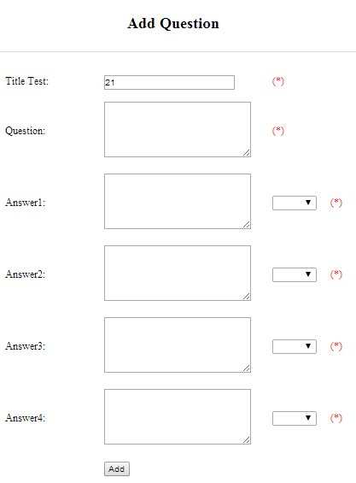

Figure 3-78: Add question

|  |  |  |  |  |  |  |
| --- | --- | --- | --- | --- | --- | --- |
| **No** | **Field name** | **Type** | **Require** | **Mandatory** | **Max-Length** | **Description** |
| 1 | Question | Text | Text | Y | 200 | Admin input question with length less than 200 characters |
| 2 | Answer 1 | Text | Text | Y | 200 | Admin input answer 1 with length less than 200 characters |
| 3 | Correct answer 1 | Drop-down list | Click | Y |  | Admin choose correct answer |
| 4 | Answer 2 | Text | Text | Y | 200 | Admin input answer 2 with length less than 200 characters |
| 5 | Correct answer 2 | Drop-down list | Click | Y |  | Admin choose correct answer |
| 6 | Answer 3 | Text | Text | Y | 200 | Admin input answer 3 with length less than 200 characters |
| 7 | Correct answer 3 | Drop-down list | Click | Y |  | Admin choose correct answer |
| 8 | Answer 4 | Text | Text | Y | 200 | Admin input answer 4 with length less than 200 characters |
| 9 | Correct answer 4 | Drop-down list | Click | Y |  | Admin choose correct answer |
| 10 | Add | Button | Click | Y |  | Admin click to add |

Table 3-44: Add question’s screen description

|  |  |  |  |  |
| --- | --- | --- | --- | --- |
| **UC0049 - Specification** | | | | |
| **Use-case No.** | <UC0049> | **Use-case Version** | | <1.0> |
| **Use-case Name** | Add test | | | |
| **Author** | Minh PT | | | |
| **Date** | 09/06/2014 | **Priority** | <High > | |
| **Actor:**  Admin  **Summary:**  When Administrator want to add new test into database. They have to insert all necessary data of test into “Add new test” screen  **Triggers**  User must click on “Test management/ Add New” and input all necessary information of test into the right fields then click on “Add” button  **Preconditions:**   * Website is available * User have logged into system as an admin. * All mandatory fields have been filled * All input data must be valid and have not existed in system   **Post Conditions:**  New test has been saved into system database successfully  **Main Success Scenario:**   |  |  |  | | --- | --- | --- | | **Step** | **User** | **System** | | 1 | Have logged into system as an admin |  | | 2 | Click on “Test management/Add New” | Display “Add New Test” screen that contains these elements:   * Title * Category * Level * Content | | 3 | Fill test information into all necessary or mandatory fields and click “Add” button | The system validates the input data and then save new test data into database | | 4 | Click on “Title link/Add new question” | Display “Add New Question” screen that contains these elements:   * Title * Question * Answer 1 * Correct answer 1 * Answer 2 * Correct answer 2 * Answer 3 * Correct answer 3 * Answer 4 * Correct answer 4 | | 5 | Fill test information into all necessary or mandatory fields and click “Add” button | The system validates the input data and then save new test data into database |     **Alternative Scenario:**   |  |  |  | | --- | --- | --- | | **At Step** | **User** | **System** | | 3 | Click on another link | Do not save new test data into database then redirect to selected page | | 5 | Click on another link | Do not save new question data into database then redirect to selected page |   **Exceptions:**   |  |  |  | | --- | --- | --- | | **At Step** | **User** | **System** | | 3 | Do not fill full information into fields then click “Add” button | Return Error message and request user input data into all fields | | 5 | Do not fill full information into fields then click “Add” button | Return Error message and request user input data into all fields | | | | | |

###### UC050: Edit test

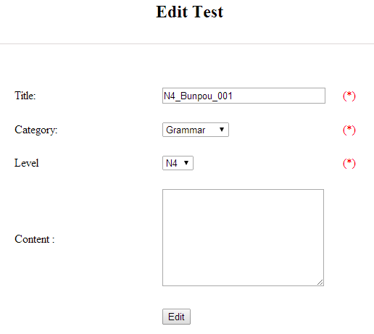

Figure 3-79: Edit test

|  |  |  |  |  |  |  |
| --- | --- | --- | --- | --- | --- | --- |
| **No** | **Field name** | **Type** | **Require** | **Mandatory** | **Max-Length** | **Description** |
| 1 | ID | Text | Text | Y | 100 | Admin input id with length less than 100 characters |
| 2 | Category | Drop-down list | Click | Y |  | Admin choose category |
| 3 | Level | Drop-down list | Click | Y |  | Admin choose level of test |
| 4 | Test content | Text | Text | Y | 5000 | Admin input content with length less than 5000 characters |
| 5 | Edit | Button | Click | Y |  | Admin click to edit test |

Table 3-45: Edit test’s screen description

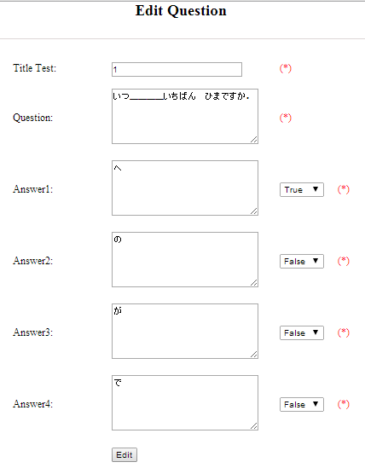

Figure 3-80: Edit question

|  |  |  |  |  |  |  |
| --- | --- | --- | --- | --- | --- | --- |
| **No** | **Field name** | **Type** | **Require** | **Mandatory** | **Max-Length** | **Description** |
| 1 | Question | Text | Text | Y | 200 | Admin input question with length less than 200 characters |
| 2 | Answer 1 | Text | Text | Y | 200 | Admin input answer 1 with length less than 200 characters |
| 3 | Correct answer 1 | Drop-down list | Click | Y |  | Admin choose correct answer |
| 4 | Answer 2 | Text | Text | Y | 200 | Admin input answer 2 with length less than 200 characters |
| 5 | Correct answer 2 | Drop-down list | Click | Y |  | Admin choose correct answer |
| 6 | Answer 3 | Text | Text | Y | 200 | Admin input answer 3 with length less than 200 characters |
| 7 | Correct answer 3 | Drop-down list | Click | Y |  | Admin choose correct answer |
| 8 | Answer 4 | Text | Text | Y | 200 | Admin input answer 4 with length less than 200 characters |
| 9 | Correct answer 4 | Drop-down list | Click | Y |  | Admin choose correct answer |
| 10 | Edit | Button | Click | Y |  | Admin click to edit |

Table 3-46: Edit question’s screen description

|  |  |  |  |  |
| --- | --- | --- | --- | --- |
| **UC0050 - Specification** | | | | |
| **Use-case No.** | <UC0050> | **Use-case Version** | | <1.0> |
| **Use-case Name** | Edit test | | | |
| **Author** | Minh PT | | | |
| **Date** | 09/06/2014 | **Priority** | <High > | |
| **Actor:**  Admin  **Summary:**  When Administrator want to edit test in database that has some new meanings or errors. When edit finished, new meaning will be updated  **Triggers**  User must click on “Test management” then search for the test. User click on “Edit” link on corresponding test. User edits necessary information of test in the right fields then click on “Edit” button.  **Preconditions:**   * Website is available * User have logged into system as an admin. * All mandatory fields have been filled * All input data must be valid and have not existed in system   **Post Conditions:**  Changed information of test has been saved into system database successfully  **Main Success Scenario:**   |  |  |  | | --- | --- | --- | | **Step** | **User** | **System** | | 1 | Have logged into system as an admin |  | | 2 | Click on “Test management ” then search for the test that they want to edit | Displays search result as a table | | 3 | Click on “Edit” link corresponding | Display “Edit Test” screen that contains the information of chosen test with these elements:   * Title * Category * Level * Content | | 4 | Edit test information and click “Edit” button | The system validates the input data and then save data into database |     **Alternative Scenario:**   |  |  |  | | --- | --- | --- | | **At Step** | **User** | **System** | | 4 | Edit test then click to another link | Do not save edited data then redirect to selected page |   **Exceptions:**   |  |  |  | | --- | --- | --- | | **At Step** | **User** | **System** | | 4 | Edit test to be similar to another existed test and click “Edit” button | The system validates the input data and return Error message and do not save edited data into database |   **Reference:**  UC0048- <Admin> Search test | | | | |

###### UC051: Delete test

|  |  |  |  |  |
| --- | --- | --- | --- | --- |
| **UC0051 - Specification** | | | | |
| **Use-case No.** | <UC0051> | **Use-case Version** | | <1.0> |
| **Use-case Name** | Delete test | | | |
| **Author** | Minh PT | | | |
| **Date** | 09/06/2014 | **Priority** | <High > | |
| **Actor:**  Admin  **Summary:**  When Administrator want to delete test in database  **Triggers**  User must click on “Test management” then search for the test. User click on “Delete” link corresponding with test.  **Preconditions:**   * Website is available * User have logged into system as an admin.   **Post Conditions:**  Test has been deleted from system database successfully  **Main Success Scenario:**   |  |  |  | | --- | --- | --- | | **Step** | **User** | **System** | | 1 | Have logged into system as an admin |  | | 2 | Click on “Test management ” then search for the test that they want to delete | Displays search result as a table | | 3 | Click on “Delete” link corresponding | Remove that test in database |     **Reference:**  UC0048 - <Admin> Search test | | | | |
|  | | | | |

#### Contact management

##### Use case diagram

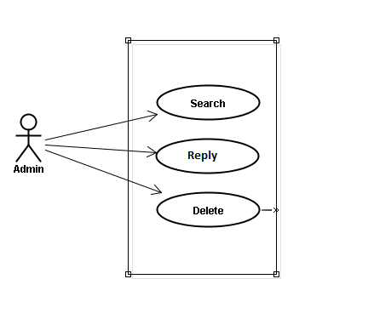

Figure 3-81: Contact – Use Case Diagram

##### Use case specifications

###### UC052: Search question

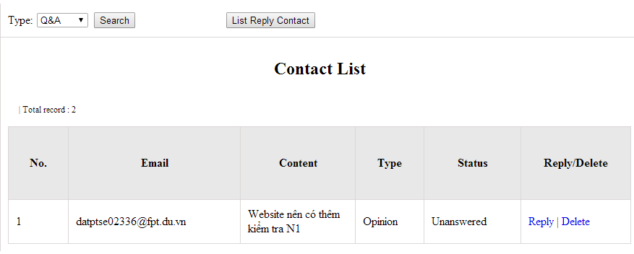

Figure 3-82: Search contact management’s screen

|  |  |  |  |  |  |  |
| --- | --- | --- | --- | --- | --- | --- |
| **No** | **Field name** | **Type** | **Require** | **Mandatory** | **Max-Length** | **Description** |
| 1 | Type | Drop-down list | Click | N |  | Admin choose the typ |
| 2 | Search | Button | Click | N |  | Admin click to search |
| 3 | Reply | Button | Click | N |  | Admin click reply the question |
| 4 | Delete | Button | Click | N |  | Admin click delete question |
| 5 | List reply | Button | Click | N |  | Admin click to view list reply |

Table 3-47: Search contact management’s screen description

|  |  |  |  |  |
| --- | --- | --- | --- | --- |
| **UC0052 – Specification** | | | | |
| **Use-case No.** | <UC0052> | **Use-case Version** | | <1.0> |
| **Use-case Name** | Search question | | | |
| **Author** | Minh PT | | | |
| **Date** | 09/06/2014 | **Priority** | <High > | |
| **Actor:**  Admin  **Summary:**  When administrator wants to search question from member. User choose data then click “Search” button.  **Triggers**  Click on “Contact Management ” tab, choose type of data in the right text box then click “Search” button  **Preconditions:**   * Website is available * User has to login as Administrator * User has to input data in search area   **Post Conditions:**  Display detail information of question  **Main Success Scenario:**   |  |  |  | | --- | --- | --- | | **Step** | **User** | **System** | | 1 | Have logged into system as an admin |  | | 2 | Click on “Contact Management ” tab | Displays criteria search screen | | 3 | Choose type of contact that they want to find then click “Search” button | Displays search result as a table with these elements:   * No * Email * Content * Type * Status * Reply * Delete |     **Alternative Scenario:**   |  |  |  | | --- | --- | --- | | **At Step** | **User** | **System** | | 3 | Fill information that they want to find into these fields then click on another link | Switch to selected page |   **Exceptions:**   |  |  |  | | --- | --- | --- | | **At Step** | **User** | **System** | | 3 | Fill information that they want to find (that do not exited in database) into these fields then click “Search” button | Return Error message to inform that cannot be found | | | | | |

###### UC053: Reply question

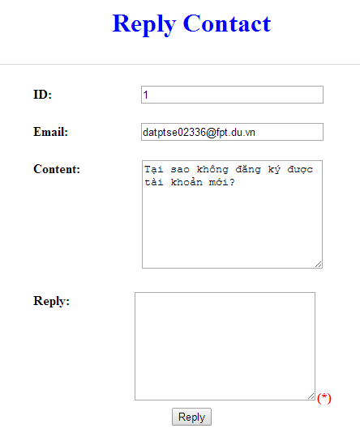

Figure 3-83: Reply contact

|  |  |  |  |  |  |  |
| --- | --- | --- | --- | --- | --- | --- |
| **No** | **Field name** | **Type** | **Require** | **Mandatory** | **Max-Length** | **Description** |
| 1 | Email | Text | Text | Y |  | Email of admin’s account |
| 2 | Content | Text | Text | Y |  | Question |
| 3 | Reply | Text | Text | Y |  | Admin input reply of question |
| 4 | Reply | Button | Click | N |  | Admin click send reply question |

Table 3-48: Reply contact’s screen description

|  |  |  |  |  |
| --- | --- | --- | --- | --- |
| **UC0053 - Specification** | | | | |
| **Use-case No.** | <UC0053> | **Use-case Version** | | <1.0> |
| **Use-case Name** | Reply question | | | |
| **Author** | Minh PT | | | |
| **Date** | 09/06/2014 | **Priority** | <High > | |
| **Actor:**  Admin  **Summary:**  When administrator wants to reply question from member.  **Triggers**  Click on “Opinion/Q&A Management ” tab, User search question then click “Reply” link corresponding  **Preconditions:**   * Website is available * User has to login as Administrator * User has to input answer   **Post Conditions:**  Answer be sent to user  **Main Success Scenario:**   |  |  |  | | --- | --- | --- | | **Step** | **User** | **System** | | 1 | Have logged into system as an admin |  | | 2 | Click on “Opinion/Q&A Management ” tab | Displays criteria search screen | | 3 | Click “Reply” link corresponding | Displays Reply screen with these elements:   * Email * Content * Reply | | 4 | Input the answer and click “Reply” button | The answer of question will be sent to member |     **Alternative Scenario:**   |  |  |  | | --- | --- | --- | | **At Step** | **User** | **System** | | 4 | Input answer then click on another link | Switch to selected page |   **Exceptions:**   |  |  |  | | --- | --- | --- | | **At Step** | **User** | **System** | |  |  |  |   **Reference:**  UC0052 - < Opinion/Q&A Management > Search question | | | | |

###### UC054: Delete question

|  |  |  |  |  |
| --- | --- | --- | --- | --- |
| **UC0054 - Specification** | | | | |
| **Use-case No.** | <UC0054> | **Use-case Version** | | <1.0> |
| **Use-case Name** | Delete question | | | |
| **Author** | Minh PT | | | |
| **Date** | 09/06/2014 | **Priority** | <High > | |
| **Actor:**  Admin  **Summary:**  When Administrator want to delete question  **Triggers**  User must click on “Contact management” then search for the test. User click on “Delete” link corresponding with test.  **Preconditions:**   * Website is available * User have logged into system as an admin.   **Post Conditions:**  Question has been deleted from system database successfully  **Main Success Scenario:**   |  |  |  | | --- | --- | --- | | **Step** | **User** | **System** | | 1 | Have logged into system as an admin |  | | 2 | Click on “Contact management ” then search for the test that they want to delete | Displays search result as a table | | 3 | Click on “Delete” link corresponding | Remove that test in database |     **Reference:**  UC0052 - <Admin> Search contact | | | | |
|  | | | | |

#### Contributed content management

##### Use case diagram

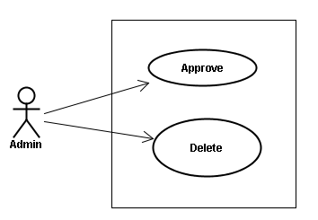

Figure 3-84: Contributed Content – Use Case Diagram

##### Use case specifications

###### UC055 <Contact’s content Management>: Approve contribute content

**Approve contribute content screen:**

1. Approve contribute kanji screen:

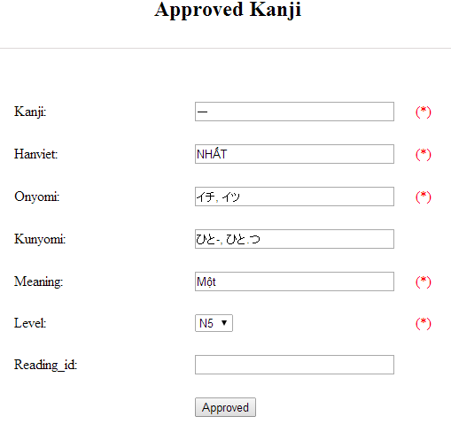

Figure 3-84: Approved kanji’s screen

|  |  |  |  |  |  |  |  |
| --- | --- | --- | --- | --- | --- | --- | --- |
| **No** | **Field name** | **File name in Vietnamese** | **Type** | **Require** | **Mandatory** | **Max-Length** | **Description** |
| 1 | Kanji | Kanji | Text | Text | Y | 10 | Admin input kanji with length less than 10 characters |
| 2 | HanViet | Hán Việt | Text | Text | N | 50 | Admin input to the field with length less than 50 characters |
| 3 | Onyomi | Âm Onyomi | Text | Text | Y | 100 | Admin input onyomi with length less than 100 characters |
| 4 | Kunyomi | Âm kunyomi | Text | Text | Y | 100 | Admin input kunyomi with length less than 100 characters |
| 5 | Meaning | Nghĩa | Text | Text | Y | 200 | Admin input meaning with length less than 200 characters |
| 6 | Level | Level | Drop-down list | Click | Y |  | Admin choose the level |
| 7 | Reading_id |  | Text | Text | N | 20 | Admin input reading id with length less than 20 characters |
| 8 | Approved | Approved | Button | Click | Y |  | Admin click to approved contribute |

Table 3-49: Approved kanji’s screen description

1. Approve contribute grammar screen:

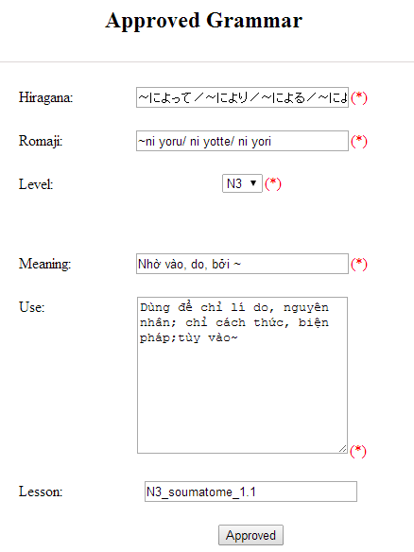

Figure 3-85: Approved grammar screen

|  |  |  |  |  |  |  |
| --- | --- | --- | --- | --- | --- | --- |
| **No** | **Field name** | **Type** | **Require** | **Mandatory** | **Max-Length** | **Description** |
| 1 | Hiragana | Text | Text | Y | 200 | Admin input hiragana with length less than 200 characters |
| 2 | Romaji | Text | Text | Y | 200 | Admin input romaji with length less than 200 characters |
| 3 | Meaning | Text | Text | Y | 200 | Admin input meaning with length less than 200 characters |
| 4 | Level | Drop-down list | Click | Y |  | Admin choose the level |
| 5 | Use | Text | Text | Y | 1000 | Admin input how to use with length less than 1000 characters |
| 6 | Lesson | Text | Text | N | 20 | Admin input lesson with length less than 20 characters |
| 7 | Approved | Button | Click | Y |  | Admin click to approved contribute |

Table 3-50: Approved grammar’s screen description

1. Approve contribute vocabulary screen:

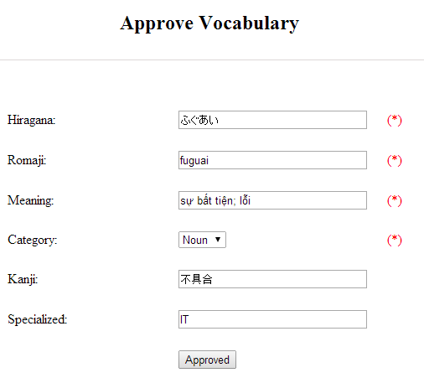

Table 3-86: Approved vocabulary

|  |  |  |  |  |  |  |
| --- | --- | --- | --- | --- | --- | --- |
| **No** | **Field name** | **Type** | **Require** | **Mandatory** | **Max-Length** | **Description** |
| 1 | Hiragana | Text | Text | Y | 200 | Admin input hiragana with length less than 200 characters |
| 2 | Romaji | Text | Text | N | 200 | Admin input romaji with length less than 200 characters |
| 3 | Meaning | Text | Text | Y | 500 | Admin input meaning with length less than 500 characters |
| 4 | Category | Drop-down list | Click | Y | 10 | Admin choose category |
| 5 | Kanji | Text | Text | N | 10 | Admin input kanji with length less than 10 characters |
| 6 | Specialized | Text | Text | N | 200 | Admin input specialized with length less than 200 characters |
| 7 | Approved | Button | Click | Y |  | Admin click to approved contribute |

Table 3-51: Approved vocabulary’s screen description

|  |  |  |  |  |
| --- | --- | --- | --- | --- |
| **UC0055 - Specification** | | | | |
| **Use-case No.** | <UC0055> | **Use-case Version** | | <1.0> |
| **Use-case Name** | Approve contribute content | | | |
| **Author** | Minh PT | | | |
| **Date** | 09/06/2014 | **Priority** | <High > | |
| **Actor:**  Admin  **Summary:**  When administrator wants to approve contribute content include kanji, grammar, vocabulary in database. User click on link corresponding with kanji, grammar, vocabulary  **Triggers**  Click on “Contribute Kanji Management” or “Contribute Grammar Management” or “Contribute Vocabulary Management” tab, input data in the right text box then click “Search” button. Click on link corresponding with kanji, grammar, vocabulary which want to approve to database  **Preconditions:**   * Website is available * User has to login as Administrator * All mandatory fields have been filled * All input data must be valid and have not existed in system   **Post Conditions:**  Display detail information of contribute content  **Main Success Scenario:**   |  |  |  | | --- | --- | --- | | **Step** | **User** | **System** | | 1 | Have logged into system as an admin |  | | 2 | Click on “Kanji Management/List contribute kanji” or “Grammar Management/List contribute grammar” or “Vocabulary/List contribute vocabulary” tab | Displays criteria search screen | | 3 | Fill information that they want to find into text box then click “Search” button | Displays search result | | 4 | Click “Approved” link corresponding want to update into database | Display Approve kanji screen with these elements:   1. Kanji - Kanji - Âm hán - Âm Onyomi - Âm Kunyoumi - Meaning - level - Reading_id - Approved 2. Grammar: - Hiragana - Romaji - Level - Meaning - Use - Lesson - Approved 3. Vocabulary: - Hiragana - Romaji - Meaning - Category - Kanji - Specialized - Approved | | 5 | Edit or add more information and Click “Approved” button | The system validates the input data and then save data into database |     **Alternative Scenario:**   |  |  |  | | --- | --- | --- | | **At Step** | **User** | **System** | | 5 | Fill information then click on another link | Switch to selected page |   **Exceptions:**   |  |  |  | | --- | --- | --- | | **At Step** | **User** | **System** | | 5 | Fill information that exited in database into fields then click “Approved” button | Return Error message to inform that data is exiting in database |   **Reference:** | | | | |

###### UC0056: < Contact’s content Management > Delete contribute content

|  |  |  |  |  |
| --- | --- | --- | --- | --- |
| **UC0056- Specification** | | | | |
| **Use-case No.** | <UC0056> | **Use-case Version** | | <1.0> |
| **Use-case Name** | Delete contribute content | | | |
| **Author** | Minh PT | | | |
| **Date** | 09/06/2014 | **Priority** | <High > | |
| **Actor:**  Admin  **Summary:**  When Administrator wants to delete a contribute content. Admin will search that content then click “Delete” link corresponding.  **Triggers:**  User must click on “Contribute Kanji Management” or “Contribute Grammar Management” or “Contribute Vocabulary Management” tab then search for the contribute content. User click on “Delete” link corresponding with kanji, grammar, vocabulary which want to delete.  **Preconditions:**   * Website is available * User has to login as Administrator   **Post Conditions:**  Kanji, grammar, vocabulary have been deleted from list successfully  **Main Success Scenario:**   |  |  |  | | --- | --- | --- | | **Step** | **User** | **System** | | 1 | Have logged into system as an admin |  | | 2 | Click on “Contribute Kanji Management ” or “Contribute Grammar Management ” or “Contribute Vocabulary Management ” tab | Displays search result as a table | | 3 | Click on “Delete” link corresponding with kanji, grammar, vocabulary | Remove that kanji, grammar, vocabulary from list |   **Reference:** | | | | |
|  | | | | |

### Non-Functional Specification Requirements

#### Reliability

- Mean time between failures: The mean time between each failure is expected to be about 480 hours of using.

- The maximum bugs per function are 2 bugs/a function when user uses software within 2 months. The average number of bugs in the software during system testing is about to be around 1 bugs/1000 LOC.

- The database must be backed up daily and can be recovered if necessary

#### Performance Requirements

##### Availability

The application must be available 95% of time. Users can access to it everywhere from their

Web browser with internet connection.

##### Response time

In term of response time, waiting time of processing will be 2 to 5 seconds; time to process any functions will not exceed 7 seconds.

#### User Interface

* **Color:** The background color will be white and blue in default. The color of text will be black or white.
* **Text:** All texts bases on Helvetica style and title or label will use upper case with the first letter.

#### Maintainability

* **Coding standards and naming conventions**
  + Output of the project must include coding standards and naming conventions documentations. Implementation code must be easy to maintain.
  + All code must be clearly commented, including class, method documentations.
  + If some components are reused, the documentations of those components must also be included.
* **Design**
  + The design of the system must be loosely coupled that chances on some module will not affect others.
* **Logging**
  + All the errors should be logged, supporting for bug fixing and maintenance.
  + All strange or sensitive situations should also be logged.
* **Mean time to repair:** Immediately when Administrator finds out problem or website is attacked/hacked by someone. Average 1 day.

#### Usability

Usability Requirements support the following from the perspective of its primary users:

● **Efficiency of use:** user can complete each function in less than 12 actions

● **Intuitiveness:** all help/error messages are simple to understand; user can know exactly how to do each feature after one time using it.

#### Security Requirements

In order to avoid unwanted access by strangers, the security implemented in various ways:

* **User layer**: Each function must be distributed system access and manipulate the individual parts. To edit information, user must declare their username and password before the operation. Functions will be show after users login dependencies user’s role and permission of each user.
* **Manage Data Layer**: Only Administrator can modify database system.
* **Stored Data**: All data about information of user, tested, etc… will be saved in My SQL Server, and be easy for data classification or backup.

#### Hardware/Software Requirements

● **Hardware requirement:** PC/Laptop (window 7, window 8, window XP…)

● **Software requirements:** Web browser (Chrome, Firefox, IE…) with internet connection

# Software Design Description

### SDD Overview

This document provides a comprehensive architectural overview of the system UJD_VN, using a number of different architectural views to depict different aspects of the system. It is intended to capture and convey the significant architectural decisions that have been made on the system.

The system of UJD is structured based on MVC combined with layered architecture and Codeigniter framework.

Developers and testers will base on this design to develop source code and perform tests.

This section of document is the **software design description** of the project in order to develop the software, it includes four main parts: Architecture Design, Class Design, Detail Design, and Database design.

## Architecture Design

### MVC Model

The purpose of UJD is developing a web application that supports users about Japanese. The system of UJD is structured based on MVC combined with layered architecture and Codeigniter framework

#### ****MVC Model overview****

MVC is a software architecture pattern that separates the representation of information from user’s interaction with it. The model consists of application data, business rules, logic and functions. A view can be any output representation of data, such as a chart or a diagram. Multiple views of the same data are possible, such as bar chart for management and a tabular view for accountants. The controller mediates input, converting it to commands for the model or view.

The Model-View-Controller (MVC) design pattern assigns objects in an application one of three roles: model, view, or controller. The pattern defines not only the roles objects play in the application, it defines the way objects communicate with each other. Each of the three types of objects is separated from the others by abstract boundaries and communicates with objects of the other types across those boundaries. The collection of objects of a certain MVC type in an application sometimes referred to as a layer—for example, model layer.



Figure 4-1: MVC Model

In addition to dividing the application into three kinds of components, the MVC design defines the interactions between them:

* **A controller:** can send commands to its associated view to change the view's presentation of the model (e.g., by scrolling through a document). It can also send commands to the model to update the model's state (e.g., editing a document).
* **A model:** notifies its associated views and controllers when there has been a change in its state. This notification allows the views to produce updated output, and the controllers to change the available set of commands. A passive implementation of MVC omits these notifications, because the application does not require them or the software platform does not support them.
* **A view:** requests from the model the information that it needs to generate an output representation to the user.

#### ****Advantages and disadvantages of MVC model****

* Advantages:
* The MVC model demonstrates professionalism in programming and design analysis. It is divided into independent components to help develop applications faster, simpler, easier upgrades and maintenance.
* Many MVC vendor framework tool kits are available.
* Multiple views synchronized with same data model.
* Easy to change or plug in new interface views, allowing updating of interface views with new technologies without overhauling the rest of system.
* Very effective for deployment if graphic, programming and database development professionals are working in a team in a designed project.
* Disadvantages:
* For small projects that apply MVC model caused cumbersome, time consuming in development process.
* Time consuming to transits data between components.
* Not suitable for agent-oriented applications such as interactive mobile and robotics applications.
* Multiple pairs of controllers and views based on the same data model make data model change expensive.
* The division between the View and the Controller is not clear in some cases.

#### ****The reason of choosing MVC model****

- Easily manage the complexity of application by dividing the application into three components: model, view and controller.

- Better support for test-driven development.

- It is good support for application built by project team has many developers and designers but still managed application features.

- UJD system is not complete system, now. We built the system that towards extensibility and maintainability in the future.

### Codeigniter

#### ****Codeigniter overview****

CodeIgniter is an open source rapid development web application framework, for use in building dynamic web sites with PHP. CodeIgniter is loosely based on the popular MVC development pattern. While view and controller classes are a necessary part of development under CodeIgniter, models are optional.

#### ****Advantages and disadvantages of Codeigniter****

* Advantages:
* Designed according to the MVC Model
* CodeIgniter is a PHP framework have the fast speed
* CodeIgniter provides libraries cater to the most common tasks in web programming, such as database access, email, data checking, session management, image processing ... to the high function as XML-RPC, encryption, security ...
* Mechanism test data is closely, preventing XSS and SQL Injection of CodeIgniter helps minimize the security risk to the system.
* Disadvantages:
* No supports about some common module
* No supports about AJAX
* No support about **Event-Driven Programming**

#### ****The reason of choosing Codeigniter****

- Consistent with UJD system.

- Some modules need to reuse shared business logic layer.

- Designed according to the MVC Model.

### Architectural Representation

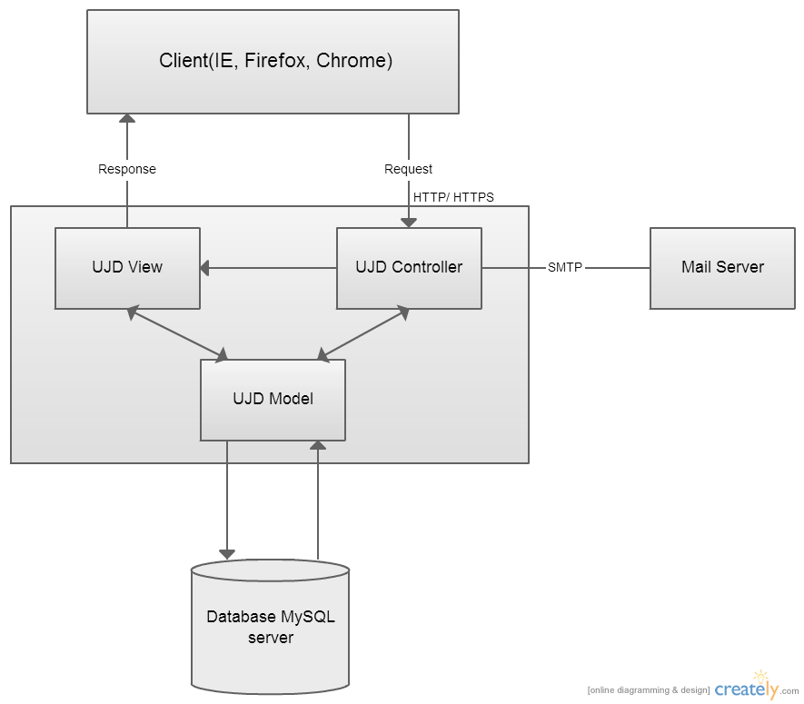

Figure 4-2: System overview

We follow MVC architecture to implement the UJD_VN Project. MVC offers architectural benefits over standard JavaScript — it helps us write better-organized and therefore more maintainable code.

**Model** is where the application’s data objects are stored. A model object is in charge of encapsulating application state and one object could be related to other objects establishing a one-to-one or one-to-many relationship. The model object does not talk directly to a View, instead is made available to a controller, which accesses it when needed. When a model changes, typically it will notify its observers that a change has occurred. As with any data object it contains instance variables and getter/setter methods.

**View** is what is presented to the users and how users interact with the system. The view is expected to render the model in a meaningful way to the user. In UJD, the view is made with .cshtml file including css, JavaScript or jQuery, it sends user gestures to controller and allows controller to select view.

**Controller** is the decision maker and the glue between the model and view; it handles user actions and gestures, and responds to user events. For example, in CMS, when a user clicks the “Create” button to create a new contract, the controller for that action is invoked.

The controller will then make changes to the contract model. The view will then render the modified contract model to the display so that user can view the new contract he added in the contract list.

### Architecture Goals and Constraints

**Availability:** The application must be available 95% of time. Users can access to it everywhere from there .Web browser with internet connection.

**Maintainability:**

* Coding standards and naming conventions
  + Output of the project must include coding standards and naming conventions documentations. Implementation code must be easy to maintain.
  + All code must be clearly commented, including class, method documentations.
  + If some components are reused, the documentations of those components must also be included.
* Design
  + The design of the system must be loosely coupled that chances on some module will not affect others.
* Logging
  + All the errors should be logged, supporting for bug fixing and maintenance.
  + All strange or sensitive situations should also be logged.

**Usability:** Usability Requirements support the following from the perspective of its primary users:

* Efficiency of use**:** user can complete each function in less than 12 actions
* Intuitiveness**:** all help/error messages are simple to understand; user can know exactly how to do each feature after one time using it.

**Capacity and scalability:** throughput, storage and growth requirements.

### Use-Case View

This application includes two parts:

* The first part is User module. User module includes member and visitor.
* Next part is Admin module. In admin side includes admin to manage vocabulary, grammar, video, test, train listening, reading document and manage member’s account.

#### User module

##### ****Common module****



Figure 4-3: Common module

|  |  |  |  |
| --- | --- | --- | --- |
| **No.** | **Use-case name** | **Actor** | **Description** |
| 1 | Search sentences | Member and Visitor | Search for example sentences |
| 2 | Search conversation | Member and Visitor | Search for conversations |
| 3 | Search grammar | Member and Visitor | Search for grammar |
| 4 | Search video | Member and Visitor | Search for video of Japanese |
| 5 | Search specialized Japanese | Member and Visitor | Search for Japanese specialized |

##### ****Account management module****



Figure 4-4: Account management

|  |  |  |  |
| --- | --- | --- | --- |
| **No.** | **Use-case name** | **Actor** | **Description** |
| 1 | Login | Member | Login to system |
| 2 | Logout | Member | Logout |
| 3 | Edit profile | Member | Edit member’s profile |
| 4 | Forgot password | Member | Forgot password |
| 5 | Register account | Member | Register account for customers to use more features of the website |

##### Contact admin module



Figure 4-5: Contact admin

|  |  |  |  |
| --- | --- | --- | --- |
| No. | Use-case name | Actor | Description |
| 1 | Contribute content | Member and Visitor | Contribute useful database for website |
| 2 | Contribute opinion | Member and Visitor | Feedback for website development |
| 3 | Send Q&A | Member and Visitor | Send any questions in the process of using Website |

##### Practice module



Figure 4-6: Practice Use Case

|  |  |  |  |
| --- | --- | --- | --- |
| **No.** | **Use-case name** | **Actor** | **Description** |
| 1 | Doing test | Member | Doing test and tracking the learning process |
| 2 | Training listening | Member and Visitor | Training listening level N2,N3,N4 |
| 3 | Listening conversation | Member and Visitor | Listening conversation |
| 4 | Reading document | Member and Visitor | Reading document |

#### Admin module

##### Admin account management



Figure 4-7: Admin account management

|  |  |  |  |
| --- | --- | --- | --- |
| **No.** | **Use-case name** | **Actor** | **Description** |
| 1 | Add new admin | Admin | Add new admin |
| 2 | Edit profile (admin) | Admin | Edit profile admin |
| 3 | Delete admin | Admin | Delete admin |

##### Member account management



Figure 4-8: Member account management

|  |  |  |  |
| --- | --- | --- | --- |
| **No.** | **Use-case name** | **Actor** | **Description** |
| 1 | Search member | Admin | Search member |
| 2 | Ban/Unban member | Admin | Ban/Unban member |
| 3 | Delete admin | Admin | Delete member |

##### Vocabulary management



Figure 4-9: Vocabulary management

|  |  |  |  |
| --- | --- | --- | --- |
| **No.** | **Use-case name** | **Actor** | **Description** |
| 1 | Search vocabulary | Admin | Search vocabulary |
| 2 | Add vocabulary | Admin | Add new vocabulary |
| 3 | Edit vocabulary | Admin | Edit vocabulary |
| 4 | Delete vocabulary | Admin | Delete vocabulary |

##### Grammar management



Figure 4-10: Grammar management

|  |  |  |  |
| --- | --- | --- | --- |
| **No.** | **Use-case name** | **Actor** | **Description** |
| 1 | Search grammar | Admin | Search grammar |
| 2 | Add grammar | Admin | Add new grammar |
| 3 | Edit grammar | Admin | Edit grammar |
| 4 | Delete grammar | Admin | Delete grammar |

##### Reading document management



Figure 4-11: Reading document management

|  |  |  |  |
| --- | --- | --- | --- |
| **No.** | **Use-case name** | **Actor** | **Description** |
| 1 | Search reading document | Admin | Search reading document |
| 2 | Add reading document | Admin | Add new reading document |
| 3 | Edit reading document | Admin | Edit reading document |
| 4 | Delete document | Admin | Delete document |

##### Conversation management



Figure 4-12: Conversation management

|  |  |  |  |
| --- | --- | --- | --- |
| **No.** | **Use-case name** | **Actor** | **Description** |
| 1 | Search conversation | Admin | Search conversation |
| 2 | Add conversation | Admin | Add new conversation |
| 3 | Edit conversation | Admin | Edit conversation |
| 4 | Delete conversation | Admin | Delete conversation |

##### Video management



Figure 4-13: Video management

|  |  |  |  |
| --- | --- | --- | --- |
| **No.** | **Use-case name** | **Actor** | **Description** |
| 1 | Search video | Admin | Search video |
| 2 | Add video | Admin | Add new video |
| 3 | Edit video | Admin | Edit video |
| 4 | Delete video | Admin | Delete video |

##### Training listening management



Figure 4-14: Training listening management

|  |  |  |  |
| --- | --- | --- | --- |
| **No.** | **Use-case name** | **Actor** | **Description** |
| 1 | Search listening | Admin | Search listening |
| 2 | Add listening | Admin | Add new listening |
| 3 | Edit listening | Admin | Edit listening |
| 4 | Delete listening | Admin | Delete listening |

##### Test management



Figure 4-15: Test management

|  |  |  |  |
| --- | --- | --- | --- |
| **No.** | **Use-case name** | **Actor** | **Description** |
| 1 | Search test | Admin | Search test |
| 2 | Add test | Admin | Add new test |
| 3 | Edit test | Admin | Edit test |
| 4 | Delete test | Admin | Delete test |

##### Contact management

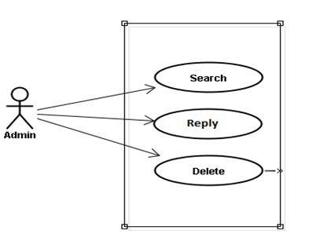

Figure 4-16: Contact management

|  |  |  |  |
| --- | --- | --- | --- |
| **No.** | **Use-case name** | **Actor** | **Description** |
| 1 | Search contact | Admin | Search contact |
| 2 | Reply contact | Admin | Reply contact |
| 3 | Delete contact | Admin | Delete contact |

### Logical View

#### Overview

Logical View includes Package diagram and Class diagram. Package diagram describes the organization of packages and elements. Class Diagram provides an overview of the target system by describing the objects and classes inside the system and the relationships between them. It provides a wide variety of usages; from modeling the domain-specific data structure to detailed design of the target system

* Controller contain the interface between
* Associated models
* Associated views
* The input devices (e.g., keyboard, pointing device, time).
* Send commands to the model to update the model's state.
* Model is:
  + the domain-specific software simulation
  + Or implementation of the application's central structure.
* View deal with everything graphical
* Requests data from their model
* Display the data

#### Architecturally Significant Design Packages

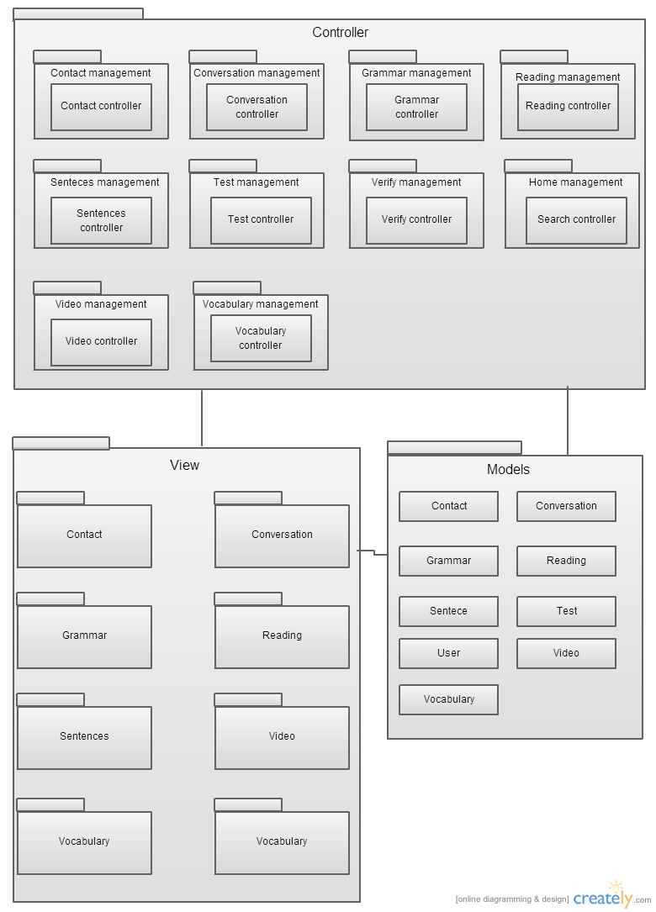

Figure 4-17: Package Diagram

* **Model**

|  |  |  |
| --- | --- | --- |
| **No.** | **Model class** | **Role** |
| 1 | Contact | Description entity of Contact in database |
| 2 | Conversation | Description entity of Conversation in database |
| 3 | Grammar | Description entity of Grammar in database |
| 4 | Reading | Description entity of Reading in database |
| 5 | Sentence | Description entity of Sentence in database |
| 6 | Test | Description entity of Test in database |
| 7 | User | Description entity of User in database |
| 8 | Video | Description entity of Video in database |
| 9 | Vocabulary | Description entity of Vocabulary in database |

Table 4-1: Model Class

* **Controller**

|  |  |  |
| --- | --- | --- |
| **No.** | **Controller class** | **Role** |
| 1 | ContactController | * Receive request contact’s information from client. * Handle request from client and call method in Contact Model to get data from Database. * Respond data back to Contact View. |
| 2 | ConversationController | * Receive request conversation’s information from client. * Handle request from client and call method in Conversation Model to get data from Database. * Respond data back to Conversation View. |
| 3 | GrammarController | * Receive request grammar’s information from client. * Handle request from client and call method in Grammar Model to get data from Database. * Respond data back to Grammar View. |
| 4 | ReadingController | * Receive request reading’s information from client. * Handle request from client and call method in Reading Model to get data from Database. * Respond data back to Reading View. |
| 5 | SentenceController | * Receive request sentence’s information from client. * Handle request from client and call method in Sentence Model to get data from Database. * Respond data back to Sentence View. |
| 6 | TestController | * Receive request test’s information from client. * Handle request from client and call method in Test Model to get data from Database. * Respond data back to Test View. |
| 7 | VerifyController | * Receive request user’s information from client. * Handle request from client and call method in User Model to get data from Database. * Respond data back to Homepage View. |
| 8 | SearchController | * Receive request search’s information from client. * Handle request from client and call method in Search Model to get data from Database. * Respond data back to Search View. |
| 9 | VideoController | * Receive request video’s information from client. * Handle request from client and call method in Video Model to get data from Database. * Respond data back to Video View. |
| 10 | VocabularyController | * Receive request vocabulary’s information from client. * Handle request from client and call method in Vocabulary Model to get data from Database. * Respond data back to Vocabulary View. |

Table 4-2: Controller Class

* **View:** Include many .php files

### Process View

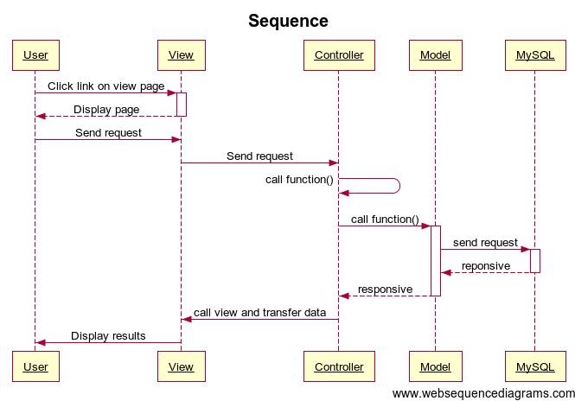

Figure 4-18: Sequence diagram

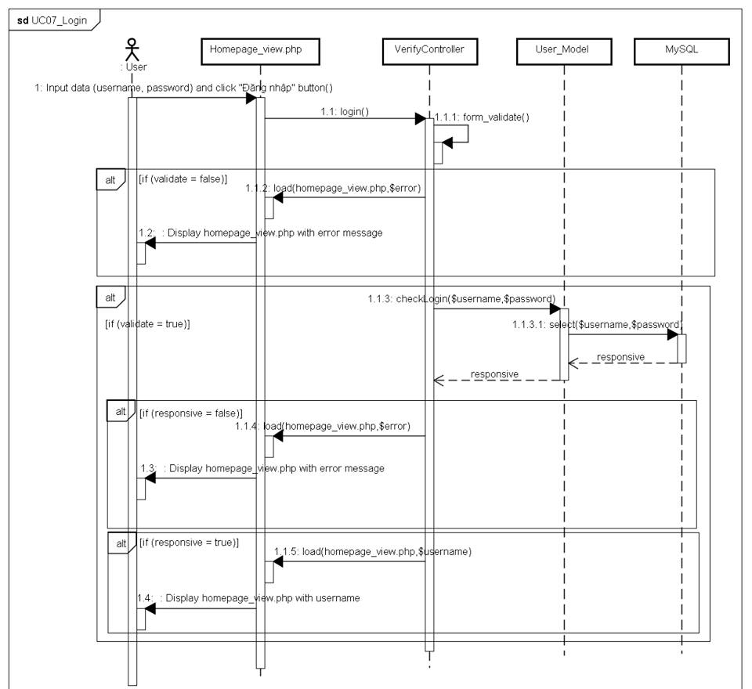

Figure 4-19: Login sequence

User input data(username, password) and click “Đăng nhập” button, user send a request login to verifyController class call function login()

If data entered validate is false, function login() will call function load(homepage_view.php.$error) in verfifyController

If data enterd is validate is true, userModel will call function checkLogin($username,$password) in verifyController and send request select($username,$password) to MySQL. MySQL will response to ViewController

If responsive is false, function load(homepage_view.php,$error) is called, display homepage_view.php with error message to User

If responsive if tru, function load(homepage_view.php,$username) is called, display homepage_view.php with username.

### Deployment view

Deployment view of website:

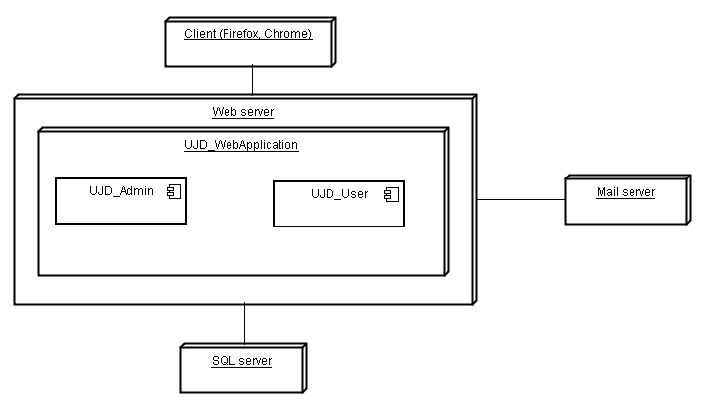

Figure 4-20: Deployment view

|  |  |  |
| --- | --- | --- |
| **No.** | **Name** | **Description** |
| 1 | MySQL sever | MySQL server use to store system’s data. MySQL 5.6.16 or higher. |
| 2 | Mail server | Mail server use to interact with user’s email. |
| 3 | Web server | Web server is host system’s website. |
| 4 | Client | Client is web browser to use system: CocCoc 35, Chrome 35 or higher. |

## Class Design

### Packages

|  |  |  |  |
| --- | --- | --- | --- |
| No | Package | Language | Description |
| 1. 01 | Common | PHP | Store all information search |
|  | Account management | PHP | Store all information user and action as : registration, login, log out, viewprofile… |
|  | Contact | PHP | Contribution (database, opinion, Q&A) |
|  | Practice management |  | Do test and Reading document |
|  | Admin’s account management | PHP | Manage to admin (add, delete, edit) |
|  | Management member | PHP | Manage to member (ban/unban, detele) |
|  | Vocabulary management | PHP | Store all information of Vocabulary. |
|  | Grammar management | PHP | Store all information of Grammar. |
|  | Kanji management | PHP | Store all information of Kanji. |
|  | ReadingDocument management | PHP | Store all information of Document. |
|  | TrainingListening management | PHP | Store all information of Listen. |
|  | Video management | PHP | Store all information of Video. |
|  | Contact management | PHP | Store all information of Contact (Q&A, opinion). |
|  | Conversation management | PHP | Store all information of Conversation. |
|  | Test management | PHP | Store all information of Test(question, answer). |

#### Common Package

##### Class diagram

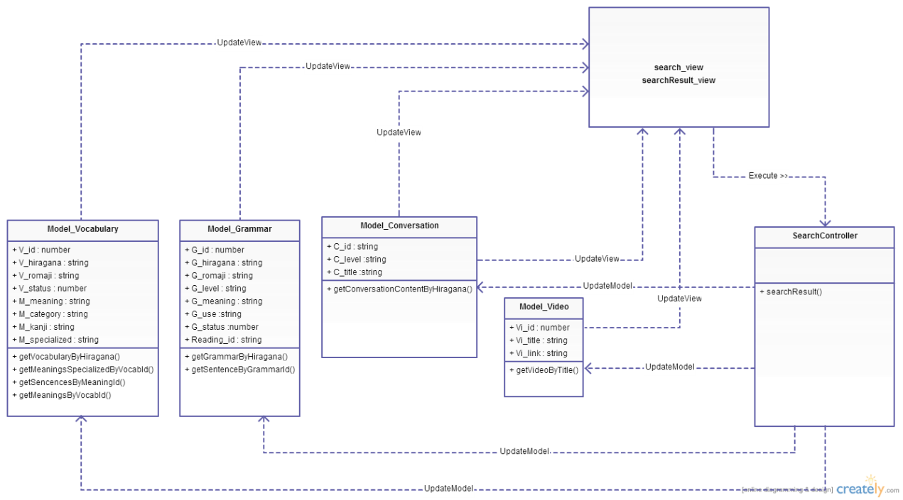

Figure 4-21: Class diagram Admin package

|  |  |  |
| --- | --- | --- |
| No | Class Name | Description |
| 1 | Model_Vocabulary | Include method interact with database |
| 2 | Model_Grammar | Include method interact with database |
| 3 | Model_Video | Include method interact with database |
| 4 | Model_Conversation | Include method interact with database |
| 5 | SearchController | Include method interact with model |

##### Model_Vocabulary class

###### Attributes

|  |  |  |  |  |  |
| --- | --- | --- | --- | --- | --- |
| No | Attribute | Type | Default | Note | Description |
| 1. 1 | V_id | Number |  | private |  |
| 1. 2 | V_hiragana | String |  | private |  |
| 1. 3 | V_romaji | String |  | private |  |
| 1. 3 | V_status | Number |  | private |  |
|  | M_id | Number |  | private |  |
|  | M_meaningvn | String |  | private |  |
|  | M_category | String |  | private |  |
|  | M_kanji | String |  | private |  |
|  | M_specialized | String |  | private |  |

###### Methods

|  |  |  |
| --- | --- | --- |
| No | Method | Description |
|  | getVocabularyByHiragana() | Interact with database: find vocabulary in database that has hiragana as keyword input. |
|  | getMeaningsSpecializedByVocabId() | Interact with database: get meaning specialized in database that id was known. |
|  | getSencencesByMeaningId() | Interact with database: get sentence in database that contained vocabulary was found. |
|  | getMeaningsByVocabId() | Interact with database: get meaning in database that id was known. |

##### Model_Grammar class

###### Attributes

|  |  |  |  |  |  |
| --- | --- | --- | --- | --- | --- |
| No | Attribute | Type | Default | Note | Description |
| 1. 1 | G_id | Number |  | private |  |
| 1. 2 | G_hiragana | String |  | private |  |
| 1. 3 | G_romaji | String |  | Private |  |
| 1. 3 | G_level | String |  | private |  |
|  | G_meaning | String |  | private |  |
|  | G_use | String |  | private |  |
|  | G_status | Number |  | Private |  |

###### Methods

|  |  |  |
| --- | --- | --- |
| No | Method | Description |
|  | getGrammarByHiragana() | Interact with database: find grammar in database that has hiragana as keyword input. |
|  | getSentenceByGrammarId() | Interact with database: Interact with database: get sentence in database that contained grammar was found. |

##### Model_Video class

###### Attributes

|  |  |  |  |  |  |
| --- | --- | --- | --- | --- | --- |
| No | Attribute | Type | Default | Note | Description |
| 1. 1 | Vi_id | Number |  | private |  |
| 1. 2 | Vi_title | String |  | private |  |
| 1. 3 | Vi_link | String |  | private |  |

###### Methods

|  |  |  |
| --- | --- | --- |
| No | Method | Description |
|  | getVideoByTitle() | Interact with database: find video in database that has title as keyword input. |

##### Model_Conversation class

###### Attributes

|  |  |  |  |  |  |
| --- | --- | --- | --- | --- | --- |
| No | Attribute | Type | Default | Note | Description |
| 1. 1 | C_id | String |  | private |  |
| 1. 2 | C_level | String |  | private |  |
| 1. 3 | C_title | String |  | private |  |
|  | C_image | String |  | private |  |
|  | Con_id | Number |  | private |  |
|  | Con_title | String |  | private |  |
|  | Con_hiragana | String |  | private |  |
|  | Con_romaji | String |  | private |  |
|  | Con_meaning | String |  | private |  |

###### Methods

|  |  |  |
| --- | --- | --- |
| No | Method | Description |
|  | getConversationContentByHiragana() | Interact with database: find conversation in database that has title as keyword input. |

##### SearchController

###### Attributes

|  |  |  |  |  |  |
| --- | --- | --- | --- | --- | --- |
| No | Attribute | Type | Default | Note | Description |
| 1 |  |  |  |  |  |

###### Methods

|  |  |  |
| --- | --- | --- |
| No | Method | Description |
|  | searchResults() | Display result search |

##### Common Sequence Diagram

###### UC001_SearchSentence

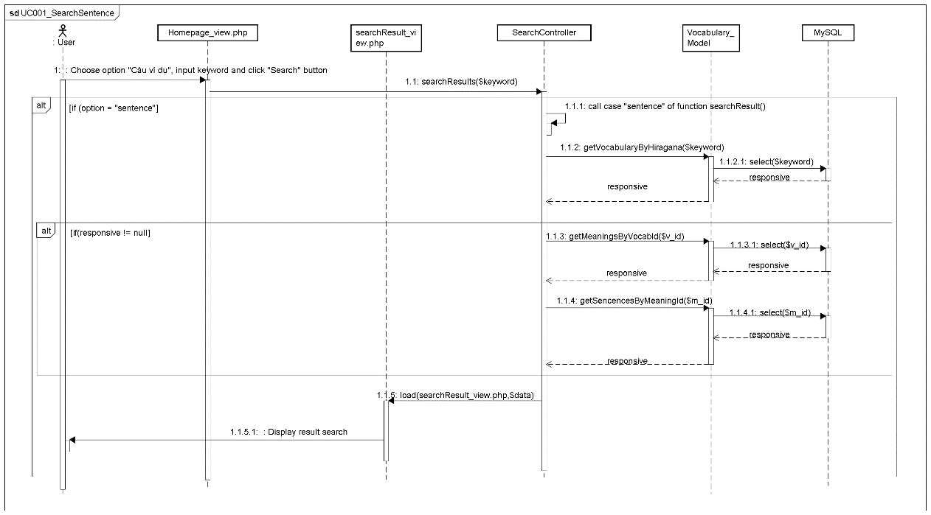

###### UC002_SearchConversation

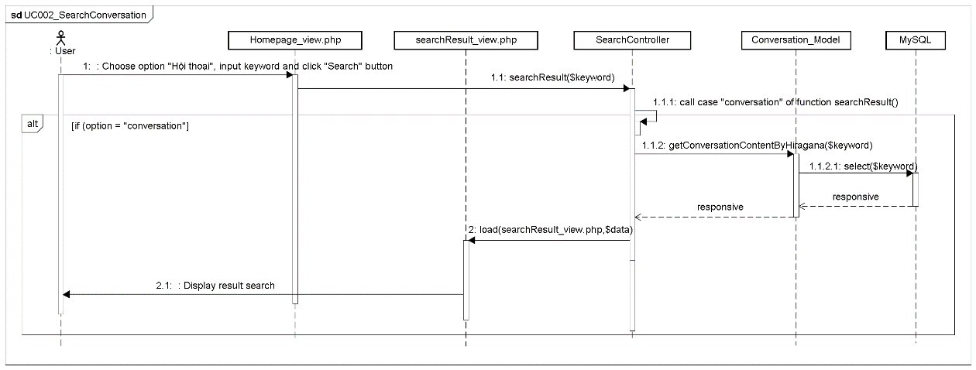

###### UC003_SearchGrammar

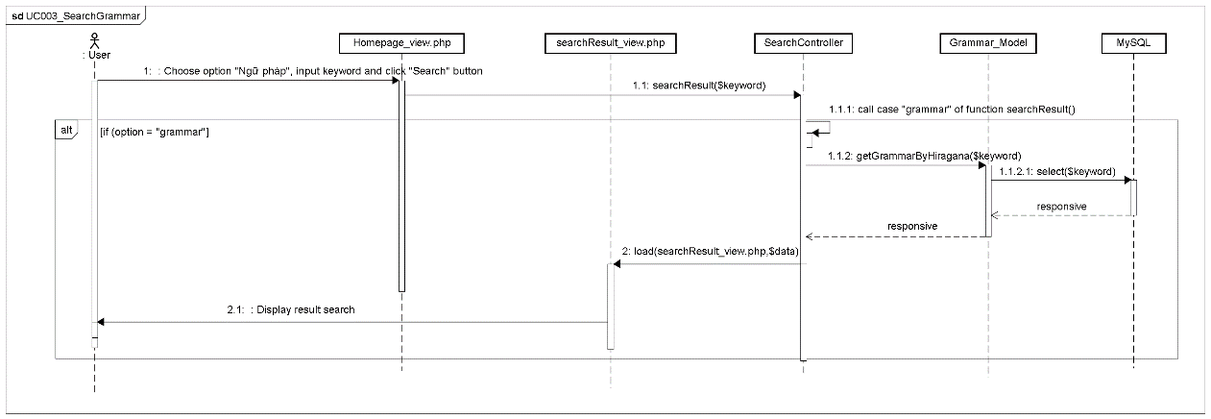

###### UC004_SearchVideo

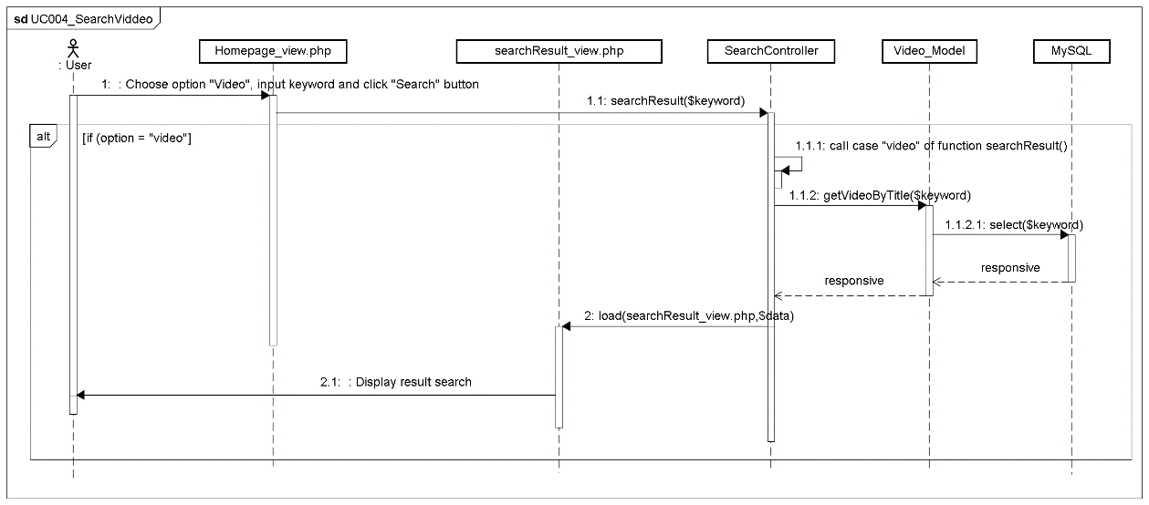

###### UC005_SearchSpecialized

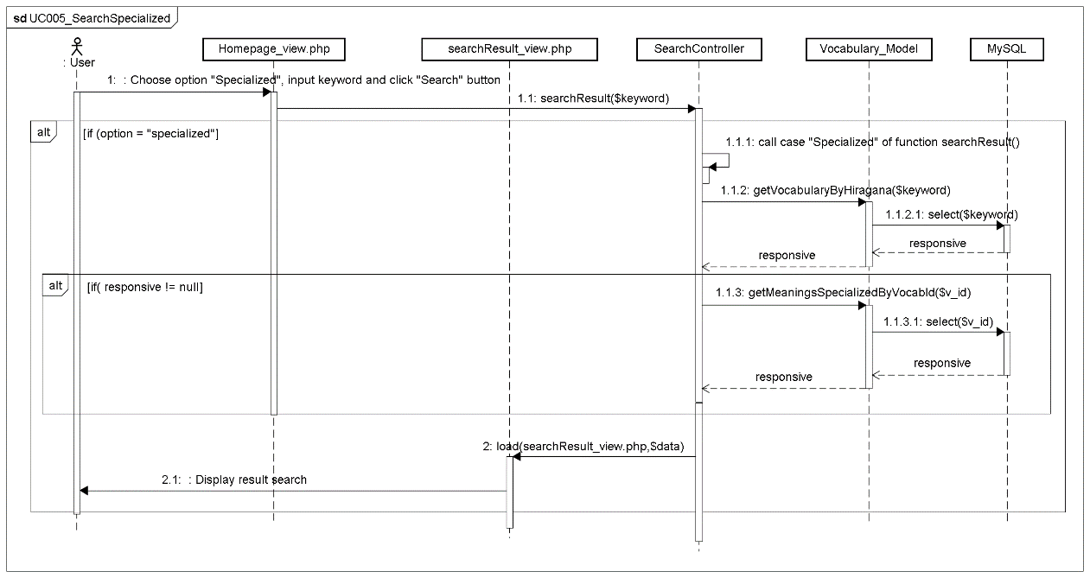

#### Account management Package

##### Class diagram

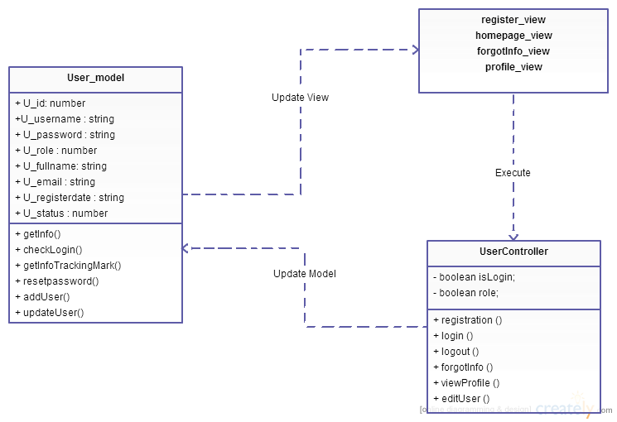

Figure 4-22: Class diagram user package

|  |  |  |
| --- | --- | --- |
| No | Class Name | Description |
| 1 | User_model | Include method interact with database |
| 2 | UserController | Include method interact with model |

##### Model_User class

###### Attributes

|  |  |  |  |  |  |
| --- | --- | --- | --- | --- | --- |
| No | Attribute | Type | Default | Note | Description |
| 1 | u_id | Number |  | private |  |
| 2 | u_username | String |  | private |  |
| 3 | u_password | String |  | private |  |
| 4 | u_role | Number |  | private |  |
| 5 | u_fullname | String |  | private |  |
| 6 | u_email | String |  | private |  |
| 7 | u_registerdate | String |  | private |  |
| 8 | u_status | Number |  | private |  |

###### Methods

|  |  |  |
| --- | --- | --- |
| No | Method | Description |
|  | addUser () | Interact with database: create a new account that has user’s information as information input |
|  | getInfo () | Interact with database: get information of user when they logged in. |
|  | checkLogin() | Interact with database: check information of user when they want login to website. |
|  | Resetpassword() | Interact with database: reset password of account that has email as email input. |
|  | updateUser() | Interact with database: update information of user. |

##### UserController class

###### Attributes

|  |  |  |  |  |  |
| --- | --- | --- | --- | --- | --- |
| No | Attribute | Type | Default | Note | Description |
| 1 |  |  |  |  |  |

#### Contact Package

##### Class diagram

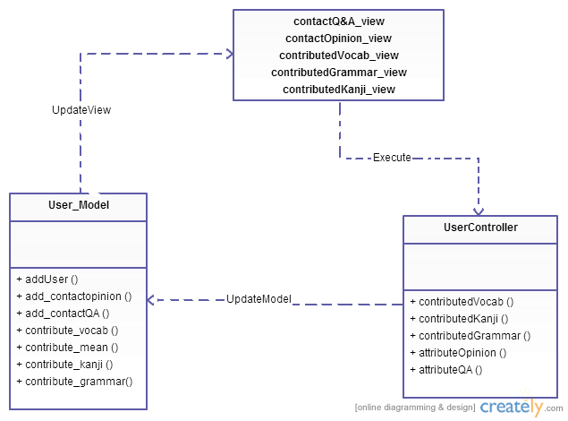

Figure 4-23: Class diagram Contact package

|  |  |  |
| --- | --- | --- |
| No | Class Name | Description |
| 1 | User_model | Include method interact with database |
| 2 | UserController | Include method interact with model |

##### Model_User class

###### Attributes

|  |  |  |  |  |  |
| --- | --- | --- | --- | --- | --- |
| No | Attribute | Type | Default | Note | Description |
| 1 |  |  |  |  |  |

###### Methods

|  |  |  |
| --- | --- | --- |
| No | Method | Description |
|  | add_contactopinion () | Interact with database: save opinion of user to database that user was input. |
|  | add_contactQA () | Interact with database: save Q&A of user to database that user was input. |
|  | contribute_vocab () | Interact with database: save vocabulary of user to database that user was input. |
|  | contribute_mean () | Interact with database: save vocabulary’s meaning of user to database that user was input. |
|  | contribute_kanji () | Interact with database: save kanji of user to database that user was input. |
|  | contribute_grammar() | Interact with database: save grammar of user to database that user was input. |

##### UserController class

###### Attributes

|  |  |  |  |  |  |
| --- | --- | --- | --- | --- | --- |
| No | Attribute | Type | Default | Note | Description |
| 1 |  |  |  |  |  |

#### Practice management Package

##### Class diagram

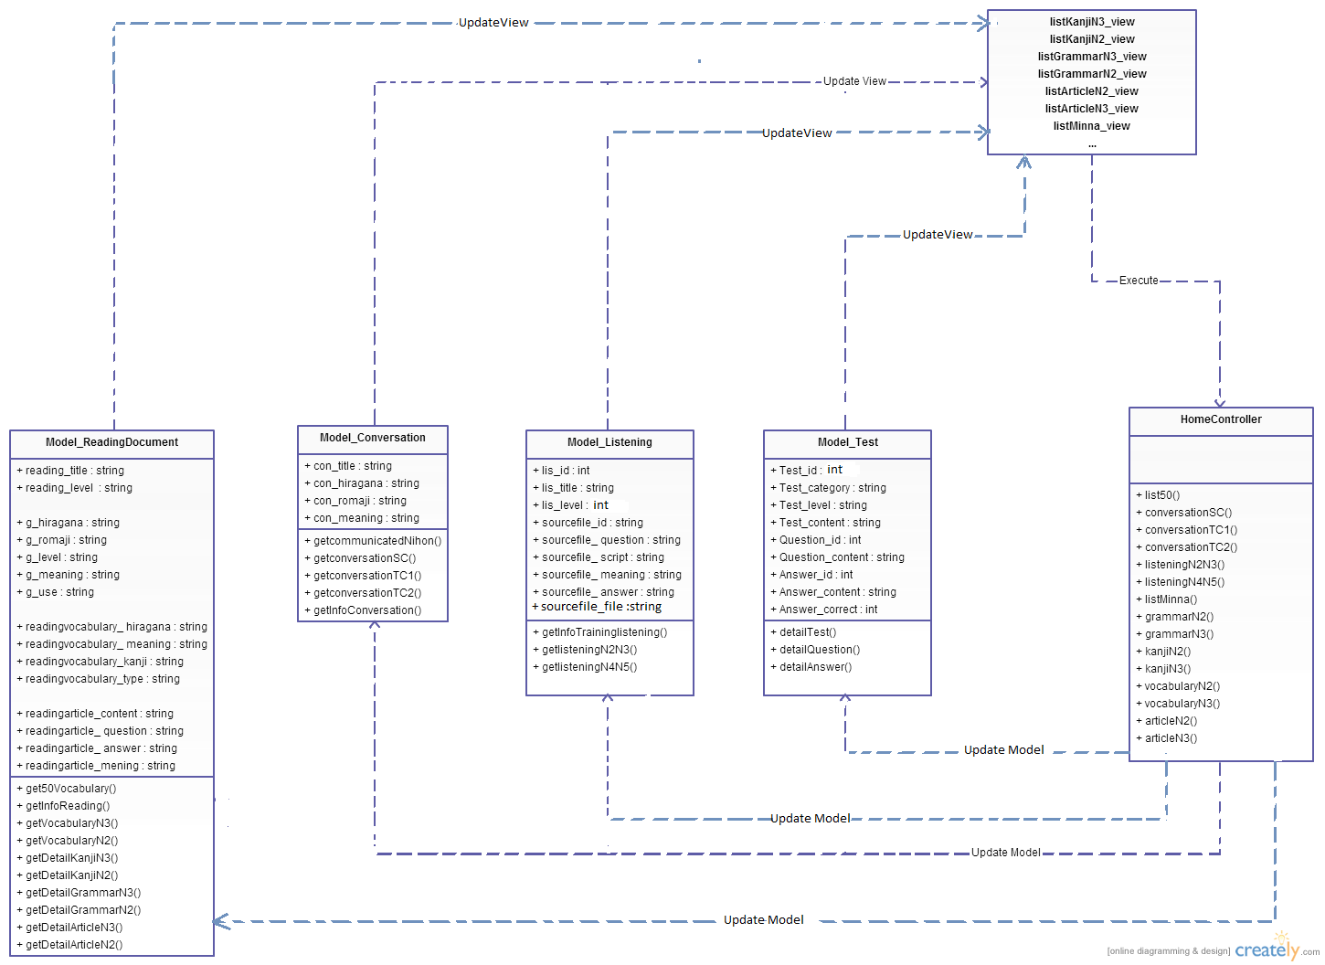

Figure 4-24: Class diagram Practice management package

|  |  |  |
| --- | --- | --- |
| No | Class Name | Description |
| 1 | Model_ReadingDocument | Include method interact with database |
| 2 | Model_Conversation | Include method interact with database |
| 3 | Model_Listening | Include method interact with database |
| 4 | Model_Test | Include method interact with database |
| 5 | ReadingDocumentController | Include method interact with models |

##### Model ReadingDocument class

###### Attributes

|  |  |  |  |  |  |
| --- | --- | --- | --- | --- | --- |
| No | Attribute | Type | Default | Note | Description |
| 1. 1 | reading_title | String |  | private |  |
| 1. 2 | reading_level | String |  | private |  |
| 1. 3 | g_hiragana | String |  | private |  |
|  | g_romaji | String |  | private |  |
|  | g_level | String |  | private |  |
|  | g_meaning | String |  | private |  |
|  | g_use | String |  | private |  |
|  | readingvocabulary_ hiragana | String |  | private |  |
|  | readingvocabulary_ meaning | String |  | private |  |
|  | readingvocabulary_kanji | String |  | private |  |
|  | readingvocabulary_type | String |  | private |  |
|  | readingarticle_content | String |  | private |  |
|  | readingarticle_ question | String |  | private |  |
|  | readingarticle_ answer | String |  | private |  |
|  | readingarticle_mening | String |  | private |  |

###### Methods

|  |  |  |
| --- | --- | --- |
| No | Method | Description |
|  | get50Vocabulary() | Interact with database: get vocabulary of 50 lessons Minna Nihon in database. |
|  | getInfoReading() | Interact with database: get detail of reading document when reading was know |
|  | getVocabularyN3() | Interact with database: get vocabulary in database that has level N3. |
|  | getVocabularyN2() | Interact with database: get vocabulary in database that has level N2. |
|  | getDetailKanjiN3() | Interact with database: get kanji in database that has level N3. |
|  | getDetailKanjiN2() | Interact with database: get kanji in database that has level N2. |
|  | getDetailGrammarN3() | Interact with database: get detail of grammar in database that has level N3. |
|  | getDetailGrammarN2() | Interact with database: get detail of grammar in database that has level N2. |
|  | getDetailArticleN3() | Interact with database: get detail of article in database that has level N3. |
|  | getDetailArticleN2() | Interact with database: get detail of article in database that has level N2. |

##### Model Conversation class

###### Attributes

|  |  |  |  |  |  |
| --- | --- | --- | --- | --- | --- |
| No | Attribute | Type | Default | Note | Description |
| 1. 1 | C_id | Number |  | private |  |
| 1. 2 | C_level | String |  | private |  |
| 1. 3 | C_title | String |  | private |  |
|  | C_image | String |  | private |  |
|  | Con_id | Number |  | private |  |
|  | Con_hiragana | String |  | private |  |
|  | Con_romaji | String |  | private |  |
|  | Con_meaning | String |  | private |  |
|  | Con_file | String |  | private |  |

#### Admin’s account management Package

##### Class diagram

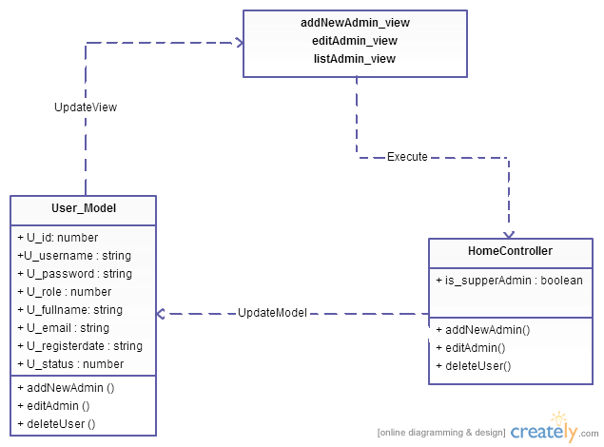

Figure 4-25: Class diagram Admin’s account management package

|  |  |  |
| --- | --- | --- |
| NNo | Class Name | Description |
| 1 | Model_User | Include method interact with database |
| 2 | HomeController | Include method interact with model |

##### Model_User class

###### Attributes

|  |  |  |  |  |  |
| --- | --- | --- | --- | --- | --- |
| No | Attribute | Type | Default | Note | Description |
| 1 | u_id | Number |  | private |  |
| 2 | u_username | String |  | private |  |
| 3 | u_password | String |  | private |  |
| 4 | u_role | Number |  | private |  |
| 5 | u_fullname | String |  | private |  |
| 6 | u_email | String |  | private |  |
| 7 | u_registerdate | String |  | private |  |
| 8 | u_status | Number |  | private |  |

###### Methods

|  |  |  |
| --- | --- | --- |
| No | Method | Description |
|  | addNewAdmin () | Interact with database: create a new account with role as admin and save to database. |
|  | editAdmin () | Interact with database: update information of account into database. |
|  | deleteUser () | Interact with database: delete account in database that id of account was known. |

##### HomeController class

###### Attributes

|  |  |  |  |  |  |
| --- | --- | --- | --- | --- | --- |
| No | Attribute | Type | Default | Note | Description |
| 1 | Is_supperAdmin | boolean |  |  | Check role admin |

###### Methods

|  |  |  |
| --- | --- | --- |
| No | Method | Description |
|  | addNewAdmin() | Add a new account with role is admin |
|  | editAdmin() | Edit information |
|  | deleteUser() | Delete Admin |

##### Sequence Diagram

###### UC018_AddNewAdmin

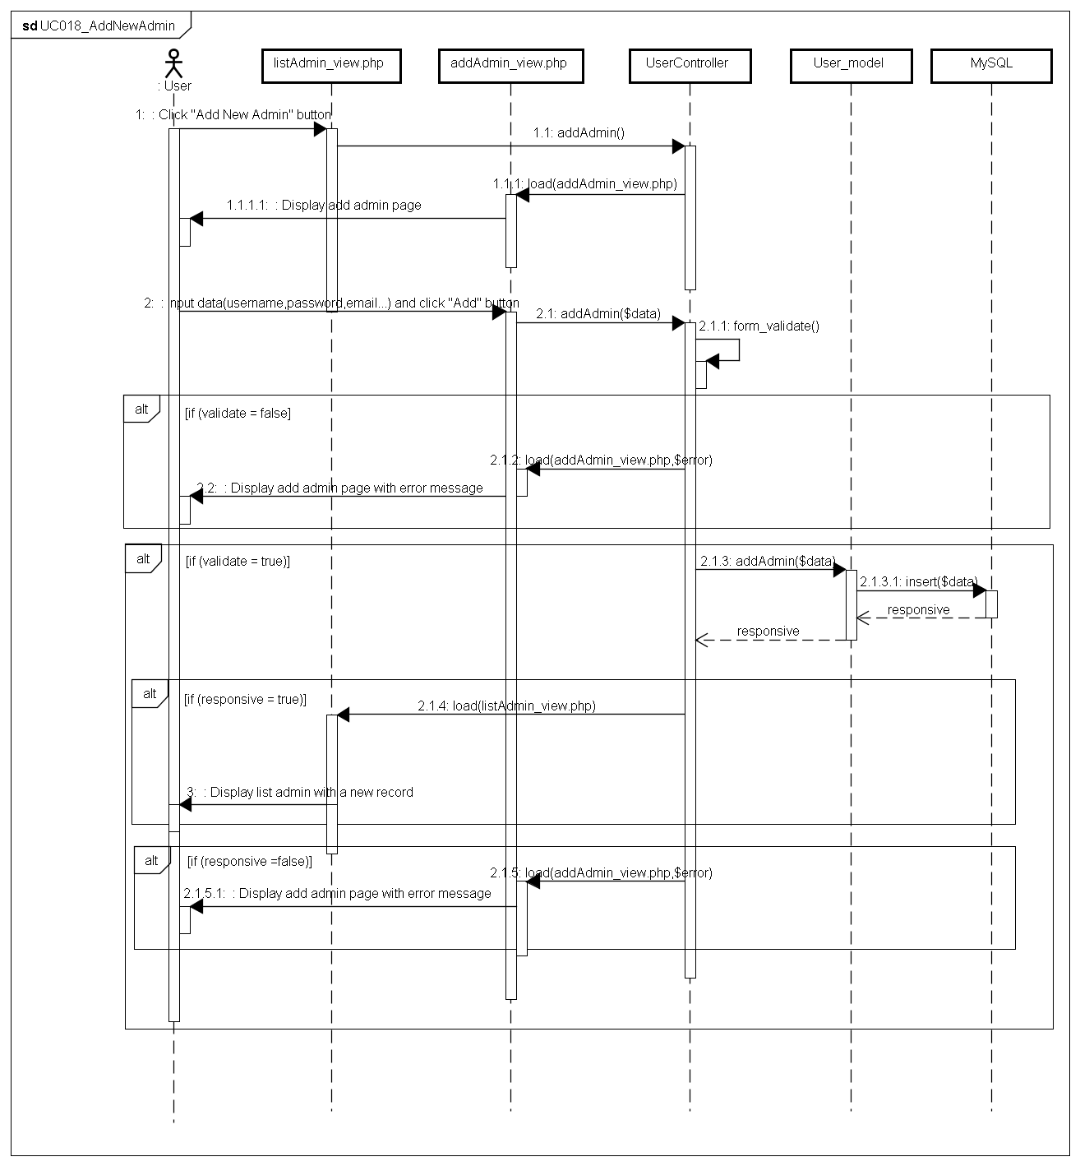

###### UC019_EditAdmin

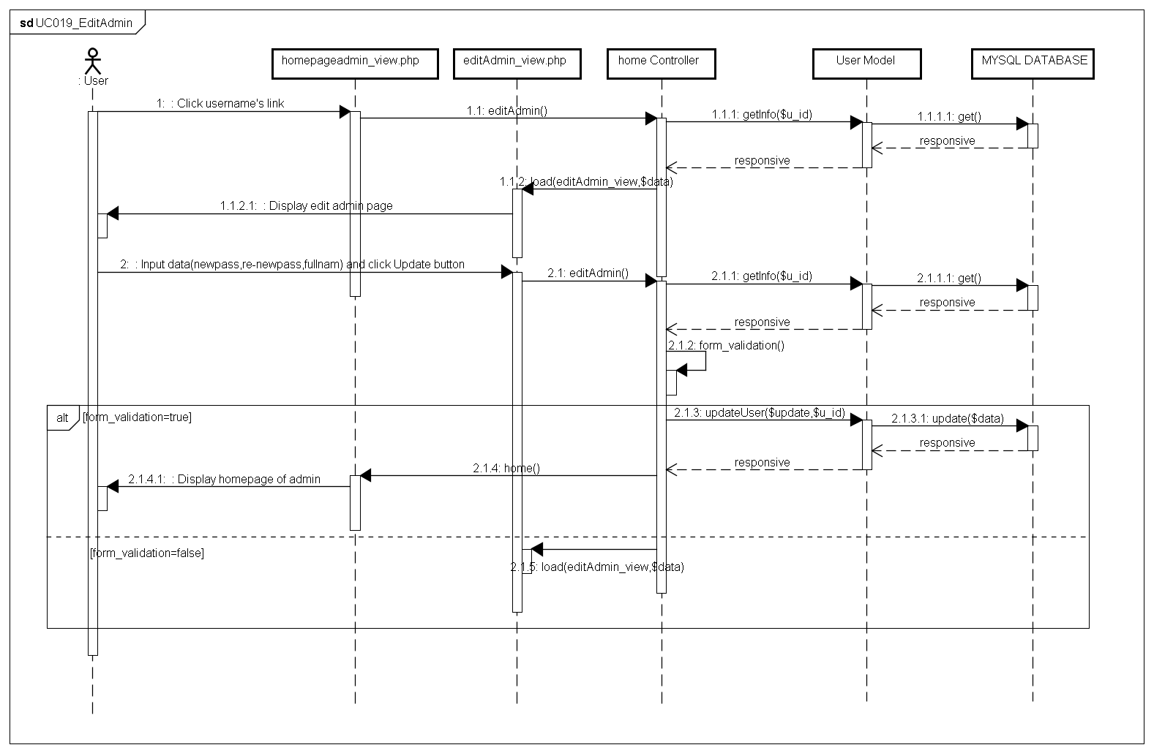

###### UC020_DeleteAdmin

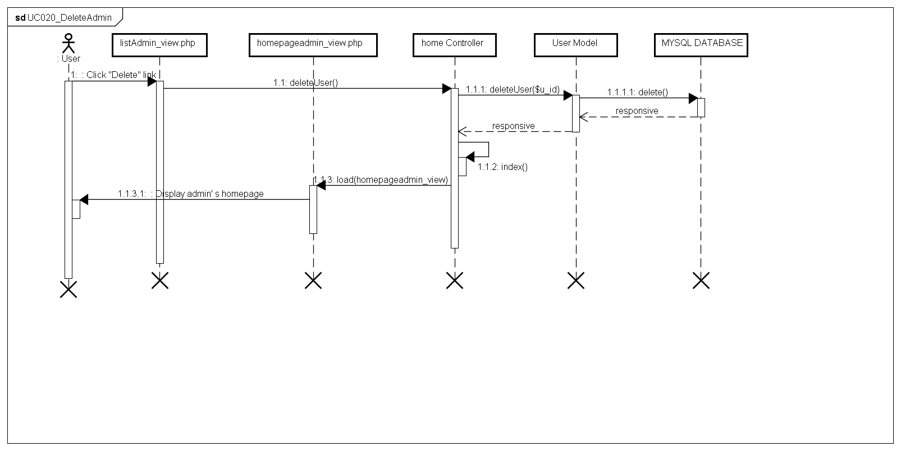

#### Management Member’s account

##### Class diagram

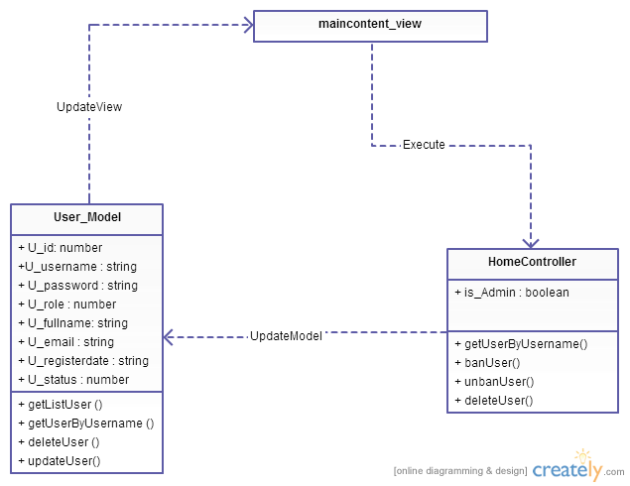

Figure 4-26: Class diagram Management member package

|  |  |  |
| --- | --- | --- |
| NNo | Class Name | Description |
| 1 | Model_User | Include method interact with database |
| 2 | HomeController | Include method interact with model |

##### Model_User class

###### Attributes

|  |  |  |  |  |  |
| --- | --- | --- | --- | --- | --- |
| No | Attribute | Type | Default | Note | Description |
| 1 | u_id | Number |  | Private |  |
| 2 | u_username | String |  | Private |  |
| 3 | u_password | String |  | Private |  |
| 4 | u_role | Number |  | Private |  |
| 5 | u_fullname | String |  | Private |  |
| 6 | u_email | String |  | Private |  |
| 7 | u_registerdate | String |  | Private |  |
| 8 | u_status | Number |  | Private |  |

###### Methods

|  |  |  |
| --- | --- | --- |
| No | Method | Description |
|  | getListUser () | Interact with database: get all accounts in database that has role as member. |
|  | getUserByUsername () | Interact with database: get information of account in database when username was known. |
|  | deleteUser () | Interact with database: delete account in database. |
|  | updateUser() | Interact with database: update information of account in database. |

##### HomeController class

###### Attributes

|  |  |  |  |  |  |
| --- | --- | --- | --- | --- | --- |
| No | Attribute | Type | Default | Note | Description |
| 1 | Is_Admin | Boolean |  |  | Check role admin |

###### Methods

|  |  |  |
| --- | --- | --- |
| No | Method | Description |
|  | banUser() | Deactive user. |
|  | unbanUser () | Active user |
|  | deleteUser() | Delete User |

##### Sequence Diagram

###### UC021_SearchMember

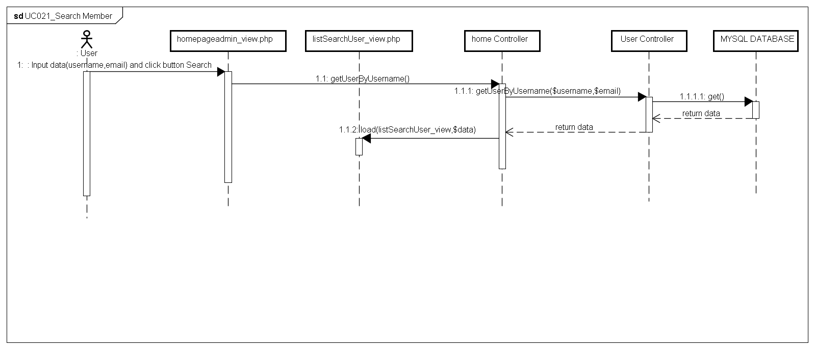

###### UC022_Ban/UnBanMember

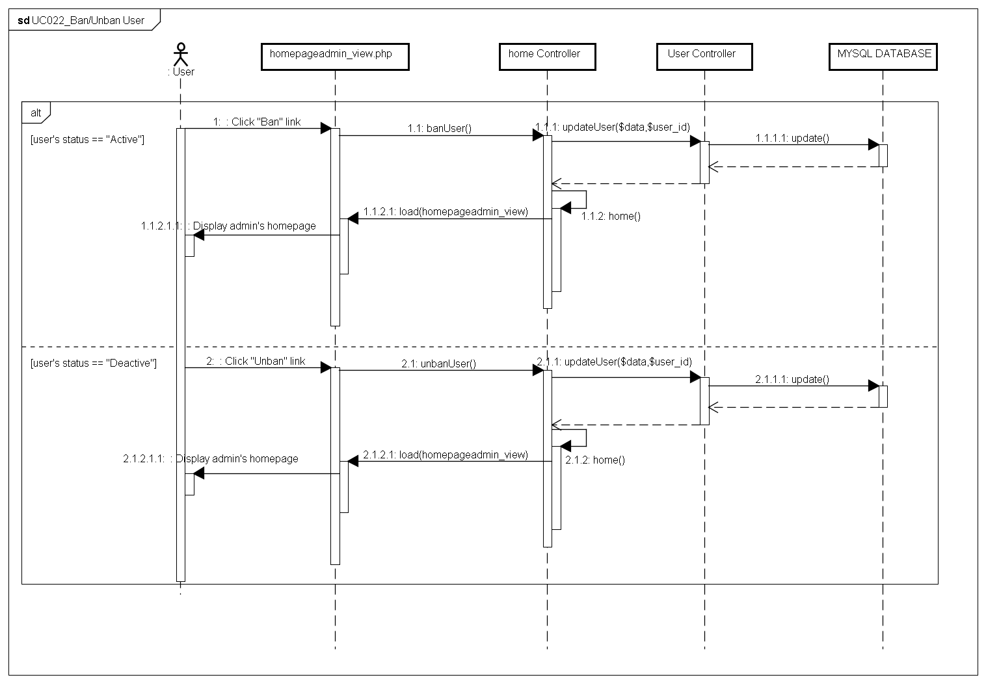

###### UC023_DeleteMember

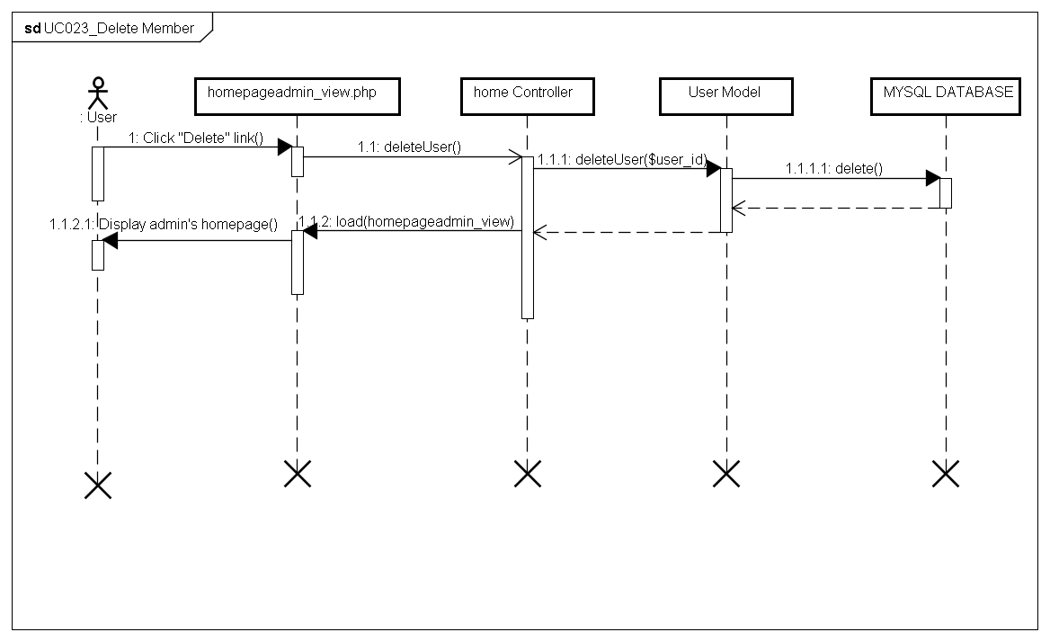

#### Vocabulary Management Package

##### Class diagram

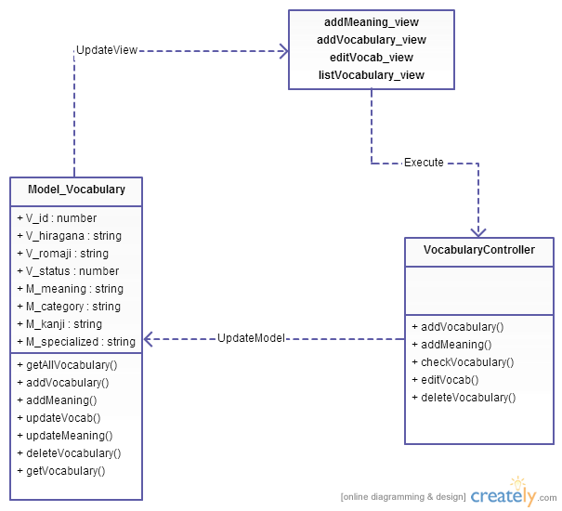

Figure 4-27: Class diagram Vocabulary management package

|  |  |  |
| --- | --- | --- |
| No | Class Name | Description |
| 1 | Model_Vocabulary | Include method interact with database |
| 2 | VocabularyController | Include method interact with model |

##### Model_Vocabulary class

###### Attributes

|  |  |  |  |  |  |
| --- | --- | --- | --- | --- | --- |
| No | Attribute | Type | Default | Note | Description |
| 1 | V_id | Number |  | private |  |
| 2 | V_hiragana | String |  | private |  |
| 3 | V_romaji | String |  | private |  |
| 5 | V_status | Number |  | private |  |
| 6 | M_id | Number |  | private |  |
| 7 | M_meaningvn | String |  | private |  |
| 8 | M_category | String |  | private |  |
| 9 | M_kanji | String |  | private |  |
| 10 | M_specialized | String |  | private |  |

###### Methods

|  |  |  |
| --- | --- | --- |
| No | Method | Description |
| 1 | getAllVocabulary() | Interact with database: get all vocabulary in database. |
| 2 | addVocabulary() | Interact with database: save vocabulary to database that created |
| 3 | addMeaning() | Interact with database: save meaning of vocabulary to database that created |
| 4 | updateVocab() | Interact with database: update vocabulary to database. |
| 5 | updateMeaning() | Interact with database: update meaning of vocabulary to database. |
| 6 | deleteVocabulary() | Interact with database: delete vocabulary in database. |
| 7 | getVocabulary() | Interact with database: get detail of vocabulary in database. |

##### VocabularyController class

###### Attributes

|  |  |  |  |  |  |
| --- | --- | --- | --- | --- | --- |
| No | Attribute | Type | Default | Note | Description |
|  |  |  |  |  |  |

###### Methods

|  |  |  |
| --- | --- | --- |
| No | Method | Description |
|  | addVocabulary() | Create vocabulary |
|  | addMeaning() | Add meaning of vocabulary |
|  | checkVocabulary() | Check exits vocabulary |
|  | editVocab() | Edit vocabulary |
|  | deleteVocabulary() | Delete Vocabulary |

##### Sequence Diagram

###### UC024_SearchVocabulary

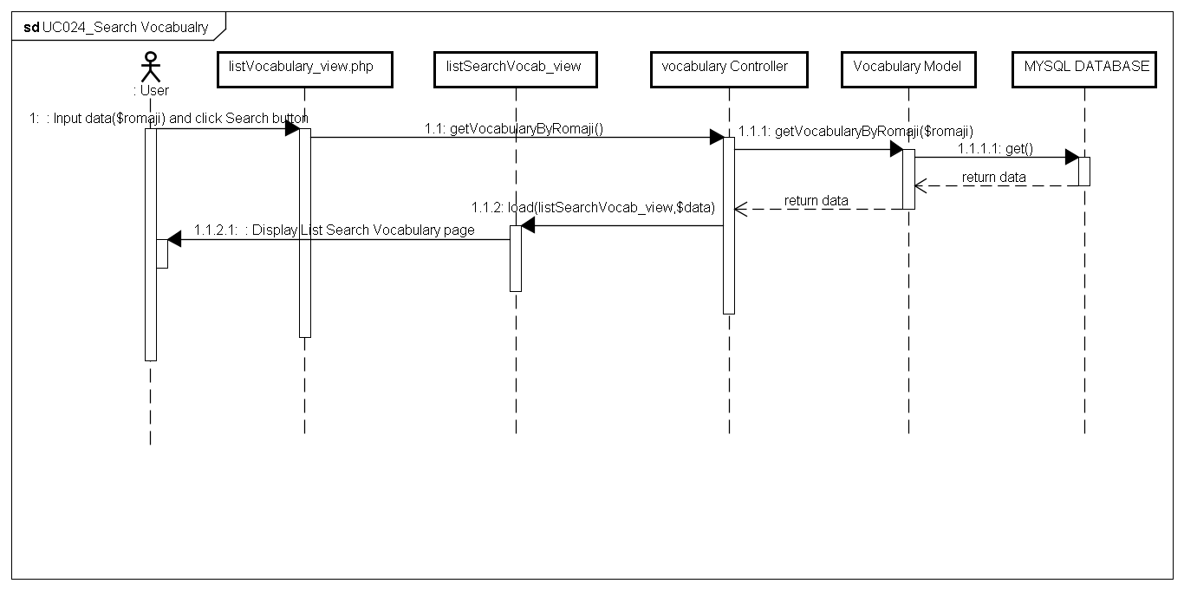

###### UC025_AddVocabulary

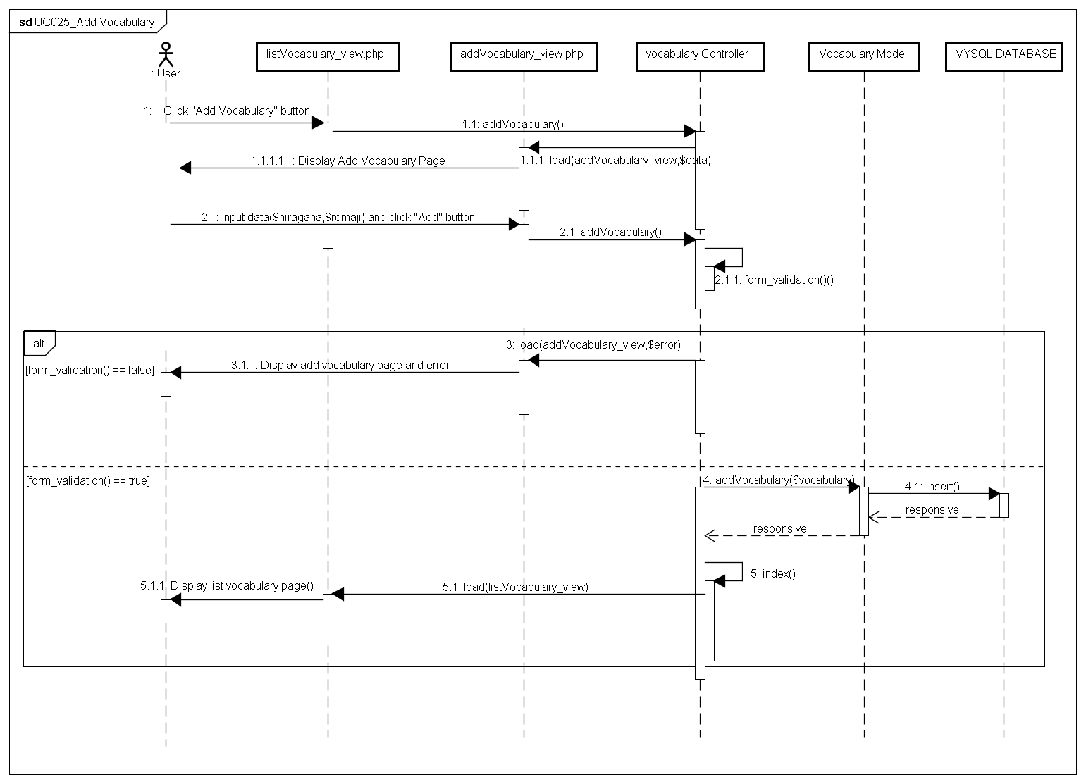

###### UC026_EditVocabulary

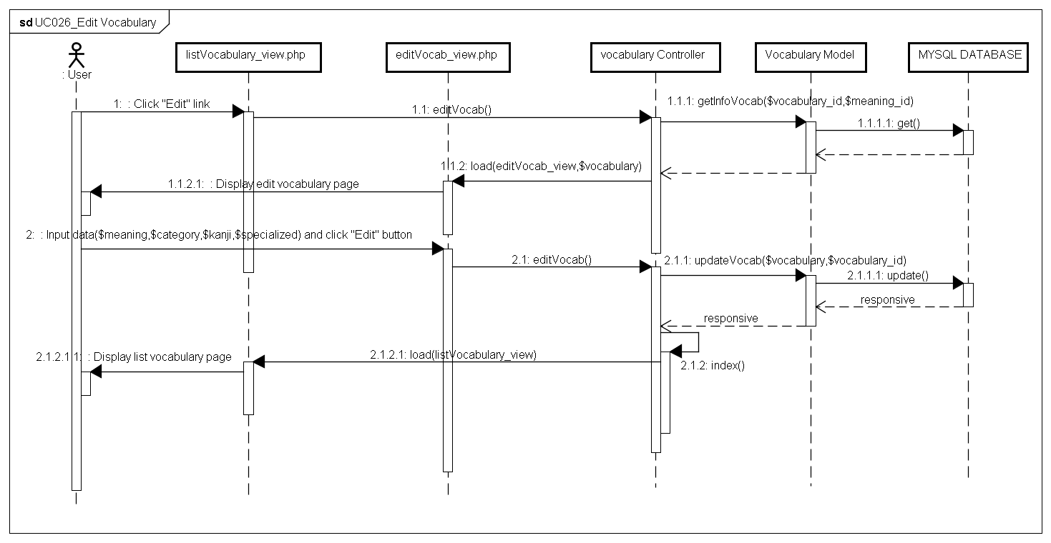

###### UC027_DeleteVocabulary

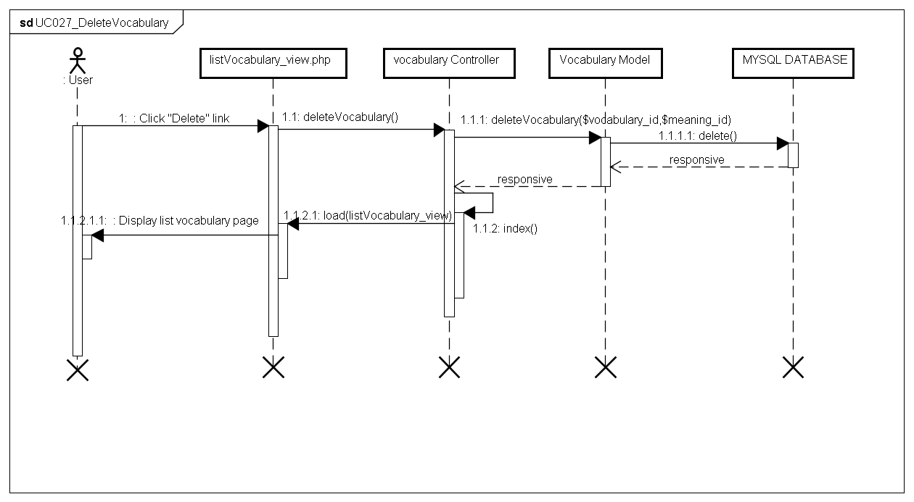

#### Grammar Management Package

##### Class diagram

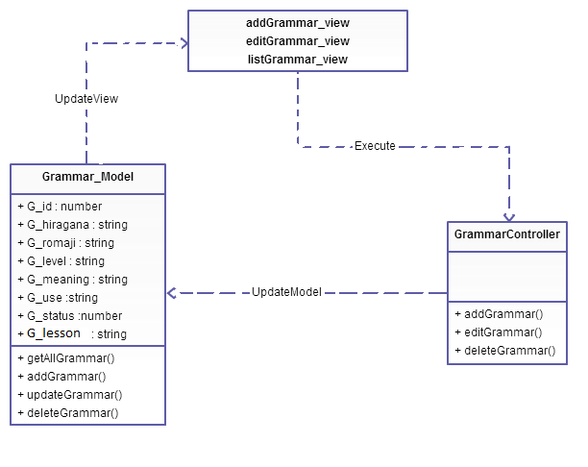

Figure 4-28: Class diagram Grammar management package

|  |  |  |
| --- | --- | --- |
| No | Class Name | Description |
| 1 | Model_Grammar | Include method interact with model |
| 2 | GrammarController | Include method interact with database |

##### Model_Grammar class

###### Attributes

|  |  |  |  |  |  |
| --- | --- | --- | --- | --- | --- |
| No | Attribute | Type | Default | Note | Description |
| 1. 1 | G_id | Number |  | Private |  |
| 1. 2 | G_hiragana | String |  | Private |  |
| 1. 3 | G_romaji | String |  | Private |  |
| 1. 3 | G_level | String |  | Private |  |
|  | G_meaning | String |  | Private |  |
|  | G_use | String |  | Private |  |
|  | G_status | Number |  | Private |  |
|  | G_lesson | String |  | Private |  |

###### Methods

|  |  |  |
| --- | --- | --- |
| No | Method | Description |
|  | getAllGrammar() | Interact with database: get all grammar in database. |
|  | addGrammar() | Interact with database: save grammar to database that created |
|  | updateGrammar() | Interact with database: update grammar to database. |
|  | deleteGrammar() | Interact with database: delete grammar in database. |

##### GrammarController class

###### Attributes

|  |  |  |  |  |  |
| --- | --- | --- | --- | --- | --- |
| No | Attribute | Type | Default | Note | Description |
|  |  |  |  |  |  |

###### Methods

|  |  |  |
| --- | --- | --- |
| No | Method | Description |
|  | addGrammar() | Create grammar |
|  | editGrammar() | Edit grammar |
|  | deleteGrammar() | Delete grammar |
|  | Index() | List grammar |

##### Sequence Diagram

###### UC028_SearchGrammar

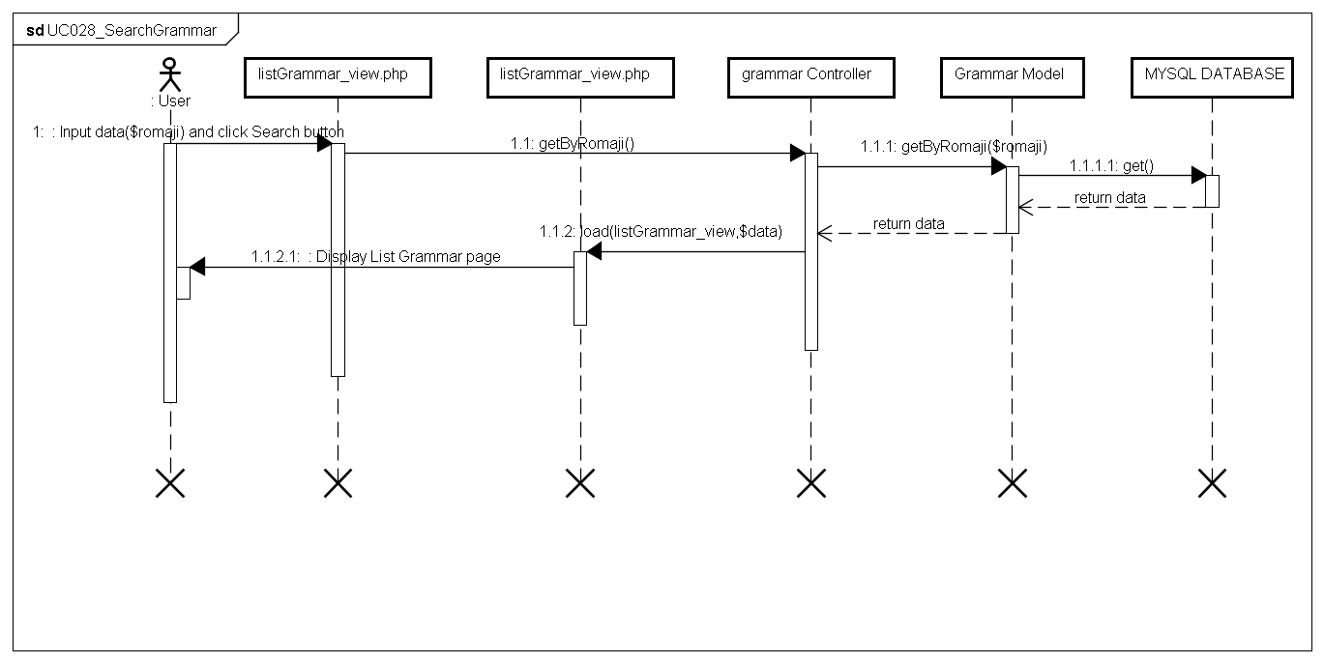

###### UC029_AddGrammar

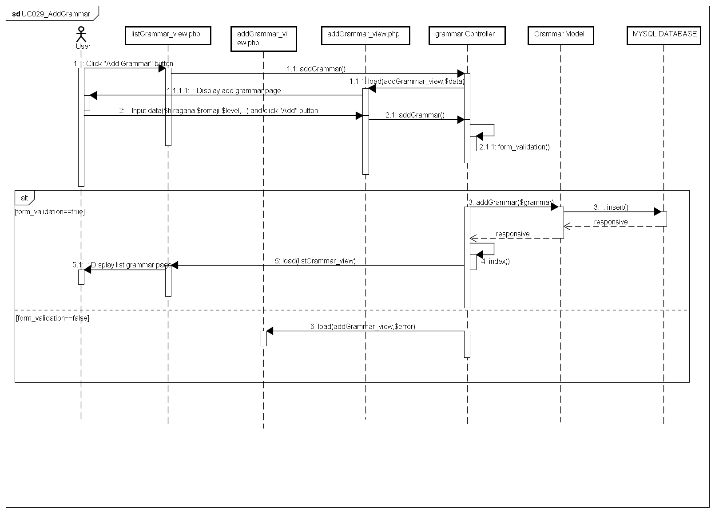

###### UC030_EditGrammar

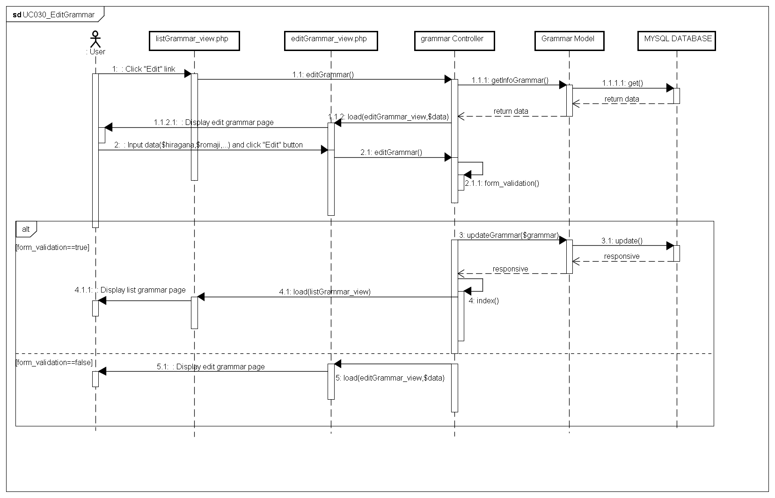

###### UC031_DeleteGrammar

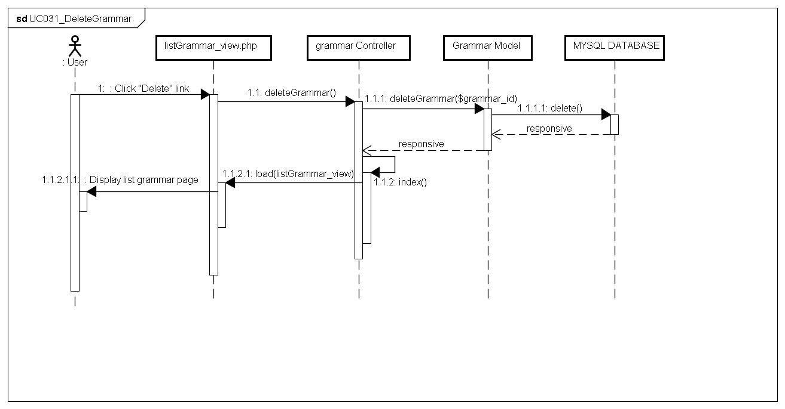

#### ReadingDocument Management Package

##### Class diagram

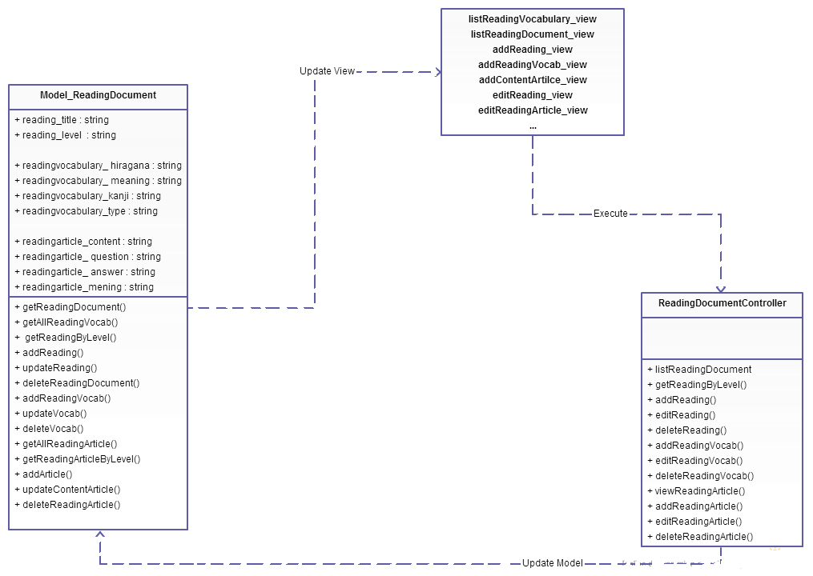

Figure 4-29: Class diagram ReadingDocument management package

|  |  |  |
| --- | --- | --- |
| No | Class Name | Description |
| 1 | Model_ReadingDocument | Include method interact with database |
| 2 | ReadingDocumentController | Include method interact with model |

##### Model ReadingDocument class

###### Attributes

|  |  |  |  |  |  |
| --- | --- | --- | --- | --- | --- |
| No | Attribute | Type | Default | Note | Description |
| 1 | reading_title | String |  | private |  |
| 2 | reading_level | String |  | private |  |
| 3 | readingvocabulary_ hiragana | String |  | private |  |
| 4 | readingvocabulary_ meaning | String |  | private |  |
| 5 | readingvocabulary_kanji | String |  | private |  |
| 6 | readingvocabulary_type | String |  | private |  |
| 7 | readingarticle_content | String |  | private |  |
| 8 | readingarticle_ question | String |  | private |  |
| 9 | readingarticle_ answer | String |  | private |  |
| 10 | readingarticle_mening | String |  | private |  |

###### Methods

|  |  |  |
| --- | --- | --- |
| No | Method | Description |
| 1 | getReadingDocument() | Interact with database: get all reading document in database. |
| 2 | getAllReadingVocab() | Interact with database: get all vocabulary of reading document in database. |
| 3 | getReadingByLevel() | Interact with database: get reading document in database that has level as keyword input. |
| 4 | addReading() | Interact with database: save reading document to database that created. |
| 5 | updateReading() | Interact with database: update reading document to database. |
| 6 | deleteReadingDocument() | Interact with database: delete reading document in database. |
| 7 | addReadingVocab() | Interact with database: save vocabulary of reading document to database that created. |
| 8 | updateVocab() | Interact with database: update vocabulary of reading document to database. |
| 9 | deleteVocab() | Interact with database: delete vocabulary of reading document in database. |
| 10 | getAllReadingArticle() | Interact with database: get all article of reading document in database. |
| 11 | getReadingArticleByLevel() | Interact with database: get article of reading document in database that has level as keyword input |
| 12 | addArticle() | Interact with database: save article to database that created. |
| 13 | updateContentArticle() | Interact with database: update article to database. |
| 14 | deleteReadingArticle() | Interact with database: delete article in database. |

##### ReadingDocumentController class

###### Attributes

|  |  |  |  |  |  |
| --- | --- | --- | --- | --- | --- |
| No | Attribute | Type | Default | Note | Description |
| 1 |  |  |  |  |  |

###### Methods

|  |  |  |
| --- | --- | --- |
| No | Method | Description |
|  | listReadingDocument () | List Reading Document |
|  | getReadingByLevel() | Search reading document |
|  | addReading() | Add Reading document |
|  | editReading() | Edit Reading document |
|  | deleteReading() | Delete Reading document |
|  | addReadingVocab() | Add vocabulary of reading document |
|  | editReadingVocab() | Edit vocabulary of reading document |
|  | deleteReadingVocab() | Delete vocabulary of reading document |
|  | viewReadingArticle() | View detail Article |
|  | addReadingArticle() | Add content of Article |
|  | editReadingArticle() | Edit Article |
|  | deleteReadingArticle() | Delete Article |

##### Sequence Diagram

###### UC032_SearchReadingDocument

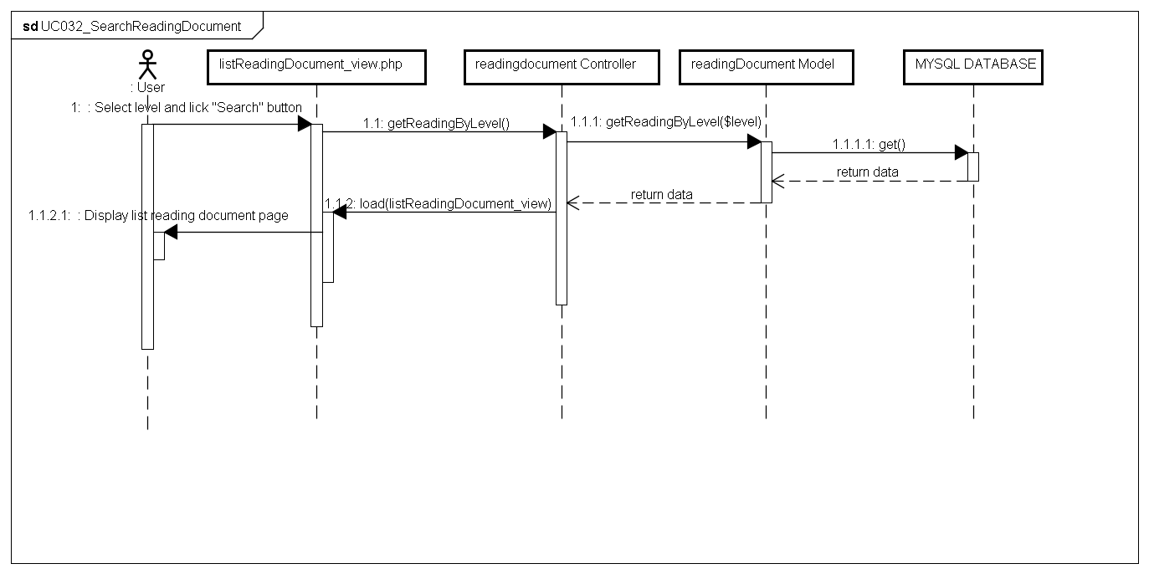

###### UC033_AddReadingDocument

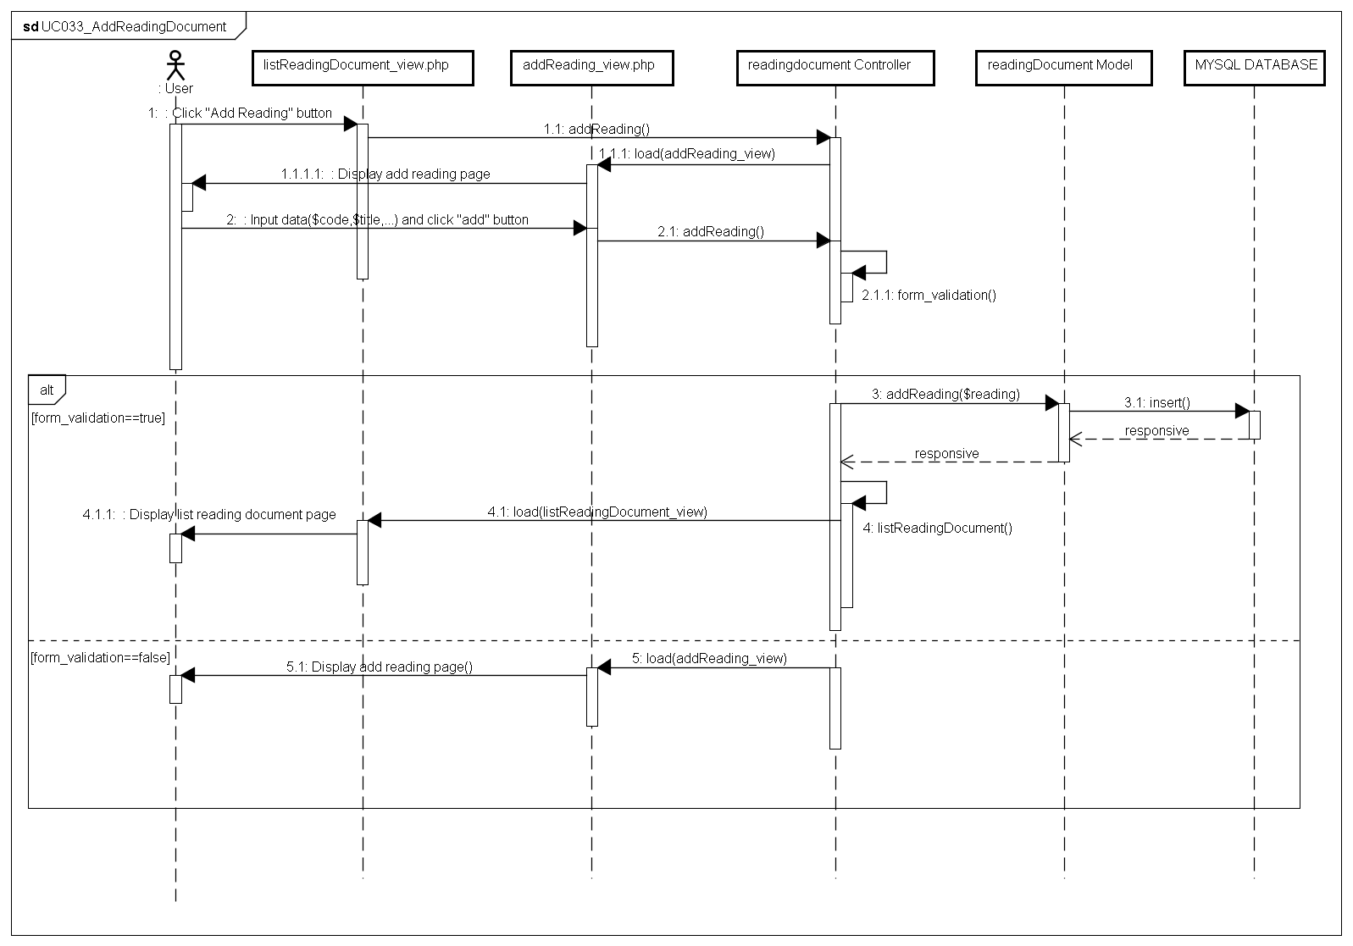

###### UC034_EditReadingDocument

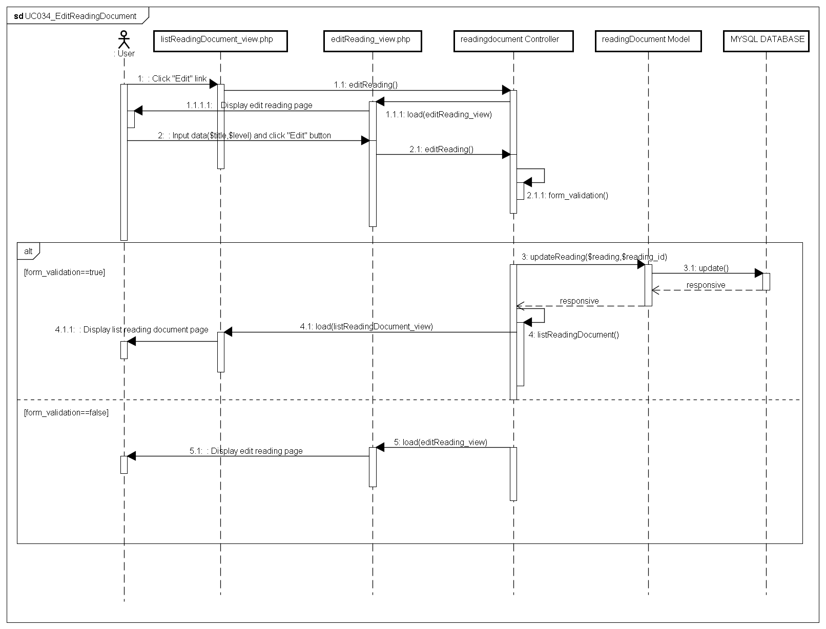

###### UC035_DeleteReadingDocument

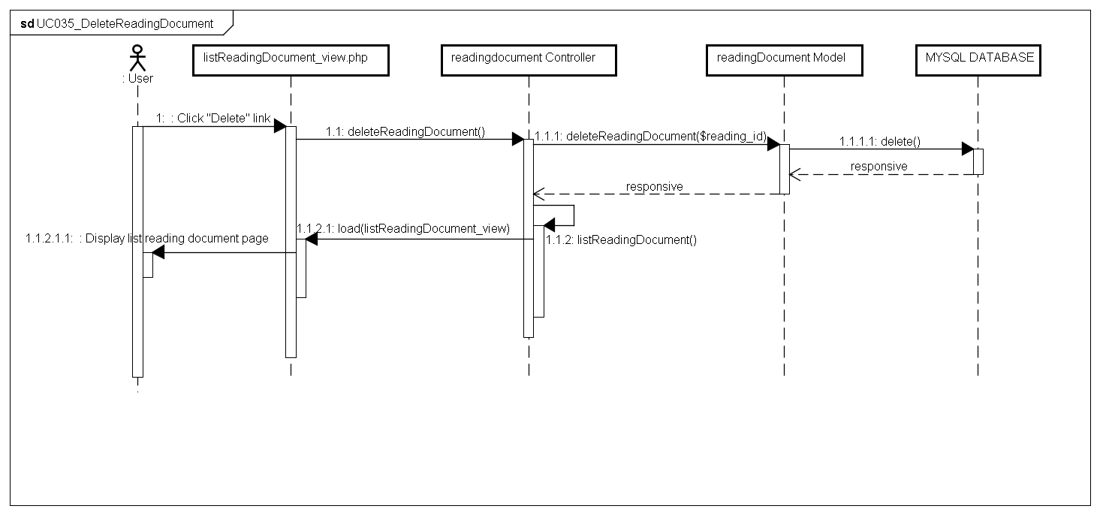

#### Conversation Management Package

##### Class diagram

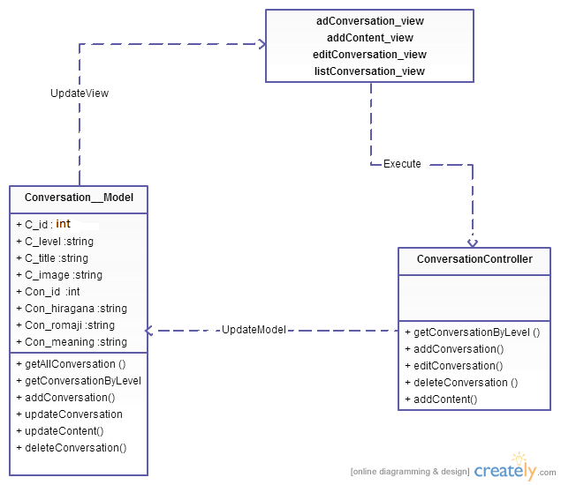

Figure 4-30: Class diagram Conversation package

|  |  |  |
| --- | --- | --- |
| No | Class Name | Description |
| 1 | Model_Conversation | Include method interact with database |
| 2 | Conversation Controller | Include method interact with model |

##### Model_Conversation class

###### Attributes

|  |  |  |  |  |  |
| --- | --- | --- | --- | --- | --- |
| No | Attribute | Type | Default | Note | Description |
| 1 | C_id | Number |  | private |  |
| 2 | C_level | String |  | private |  |
| 3 | C_title | String |  | private |  |
| 4 | C_image | String |  | private |  |
| 5 | Con_id | Number |  | private |  |
| 6 | Con_hiragana | String |  | private |  |
| 7 | Con_romaji | String |  | private |  |
| 8 | Con_meaning | String |  | private |  |
| 9 | Con_file | String |  | private |  |

###### Methods

|  |  |  |
| --- | --- | --- |
| No | Method | Description |
| 1 | getAllConversation () | Interact with database: get all conversation in database. |
| 2 | getConversationByLevel() | Interact with database: get conversation in database that has level as keyword input. |
| 3 | addConversation() | Interact with database: save conversation to database that created. |
| 4 | updateConversation() | Interact with database: update conversation to database. |
| 5 | updateContent() | Interact with database: update content of conversation to database. |
| 6 | deleteConversation() | Interact with database: delete conversation in database. |

##### ConversationController

###### Attributes

|  |  |  |  |  |  |
| --- | --- | --- | --- | --- | --- |
| No | Attribute | Type | Default | Note | Description |
|  |  |  |  |  |  |

###### Methods

|  |  |  |
| --- | --- | --- |
| No | Method | Description |
|  | getConversationByLevel () | Search Conversation |
|  | addConversation() | Add Conversation |
|  | editConversation() | Edit Conversation |
|  | deleteConversation () | Delete Conversation |
|  | addContent() | Add Content of Conversation |

##### Sequence Diagram

###### UC036_SearchConversation

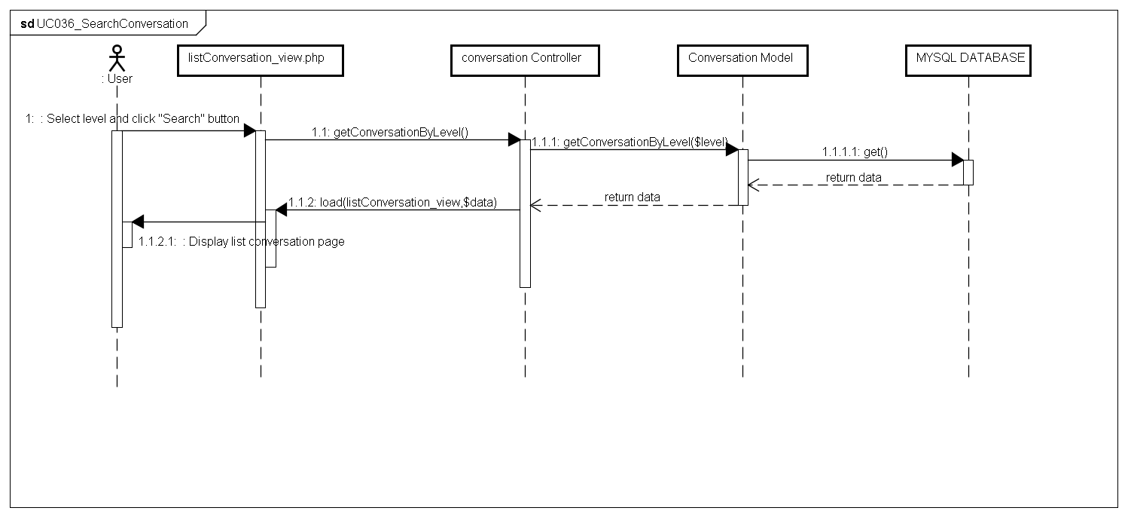

###### UC037_AddConversation

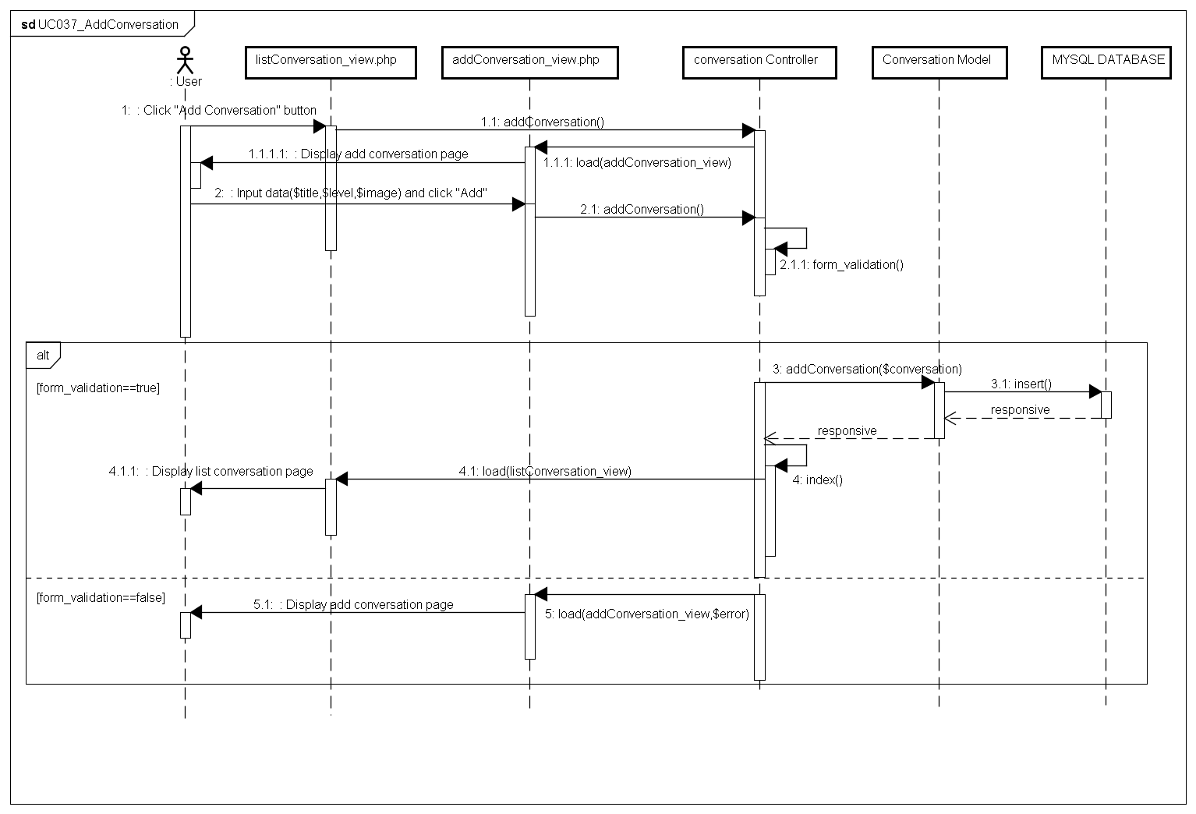

###### UC038_EditConversation

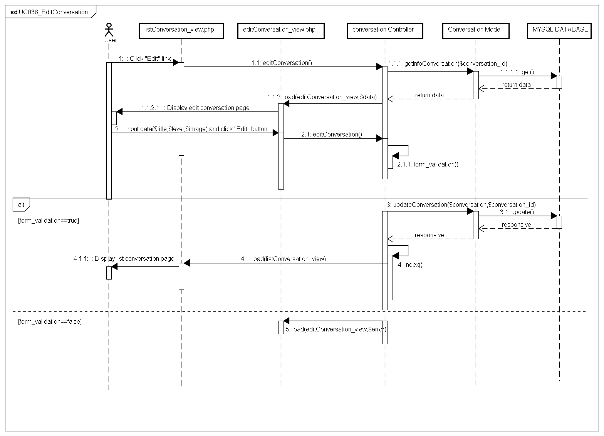

###### UC039_DeleteConversation

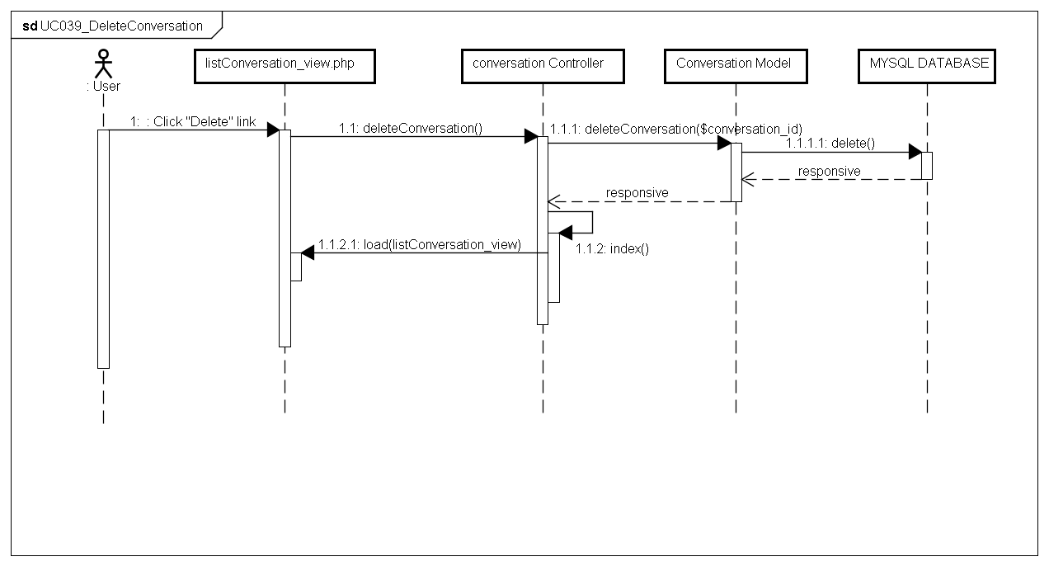

#### Video Package

##### Class diagram

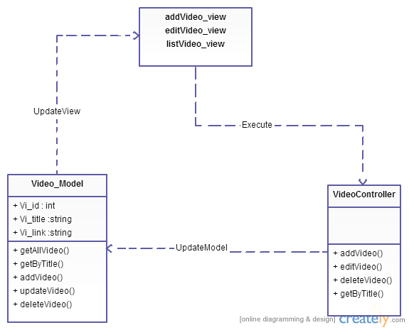

Figure 4-31: Class diagram Video package

|  |  |  |
| --- | --- | --- |
| No | Class Name | Description |
| 1 | Model_Video | Include method interact with database |
| 2 | VideoController | Include method interact with model |

##### Model_Video class

###### Attributes

|  |  |  |  |  |  |
| --- | --- | --- | --- | --- | --- |
| No | Attribute | Type | Default | Note | Description |
| 1. 1 | Vi_id | Number |  | private |  |
| 1. 2 | Vi_title | String |  | private |  |
| 1. 3 | Vi_link | String |  | Private |  |

###### Methods

|  |  |  |
| --- | --- | --- |
| No | Method | Description |
|  | getAllVideo() | Interact with database: get all video in database. |
|  | getByTitle() | Interact with database: get video in database that has title as keyword input. |
|  | addVideo() | Interact with database: save video to database that created. |
|  | updateVideo() | Interact with database: update video to database. |
|  | deleteVideo() | Interact with database: delete video in database. |

##### VideoController

###### Attributes

|  |  |  |  |  |  |
| --- | --- | --- | --- | --- | --- |
| No | Attribute | Type | Default | Note | Description |
|  |  |  |  |  |  |

###### Methods

|  |  |  |
| --- | --- | --- |
| No | Method | Description |
|  | addVideo() | Create Video |
|  | editVideo() | Edit Video |
|  | deleteVideo() | Delete Video |
|  | getByTitle() | Search Video |

##### Sequence Diagram

###### UC040_SearchVideo

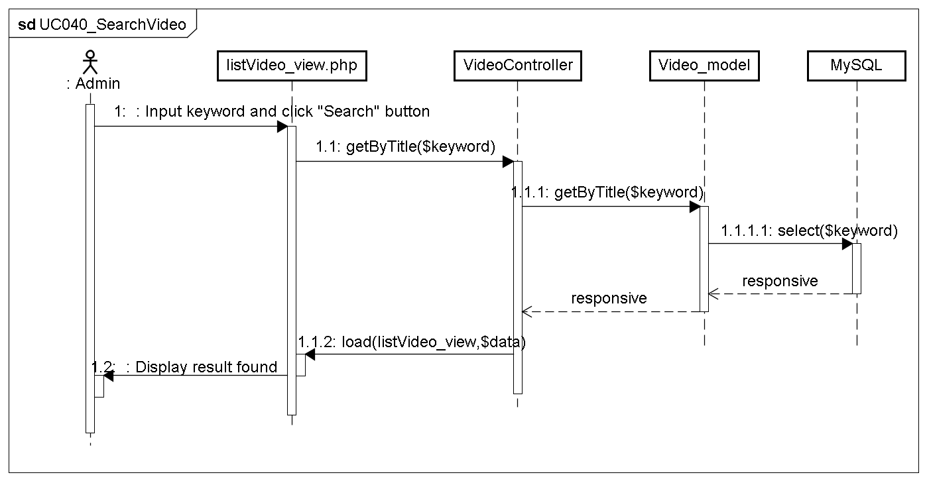

###### UC041_AddVideo

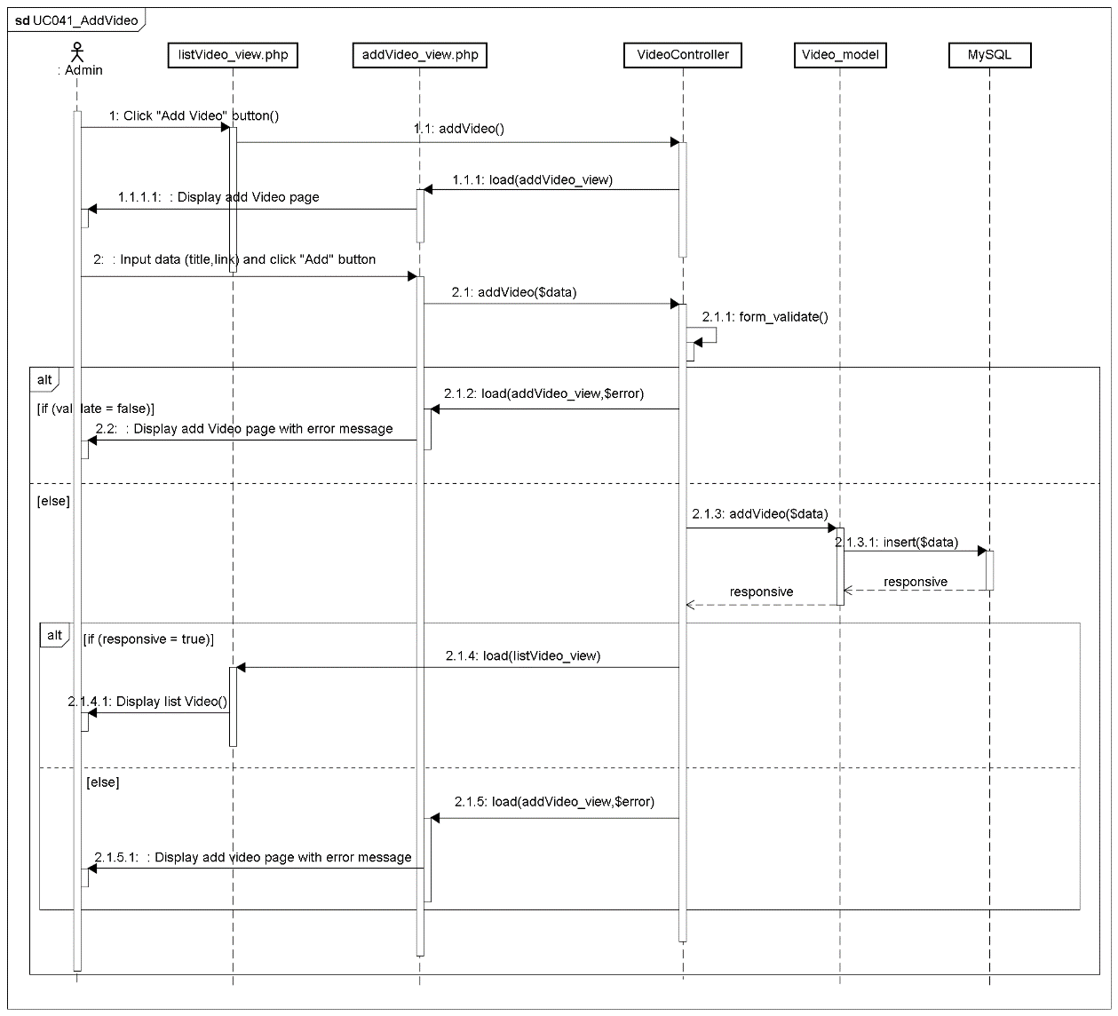

###### UC042_EditVideo

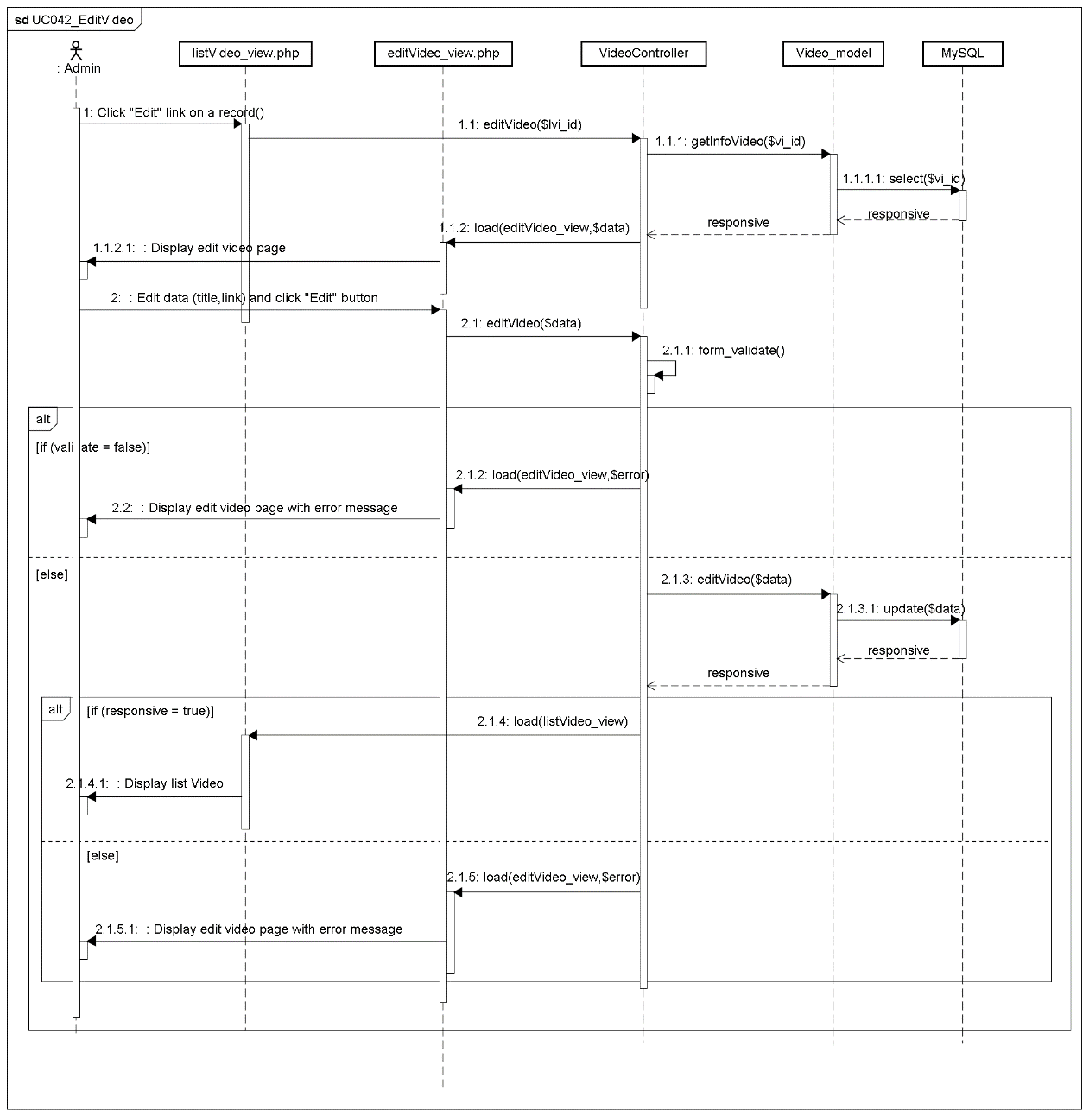

###### UC043_DeleteVideo

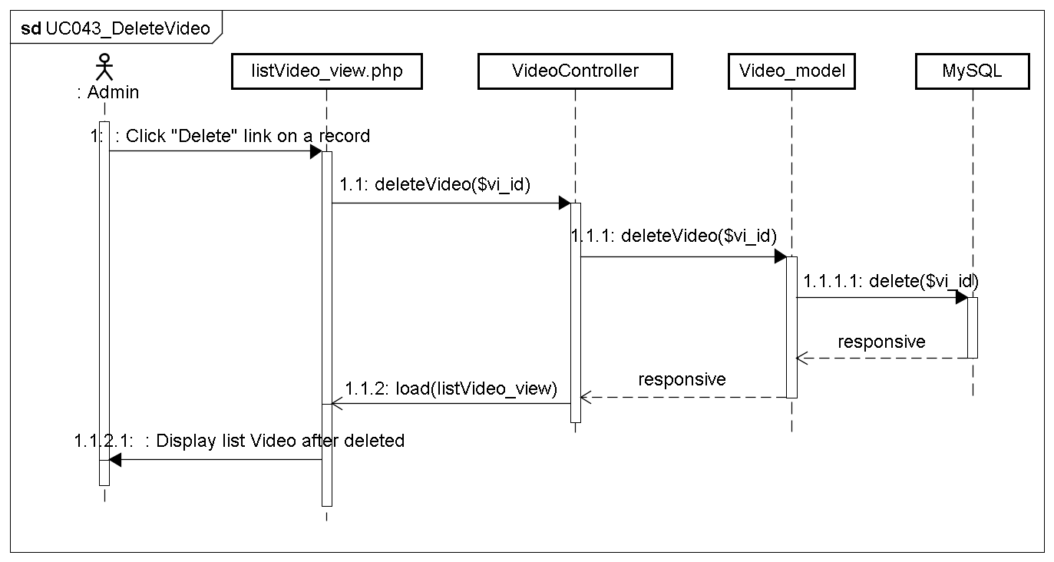

#### TrainingListening Package

##### Class diagram

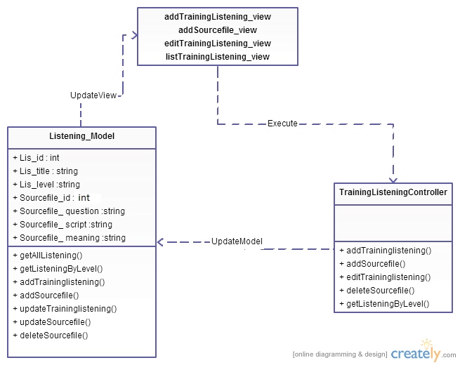

Figure 4-32: Class diagram TrainingListening package

|  |  |  |
| --- | --- | --- |
| No | Class Name | Description |
| 1 | Model_TrainingListening | Include method interact with database |
| 2 | TrainingListening Controller | Include method interact with model |

##### Model_TraniningListening class

###### Attributes

|  |  |  |  |  |  |
| --- | --- | --- | --- | --- | --- |
| No | Attribute | Type | Default | Note | Description |
| 1 | Lis_id | Number |  | private |  |
| 2 | Lis_title | String |  | private |  |
| 3 | Lis_level | String |  | Private |  |
| 4 | Sourcefile_id | String |  | Private |  |
| 5 | Sourcefile_ question | String |  | Private |  |
| 6 | Sourcefile_ script | String |  | Private |  |
| 7 | Sourcefile_ meaning | String |  | Private |  |

###### Methods

|  |  |  |
| --- | --- | --- |
| No | Method | Description |
| 1 | getAllListening() | Interact with database: get all listening in database. |
| 2 | getListeningByLevel() | Interact with database: get listening in database that has level as keyword input. |
| 3 | addTraininglistening() | Interact with database: save listening to database that created. |
| 4 | addSourcefile() | Interact with database: save content of listening to database that created . |
| 5 | updateTraininglistening() | Interact with database: update listening to database. |
| 6 | updateSourcefile() | Interact with database: update content of listening to database. |
| 7 | deleteTrainingListening() | Interact with database: delete listening in database. |

##### TrainingListeningController

###### Attributes

|  |  |  |  |  |  |
| --- | --- | --- | --- | --- | --- |
| No | Attribute | Type | Default | Note | Description |
|  |  |  |  |  |  |

###### Methods

|  |  |  |
| --- | --- | --- |
| No | Method | Description |
|  | addTraininglistening() | Create Training Listening |
|  | addSourcefile() | Add Source file |
|  | editTraininglistening() | Edit Training Listening |
|  | deleteSourcefile() | Delete Training Listening |
|  | getListeningByLevel() | Search Training Listening |

##### Sequence Diagram

###### UC044_SearchListening

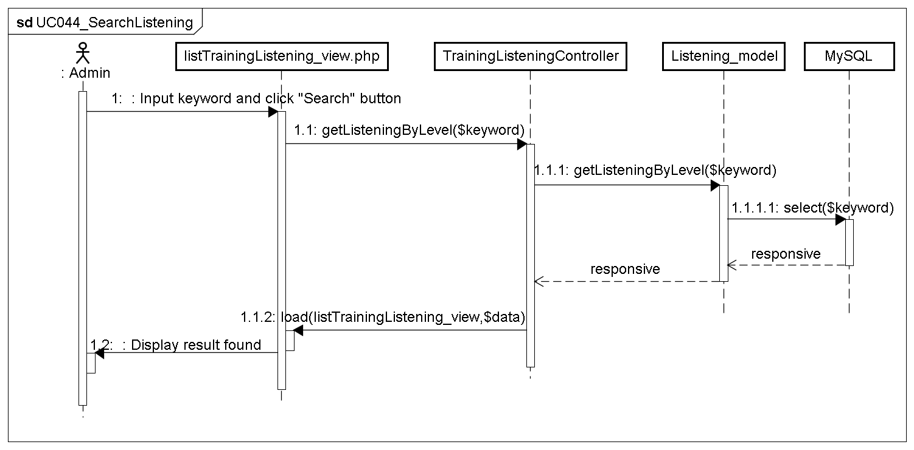

###### UC045_AddListening

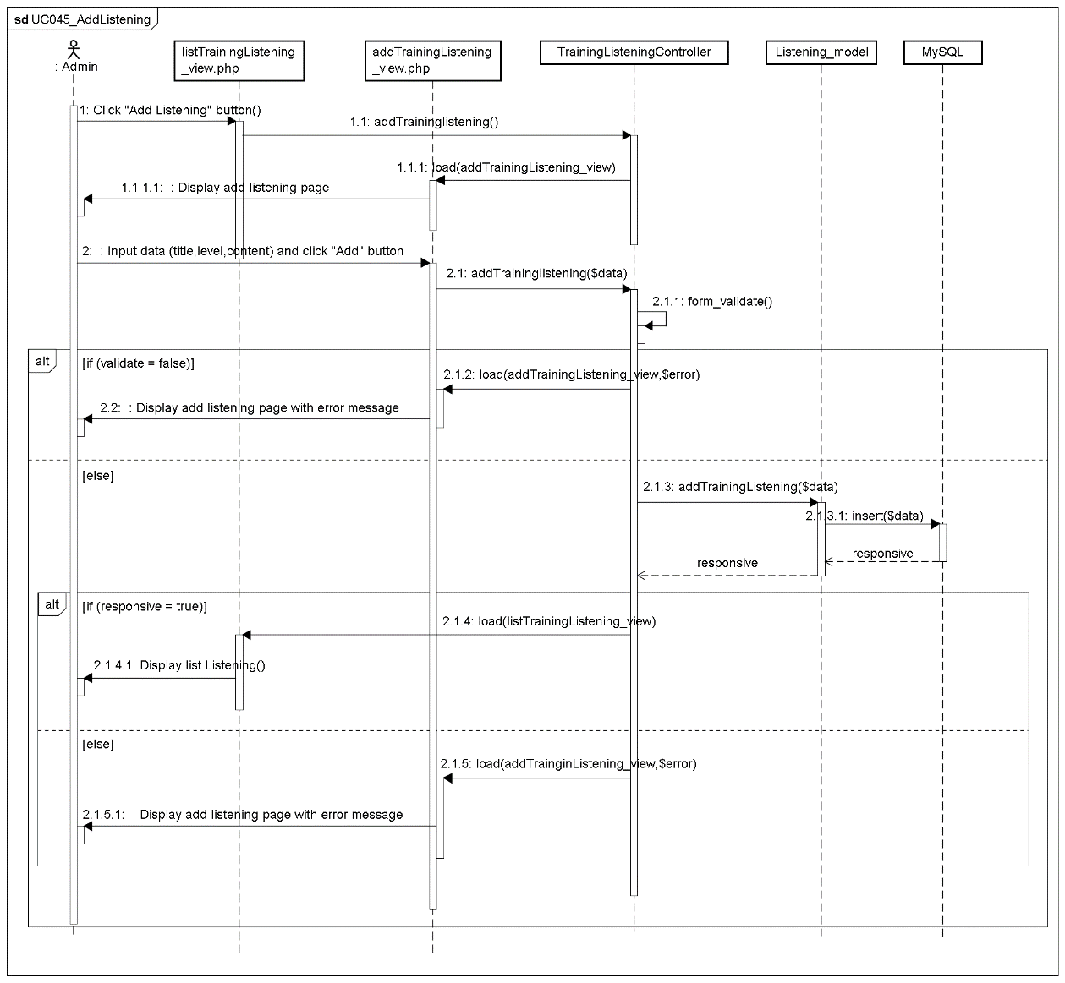

###### UC046_EditListening

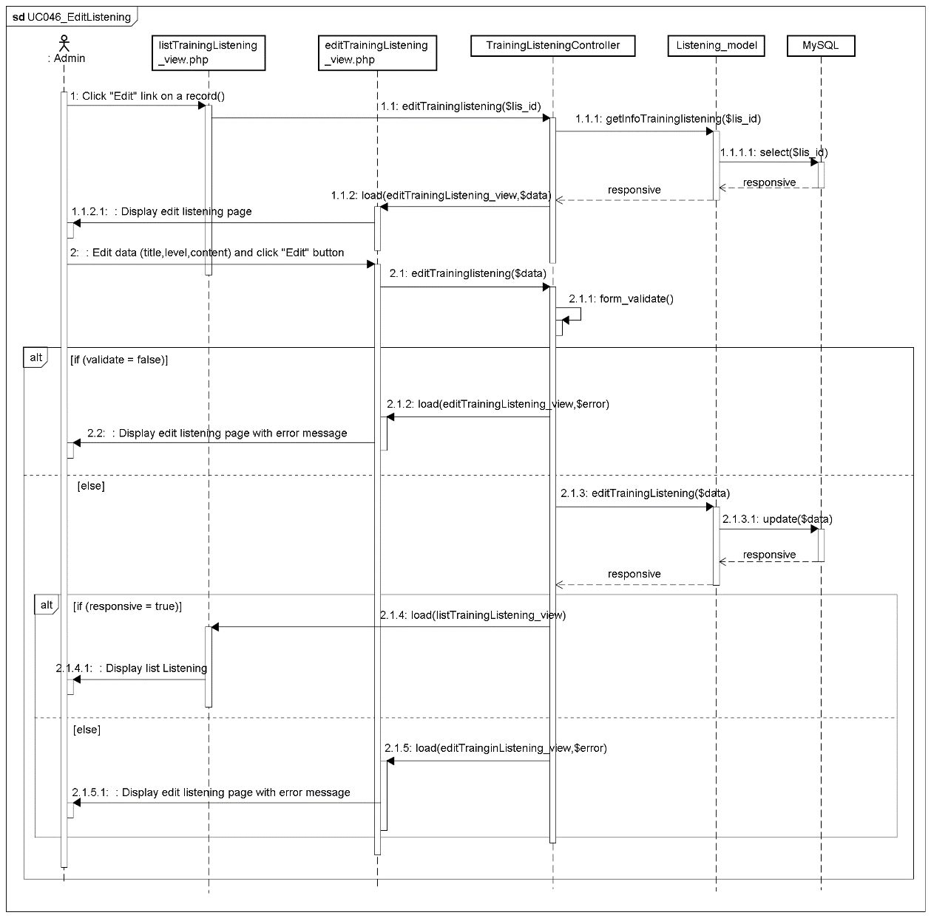

###### UC047_DeleteListening

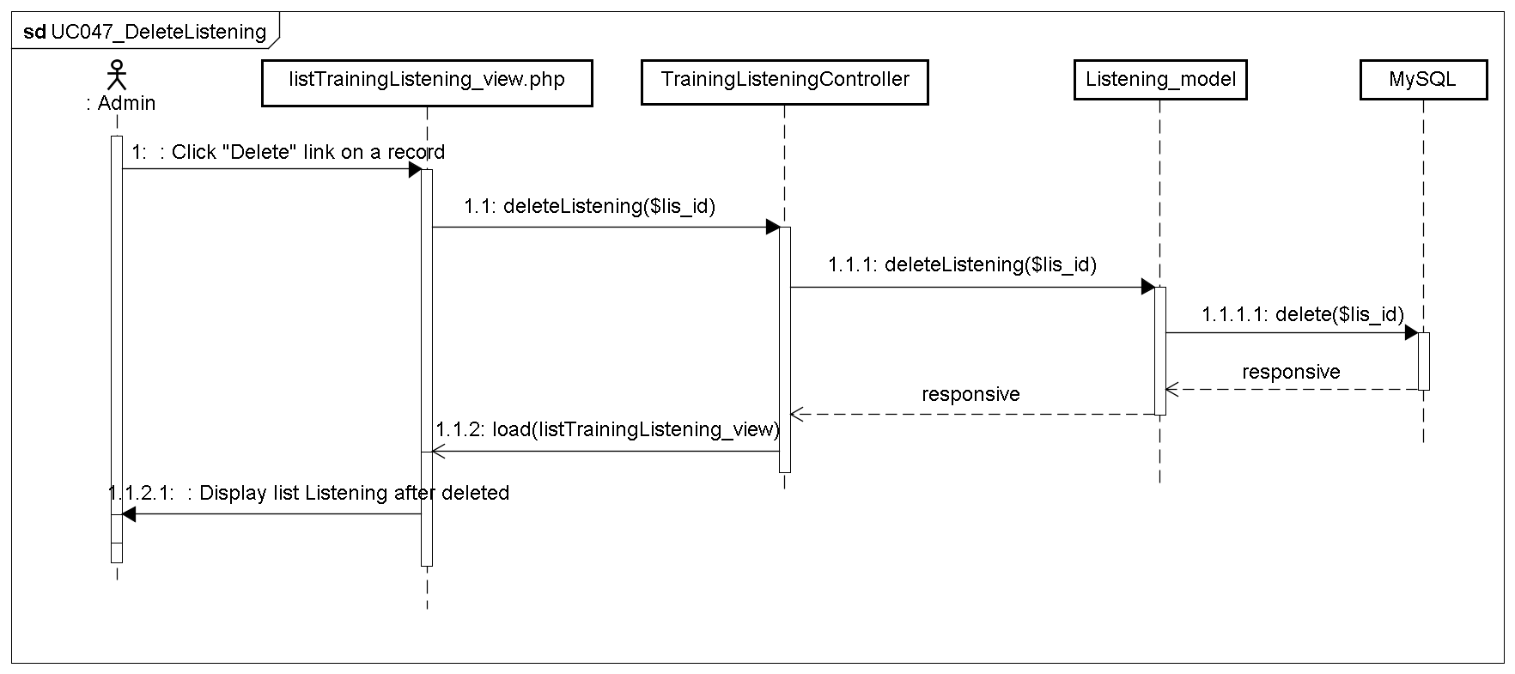

#### Test Management Package

##### Class diagram

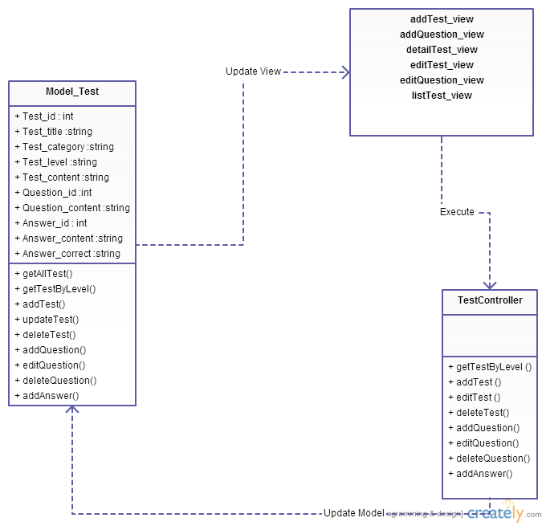

Figure 4-33: Class diagram Test package

|  |  |  |
| --- | --- | --- |
| No | Class Name | Description |
| 1 | Model_Test | Include method interact with database |
| 2 | Test Controller | Include method interact with model |

##### Model_Test class

###### Attributes

|  |  |  |  |  |  |
| --- | --- | --- | --- | --- | --- |
| No | Attribute | Type | Default | Note | Description |
| 1 | Test_id | Number |  | Private |  |
| 2 | Test_title | String |  | Private |  |
| 3 | Test_category | String |  | Private |  |
| 3 | Test_level | String |  | Private |  |
| 4 | Test_content | String |  | Private |  |
| 5 | Question_id | String |  | Private |  |
| 6 | Question_content | String |  | Private |  |
| 7 | Answer_id | Number |  | Private |  |
| 8 | Answer_content | String |  | Private |  |
| 9 | Answer_correct | Number |  | Private |  |

###### Methods

|  |  |  |
| --- | --- | --- |
| No | Method | Description |
| 1 | getAllTest () | Interact with database: get all test in database. |
| 2 | getTestByLevel () | Interact with database: get test in database that has level as keyword input. |
| 3 | addTest () | Interact with database: save test to database that created |
| 4 | updateTest() | Interact with database: update test to database. |
| 5 | deleteTest() | Interact with database: delete test in database. |
| 6 | addQuestion() | Interact with database: save question of test to database that created |
| 7 | updateQuestion() | Interact with database: update question of test to database. |
| 8 | deleteQuestion() | Interact with database: delete question of test in database. |
| 9 | addAnswer() | Interact with database: save answer of question to database that created |

##### TestController

###### Attributes

|  |  |  |  |  |  |
| --- | --- | --- | --- | --- | --- |
| No | Attribute | Type | Default | Note | Description |
|  |  |  |  |  |  |

###### Methods

|  |  |  |
| --- | --- | --- |
| No | Method | Description |
| 1 | getTestByLevel () | Search Test |
| 2 | addTest () | Create Test |
| 3 | editTest () | Edit Test |
| 4 | deleteTest() | Delete Test |
| 5 | addQuestion() | Add Question of Test |
| 6 | editQuestion() | Edit Question of Test |
| 7 | deleteQuestion() | Delete Question of Test |
| 8 | addAnswer() | Add Answer of Question |

##### Sequence Diagram

###### UC048_SearchTest

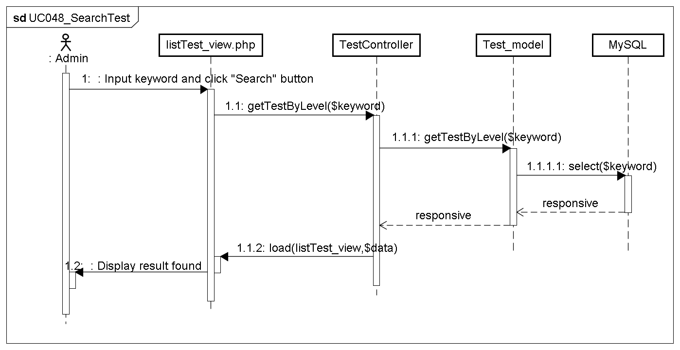

###### UC049_AddTest

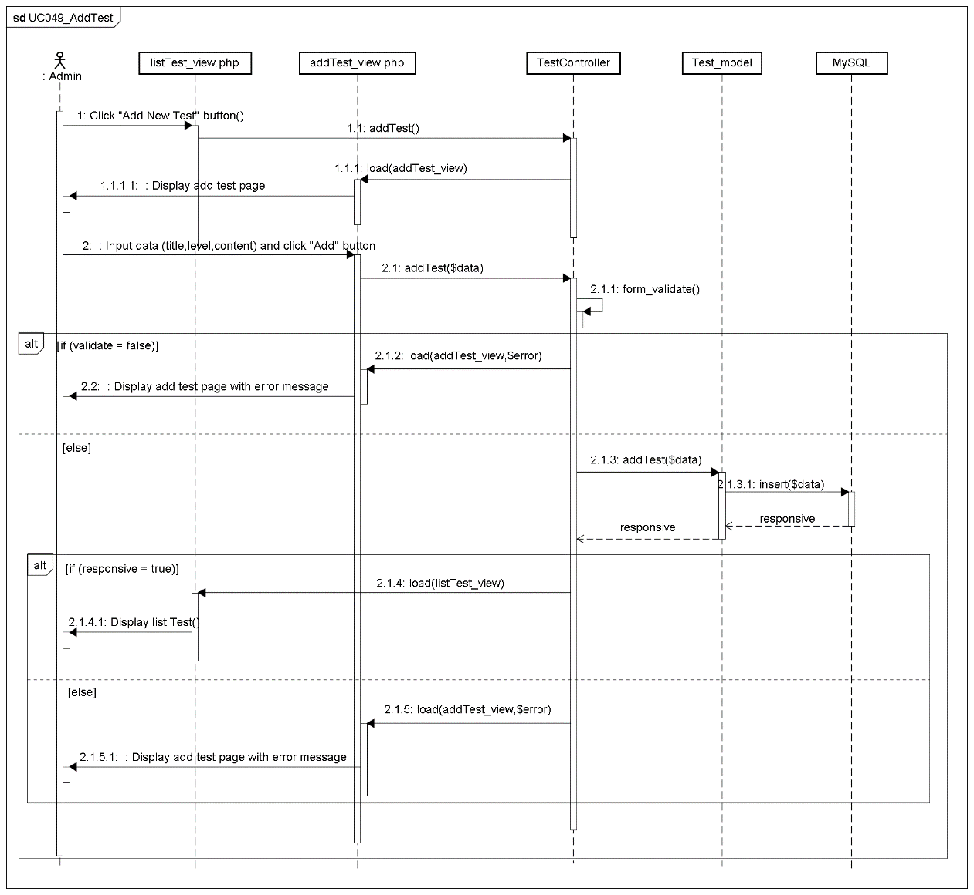

###### UC050_EditTest

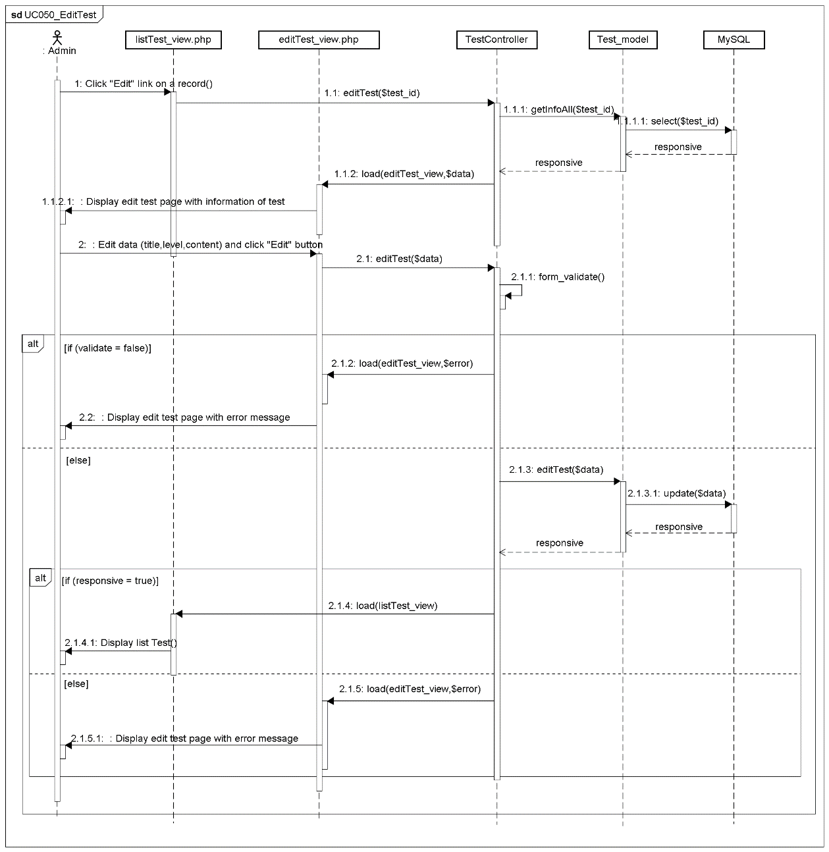

###### UC051_DeleteTest

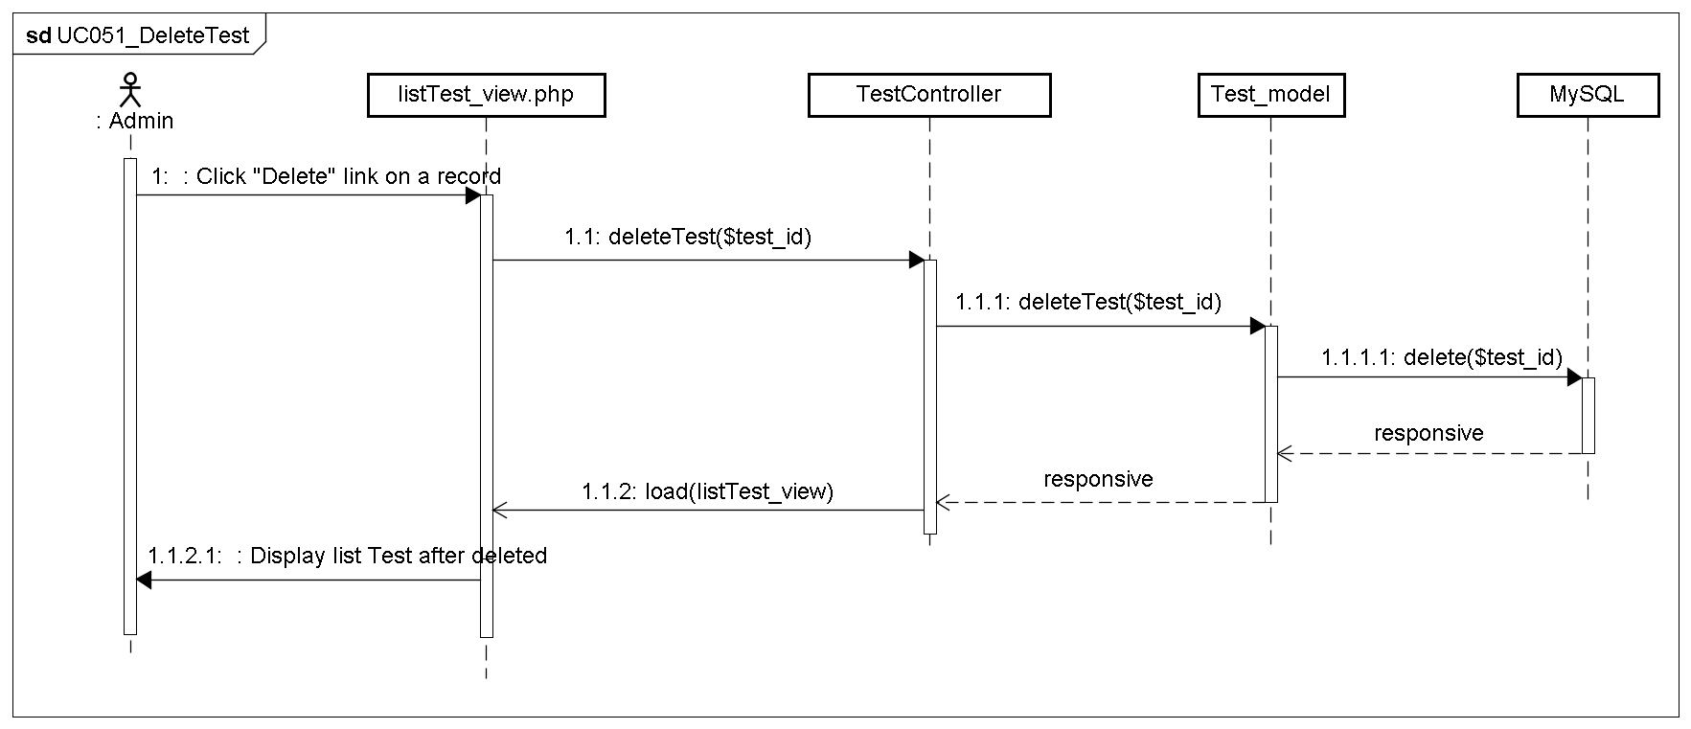

#### Contact management Package

##### Class diagram

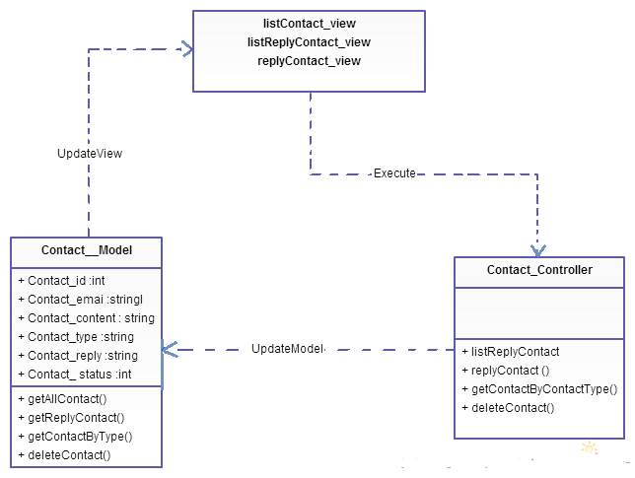

Figure 4-34: Class diagram Contact package

|  |  |  |
| --- | --- | --- |
| No | Class Name | Description |
| 1 | Model_Contact | Include method interact with database |
| 2 | ContactController | Include method interact with model |

##### Model_Contact class

###### Attributes

|  |  |  |  |  |  |
| --- | --- | --- | --- | --- | --- |
| No | Attribute | Type | Default | Note | Description |
| 1. 1 | Contact_id | Number |  | private |  |
| 1. 2 | Contact_email | String |  | private |  |
| 1. 3 | Contact_content | String |  | private |  |
|  | Contact_type | String |  | private |  |
|  | Contact_reply | String |  | Private |  |
|  | Contact_ status | Number |  | Private |  |

###### Methods

|  |  |  |
| --- | --- | --- |
| No | Method | Description |
|  | getAllContact() | Interact with database: get all contact in database that unanswered. |
|  | getReplyContact() | Interact with database: get all contact in database that answered. |
|  | getContactByType() | Interact with database: get contact in database that has type as keyword input. |
|  | deleteContact() | Interact with database: delete contact in database. |

##### ContactController

###### Attributes

|  |  |  |  |  |  |
| --- | --- | --- | --- | --- | --- |
| No | Attribute | Type | Default | Note | Description |
|  |  |  |  |  |  |

###### Methods

|  |  |  |
| --- | --- | --- |
| No | Method | Description |
|  | listReplyContact | List Contact |
|  | replyContact () | Reply Contact |
|  | getContactByContactType() | Search Contact |
|  | deleteContact() | Delete Contact |

##### Sequence Diagram

###### UC052_SearchContact

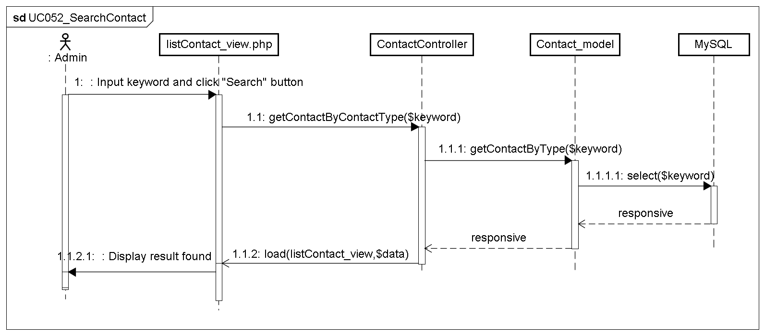

###### UC053_ReplyContact

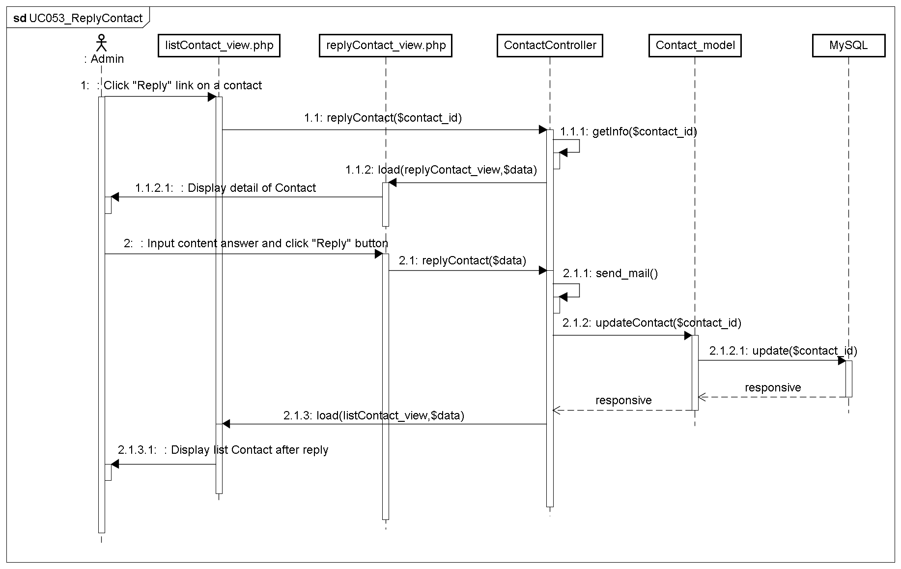

###### UC054_DeleteContact

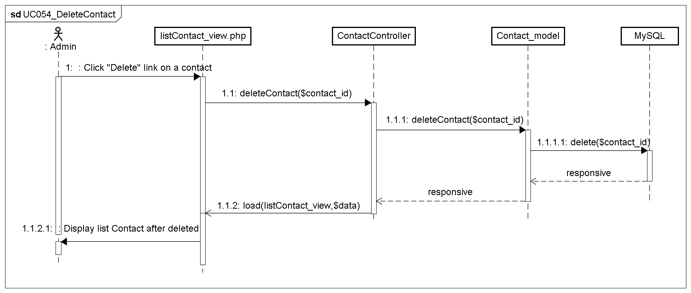

#### Contributed Content management

##### Class diagram

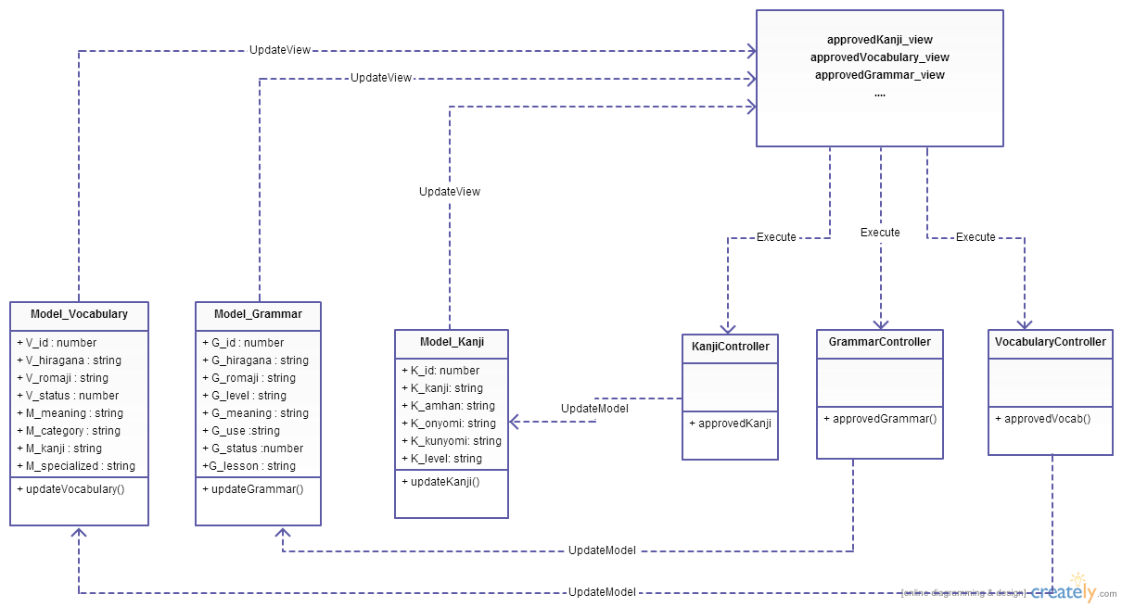

Figure 4-35: Class diagram Contributed Content Management package

|  |  |  |
| --- | --- | --- |
| No | Class Name | Description |
| 1 | Model_Vocabulary | Include method interact with database |
| 2 | Model_Grammar | Include method interact with database |
| 3 | Model_Kanji | Include method interact with database |
| 4 | VocabularyController | Include method interact with model |
| 5 | GrammarController | Include method interact with model |
| 6 | KanjiController | Include method interact with model |

##### Model_Grammar class

###### Attributes

|  |  |  |  |  |  |
| --- | --- | --- | --- | --- | --- |
| No | Attribute | Type | Default | Note | Description |
| 1. 1 | G_id | Number |  | private |  |
| 1. 2 | G_hiragana | String |  | private |  |
| 1. 3 | G_romaji | String |  | Private |  |
| 1. 3 | G_level | String |  | private |  |
|  | G_meaning | String |  | private |  |
|  | G_use | String |  | private |  |
|  | G_status | Number |  | Private |  |

###### Methods

|  |  |  |
| --- | --- | --- |
| No | Method | Description |
| 1 | approvedGrammar() | Interact with database: approved grammar in database that user contributed. |

##### Model_Vocabulary class

###### Attributes

|  |  |  |  |  |  |
| --- | --- | --- | --- | --- | --- |
| No | Attribute | Type | Default | Note | Description |
| 1. 1 | V_id | Number |  | private |  |
| 1. 2 | V_hiragana | String |  | private |  |
| 1. 3 | V_romaji | String |  | private |  |
| 1. 3 | V_status | Number |  | private |  |
|  | M_id | Number |  | private |  |
|  | M_meaningvn | String |  | private |  |
|  | M_category | String |  | private |  |
|  | M_kanji | String |  | private |  |
|  | M_specialized | String |  | private |  |

###### Methods

|  |  |  |
| --- | --- | --- |
| No | Method | Description |
| 1 | approvedVocabulary() | Interact with database: approved vocabulary in database that user contributed. |

##### Model_Kanji class

###### Attributes

|  |  |  |  |  |  |
| --- | --- | --- | --- | --- | --- |
| No | Attribute | Type | Default | Note | Description |
| 1. 1 | K_id | Number |  | private |  |
| 1. 2 | K_kanji | String |  | private |  |
| 1. 3 | K_amhan | String |  | private |  |
| 1. 3 | K_onyomi | String |  | private |  |
|  | K_kunyomi | String |  | private |  |
|  | K_level | String |  | private |  |

###### Methods

|  |  |  |
| --- | --- | --- |
| No | Method | Description |
| 1 | approvedKanji() | Interact with database: approved kanji in database that user contributed. |

##### GrammarController class

###### Attributes

|  |  |  |  |  |  |
| --- | --- | --- | --- | --- | --- |
| No | Attribute | Type | Default | Note | Description |
| 1 |  |  |  |  |  |

###### Methods

|  |  |  |
| --- | --- | --- |
| No | Method | Description |
|  | approvedGrammar() | Approved Grammar |

##### VocabularyController

###### Attributes

|  |  |  |  |  |  |
| --- | --- | --- | --- | --- | --- |
| No | Attribute | Type | Default | Note | Description |
| 1 |  |  |  |  |  |

###### Methods

|  |  |  |
| --- | --- | --- |
| No | Method | Description |
|  | approvedVocabulary() | Approved Vocabulary |

##### KanjiController

###### Attributes

|  |  |  |  |  |  |
| --- | --- | --- | --- | --- | --- |
| No | Attribute | Type | Default | Note | Description |
| 1 |  |  |  |  |  |

###### Methods

|  |  |  |
| --- | --- | --- |
| No | Method | Description |
|  | approvedKanji() | Approved Kanji |

##### Sequence Diagram

###### UC055_ApproveContribute

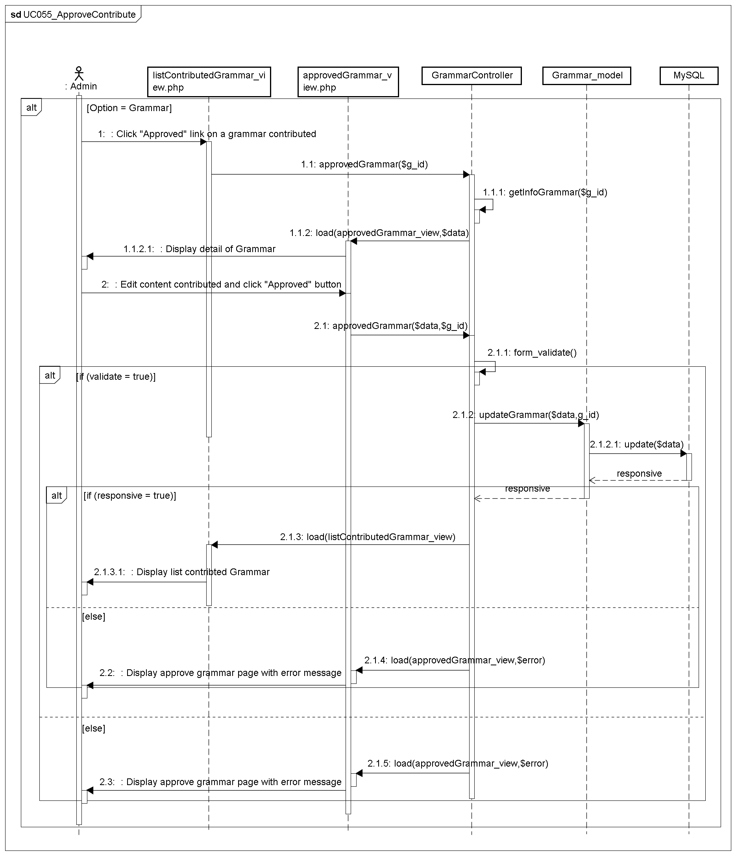

###### UC056_DeleteContribute

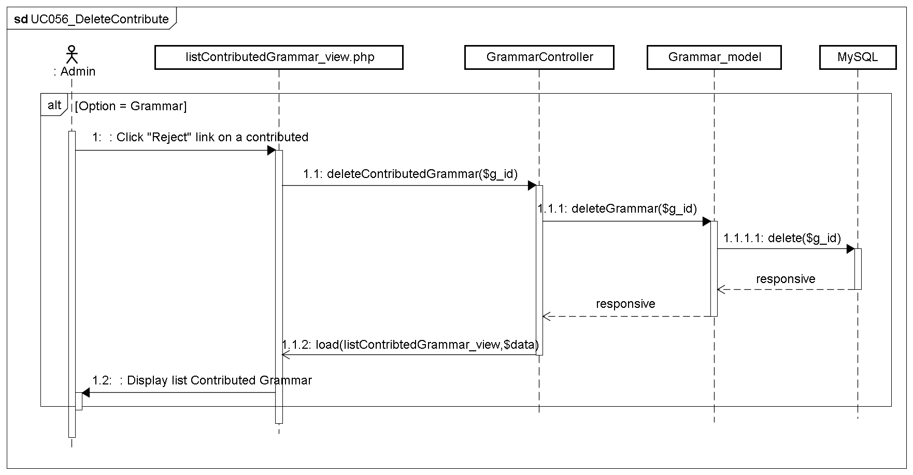

## Screen Design

### Screen Flow

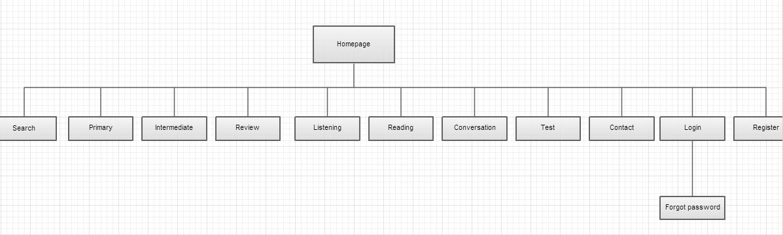

Figure 4-36: Screen Flow

|  |  |  |
| --- | --- | --- |
| No | Screen Name | Description |
| 1 | Homepage | Homepage |
| 2 | Primary | Primary lesson |
| 3 | Intermediate | Intermediate lesson (level N3, N2) |
| 4 | Review | Review lesson |
| 5 | Listening | Listening lesson |
| 6 | Reading | Reading lesson |
| 7 | Conversation | Conversation lesson |
| 8 | Test | Doing test (level N4,N3,N2) |
| 9 | Contact | To contact with UJD administrator |
| 11 | Login | Login as a member |
| 12 | Forgot password | Contact to admin to receive password |
| 13 | Register | Create new account |
| 14 | Search | Search |

Table 4-3: Screen Description

#### Search screen

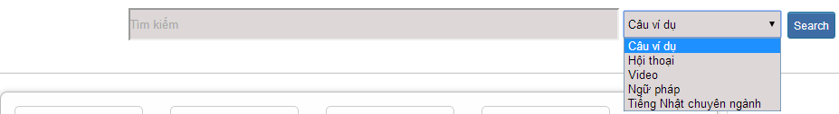

Figure 4-37: Search screen

|  |  |  |  |  |  |  |  |
| --- | --- | --- | --- | --- | --- | --- | --- |
| **No** | **Field name** | **Field name in Vietnamese** | **Type** | **Require** | **Mandatory** | **Max-Length** | **Description** |
| 1 | txtSearch | Tìm kiếm | Text | Text | Y | 255 | User input a new word with length less than 255 characters |
| 2 | SearchOption | Kiểu tìm kiếm | Drop-down list | Click | Y |  | User choose type of search |
| 2 | Search | Search | Button | Click | Y |  | User click on search button |

#### Login



Figure 4-38: Login screen

|  |  |  |  |  |  |  |  |
| --- | --- | --- | --- | --- | --- | --- | --- |
| **No** | **Field name** | **Field name in Vietnamese** | **Type** | **Require** | **Mandatory** | **Max-Length** | **Description** |
| 1 | Username | Tên đăng nhập | Text | Text | Y | 32 | User input username with length less than 32 character |
| 2 | Password | Mật khẩu | Password | Text | Y | 32 | User input their password with length less than 32 characters |
| 3 | Login | Đăng nhập | Button | Click | Y |  | User click on Login button |

#### Register



Figure 4-39: Register

|  |  |  |  |  |  |  |  |
| --- | --- | --- | --- | --- | --- | --- | --- |
| **No** | **Field name** | **Field name in Vietnamese** | **Type** | **Require** | **Mandatory** | **Max-Length** | **Description** |
| 1 | Username | Tên đăng nhập | Text | Text | Y | 32 | User input username with length less than 32 characters |
| 2 | Password | Mật khẩu | Password | Text | Y | 32 | User input their password with length less than 32 characters |
| 3 | Re-password | Nhập lại mật khẩu | Password | Text | Y | 32 | User re-input password with length less than 32 characters |
| 4 | Name | Họ và tên | Text | Text | Y | 100 | User input their name with length less than 100 characters |
| 5 | Email | Email | Text | Text | Y | 100 | User input email with length less than 32 characters |
| 6 | Capcha | Mã xác nhận | Text | Text | Y |  | User input the verification code |
| 7 | Register | Đăng ký | Button | Click | Y |  | User click Register button |

#### Edit profile

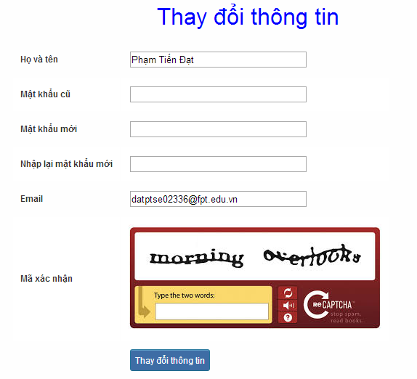

Figure 4-40: Edit profile

|  |  |  |  |  |  |  |  |
| --- | --- | --- | --- | --- | --- | --- | --- |
| **No** | **Field name** | **Field name in Vietnamese** | **Type** | **Require** | **Mandatory** | **Max-Length** | **Description** |
| 1 | Name | Họ và tên | Text | Text | Y | 100 | User input their name with length less than 100 characters |
| 2 | Old-Password | Mật khẩu cũ | Password | Text | Y | 32 | User input their old password with length less than 32 characters |
| 3 | New-password | Mật khẩu mới | Password | Text | Y | 32 | User input new password with length less than 32 characters |
| 4 | Re-password | Nhập lại mật khẩu mới | Password | Text | Y | 32 | User re-input password with length less than 32 characters |
| 5 | Email | Email | Text | Text | Y | 100 | User input email to with length less than 100 characters |
| 6 | Capcha | Mã xác nhận | Text | Text | Y |  | User input the verification code |
| 7 | Edit | Thay đổi thông tin | Button | Click | Y |  | User click on Edit button |

#### Forgot password

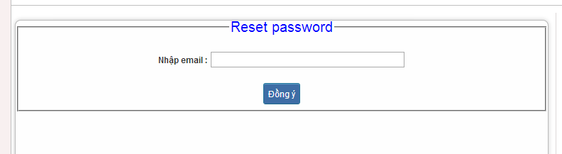

Figure 4-41: Forgot password

|  |  |  |  |  |  |  |  |
| --- | --- | --- | --- | --- | --- | --- | --- |
| **No** | **Field name** | **Field name in Vietnamese** | **Type** | **Require** | **Mandatory** | **Max-Length** | **Description** |
| 1 | Email | Email | Text | Text | Y | 100 | User input email with length less than 100 characters |
| 2 | Send | Đồng ý | Button | Click | Y |  | Click to receive password |

#### Contribute content



Figure 4-42: Contribute content

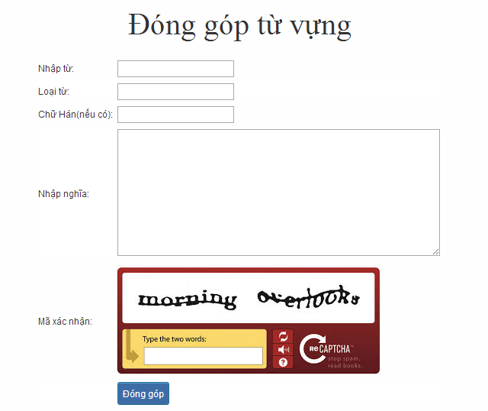

Figure 4-43: Contribute vocabulary

|  |  |  |  |  |  |  |  |
| --- | --- | --- | --- | --- | --- | --- | --- |
| **No** | **Field name** | **Field name in Vietnamese** | **Type** | **Require** | **Mandatory** | **Max-Length** | **Description** |
| 1 | Vocabulary | Từ | Text | Text | Y | 200 | User input vocabulary with length less than 200 characters |
| 2 | Category | Loại từ | Drop-down list | Click | Y |  | User choose type of category |
| 3 | Kanji | Chữ Hán | Text | Text | Y | 10 | User input kanji of vocabulary (if exist) with length less than 10 characters |
| 4 | Mean | Nhập nghĩa | Text | Text | Y | 500 | User input mean of vocabulary with length less than 500 characters |
| 5 | Capcha | Mã xác nhận | Text | Text | Y |  | User input the verification code |
| 6 | Contribute | Đóng góp | Button | Click | Y |  | User click on contribute button |

#### Contribute opinion



Figure 4-44: Contribute opinion

|  |  |  |  |  |  |  |  |
| --- | --- | --- | --- | --- | --- | --- | --- |
| **No** | **Field name** | **Field name in Vietnamese** | **Type** | **Require** | **Mandatory** | **Max-Length** | **Description** |
| 1 | Email | Email | Text | Text | Y | 100 | User input email with length less than100 characters |
| 2 | Content | Nhập nội dung | Text | Text | Y | 1000 | User input content with length less than1000 characters |
| 3 | Capcha | Mã xác nhận | Text | Text | Y |  | User input the verification code |
| 4 | Contribute | Đóng góp | Button | Click | Y |  | User click on contribute button |

#### Send Q&A



Figure 4-45: Send Q&A

|  |  |  |  |  |  |  |  |
| --- | --- | --- | --- | --- | --- | --- | --- |
| **No** | **Field name** | **Field name in Vietnamese** | **Type** | **Require** | **Mandatory** | **Max-Length** | **Description** |
| 1 | QA | Q&A | Text | Text | Y | 1000 | User input Q&A with length less than 1000 characters |
| 2 | Email | Email | Text | Text | Y | 100 | User input email with length less than 100 characters |
| 3 | Capcha | Mã xác nhận | Text | Text | Y |  | User input the verification code |
| 4 | Contribute | Đóng góp | Button | Click | Y |  | User click on contribute button |

#### Test

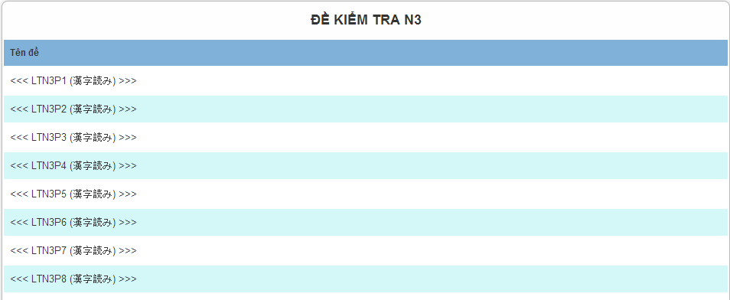

Figure 4-46: Doing test

|  |  |  |  |  |  |  |
| --- | --- | --- | --- | --- | --- | --- |
| **No** | **Field name** | **Type** | **Require** | **Mandatory** | **Length** | **Description** |
| 1 | N3P1 | Hyperlink | Click | N |  | Display information of test |
| 2 | N3P2 | Hyperlink | Click | N |  | Display information of test |
| 3 | N3P3 | Hyperlink | Click | N |  | Display information of test |
| 4 | N3P4 | Hyperlink | Click | N |  | Display information of test |
|  |  |  |  |  |  |  |

#### Training listening



Figure 4-47: Training listening

|  |  |  |  |  |  |  |
| --- | --- | --- | --- | --- | --- | --- |
| **No** | **Field name** | **Type** | **Require** | **Mandatory** | **Length** | **Description** |
| 1 | Choukai_P1 | Hyperlink | Click | N |  | Display information of listening |
| 2 | Choukai_P2 | Hyperlink | Click | N |  | Display information of listening |
| 3 | Choukai_P3 | Hyperlink | Click | N |  | Display information of listening |
| 4 | Choukai_P4 | Hyperlink | Click | N |  | Display information of listening |
| 5 | Choukai_P5 | Hyperlink | Click | N |  | Display information of listening |



Figure 4-48: Training listening content

|  |  |  |  |  |  |  |
| --- | --- | --- | --- | --- | --- | --- |
| **No** | **Field name** | **Field name in Vietnamese** | **Type** | **Require** | **Mandatory** | **Description** |
| 1 | Audio | Audio | Audio | Click | Y | User click play button |
| 2 | Translation and Answer | Dịch và đáp án | Link | Click | Y | User click to display translation and answer |

#### Conversation



Figure 4-49: Conversation

|  |  |  |  |  |  |  |
| --- | --- | --- | --- | --- | --- | --- |
| **No** | **Field name** | **Type** | **Require** | **Mandatory** | **Length** | **Description** |
| 1 | SC_P1 | Hyperlink | Click | N |  | Display information of conversation |
| 2 | SC_P2 | Hyperlink | Click | N |  | Display information of conversation |
| 3 | SC_P3 | Hyperlink | Click | N |  | Display information of conversation |
| 4 | SC_P4 | Hyperlink | Click | N |  | Display information of conversation |
| 5 | SC_P5 | Hyperlink | Click | N |  | Display information of conversation |



Figure 4-50: Conversation content

|  |  |  |  |  |  |  |
| --- | --- | --- | --- | --- | --- | --- |
| **No** | **Field name** | **Field name in Vietnamese** | **Type** | **Require** | **Mandatory** | **Description** |
| 1 | Translation | Dịch | Link | Click | Y | User click to display translation |

#### Reading



Figure 4-51: Reading document

#### Management Member’s account

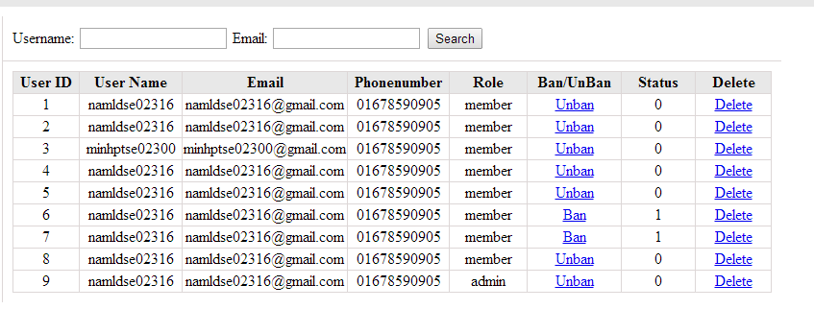

Figure 4-52: Management Member

|  |  |  |  |  |  |  |
| --- | --- | --- | --- | --- | --- | --- |
| **No** | **Field name** | **Type** | **Require** | **Mandatory** | **Max-Length** | **Description** |
| 1 | Username | Text | Text | Y | 32 | Admin input username to search member by username |
| 2 | Email | Text | Text | Y | 100 | Admin input email to search member by email |
| 3 | Ban/Unban | Button | Click | N |  | Admin click ban/unban member |
| 4 | Delete | Button | Click | N |  | Admin click delete member |

#### Vocabulary management

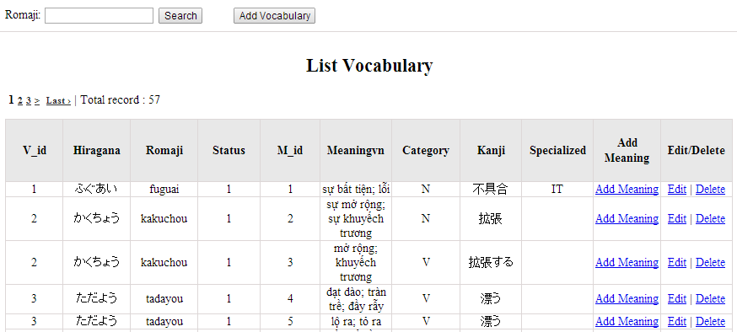

Figure 4-53: Vocabulary management

|  |  |  |  |  |  |  |
| --- | --- | --- | --- | --- | --- | --- |
| **No** | **Field name** | **Type** | **Require** | **Mandatory** | **Max-Length** | **Description** |
| 1 | Romaji | Text | Text | Y | 100 | Admin input romaji with length less than 100 character |
| 2 | Addnew | Button | Click | N |  | Admin add new vocabulary into database |
| 3 | Add meaning | Button | Click | Y |  | Admin add meaning of vocabulary |
| 4 | Edit | Button | Click | N |  | Admin click edit vocabulary |
| 5 | Delete | Button | Click | N |  | Admin click delete vocabulary |

#### Grammar management

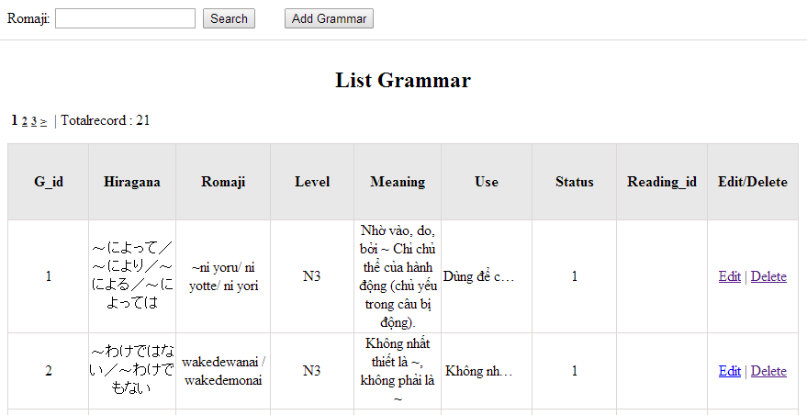

Figrure 4-54: Grammar management

|  |  |  |  |  |  |  |
| --- | --- | --- | --- | --- | --- | --- |
| **No** | **Field name** | **Type** | **Require** | **Mandatory** | **Max-Length** | **Description** |
| 1 | Romaji | Text | Text | Y | 100 | Admin input romaji with length less than 100 character |
| 2 | Addnew | Button | Click | N |  | Admin add new grammar into database |
| 3 | Edit | Button | Click | N |  | Admin click edit grammar |
| 4 | Delete | Button | Click | N |  | Admin click delete grammar |

#### Conversation management

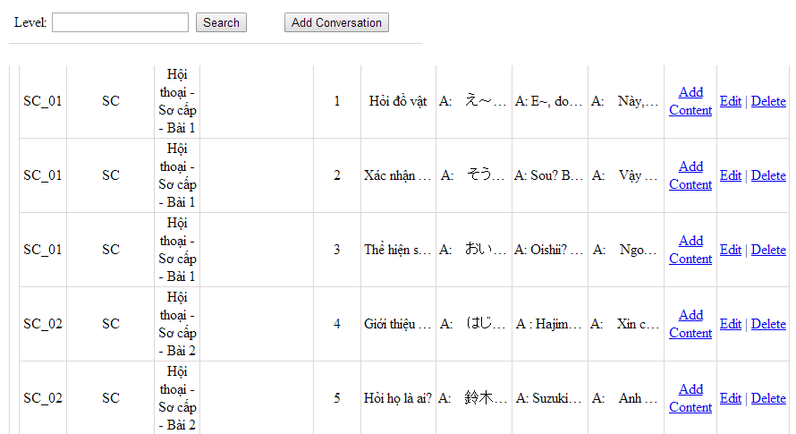

Figure 4-55: Conversation management

|  |  |  |  |  |  |  |
| --- | --- | --- | --- | --- | --- | --- |
| **No** | **Field name** | **Type** | **Require** | **Mandatory** | **Max-Length** | **Description** |
| 1 | Level | Text | Text | Y | 100 | Admin input level with length less than 100 characters |
| 2 | Addnew | Button | Click | N |  | Admin add new conversation into database |
| 3 | Add content | Button | Click | Y |  | Admin input content of conversation |
| 4 | Edit | Button | Click | N |  | Admin click edit conversation |
| 5 | Delete | Button | Click | N |  | Admin click delete conversation |

#### Video management

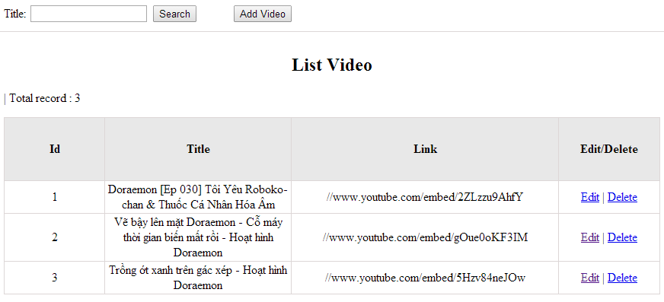

Figrure 4-56: Video management

|  |  |  |  |  |  |  |
| --- | --- | --- | --- | --- | --- | --- |
| **No** | **Field name** | **Type** | **Require** | **Mandatory** | **Max-Length** | **Description** |
| 1 | Title | Text | Text | Y | 100 | Admin input title with length less than 100 character |
| 2 | Addnew | Button | Click | N |  | Admin add new video into database |
| 3 | Edit | Button | Click | N |  | Admin click edit video |
| 4 | Delete | Button | Click | N |  | Admin click delete video |

#### Listening article management

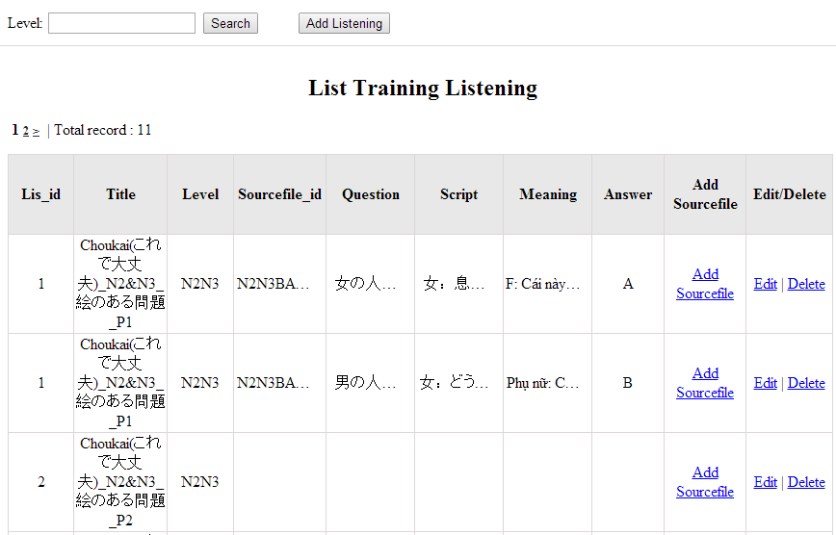

Figure 4-57: Listening article management

|  |  |  |  |  |  |  |
| --- | --- | --- | --- | --- | --- | --- |
| **No** | **Field name** | **Type** | **Require** | **Mandatory** | **Max-Length** | **Description** |
| 1 | Level | Text | Text | Y | 100 | Admin input level with length less than 100 characters |
| 2 | Addnew | Button | Click | N |  | Admin add new listening article into database |
| 3 | Add source | Button | Click | Y |  | Admin input source file |
| 4 | Edit | Button | Click | N |  | Admin click edit listening article |
| 5 | Delete | Button | Click | N |  | Admin click delete article |

#### Doing test management

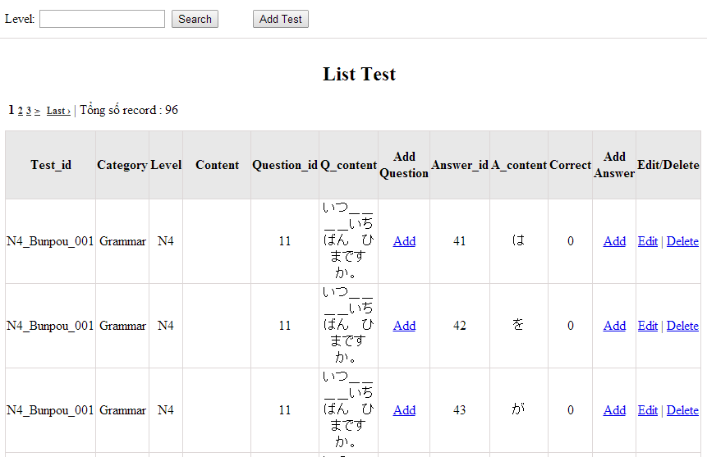

Figure 4-58: Doing test management

|  |  |  |  |  |  |  |
| --- | --- | --- | --- | --- | --- | --- |
| **No** | **Field name** | **Type** | **Require** | **Mandatory** | **Max-Length** | **Description** |
| 1 | Level | Text | Text | Y | 100 | Admin input level |
| 2 | Add new test | Button | Click | N |  | Admin add new test into database |
| 3 | Add question | Button | Click | N |  | Admin add question |
| 4 | Add answer | Button | Click | N |  | Admin add answer |
| 4 | Edit | Button | Click | N |  | Admin click edit test |
| 5 | Delete | Button | Click | N |  | Admin click delete test |

#### Search contribute content

1. Contribute kanji screen:

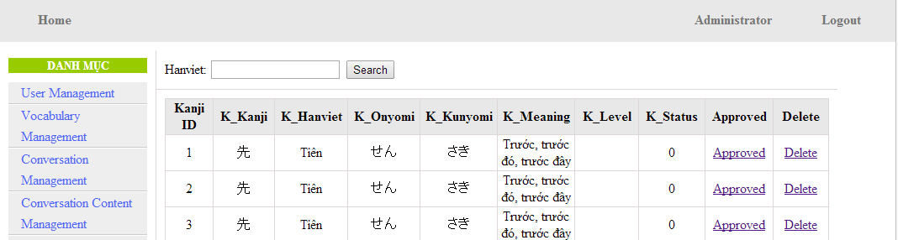

Figure 4-59: Contribute kanji’s screen

|  |  |  |  |  |  |  |
| --- | --- | --- | --- | --- | --- | --- |
| **No** | **Field name** | **Type** | **Require** | **Mandatory** | **Max-Length** | **Description** |
| 1 | HanViet | Text | Text | Y | 100 | Admin input to search |
| 2 | Approved | Button | Click | N |  | Admin click to approved contribute |
| 3 | Delete | Button | Click | N |  | Admin click delete contribute |

1. Contribute grammar screen:

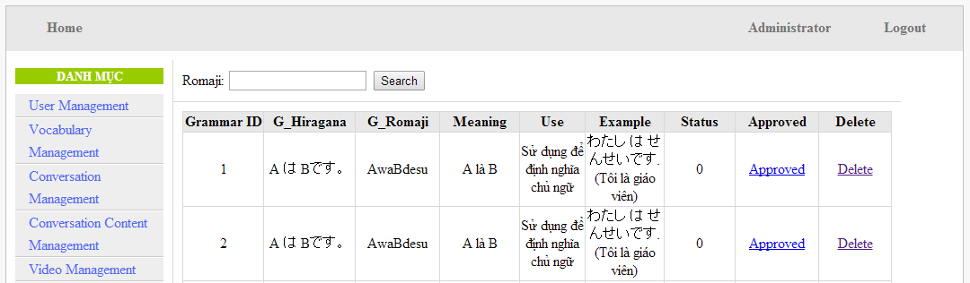

Figure 4-60: Contribute grammar’ screen:

|  |  |  |  |  |  |  |
| --- | --- | --- | --- | --- | --- | --- |
| **No** | **Field name** | **Type** | **Require** | **Mandatory** | **Max-Length** | **Description** |
| 1 | Romaji | Text | Text | Y | 100 | Admin input to search |
| 2 | Approved | Button | Click | N |  | Admin click to approved contribute |
| 3 | Delete | Button | Click | N |  | Admin click delete contribute |

1. Contribute vocabulary screen:

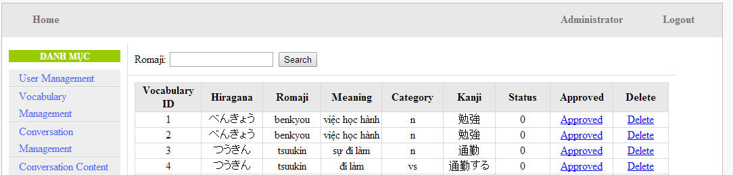

Figure 4-61: Contribute vocabulary screen:

|  |  |  |  |  |  |  |
| --- | --- | --- | --- | --- | --- | --- |
| **No** | **Field name** | **Type** | **Require** | **Mandatory** | **Max-Length** | **Description** |
| 1 | Romaji | Text | Text | Y | 100 | Admin input to search |
| 2 | Approved | Button | Click | N |  | Admin click to approved contribute |
| 3 | Delete | Button | Click | N |  | Admin click delete contribute |

#### Approve contribute content

1. Approve contribute kanji screen:

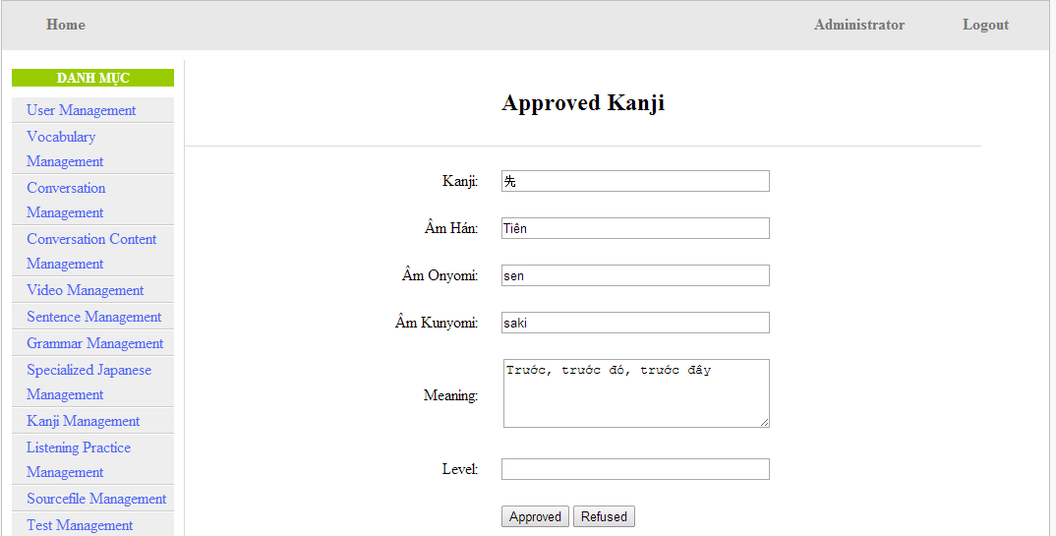

Figure 4-62: Approved kanji’s screen

|  |  |  |  |  |  |  |  |
| --- | --- | --- | --- | --- | --- | --- | --- |
| **No** | **Field name** | **File name in Vietnamese** | **Type** | **Require** | **Mandatory** | **Max-Length** | **Description** |
| 1 | Kanji | Kanji | Text | Text | Y | 10 | Admin input kanji |
| 2 | AmHan | Âm hán | Text | Text | N | 50 | Admin input to the field |
| 3 | Onyomi | Âm Onyomi | Text | Text | Y | 100 | Admin input onyomi |
| 4 | Kunyomi | Âm kunyomi | Text | Text | Y | 100 | Admin input kunyomi |
| 5 | Meaning | Nghĩa | Text | Text | Y | 200 | Admin input meaning |
| 6 | Level | Level | Text | Text | Y | 10 | Admin choose the level |
| 7 | Approved | Approved | Button | Click | N |  | Admin click to approved contribute |
| 8 | Refuse | Refuse | Button | Click | N |  | Admin click to refuse contribute |

1. Approve contribute grammar screen:

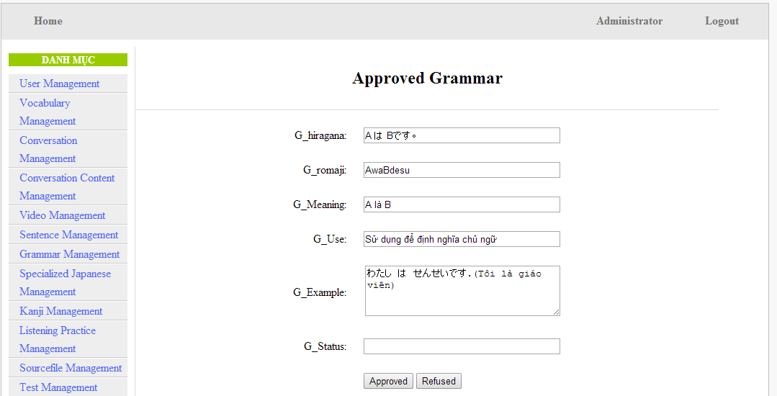

Figure 4-63: Approved grammar screen

|  |  |  |  |  |  |  |
| --- | --- | --- | --- | --- | --- | --- |
| **No** | **Field name** | **Type** | **Require** | **Mandatory** | **Max-Length** | **Description** |
| 1 | Hiragana | Text | Text | Y | 200 | Admin input hiragana |
| 2 | Romaji | Text | Text | N | 200 | Admin input romaji |
| 3 | Meaning | Text | Text | Y | 200 | Admin input meaning |
| 4 | Use | Text | Text | Y | 100 | Admin input kunyomi |
| 5 | Example | Text | Text | Y | 200 | Admin input meaning |
| 6 | Level | Text | Text | Y | 10 | Admin input level of grammar |
| 7 | Approved | Button | Click | N |  | Admin click to approved contribute |
| 8 | Refuse | Button | Click | N |  | Admin click to refuse contribute |

1. Approve contribute vocabulary screen:

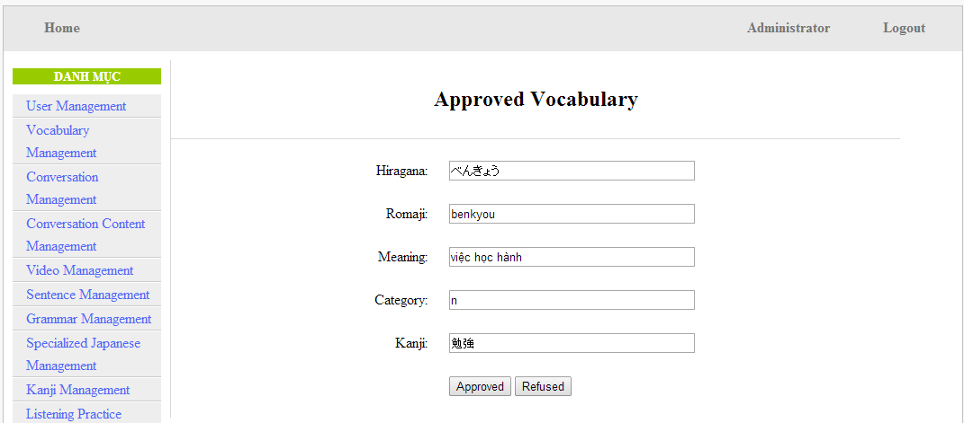

Table 4-64: Approved vocabulary

|  |  |  |  |  |  |  |
| --- | --- | --- | --- | --- | --- | --- |
| **No** | **Field name** | **Type** | **Require** | **Mandatory** | **Max-Length** | **Description** |
| 1 | Hiragana | Text | Text | Y | 200 | Admin input hiragana |
| 2 | Romaji | Text | Text | N | 200 | Admin input romaji |
| 3 | Meaning | Text | Text | Y | 500 | Admin input meaning |
| 4 | Category | Text | Text | Y | 10 | Admin choose category |
| 5 | Kanji | Text | Text | Y | 10 | Admin input kanji |
| 6 | Approved | Button | Click | N |  | Admin click to approved contribute |
| 7 | Refuse | Button | Click | N |  | Admin click to refuse contribute |

#### Contribute opinion management

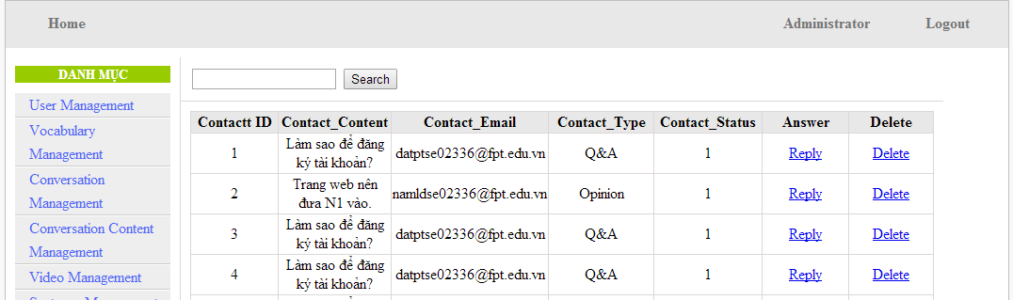

Figure 4-65: Contribute opinion management’s screen

|  |  |  |  |  |  |  |
| --- | --- | --- | --- | --- | --- | --- |
| **No** | **Field name** | **Type** | **Require** | **Mandatory** | **Max-Length** | **Description** |
| 1 | Reply | Button | Click | N |  | Admin click reply the question |
| 2 | Delete | Button | Click | N |  | Admin click delete question |

## Database design

### Table diagram

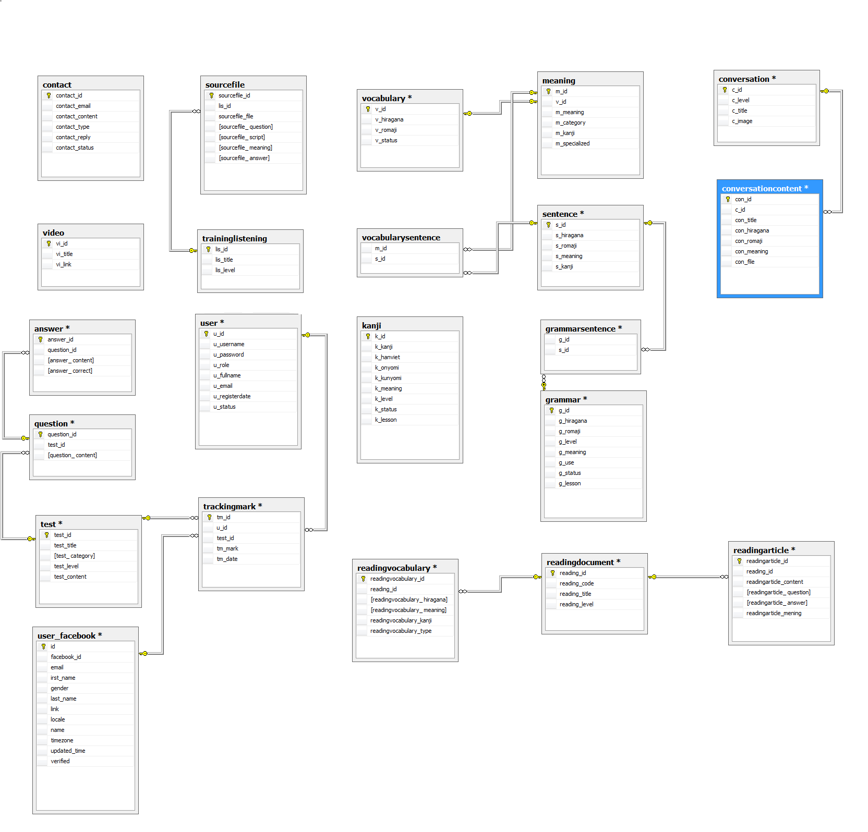

Figure 4-66: Table diagram

n

**List of tables and brief description**

|  |  |  |
| --- | --- | --- |
| **No** | **Table Name** | **Description** |
|  | user | Store all user information that registered by created new account. |
|  | user_facebook | Store all user information that registered by facebook. |
|  | vocabulary | Store some information of vocabulary. |
|  | meaning | Store some information of vocabulary. |
|  | sentence | Store all information of sentence. |
|  | vocabularySentence | Store id of Vocabulary and Sentence. |
|  | grammar | Store all information of grammar. |
|  | grammarsentence | Store id of Grammar and Sentence. |
|  | video | Store all information of video. |
|  | kanji | Store all information of kanji. |
|  | conversation | Store information of conversation. |
|  | conversationcontent | Store information of conversation. |
|  | contact | Store all content of contact that member send to admin. |
|  | traininglistening | Store information of listening. |
|  | sourcefile | Store information of listening. |
|  | readingdocument | Store information of document. |
|  | readingvocabulary | Store all information of vocabulary in document. |
|  | test | Store information of test. |
|  | question | Store content of question of test. |
|  | readingarticle | Store all information of article. |
|  | trackingmark | Store all information of user who did test. |
|  | answer | Store answer of question. |

### User table

|  |  |  |  |  |  |  |  |  |
| --- | --- | --- | --- | --- | --- | --- | --- | --- |
| No | Field Name | Type | Length | Null | Unique | P/F Key | Default | Description |
| 1 | u_id | Int |  |  |  | P |  | PRIMARY KEY  This is automatically increase value 1 |
| 2 | u_username | Varchar | 32 |  | Y |  |  | Username login |
| 3 | u_password | Varchar | 32 |  |  |  |  | Store password login of user.  Using md5 algorithm. |
| 4 | u_role | int |  |  |  |  |  | Admin can assign permission for user |
| 5 | u_fullname | Varchar | 100 | V |  |  |  | User’s name display |
| 6 | u_email | Varchar | 100 |  | Y |  |  | User’s email |
| 7 | u_registerdate | Date |  |  |  |  |  | Date register |
| 8 | u_status | Int |  |  |  |  |  | Active or deactive |

### User_facebook table

|  |  |  |  |  |  |  |  |
| --- | --- | --- | --- | --- | --- | --- | --- |
| No | Field Name | Type | Length | Null | Unique | P/F Key | Description |
|  | id | Int |  |  |  | P | PRIMARY KEY  This is automatically increase value 1 |
|  | facebook_id | Varchar | 50 |  | Y |  | ID of facebook |
|  | email | Varchar | 200 |  |  |  | Email of user facebook |
|  | first_name | int |  |  |  |  | First name of user facebook |
| 1. gen | gender | Varchar | 20 |  |  |  | Gender of user facebook |
|  | last_name | Varchar | 50 |  |  |  | Last name of user facebook |
|  | link | varchar | 200 |  |  |  | Link of user facebook |
|  | locale | varchar | 20 |  |  |  | Locale of user facebook |
|  | name | varchar | 50 |  |  |  | Name of user facebook |
|  | timezone | varchar | 10 |  |  |  | Timezone of user facebook |
|  | update_time | varchar | 50 |  |  |  | Update time of user facebook |
|  | verified | varchar | 10 |  |  |  | Verified of user facebook |

### Vocabulary table

|  |  |  |  |  |  |  |  |
| --- | --- | --- | --- | --- | --- | --- | --- |
| No | Field Name | Type | Length | Null | Unique | P/F Key | Description |
| 1 | v_id | Int |  |  |  | P | PRIMARY KEY  This is automatically increase value 1 |
| 2 | v_hiragana | varchar | 200 |  | Y |  | Vocabulary’s hiragana |
| 3 | v_romaji | Varchar | 200 |  |  |  | Vocabulary’s romaji |
| 4 | v_status | int |  |  |  |  | Vocabulary’s status |

### Meaning table

|  |  |  |  |  |  |  |  |
| --- | --- | --- | --- | --- | --- | --- | --- |
| No | Field Name | Type | Length | Null | Unique | P/F Key | Description |
|  | m_id | Int |  |  |  | P | PRIMARY KEY  This is automatically increase value 1 |
|  | v_id | Int |  |  |  | FK | Foreign key to Vocabulary |
|  | m_meaningvn | varchar | 500 |  | Y |  | Meaning of vocabulary |
|  | m_category | Varchar | 10 |  |  |  | Category of vocabulary |
|  | m_kanji | Varchar | 10 | V |  |  | Kanji of vocabulary |
|  | m_specialized | varchar | 200 | V |  |  | Vocabulary’s specialized |

### Sentence table

|  |  |  |  |  |  |  |  |
| --- | --- | --- | --- | --- | --- | --- | --- |
| No | Field Name | Type | Length | Null | Unique | P/F Key | Description |
|  | s_id | Int |  |  |  | P | PRIMARY KEY  This is automatically increase value 1 |
|  | s_hiragana | varchar | 1000 |  |  |  | Sentence’s hiragana |
|  | s_romaji | Varchar | 1000 |  |  |  | Sentence’s romaji |
|  | s_meaning | varchar | 1000 |  |  |  | Sentence’s meaning |
|  | s_kanji | varchar | 1000 |  |  |  | Sentence’s kanji |

### Vocabularysentence table

|  |  |  |  |  |  |  |  |
| --- | --- | --- | --- | --- | --- | --- | --- |
| No | Field Name | Type | Length | Null | Unique | P/F Key | Description |
|  | m_id | Int |  |  |  | FK | Foreign key to Meaning |
|  | s_id | Int |  |  |  | FK | Foreign key to Sentence |

### Grammar table

|  |  |  |  |  |  |  |  |
| --- | --- | --- | --- | --- | --- | --- | --- |
| No | Field Name | Type | Length | Null | Unique | P/F Key | Description |
|  | g_id | Int |  |  |  | P | PRIMARY KEY  This is automatically increase value 1 |
|  | g_hiragana | varchar | 200 |  | Y |  | Grammar’s hiragana |
|  | g_romaji | Varchar | 200 |  |  |  | Grammar’s romaji |
|  | g_level | Varchar | 10 |  |  |  | Grammar’s level |
|  | g_meaning | varchar | 200 |  |  |  | Grammar’s meaning |
|  | g_use | varchar | 1000 |  |  |  | Grammar’s use |
|  | g_status | int |  |  |  |  | Grammar’s status |
|  | g_lesson | Varchar | 20 | V |  |  | Grammar’s lesson |

### Grammarsentence table

|  |  |  |  |  |  |  |  |
| --- | --- | --- | --- | --- | --- | --- | --- |
| No | Field Name | Type | Length | Null | Unique | P/F Key | Description |
|  | g_id | Int |  |  |  | FK | Foreign key to Grammar |
|  | s_id | Int |  |  |  | FK | Foreign key to Sentence |

### Video table

|  |  |  |  |  |  |  |  |
| --- | --- | --- | --- | --- | --- | --- | --- |
| No | Field Name | Type | Length | Null | Unique | P/F Key | Description |
|  | vi_id | Int |  |  |  | P | PRIMARY KEY  This is automatically increase value 1 |
|  | vi_title | varchar | 200 |  |  |  | Video’s title |
|  | vi_link | varchar | 200 |  | Y |  | Video’s link |

### Kanji table

|  |  |  |  |  |  |  |  |
| --- | --- | --- | --- | --- | --- | --- | --- |
| No | Field Name | Type | Length | Null | Unique | P/F Key | Description |
|  | k_id | Int |  |  |  | P | PRIMARY KEY  This is automatically increase value 1 |
|  | k_kanji | varchar | 10 |  | Y |  | Kanji in Japanese |
|  | k_hanviet | varchar | 50 |  |  |  | Kanji’s Vietnamese-Han |
|  | k_onyomi | varchar | 100 | V |  |  | Kanji’s onyomi |
|  | k_kunyomi | varchar | 100 | V |  |  | Kanji’s kunyomi |
|  | k_meaning | varchar | 200 |  |  |  | Kanji’s meaning |
|  | k_level | varchar | 10 |  |  |  | Kanji’s level |
|  | k_status | int |  |  |  |  | Kanji’s status |
|  | k_lesson | varchar | 20 | V |  |  | Kanji’s lesson |

### Conversation table

|  |  |  |  |  |  |  |  |
| --- | --- | --- | --- | --- | --- | --- | --- |
| No | Field Name | Type | Length | Null | Unique | P/F Key | Description |
|  | c_id | int |  |  |  | P | PRIMARY KEY  This is automatically increase value 1 |
|  | c_level | varchar | 10 |  |  |  | Conversation’s level |
|  | c_title | varchar | 100 |  |  |  | Conversation’s title |
| 1. C_ | c_image | Varchar | 200 | V |  |  | Conversation’s image |

### Conversationcontent table

|  |  |  |  |  |  |  |  |
| --- | --- | --- | --- | --- | --- | --- | --- |
| No | Field Name | Type | Length | Null | Unique | P/F Key | Description |
|  | con_id | Int |  |  |  | P | PRIMARY KEY  This is automatically increase value 1 |
|  | c_id | int |  |  |  | FK | Foreign key to Sentence |
|  | con_title | Varchar | 200 |  |  |  | Content’s title |
|  | con_hiragana | varchar | 5000 |  |  |  | Conversation’s hiragana |
|  | con_romaji | Varchar | 5000 |  |  |  | Conversation’s romaji |
|  | con_meaning | varchar | 5000 |  |  |  | Conversation’s meaning |
| 1. c | con_file | Varchar | 200 |  |  |  | File listen of conversation |

### Contact table

|  |  |  |  |  |  |  |  |
| --- | --- | --- | --- | --- | --- | --- | --- |
| No | Field Name | Type | Length | Null | Unique | P/F Key | Description |
|  | contact_id | Int |  |  |  | P | PRIMARY KEY  This is automatically increase value 1 |
|  | contact_email | varchar | 100 |  |  |  | Contact’s email |
|  | contact_content | varchar | 5000 |  |  |  | Contact’s content |
|  | contact_type | varchar | 10 |  |  |  | Contact’s type |
|  | contact_reply | varchar | 5000 | V |  |  | Contact’s reply |
|  | contact_status | int |  |  |  |  | Contact’s status |

### Traininglistening table

|  |  |  |  |  |  |  |  |
| --- | --- | --- | --- | --- | --- | --- | --- |
| No | Field Name | Type | Length | Null | Unique | P/F Key | Description |
|  | lis_id | int |  |  |  | P | PRIMARY KEY  This is automatically increase value 1 |
|  | lis_title | Varchar | 500 |  |  |  | Listening’s title |
|  | lis_level | varchar | 10 |  |  |  | Listening’s level |

### Sourcefile table

|  |  |  |  |  |  |  |  |
| --- | --- | --- | --- | --- | --- | --- | --- |
| No | Field Name | Type | Length | Null | Unique | P/F Key | Description |
|  | sourcefile_id | int |  |  |  | P | PRIMARY KEY  This is automatically increase value 1 |
|  | lis_id | Int |  |  |  | FK | Foreign key to TrainingListening |
|  | sourcefile_file | Varchar | 100 |  |  |  | Listen’s file |
|  | sourcefile_ question | varchar | 5000 |  |  |  | Listen’s question |
|  | sourcefile_ script | varchar | 5000 |  |  |  | Listen’s script |
|  | sourcefile_ meaning | varchar | 5000 |  |  |  | Listen’s meaning |
|  | sourcefile_ answer | Varchar | 100 |  |  |  | Listen’s answer |

### Readingdocument table

|  |  |  |  |  |  |  |  |
| --- | --- | --- | --- | --- | --- | --- | --- |
| No | Field Name | Type | Length | Null | Unique | P/F Key | Description |
|  | reading_id | int |  |  |  | P | PRIMARY KEY  This is automatically increase value 1 |
|  | reading_code | varchar | 50 |  |  |  | Reading’s code |
|  | reading_title | varchar | 100 |  |  |  | Reading’s title |
|  | reading_level | varchar | 10 |  |  |  | Reading’s level |

### Readingvocabulary table

|  |  |  |  |  |  |  |  |
| --- | --- | --- | --- | --- | --- | --- | --- |
| No | Field Name | Type | Length | Null | Unique | P/F Key | Description |
|  | readingvocabulary_id | Int |  |  |  | P | PRIMARY KEY  This is automatically increase value 1 |
|  | reading_id | int |  |  |  | FK | Foreign key to ReadingDocument |
|  | readingvocabulary_ hiragana | varchar | 100 |  |  |  | Vocabulary’s hiragana |
|  | readingvocabulary_ meaning | varchar | 100 |  |  |  | Vocabulary’s meaning |
|  | readingvocabulary_kanji | varchar | 10 | V |  |  | Vocabulary’s kanji |
|  | readingvocabulary_type | Varchar | 50 |  |  |  | Type of readingvocabulary |

### Test table

|  |  |  |  |  |  |  |  |
| --- | --- | --- | --- | --- | --- | --- | --- |
| No | Field Name | Type | Length | Null | Unique | P/F Key | Description |
|  | test_id | int |  |  |  | P | PRIMARY KEY  This is automatically increase value 1 |
|  | test_title | varchar | 20 |  |  |  | Test’s title |
|  | test_ category | varchar | 50 |  |  |  | Test’s category |
|  | test_level | Varchar | 10 |  |  |  | Test’s level |
|  | test_content | varchar | 5000 | V |  |  | Test’s content |

### Question table

|  |  |  |  |  |  |  |  |
| --- | --- | --- | --- | --- | --- | --- | --- |
| No | Field Name | Type | Length | Null | Unique | P/F Key | Description |
|  | question_id | Int |  |  |  | P | PRIMARY KEY  This is automatically increase value 1 |
|  | test_id | int |  |  |  | FK | Foreign key to Test |
|  | question_ content | varchar | 200 |  |  |  | Question’s content |

### Readingarticle table

|  |  |  |  |  |  |  |  |
| --- | --- | --- | --- | --- | --- | --- | --- |
| No | Field Name | Type | Length | Null | Unique | P/F Key | Description |
|  | readingarticle_id | Int |  |  |  | P | PRIMARY KEY  This is automatically increase value 1 |
|  | reading_id | int |  |  |  |  | Foreign key to ReadingDocument |
|  | readingarticle_content | Varchar | 5000 |  |  |  | Article’s content |
|  | readingarticle_ question | Varchar | 5000 |  |  |  | Artcle’s question |
|  | readingarticle_ answer | Varchar | 5000 |  |  |  | Article’s answer |
|  | readingarticle_mening | Varchar | 5000 |  |  |  | Translate of article |

### Trackingmark table

|  |  |  |  |  |  |  |  |
| --- | --- | --- | --- | --- | --- | --- | --- |
| No | Field Name | Type | Length | Null | Unique | P/F Key | Description |
|  | tm_id | Int |  |  |  | P | PRIMARY KEY  This is automatically increase value 1 |
|  | u_id | Int |  |  |  | FK | Foreign key to User |
|  | test_id | int |  |  |  | FK | Foreign key to Test |
|  | tm_mark | varchar | 10 |  |  |  | Test’s mark |
|  | tm_date | Date |  |  |  |  | Test’s date |

### Answer table

|  |  |  |  |  |  |  |  |
| --- | --- | --- | --- | --- | --- | --- | --- |
| No | Field Name | Type | Length | Null | Unique | P/F Key | Description |
|  | answer_id | Int |  |  |  | P | PRIMARY KEY  This is automatically increase value 1 |
|  | question_id | Int |  |  |  | FK | Foreign key to Question |
|  | answer_ content | varchar | 200 |  |  |  | Answer’s content |
|  | answer_ correct | int |  |  |  |  | Answer’s correct |

# Software Source Code

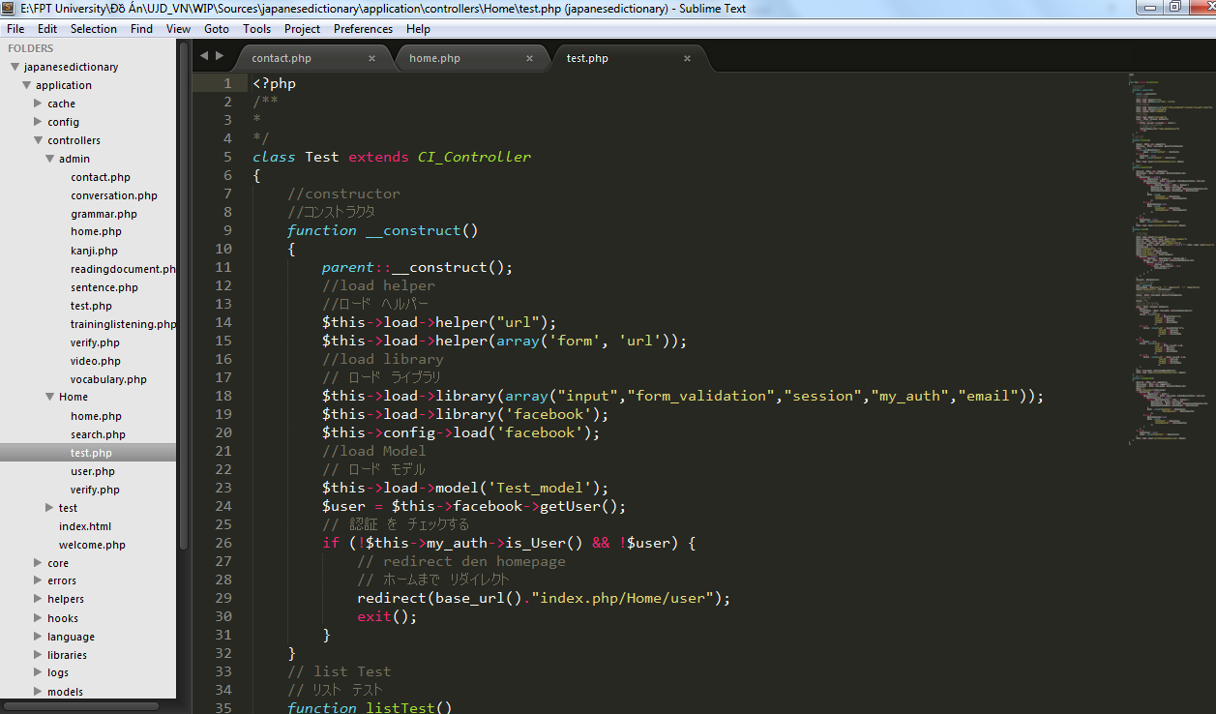

Figure 5-1: Sample of Source Code (Test Controller)

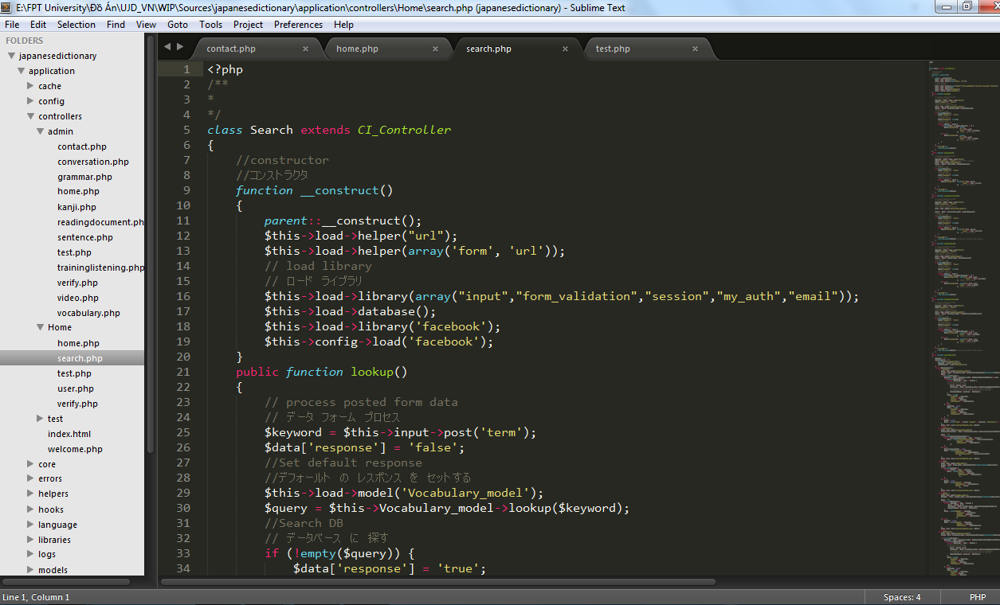

Figure 5-2: Sample of Source Code (Search Controller)

# Software Test Documentation

## INTRODUCTION

### Purposes

The purpose of this document is show the activity of testing during develop system time. This document define test plan, test case, checklist and test logs.

## TEST PLAN

### Scope of Testing

UJD_VN will be tested by five phases:

**Phase 1: Unit testing**

* Unit testing will be done by developers
* Developers user While Box Testing technique to do
* When executing unit testing, if any bugs are found, developers have to log bug on “Defect Log Management” file and fix it until it is correct.

**Rule for filling test result:**

|  |  |
| --- | --- |
| **Test result pass** | Pass |
| **Test result fail** | Fail |
| **Do not test** | Untested |
| **Cannot test** | N/A (Not available) |

**Phase 2: Component testing**

* After finishing unit testing, component testing will be performed by testers.
* Material are component test cases, low- level design
* Testers user Black Box Testing technique to do
* When executing component testing, if any bugs are found, testers have to log on “Defect Log Management” file and assign to developer fix it and redo this process until it is correct.

**Rule for filling test result:**

|  |  |
| --- | --- |
| **Test result pass** | Pass |
| **Test result fail** | Fail |
| **Do not test** | Untested |
| **Cannot test** | N/A (Not available) |

**Phase 3: Integration testing**

* After finishing component testing, integration testing will be performed by testers.
* Material are integration test cases, high- level design and test tools.
* Do test by flow of functions and items which have relation.
* When executing integration testing, if any bugs are found, testers have to log on “Defect Log Management” file and assign to developer fix it and redo this process until it is correct.

**Rule for filling test result:**

|  |  |
| --- | --- |
| **Test result pass** | Pass |
| **Test result fail** | Fail |
| **Do not test** | Untested |
| **Cannot test** | N/A (Not available) |

**Phase 4: System testing**

* After finishing integration testing and developers collect all functions and items, testers will be performed system testing, it means doing test whole system.
* Material area system test case, SRS
* If any bugs are found, developers have to fix and testers will verify them. System test is ended only when test cases are passed and no bug is found.

**Rule for filling test result:**

|  |  |
| --- | --- |
| **Test result pass** | Pass |
| **Test result fail** | Fail |
| **Do not test** | Untested |
| **Cannot test** | N/A (Not available) |

**Phase 5: Acceptance testing**

* Base on customer/user requirement specification, system is tested again, for ensure there is not lacking or mistake any requirement.
* If there is any problem, developers have to fix/update and tester will verify them.
* Acceptance testing is ended only when whole system met requirement specification.

#### Test Items

1. **Member functions**

* Search sentences
* Search conversation
* Search grammar
* Search video
* Search specialized Japanese
* Log in by Facebook account
* Log in by registered account
* Log out
* Register
* Edit profile
* Forgot password
* Contribute content
* Contribute opinion
* Send Q&A
* Doing test
* Tracking mark
* Training listening
* Listening conversation
* Reading Elementary document
* Reading Intermediate document
* Reading Review document
* Reading Test document
* Reading Kanji document

1. **Admin functions**

* Add new admin
* Edit profile
* Delete admin
* Search member
* Ban/Unban member’s account
* Delete member
* Search vocabulary
* Add vocabulary
* Edit vocabulary
* Add reference sentence for vocabulary
* Delete vocabulary
* Approve contributed vocabulary
* Reject contributed vocabulary
* Search grammar
* Add grammar
* Edit grammar
* Add reference sentence for grammar
* Delete grammar
* Approve contributed grammar
* Reject contributed grammar
* Search reading document
* Add reading document
* Edit reading document
* Delete reading document
* Search conversation
* Add conversation
* Edit conversation
* Delete conversation
* Search video
* Add video
* Edit video
* Delete video
* Search listening article
* Add listening article
* Edit listening article
* Delete listening article
* Search test
* Add test
* Edit test
* Delete test
* Search Q&A
* Reply Q&A
* Delete Q&A
* Search opinion
* Reply opinion
* Delete opinion

#### Acceptance Test Criteria

* Criteria for Unit test of Development team, for Test team accepts to start testing:
* Number of UTC/KLOC: 40 UTC/KLOC
* Number defects/KLOC: 3-4 defects/KLOC
* Statement coverage: 97%
* Branch coverage: 100%
* Path coverage: 100%
* Criteria for Integration test:
* Number of UTC/KLOC: 30 UTC/KLOC
* Number defects/KLOC: 2-3 defects/KLOC
* Criteria for System test:
* Number of UTC/KLOC: 60 UTC/KLOC
* Number defects/KLOC: 4-6 defects/KLOC
* Criteria for Acceptance test:
* Number defects/KLOC: 1-2 defects/KLOC

#### Testing Risks

* Performance test: Cannot test the case which many users connect to website at the same time.
* Not enough time to write all test cases, execute test or re-test for fixed bug.
* Tester can be ill during the testing phase

### Test Strategies

#### Test Model

UJD_VN project follows V-Model process:

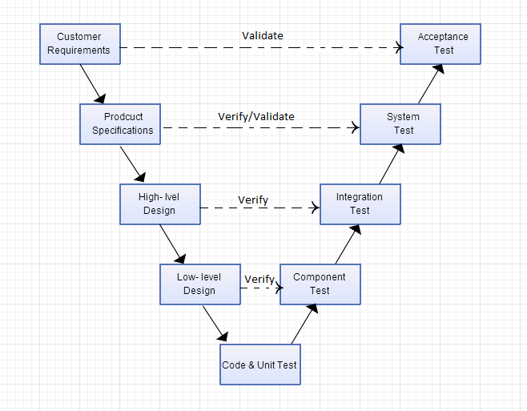

Figure 6-1: V-Model

Testing progress is divided to five phases include: Unit test, Component test, Integration test, System test and Acceptance test

* **Unit test:**
* Unit testing is used to verify a single minimal unit of source code. The purpose of unit testing is to isolate the smallest testable parts of UJD_VN and verify that they function properly in isolation.
* Unit testing is the first level of testing and is perform prior to component testing.
* Unit testing will be done by developer.
* **Component test:**
* Component testing is used to validate a combined many minimal units of source code.
* Component testing is performed after unit testing and before integration testing.
* Component testing will be done by tester
* **Integration test:**
* Integration testing is a level of the software testing process where individual units or component are combined and tested as a group.
* The purpose is to expose faults in the interaction between integrated units.
* Integration testing is performed after component testing.
* Integration testing will be done by tester.
* There are two methods of doing integration testing: Bottom-up Integration testing and Top Down Integration testing:

| No | Integration Testing Method |
| --- | --- |
| 1 | Bottom-up integration  This testing begins with unit testing, followed by tests of progressively higher-level combinations of units called modules. |
| 2 | Top- Down integration  This testing, the highest-level modules are tested first and progressively lower-level modules are tested after that |

Table 6-1: Integration test

* **System test:**
* System Testing is a level of the software testing process where a complete, integrated system is tested
* The purpose is to evaluate the system’s compliance with the specified requirements
* System testing is performed after integration testing
* System testing will be done by tester
* **Acceptance test:**
* Acceptance testing is performed after system testing
* Acceptance testing will be performed by the test leader and team leader.
* The acceptance test will be done for a period of 1 weeks after completion of the system test process.

#### Types of Testing

##### Function Testing

* Functional testing is a type of software testing whereby the system is tested against the functional requirements/specifications.
* Functions are tested by feeding them input and examining the output. Functional testing ensure that the requirements are properly satisfied by the website. This type of testing is not concerned with how processing occurs, but rather, with the results of processing.
* During functional testing, [**Black Box Testing**](http://softwaretestingfundamentals.com/black-box-testing/) technique is used in which the internal logic of the system being tested is not known to the tester.

|  |  |
| --- | --- |
| **Test Objective:** | The type of this test is to ensure proper target-of-test functionality, including user interaction, all function defined in specification document implemented correctly. |
| **Technique:** | Executing each use case, use-case flow, or function, using valid and invalid data, to verify the following:  - The expected results occur when valid data is used.  - The appropriate error or warning messages are displayed when invalid data is used.  - Each business rule is properly applied. |
| **Completion Criteria:** | - All planned tests have been executed.  - All identified defects have been addressed and closed. |
| **Special Considerations:** | Testing may be stopped when:   * Time runs out * A certain number of defects found * Test coverage > 97% * Stop when testing becomes unproductive |

Table 6-2: Function Testing

##### User Interface Testing

* GUI testing is the process of ensuring proper functionality of the GUI for a given web and making sure it conforms to its written specifications.
* GUI testing evaluates design elements such as layout, color, font sizes, labels, text boxes, text formatting, captions, buttons, lists, icons, links, content and more.

|  |  |
| --- | --- |
| **Test Objective:** | Verify the following:  - Navigation through the target-of-test properly reflects business       functions and requirements, including window-to-window, field-to-field, and use of access methods (tab keys, mouse movements, accelerator keys)  - Window objects and characteristics, such as menus, size, position, state, and focus conform to standards. |
| **Technique:** | Create or modify tests for each window to verify proper navigation and object states for each application window and objects. |
| **Completion Criteria:** | Each window successfully verified to remain consistent with benchmark version or within acceptable standard. |
| **Special Considerations:** | Not all properties for custom and third party objects can be accessed. |

Table 6-3: GUI Testing

##### Data and Database Integrity Testing

The databases and the database processes should be tested as a subsystem within the Project. These subsystems should be tested without the target-of-test’s User Interface as the interface to the data.  Additional research into the Database Management System (DBMS) needs to be performed to identify the tools and techniques that may exist to support the testing identified below.

|  |  |
| --- | --- |
| **Test Objective:** | Ensure database access methods and processes function properly and without data corruption. |
| **Technique:** | - Invoke each database access method and process, seeding each with valid and invalid data or requests for data.  - Inspect the database to ensure the data has been populated as intended, all database events occurred properly, or review the returned data to ensure that the correct data was retrieved for the correct reasons. |
| **Completion Criteria:** | All database access methods and processes function as designed and without any data corruption. |
| **Special Considerations:** | - Testing may require a DBMS development environment or drivers to enter or modify data directly in the databases.  - Processes should be invoked manually.  - Small or minimally sized databases (limited number of records) should be used to increase the visibility of any non-acceptable events. |

Table 6-4: Data and Data Integrity Testing

#### Test Stages

Clearly state the stage in which the test will be executed. Identified below are the stages in which common test are executed.

| Type of Tests | Stage of Test | | | |
| --- | --- | --- | --- | --- |
| Unit | Component | Integration | System |
| Function Testing | X | X | X | X |
| User Interface Testing |  | X | X |  |

# 

#### Tools/Environments

##### Hardware

|  |  |  |
| --- | --- | --- |
| Name | Purpose | Detail |
| Laptop Asus | Device for create and execute test | Window 7 Professional Core i3 |
| Laptop Vaio | Device for create and execute test | Window 7 Professional Core i3 |

Table 6-5: Hardware

##### Software

|  |  |  |
| --- | --- | --- |
| Name | Purpose | Detail |
| Test Plan | Managing test | Microsoft Word 2013, 2010 |
| Test case | Executing test | Microsoft Excel 2013, 2010 |
| Test report, Test checklist | Tracking test | Microsoft Excel 2013, 2010 |
| Chrome, CocCoc | Executing test | Chrome 35.0, CocCoc 35.0 |

Table 6-6: Software

### Resources

|  |  |  |
| --- | --- | --- |
| Worker/Doer | Role | Specific Responsibilities/Comments |
| MinhPT | Test Leader | * Manage Test Resource and assign test tasks. * Create and review Test Plan. * Create and review Test Case. * Execute test. * Create and review Test Report |
| TuanNN | Tester | * Create and review Test Case. * Execute test. * Create Test view points * Create and review Test Report |

Table 6-7: Resources

### Test Milestones

|  |  |  |  |
| --- | --- | --- | --- |
| Milestone Task | Effort (pd) | Start Date | End Date |
| Create Test Plan | 6 | 16/06/2014 | 22/06/2014 |
| Review & update TP | 2 | 23/06/2014 | 23/06/2014 |
| Create Component Test case | 12 | 23/06/2014 | 26/06/2014 |
| Review & update Component TC | 2 | 27/06/2014 | 27/06/2014 |
| Create Integration Test case | 2 | 07/07/2014 | 07/07/2014 |
| Review & Update Integration TC | 2 | 08/07/2014 | 08/07/2014 |
| Create System Test case | 6 | 09/07/2014 | 11/07/2014 |
| Review & Update System TC | 2 | 11/07/2014 | 11/07/2014 |
| Execute Component test phase 1 | 1 | 16/07/2014 | 16/07/2014 |
| Execute Component test phase 2 | 1 | 24/07/2014 | 24/07/2014 |
| Execute Integration test phase 1 | 2 | 17/07/2014 | 17/07/2014 |
| Execute Integration test phase 2 | 2 | 25/07/2014 | 28/07/2014 |
| Execute System test phase 1 | 4 | 21/07/2014 | 22/07/2014 |
| Execute System test phase 2 | 4 | 28/07/2014 | 29/07/2014 |

Table 6-8: Test milestone

## TEST CASES

### Component Test Case

Refer to UJD_VN_User Component Test Case_v1.0_EN, UJD_VN_Admin Component Test Case_v1.0_EN to see detail all test cases.

|  |  |  |  |  |  |  |  |  |  |  |  |  |  |  |  |  |  |  |  |  |
| --- | --- | --- | --- | --- | --- | --- | --- | --- | --- | --- | --- | --- | --- | --- | --- | --- | --- | --- | --- | --- |
| **Function Code** | | *Register* | | **Function Name** | | | | Register | | | | | | | | | | | | |
| **Created By** | | *TuanNNSE02189* | | **Executed By** | | | | *TuanNNSE02189* | | | | | | | | | | | | |
| **Lines of code** | |  | | **Lack of test cases** | | | |  | | | | | | | | | | | | |
| **Test requirement** | | *Register form will be shown as requirement.* | | | | | | | | | | | | | | | | | | |
| **Passed** | | **Failed** | | **Untested** | | | | **N/A/B** | | | **Total Test Cases** | | | | | | | | | |
| 17 | | 0 | | 0 | | | | 4 | 12 | 1 | 17 | | | | | | | | | |
|  |  |  |  |  |  |  |  |  |  |  |  |  |  |  |  |  |  |  |  |  |
|  |  |  |  | **UTCID01** | **UTCID02** | **UTCID03** | **UTCID04** | **UTCID05** | **UTCID06** | **UTCID07** | **UTCID08** | **UTCID09** | **UTCID10** | **UTCID11** | **UTCID12** | **UTCID13** | **UTCID14** | **UTCID15** | **UTCID16** | **UTCID17** |
| **Condition** |  |  |  |  |  |  |  |  |  |  |  |  |  |  |  |  |  |  |  |  |
|  | **Username** |  |  |  |  |  |  |  |  |  |  |  |  |  |  |  |  |  |  |  |
|  | Input more than 32 character | |  | O |  |  |  |  |  |  |  |  |  |  |  |  |  |  |  |  |
|  |  |  | null |  |  |  |  | O |  |  |  |  |  |  |  |  |  |  |  |  |
|  |  |  |  |  |  |  |  |  |  |  |  |  |  |  |  |  |  |  |  |  |
|  |  |  | " " |  |  |  |  |  | O |  |  |  |  |  |  |  |  |  |  |  |
|  |  |  | [!@#$%](mailto:!@#$%) |  |  |  |  |  |  | O |  |  |  |  |  |  |  |  |  |  |
|  | Correct username |  | tendangnhap |  |  |  |  |  |  |  | O |  |  | O |  | O |  |  |  |  |
|  |  |  | 123456 |  |  |  |  |  |  |  |  |  |  |  |  |  |  |  |  | O |
|  | Incorrect username |  | ten dang |  |  |  |  |  |  |  |  | O |  |  |  |  |  |  |  |  |
|  | Input less than 6 characters | | ten12 |  |  |  |  |  |  |  |  |  | O |  |  |  |  |  |  |  |
|  | Username is existing in DB | | tendangnhap |  |  |  |  |  |  |  |  |  |  |  | O |  |  |  |  |  |
|  | **Password** |  |  |  |  |  |  |  |  |  |  |  |  |  |  |  |  |  |  |  |
|  | Input more than 32 characters | |  |  | O |  |  |  |  |  |  |  |  |  |  |  |  |  |  |  |
|  |  |  | null |  |  |  |  | O |  |  |  |  |  |  |  |  |  |  |  |  |
|  |  |  | " " |  |  |  |  |  | O |  |  |  |  |  |  |  |  |  |  |  |
|  |  |  | $%&()%@^ |  |  |  |  |  |  | O |  |  |  |  |  |  |  |  |  |  |
|  | Correct password |  | matkhau |  |  |  |  |  |  |  | O |  |  | O | O | O |  |  |  |  |
|  |  |  | mat khau |  |  |  |  |  |  |  |  | O |  |  |  |  |  |  |  |  |
|  |  |  | 123456 |  |  |  |  |  |  |  |  |  |  |  |  |  |  |  |  | O |
|  | Incorrect password |  | 12345 |  |  |  |  |  |  |  |  |  | O |  |  |  |  |  |  |  |
|  | **Re-enter password** | |  |  |  |  |  |  |  |  |  |  |  |  |  |  |  |  |  |  |
|  |  |  | null |  |  |  |  | O |  |  |  |  |  |  |  |  |  |  |  |  |
|  |  |  | " " |  |  |  |  |  | O |  |  |  |  |  |  |  |  |  |  |  |
|  |  |  | $%&()%@^ |  |  |  |  |  |  | O |  |  |  |  |  |  |  |  |  |  |
|  | Correct re-enter password | | matkhau |  |  |  |  |  |  |  | O |  |  |  | O | O |  |  |  |  |
|  |  |  | 123456 |  |  |  |  |  |  |  |  |  |  |  |  |  |  |  |  | O |
|  |  |  | mat khau |  |  |  |  |  |  |  |  | O |  |  |  |  |  |  |  |  |
|  |  |  | 12345 |  |  |  |  |  |  |  |  |  | O |  |  |  |  |  |  |  |
|  | Incorrect re-enter password | | matkhau12 |  |  |  |  |  |  |  |  |  |  | O |  |  |  |  |  |  |
|  | **Email** |  |  |  |  |  |  |  |  |  |  |  |  |  |  |  |  |  |  |  |
|  | Input more than 100 characters | |  |  |  |  | O |  |  |  |  |  |  |  |  |  |  |  |  |  |
|  |  |  | null |  |  |  |  | O |  |  |  |  |  |  |  |  |  |  |  |  |
|  |  |  | " " |  |  |  |  |  | O |  |  |  |  |  |  |  |  |  |  |  |
|  |  |  | $%&()%@^ |  |  |  |  |  |  | O |  |  |  |  |  |  |  |  |  |  |
|  |  |  | tuan@@gmail |  |  |  |  |  |  |  |  | O |  |  |  |  |  |  |  |  |
|  | Correct email | tuannnse02189@fpt.edu.vn | |  |  |  |  |  |  |  | O |  | O | O |  | O |  |  |  | O |
|  | Email is existing in DB | tuannnse02189@fpt.edu.vn | |  |  |  |  |  |  |  |  |  |  |  | O |  |  |  |  |  |
|  | **Fullname** |  |  |  |  |  |  |  |  |  |  |  |  |  |  |  |  |  |  |  |
|  | Input more than 100 characters | |  |  |  | O |  |  |  |  |  |  |  |  |  |  |  |  |  |  |
|  |  |  | null |  |  |  |  | O |  |  |  |  |  |  |  |  |  |  |  |  |
|  |  |  | " " |  |  |  |  |  | O |  |  |  |  |  |  |  |  |  |  |  |
|  |  |  | ^$%^&^ |  |  |  |  |  |  | O |  |  |  |  |  |  |  |  |  |  |
|  |  |  | Nguyen Tuan |  |  |  |  |  |  |  | O | O | O | O | O | O |  |  |  | O |
|  | **Captcha** |  |  |  |  |  |  |  |  |  |  |  |  |  |  |  |  |  |  |  |
|  |  |  | null |  |  |  |  | O |  |  |  |  |  |  |  |  |  |  |  |  |
|  |  |  | " " |  |  |  |  |  | O |  |  |  |  |  |  |  |  |  |  |  |
|  | Correct captcha |  |  |  |  |  |  |  |  | O | O | O | O | O | O |  |  |  |  | O |
|  | Incorrect captcha |  |  |  |  |  |  |  |  |  |  |  |  |  |  | O |  |  |  |  |
|  | Refresh-captcha |  | click() |  |  |  |  |  |  |  |  |  |  |  |  |  | O |  |  |  |
|  | Listening captcha |  | click() |  |  |  |  |  |  |  |  |  |  |  |  |  |  | O |  |  |
|  | Help captcha |  | click() |  |  |  |  |  |  |  |  |  |  |  |  |  |  |  | O |  |
|  | **"Register" button** |  |  |  |  |  |  |  |  |  |  |  |  |  |  |  |  |  |  |  |
|  |  |  | click() | O | O | O | O | O | O | O | O | O | O | O | O | O | O | O | O | O |
|  |  |  |  |  |  |  |  |  |  |  |  |  |  |  |  |  |  |  |  |  |
| **Confirm** |  |  |  |  |  |  |  |  |  |  |  |  |  |  |  |  |  |  |  |  |
|  | **Tên đăng nhập không được để trống** | |  |  |  |  |  | O | O |  |  |  |  |  |  |  |  |  |  |  |
|  | **Tên đăng nhập chỉ chứa chữ hoặc số** | |  |  |  |  |  |  |  | O |  | O |  |  |  |  |  |  |  |  |
|  | **Tên đăng nhập phải có ít nhất 6 kí tự** | |  |  |  |  |  |  |  |  |  |  | O |  |  |  |  |  |  |  |
|  | **Tên đăng nhập đã tồn tại** | |  |  |  |  |  |  |  |  |  |  |  |  | O |  |  |  |  |  |
|  | **Mật khẩu không được để trống** | |  |  |  |  |  | O | O |  |  |  |  |  |  |  |  |  |  |  |
|  | **Mật khẩu phải có ít nhất 6 kí tự** | |  |  |  |  |  |  |  |  |  |  | O |  |  |  |  |  |  |  |
|  | **Nhập lại mật khẩu không được để trống** | |  |  |  |  |  | O | O |  |  |  |  |  |  |  |  |  |  |  |
|  | **Nhập lại mật khẩu và mật khẩu không giống nhau** | | |  |  |  |  |  |  |  |  |  |  | O |  |  |  |  |  |  |
|  | **Email không được để trống** | |  |  |  |  |  | O | O |  |  |  |  |  |  |  |  |  |  |  |
|  | **Email không chính xác** | |  |  |  |  |  |  |  | O |  | O |  |  |  |  |  |  |  |  |
|  | **Email đã tồn tại** |  |  |  |  |  |  |  |  |  |  |  |  |  | O |  |  |  |  |  |
|  | **Bạn chưa nhập mã xác nhận** | |  |  |  |  |  | O |  |  |  |  |  |  |  |  |  |  |  |  |
|  | **Bạn đã nhập sai mã xác nhận** | |  |  |  |  |  |  | O |  |  |  |  |  |  | O |  |  |  |  |
|  | **Thông báo đăng ký thành công tài khoản mới** | | |  |  |  |  |  |  |  | O |  |  |  |  |  |  |  |  | O |
|  | **Non-message( capcha is changed)** | |  |  |  |  |  |  |  |  |  |  |  |  |  |  | O |  |  |  |
|  | **Non-message ( capcha's audio is played)** |  |  |  |  |  |  |  |  |  |  |  |  |  |  |  |  | O |  |  |
|  | **Display help captcha page** |  |  |  |  |  |  |  |  |  |  |  |  |  |  |  |  |  | O |  |
|  | **Tên đăng nhập chứa nhiều nhất 32 ký tự** |  |  | O |  |  |  |  |  |  |  |  |  |  |  |  |  |  |  |  |
|  | **Mật khẩu chứa nhiều nhất 32 ký tự** |  |  |  | O |  |  |  |  |  |  |  |  |  |  |  |  |  |  |  |
|  | **Họ tên chứa nhiều nhất 100 ký tự** |  |  |  |  | O |  |  |  |  |  |  |  |  |  |  |  |  |  |  |
|  | **Email chứa nhiều nhất 100 ký tự** |  |  |  |  |  | O |  |  |  |  |  |  |  |  |  |  |  |  |  |
|  |  |  |  |  |  |  |  |  |  |  |  |  |  |  |  |  |  |  |  |  |
| **Result** | Type(N : Normal, A : Abnormal, B : Boundary) | | | A | A | A | A | A | A | A | N | A | A | A | A | A | N | N | N | B |
|  | Passed/Failed | | | P | P | P | P | P | P | P | P | P | P | P | P | P | P | P | P | P |
|  | Executed Date | | | 24/7/2014 | 24/7/2014 | 24/7/2014 | 24/7/2014 | 24/7/2014 | 24/7/2014 | 24/7/2014 | 24/7/2014 | 24/7/2014 | 24/7/2014 | 24/7/2014 | 24/7/2014 | 24/7/2014 | 24/7/2014 | 24/7/2014 | 24/7/2014 | 24/7/2014 |
|  | Defect ID | | |  |  |  |  |  |  | UJD_VN/DP84 |  | UJD_VN/DP84 |  |  |  |  |  |  |  |  |

### Integration Test Case

Refer to UJD_VN_Integration Test Case_v1.0_EN to see detail all test cases.

|  |  |  |  |  |  |  |  |
| --- | --- | --- | --- | --- | --- | --- | --- |
| **Module Code** | *Admin_login* | | | | |  |  |
| **Test requirement** | *This test cases were created to test integration between login with all functions and all functions together* | | | | |  |  |
| **Tester** | *MinhPTSE02300* | | | | |  |  |
| **Pass** | **Fail** | **Untested** | **N/A** | **Number of Test cases** | |  |  |
| 118 | 0 | 0 | 0 | 118 | |  |  |
|  |  |  |  |  |  |  |  |
| **ID** | **Test Case Description** | **Test Case Procedure** | **Expected Output** | **Inter-test case Dependence** | **Result** | **Test date** | **Note** |
|  | **Integrate Login with admin's account management** | |  |  |  |  |  |
| [Admin_login-] | Superadmin login to system | 1. Enter the login page 2. Input username: superadmin password: admin1 3. Click "Login" button | 1. The login page is displayed  2.  3. Display "User management" page |  | Pass | 17/7/2014 |  |
| [Admin_login-1] | Normal admin login to system | 1. Enter the login page 2. Input username: phamminh password: phamminh 3. Click "Login" button | 1. The login page is displayed  2.  3. Display "User management" page |  | Pass | 17/7/2014 |  |
| [Admin_login-2] | When superadmin logged in successfully then user use "Admin management" feature | 1. Enter the admin page 2. Logged in with  username: superadmin password: admin1 3. Click "admin management" tab | 1. The login page is displayed  2. Display "User management" page 3. Display "Admin's account management" page | [Admin_login-] | Pass | 17/7/2014 |  |
| [Admin_login-3] | When normal admin logged in successfully then user use "Admin management" feature | 1. Enter the admin page 2. Logged in with  username: phamminh password: phamminh 3. Click "admin management" tab | 1. The login page is displayed  2. Display "User management" page 3. | [Admin_login-1] | Pass | 17/7/2014 |  |
| [Admin_login-4] | When superadmin logged in successfully then user use "Admin management" feature | 1. Enter the admin page 2. Logged in with  username: superadmin password: admin1 3. Click "admin management" tab 4. Click "Add new admin" button | 1. The login page is displayed  2. Display "User management" page 3. Display "Admin's account management" page 4. Display "Add new admin" page | [Admin_login-] | Pass | 17/7/2014 |  |
| [Admin_login-5] | When superadmin logged in successfully then user use "Admin management" feature | 1. Enter the admin page  2. Logged in with username: superadmin  password: admin1  3. Click "admin management" tab  4. Click "Add new admin" button  5. Input information then Click "Register" button | 1. The login page is displayed 2. Display "User management" page  3. Display "Admin's account management" page  4. Display "Add new admin" page  5. Add new admin successfully, Display "Admin's account management" page | [Admin_login- 4] | Pass | 17/7/2014 |  |
| [Admin_login-6] | When superadmin logged in successfully then user use "Admin management" feature | 1. Enter the admin page 2. Logged in with  username: superadmin password: admin1 3. Click "admin management" tab 4. Click "Delete" link | 1. The login page is displayed  2. Display "User management" page 3. Display "Admin's account management" page 4. Remove that admin's account from list | [Admin_login- 4] | Pass | 17/7/2014 |  |
| [Admin_login-7] | When superadmin logged in successfully then user use "Admin management" feature | 1. Enter the admin page 2. Logged in with  username: superadmin password: admin1 3. Click "admin name" link | 1. The login page is displayed  2. Display "User management" page 3. Display "Edit account" page | [Admin_login-] | Pass | 17/7/2014 |  |
| [Admin_login-8] | When superadmin logged in successfully then user use "Admin management" feature | 1. Enter the admin page 2. Logged in with  username: superadmin password: admin1 3. Click "admin name" tab 4. Input information then click "Update" button | 1. The login page is displayed  2. Display "User management" page 3. Display "Edit account" page 4. Information is updated, display "User management" page | [Admin_login- 7] | Pass | 17/7/2014 |  |
| [Admin_login-9] | When normal admin logged in successfully then user use "Admin management" feature | 1. Enter the admin page 2. Logged in with  username: phamminh password: phamminh 3. Click "admin name" link | 1. The login page is displayed  2. Display "User management" page 3. Display "Edit account" page | [Admin_login-1] | Pass | 17/7/2014 |  |
| [Admin_login-10] | When normal admin logged in successfully then user use "Admin management" feature | 1. Enter the admin page 2. Logged in with  username: phamminh password: phamminh 3. Click "admin name" link 4. Input information then click "Update" button | 1. The login page is displayed  2. Display "User management" page 3. Display "Edit account" page 4. Information is updated, display "User management" page | [Admin_login- 9] | Pass | 17/7/2014 |  |

### System Test Case

Refer to UJD_VN_System Test Case_v1.0_EN to see detail all test cases.

|  |  |  |  |  |  |  |  |
| --- | --- | --- | --- | --- | --- | --- | --- |
| **Module Code** | *Practice management* | | | | |  |  |
| **Test requirement** | *This test cases were created to test Practice management module.* | | | | |  |  |
| **Tester** | *TuanNNSE02189* | | | | |  |  |
| **Pass** | **Fail** | **Untested** | **N/A** | **Number of Test cases** | |  |  |
| 229 | 0 | 0 | 0 | 229 | |  |  |
|  |  |  |  |  |  |  |  |
| **ID** | **Test Case Description** | **Test Case Procedure** | **Expected Output** | **Inter-test case Dependence** | **Result** | **Test date** | **Note** |
|  | **Doing test** |  |  |  |  |  |  |
| [Practice management-] | Test viewing "Kiểm tra\ Đề kiểm tra trắc nghiệm N4" form. | 1. Login the system with Member role. 2. Click "Kiểm tra\ Đề kiểm tra trắc nghiệm N4" tab in homepage. | 1. The Homepage is displayed 2. The "Đề kiểm tra N4" view form is displayed with the following informations: list of small test N4 link: - Grammar test - Listening test - Vocabulary test - Reading test | [Account Management Module- 4] | Pass | 29/7/2014 |  |
| [Practice management-1] | Test viewing "Kiểm tra\ Đề kiểm tra trắc nghiệm N3" form. | 1. Login the system with Member role. 2. Click "Kiểm tra\ Đề kiểm tra trắc nghiệm N3" tab in homepage. | 1. The Homepage is displayed 2. The "Đề kiểm tra N3" view form is displayed with the following informations: list of small test N3 link: - Grammar test - Listening test - Vocabulary test - Reading test | [Account Management Module- 4] | Pass | 29/7/2014 |  |
| [Practice management-2] | Test viewing "Kiểm tra\ Đề kiểm tra trắc nghiệm N2" form. | 1. Login the system with Member role. 2. Click "Kiểm tra\ Đề kiểm tra trắc nghiệm N2" tab in homepage. | 1. The Homepage is displayed 2. The "Đề kiểm tra N2" view form is displayed with the following informations: list of small test N2 link: - Grammar test - Listening test - Vocabulary test - Reading test | [Account Management Module- 4] | Pass | 29/7/2014 |  |
| [Practice management-3] | Verify all of links in " Kiểm tra\ Đề kiểm tra trắc nghiệm N4" | 1. Login the system with Member role.  2. Click "Kiểm tra\ Đề kiểm tra trắc nghiệm N4" tab in homepage.  3. Click to each link in list of link | 1. The Homepage is displayed  2. The "Đề kiểm tra N4" page is displayed  3. All of link are available | [Practice management-] | Pass | 29/7/2014 |  |
| [Practice management-4] | Test viewing "Kiểm tra\ Đề kiểm tra trắc nghiệm N4\ Reading test type" form. | 1. Login the system with Member role. 2. Click "Kiểm tra\ Đề kiểm tra trắc nghiệm N4" tab in homepage. 3. Click "Reading test type" link | 1. The Homepage is displayed 2. The "Đề kiểm tra N4" page is displayed 3. "Reading test" view form is displayed with the following informations: - text of reading - list of question and answer -"Hoàn thành" button | [Practice management- 3] | Pass | 29/7/2014 |  |
| [Practice management-5] | Check "Hoàn thành" button in reading test type | 1. Login the system with Member role. 2. Click "Kiểm tra\ Đề kiểm tra trắc nghiệm N4" tab in homepage. 3. Click "Reading test type" link 4. Click "Hoàn thành" button 5. Click "Đây" link | 1. The Homepage is displayed 2. The "Đề kiểm tra N4" page is displayed 3. "Reading test" page is display 4. "Result" page is display 5. Detail of test is displayed, correct answer is highlight with red - "Quay lại" button | [Practice management- 4] | Pass | 29/7/2014 |  |
| [Practice management-6] | When user tick to answer box then click "Hoàn thành" button in reading test type | 1. Login the system with Member role. 2. Click "Kiểm tra\ Đề kiểm tra trắc nghiệm N4" tab in homepage. 3. Click "Reading test type" link 4. Click "Hoàn thành" button 5. Click "Đây" link | 1. The Homepage is displayed 2. The "Đề kiểm tra N4" page is displayed 3. "Reading test" page is display 4. "Result" page is display 5. Detail of test is displayed, correct answer is highlight with red - "Quay lại" button | [Practice management- 4] | Pass | 29/7/2014 |  |
| [Practice management-7] | Check "Quay lại" button when finish test | 1. Login the system with Member role. 2. Click "Kiểm tra\ Đề kiểm tra trắc nghiệm N4" tab in homepage. 3. Click "Reading test type" link 4. Click "Hoàn thành" button 5. Click "Đây" link 6. Click " Quay lại" button | 1. The Homepage is displayed 2. The "Đề kiểm tra N4" page is displayed 3. "Reading test" page is display 4. "Result" page is display 5. Detail of test is displayed, correct answer is highlight with red 6. Back to homepage | [Practice management- 4] | Pass | 29/7/2014 |  |

## CHECKLISTS

### Test Checklist

|  |  |  |  |  |  |  |
| --- | --- | --- | --- | --- | --- | --- |
| **Question** | **Yes** | **No** | **N/A** | **Note** | **Priority** | **Severity** |
| Is the system test using the unit tests and incremental integration test cases, requirements and design? | x |  |  |  |  |  |
| Have volume tests been included? |  |  | x |  |  |  |
| Have concurrency tests been included? (Multi user tests) | x |  |  |  |  |  |
| Have error-logging conditions been tested? | x |  |  |  | Mandatory |  |
| Have restart features been tested? | x |  |  |  | Mandatory |  |
| Have invalid input conditions been tested? | x |  |  |  | Mandatory |  |
| Have invalid output conditions been tested? | x |  |  |  | Mandatory |  |
| Has the functionality as per requirements been tested? | x |  |  |  | Mandatory |  |
| Have performance requirements been tested? |  |  | x |  | Mandatory |  |
| Have security requirements been tested? | x |  |  |  |  |  |
| Have the test results regarding security requirements been reviewed? | x |  |  |  |  |  |
| Have fail over conditions been tested? | x |  |  |  | Mandatory |  |
| Have scalability tests been conducted? | x |  |  |  |  |  |
| Is the correct version of the requirements, design, test case being used for system test? | x |  |  |  |  |  |

Table 6-9: System Test Checklist

|  |  |  |  |  |  |
| --- | --- | --- | --- | --- | --- |
| **Question** | **Yes** | **No** | **N/A** | **Note** | **Priority** |
| **DOCUMENT CONTROL** |  |  |  |  |  |
| Verify whether document control procedures have been followed by checking for the following: |  |  |  |  | Mandatory |
| *Does the title page contain the document name, version number, release date and issued date?* | X |  |  |  |  |
| *Does the header and footer correctly specify the name, and version of the document?* | X |  |  |  |  |
| *Does the page – numbering scheme indicate the total number of pages in the document?* | X |  |  |  |  |
| *Is the history traceable?* | X |  |  |  |  |
| *Does it include list of reference documents?* | X |  |  |  |  |
| *Are all documents checked Spelling and Grammar in MS Word or similar tools?* | X |  |  |  |  |
| **TEST PLAN CHECKLIST** |  |  |  |  |  |
| Have products that are to be tested been identified? | X |  |  |  | Mandatory |
| Is the overall defect expectation or defect expectation rate stated in the plan? | X |  |  |  | Mandatory |
| Does the plan provide clearly scope for the following? | X |  |  |  | Mandatory |
| *Unit testing* | X |  |  |  |  |
| *Integration testing* | X |  |  |  |  |
| *System testing* | X |  |  |  |  |
| *Acceptance testing* | X |  |  |  |  |
| Does the plan reflect the requirements as specified in the SRS? | X |  |  |  | Mandatory |
| Have the conditions that would cause each test to be stopped been stated? | X |  |  |  |  |
| Have the test types addressed the following? | X |  |  |  |  |
| *Function testing* | X |  |  |  |  |
| *User interface testing* | X |  |  |  |  |
| *Data and Database Integrity Testing* | X |  |  |  |  |
| *Performance testing* |  | X |  |  |  |
| *Security and Access Control Testing* |  | X |  |  |  |
| *Portability* |  | X |  |  |  |
| Have acceptance criteria for requirements been identified? | X |  |  |  |  |
| Do the types of tests reflect all requests specified in SRS? |  |  |  |  |  |
| Is it a maintenance project? If yes, Has the regression test been identified? |  |  | X |  |  |
| *Trigger for Regression test* |  |  | X |  |  |
| *Period for Regression test* |  |  | X |  |  |
| *Scope of Regression test* |  |  | X |  |  |
| Does the description of each type of test include the following? |  |  |  |  |  |
| *Test objectives* | X |  |  |  | Mandatory |
| *Techniques* | X |  |  |  | Mandatory |
| *Completion criteria* | X |  |  |  |  |
| *Special consideration* | X |  |  |  |  |
| Have the testing environment, testing tools and testing software and hardware been described? | X |  |  |  | Mandatory |
| Are the Pass/Fail criteria of tested products defined in Special consideration correspondent with requirements in SRS? | X |  |  |  |  |
| Are Doer and Responsibilities identified correctly? | X |  |  |  |  |
| Have the test deliverables been defined? | X |  |  |  | Mandatory |
| Does the testing schedule correspond to the development schedule? | X |  |  |  | Mandatory |
| Have staffing and training needs been specified? | X |  |  |  |  |
| Have the risks of testing been identified? | X |  |  |  | Mandatory |

Table 6-9: Checklist Test Plan

### GUI checklist

Refer to UJD_VN_GUI Checklist_v1.0_EN to see all detail.

## TEST LOGS

### Defect Logs

Refer to UJD_VN_Defect Log Management_v1.0_EN to see detail all Bug List.

|  |  |  |  |  |
| --- | --- | --- | --- | --- |
| **Defects** | **Logged** | **%Closed** | **%Invalid** | **%Open** |
| **Critical** | 0 | 0% | 0% | 0% |
| **High** | 0 | 0% | 0% | 0% |
| **Medium** | 9 | 100% | 0% | 0% |
| **Low** | 15 | 100% | 0% | 0% |
| **Total** | 24 | 100% | 0% | 0% |

Tabel 6-11: Defect Logs

### 

### Test Reports

This is Test report of UJD_VN project during Test process.

Refer to:

* UJD_VN_Unit Test Report_v1.0_EN
* UJD_VN_Component Test Report_v1.0_EN
* UJD_VN_Integration Test Report_v1.0_EN
* UJD_VN_System Test Report_v1.0_EN

To see detail test report for each phase.

|  |  |  |  |  |  |  |  |
| --- | --- | --- | --- | --- | --- | --- | --- |
| **Phase** | **# Test cases Planned** | **#Defects Planned** | **#Test cases Actual(cases)** | **#Defects Actual** | **% Tests Executed** | **% Tests Passed** | **% Tests Fail** |
| **Unit Test** | 40TC/KLOC | 3-4 defects/KLOC | 542 | 0 | 100% | 100% | 0% |
| **Component Test** | 40TC/KLOC | 3-4 defects/KLOC | 751 | 16 | 100% | 100% | 0% |
| **Integration Test** | 30TC/KLOC | 2-3 defects/KLOC | 284 | 1 | 100% | 100% | 0% |
| **System Test** | 60TC/KLOC | 4-6 defects/KLOC | 1493 | 7 | 100% | 100% | 0% |
| **Total** | 3400 | 240 – 340 defects/KLOC | 3070 | 24 | 100% | 100% | 0% |

Table 6-12: Test Report

|  |  |  |  |  |  |  |  |  |
| --- | --- | --- | --- | --- | --- | --- | --- | --- |
| **Phase** | **Round 1** | | | | **Round 2** | | | |
| Pass | Fail | Untested | Bug | Pass | Fail | Untested | Bug |
| **Unit Test** | 439 | 0 | 0 | 0 | 103 | 0 | 0 | 0 |
| **Component Test** | 477 | 0 | 0 | 12 | 274 | 0 | 0 | 4 |
| **Integration Test** | 118 | 0 | 0 | 0 | 166 | 0 | 0 | 1 |
| **System Test** | 996 | 0 | 0 | 6 | 497 | 0 | 0 | 1 |
| **Total** | 2030 | 0 | 0 | 18 | 1040 | 0 | 0 | 6 |

Table 6-13: Test Report

# Software User Manual

## Installation guide

### Introduction

This document contains guide-lines step by step to use UJD_VN website, and set up its own database.

### Environment

Following are the software required to start the UJD_VN System:

* Operating System: Windows 7, WinXP, Win8
* Browsers: Firefox 20, Chrome 36 or higher.
* Database: MySQL 5.6.16 or higher
* Xampp 1.8.3/ PHP 5.5.11

### Application Installation

#### Set up Environments:

* **Web**: If users want to use UJD_VN system on personal computer, users need to install Chrome36 /Firefox 20 or higher version and MySQL to create and store database.
* **Server**: Xampp 1.8.3

#### Installation Xampp 1.8.3

Go to link: http://toidongianchannel.wordpress.com/2014/03/31/huong-dan-cai-dat-localhost-bang-phan-mem-xampp-server/ and follow the guides.

#### Create Database

* After set up Xampp 1.8.3, start XAMPP Control Panel :

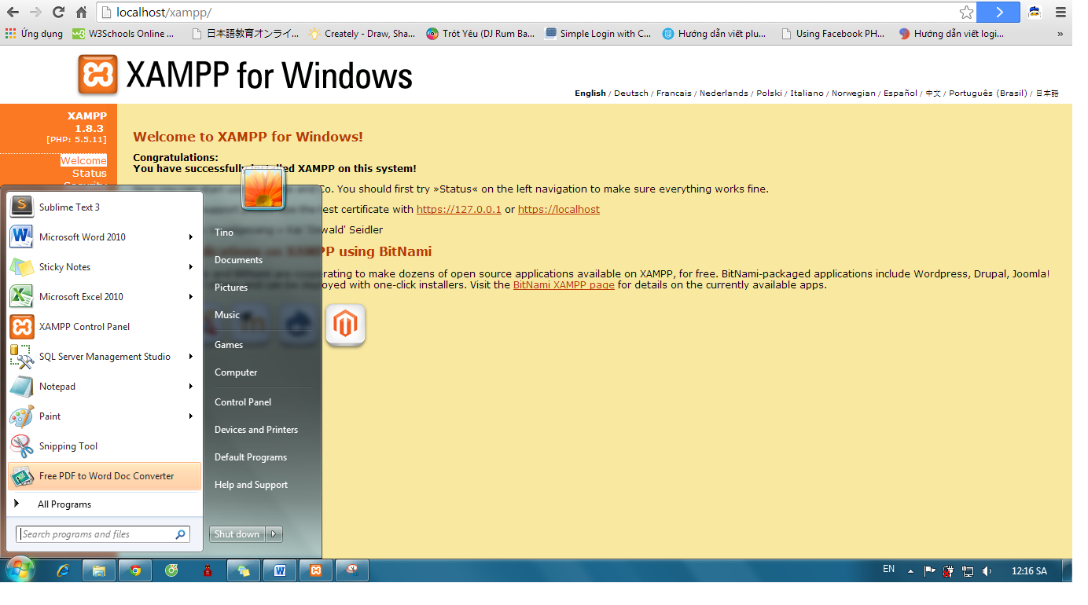

* Click “Start”of Apache and MySQL:

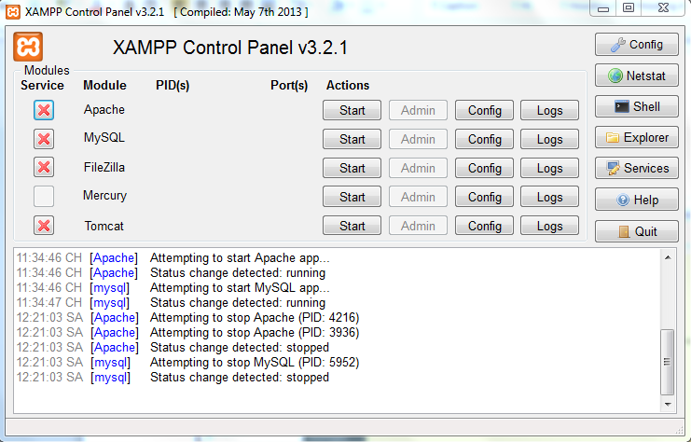

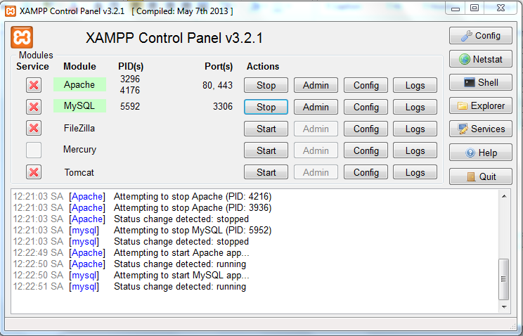

* Go to link: http://localhost/xampp/ and click on phpMyAdmin

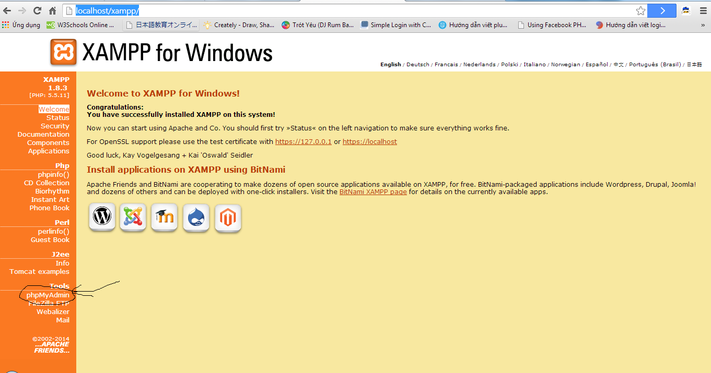

* Click on “New” to create a new database with name as “japanesedictionary” and collation “utf8_general_ci”. After click “Create”

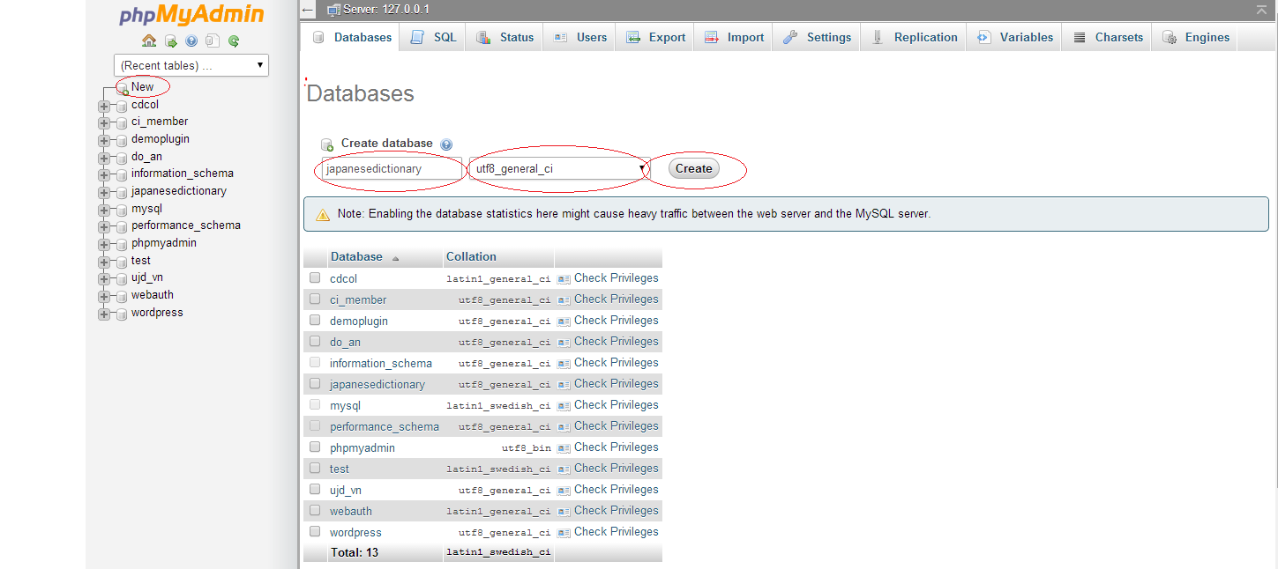

* After click “Create”, a new database were created with name as “japanesedictionary”

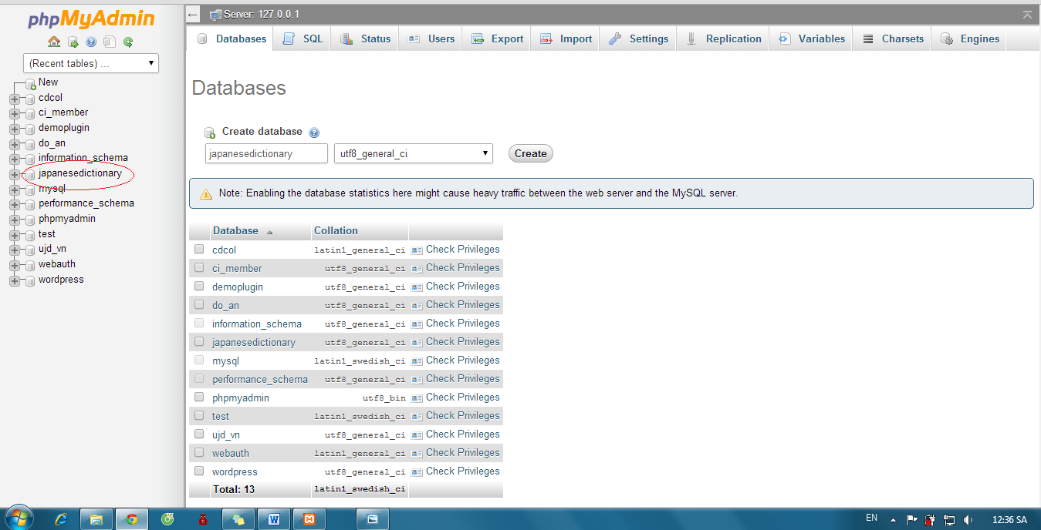

* Click “japanesedictionary” and “Import” :

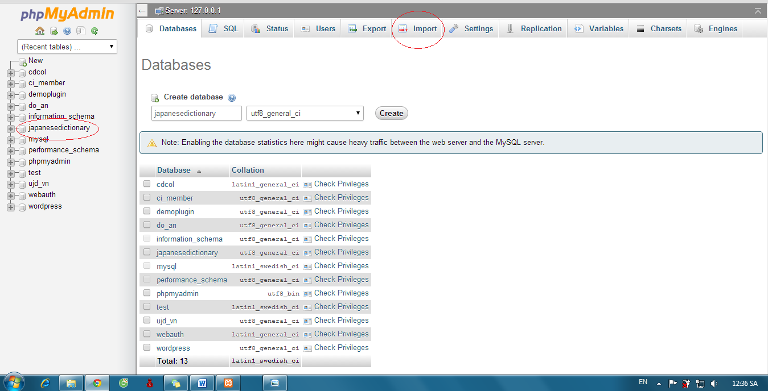

* Click “Chọn tệp” button:

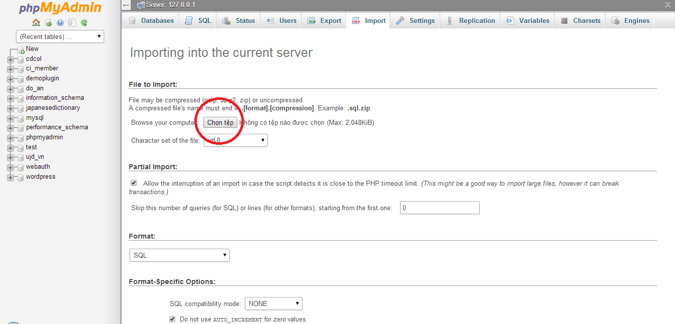

* Select file “japanesedictionary.sql” (for our project, you can select file .sql in folder project’s source code)

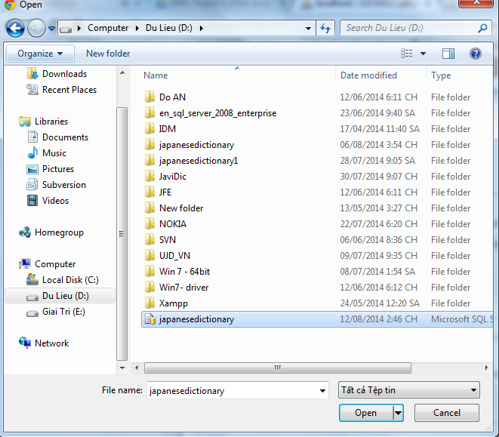

* Click “Go”

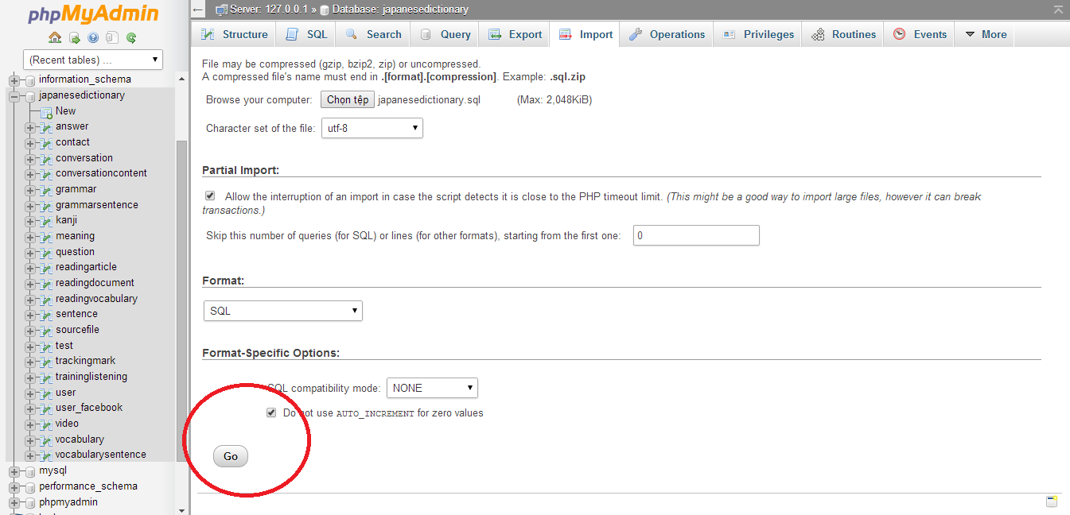

* Database was created with some table that contained data

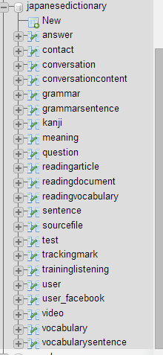

#### Installation Web Application

Step 1: Preparing package japanesedictionary.rar. Make sure package is available (incorrupt).

Step 2: Move package to htdocs folder of folder which installed xampp server (.\Xampp\htdocs)

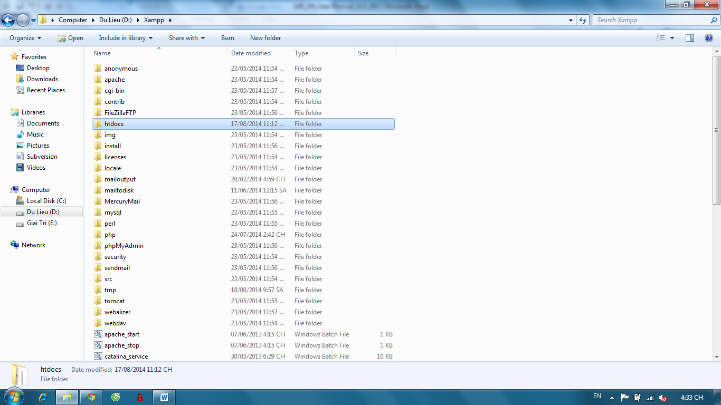

Step 3: Extract file japanesedictionary.rar, select “Extract here”

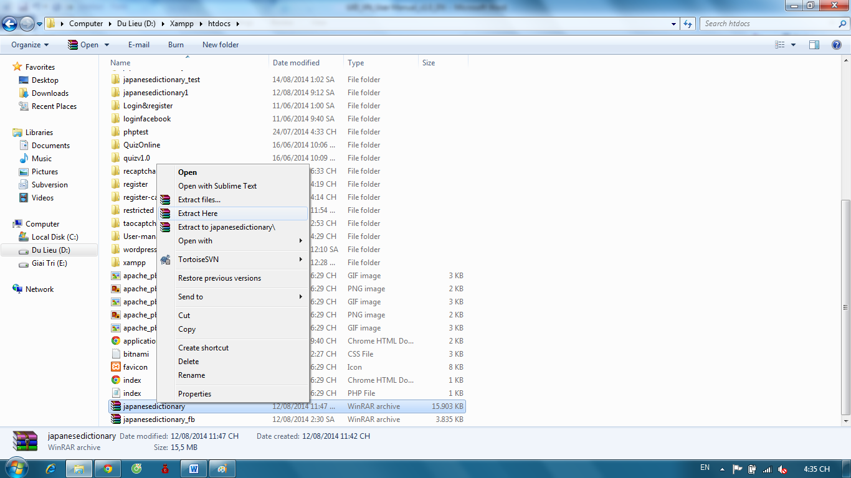

Step 4: Open Browser (Chrome or Firefox) and go to link <http://localhost/japanesedictionary/index.php/Home/verify/login> or <http://localhost/japanesedictionary/index.php/Admin/verify/login>

**Hompage User Interface:**

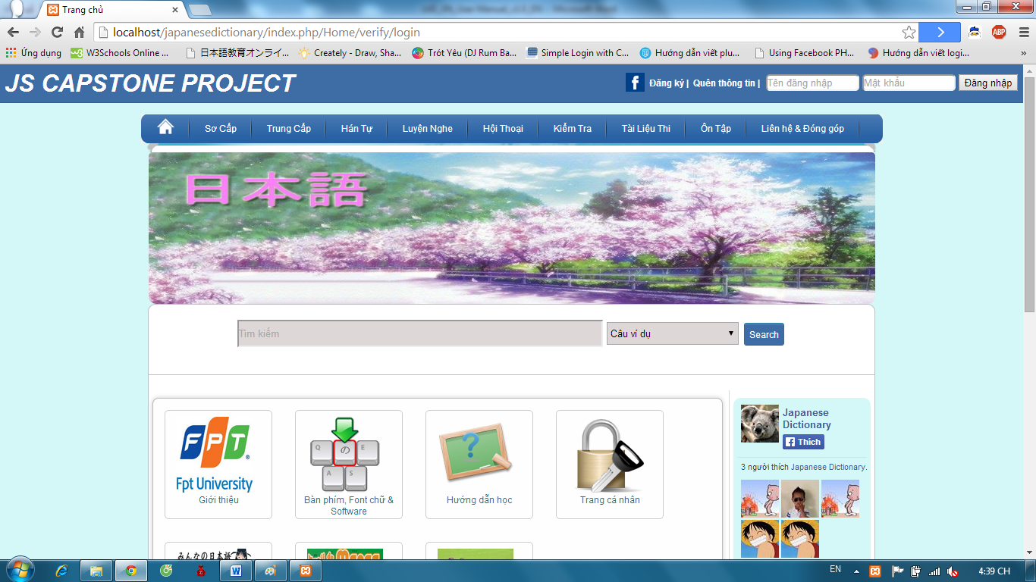

**Homepage Admin Interface:**

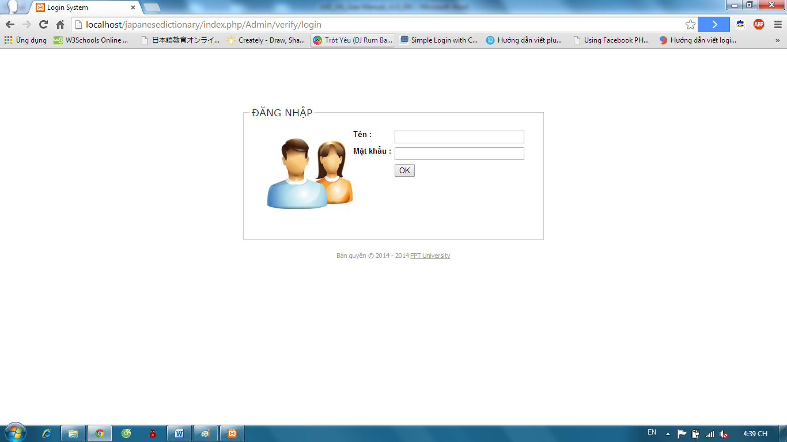

## User Guide

### Overview

This user's manual has been developed to help users better understand the requirements that may apply to use this website by providing them simple step by step tutorials. This manual is intended to help make website's functions more accessible and their associated requirements more understandable to users.

### Details guidelines

#### Homepage

The first page which user will see is the homepage. From this page the user can go to every page they want.

Open browser and enter to the address bar: <http://localhost/japanesedictionary/index.php/Home/verify/login>

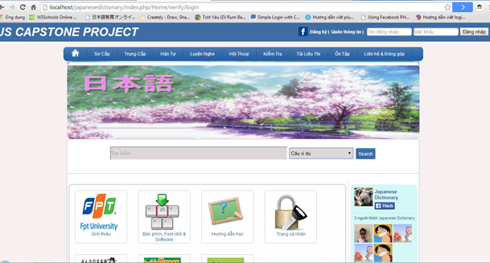

#### Search sentences

To use search sentences function on website, the users do the steps below:

Step 1: Choose option search “Câu ví dụ”

Step 2: Type vocabulary’s hiragana or vocabulary’s romaji into search box on Home page

Step 3: Click “Search” button. Display result list of found.

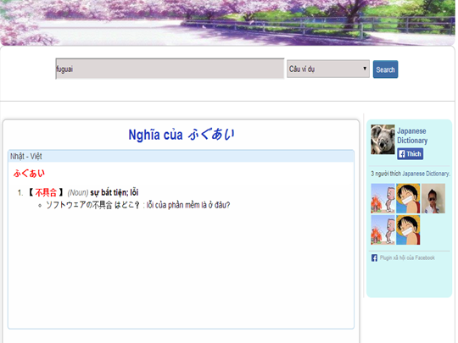

#### Search conversation

To use search conversation function on website, the users do the steps below:

Step 1: Choose option search “Hội thoại”

Step 2: Type conversation’s title into search box on Home page

Step 3: Click “Search” button. Display result list of found.

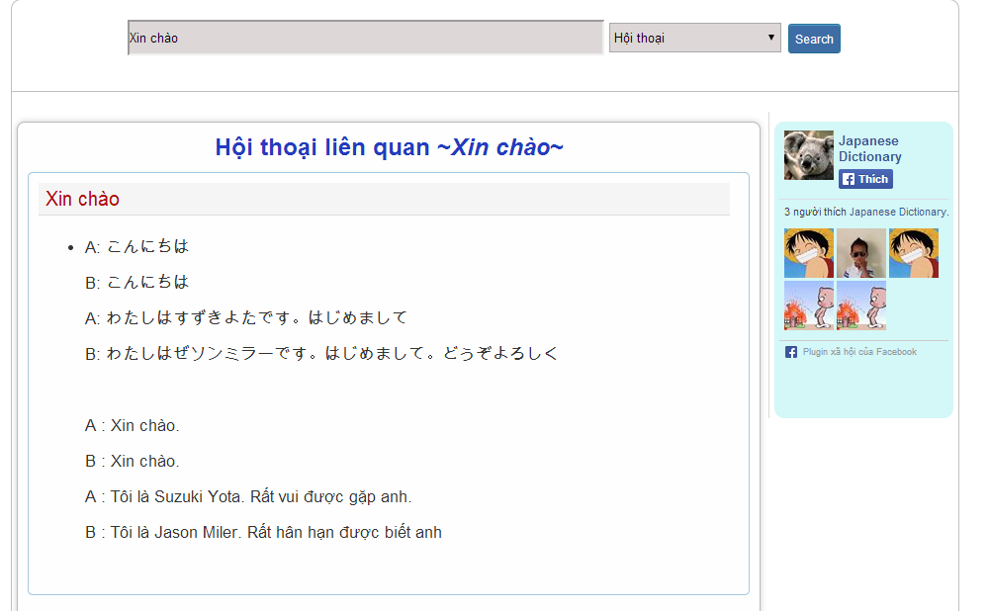

#### Search grammar

To use search grammar function on website, the users do the steps below:

Step 1: Choose option search “Ngữ pháp”

Step 2: Type grammar’s hiragana or grammar’s romaji into search box on Home page

Step 3: Click “Search” button. Display result list of found.

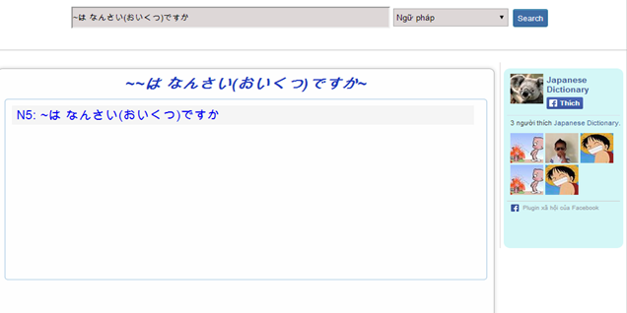

Step 4: Click title of grammar that was found to view detail.

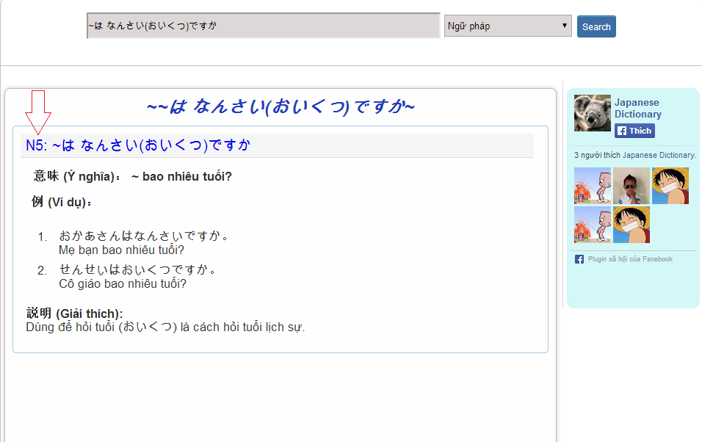

#### Search video

To use search conversation function on website, the users do the steps below:

Step 1: Choose option search “Video”

Step 2: Type video’s title into search box on Home page

Step 3: Click “Search” button. Display result list of found.

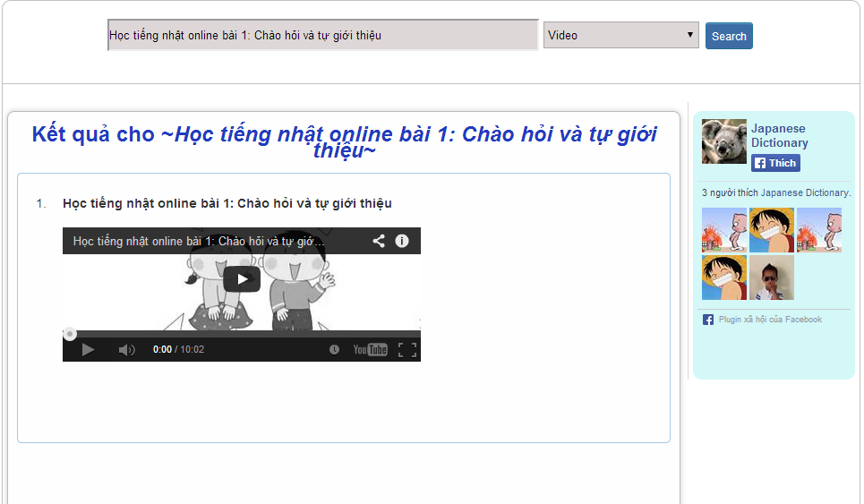

#### Login

##### Login by facebook

To use login by facebook function on website, the users do the steps below:

Step 1: Click icon Facebook on Homepage

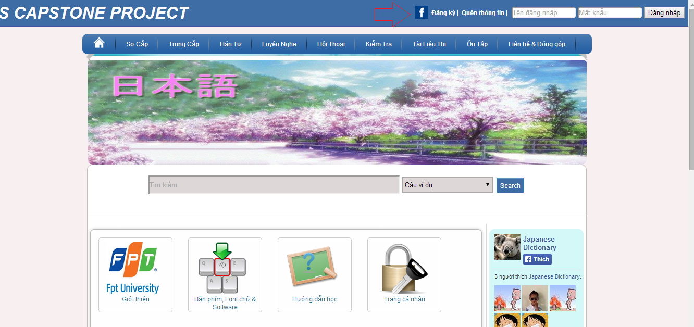

Step 2: If you not login Facebook, user need input username and password of Facebook account and login.

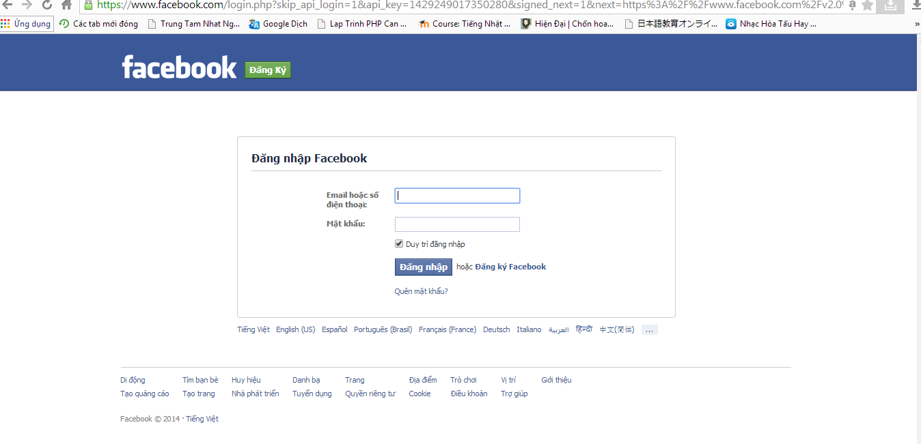

Step 3: Click “Đồng ý” to login by Facebook.

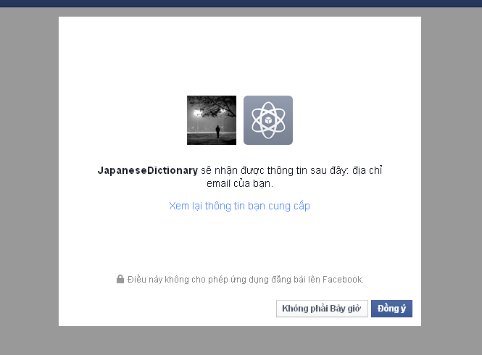

Step 4: System will redirect to homepage if login successful.

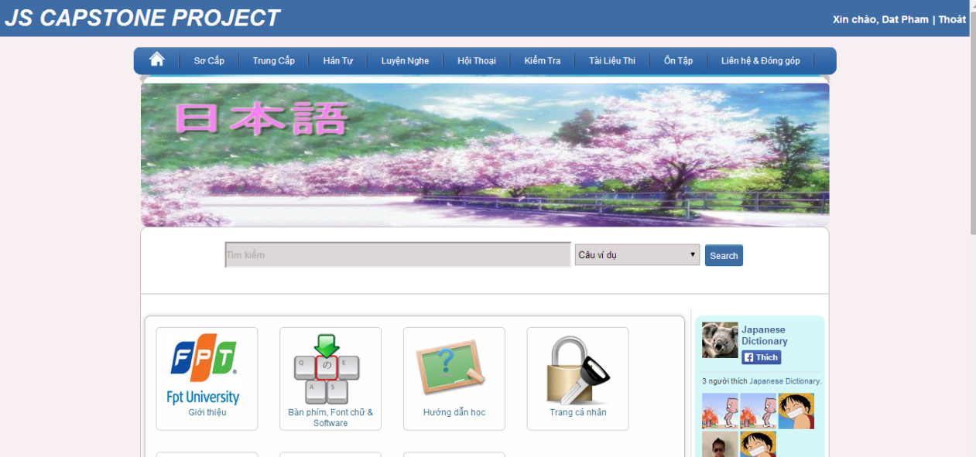

##### Login by registered account

To use login by register account function on website, the users do the steps below:

Step 1: Go to homepage

Step 2: Input correct username and password

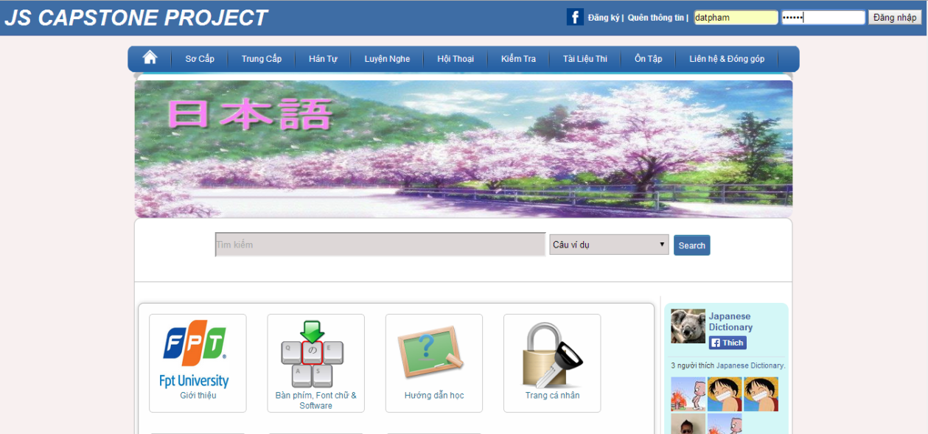

Step 3: Click “Đăng nhập” button

* Success:



* Fails: Error message will notify. You must be try again.

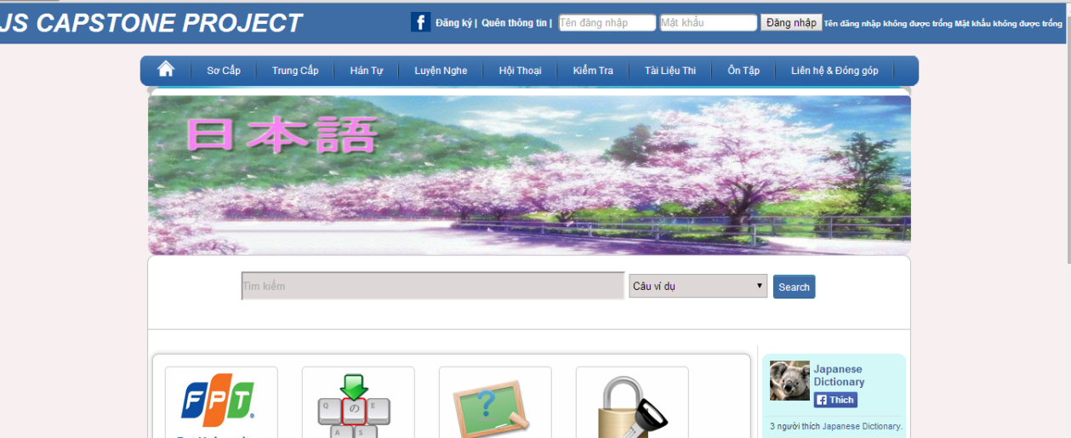

#### Logout

To use logout function on website, the users do the steps below:

Step 1: Login with facebook account or registered account as 4.2.6

Step 2: Click “Thoát” link.

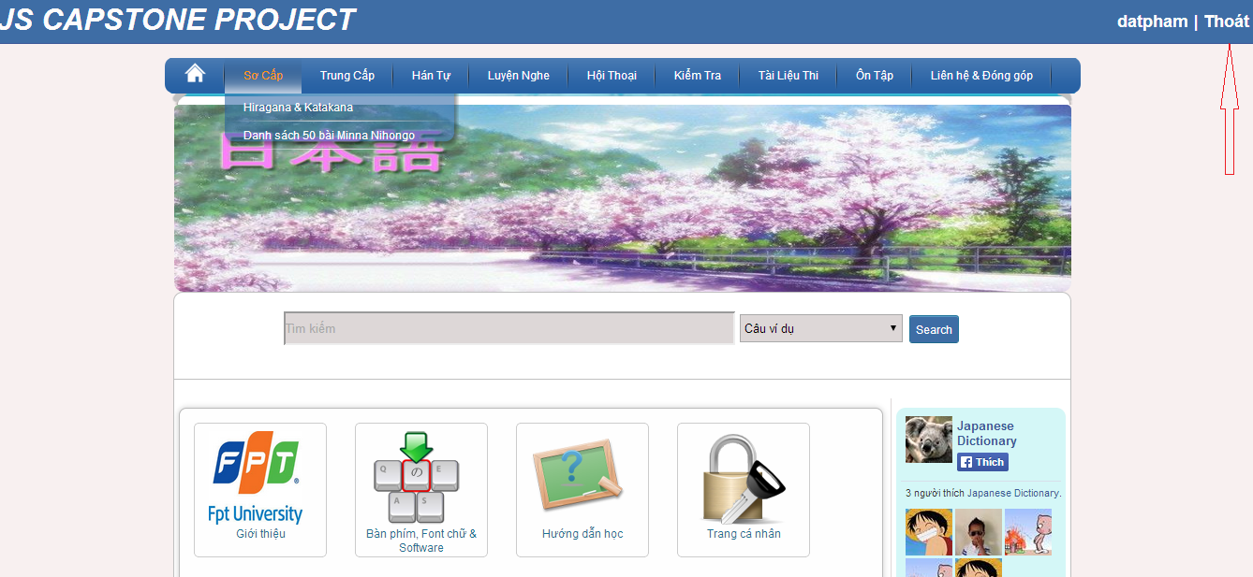

#### Register

To use register function on website, the users do the steps below:

Step 1: Go to homepage

Step 2: Click “Đăng ký” link.

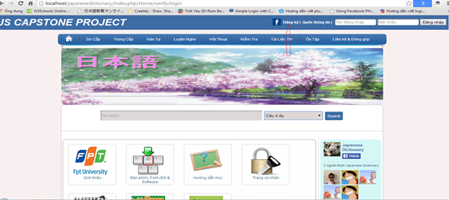

Step 3: Fill full your information to textbox. (*) is required.

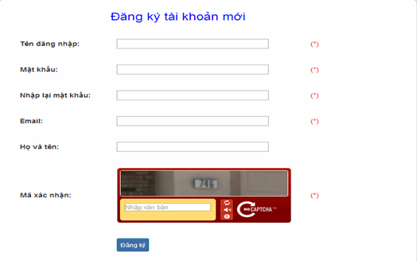

Step 4: Click “Đăng ký” button. System will check your information.

* If it suitable, a new account will create.

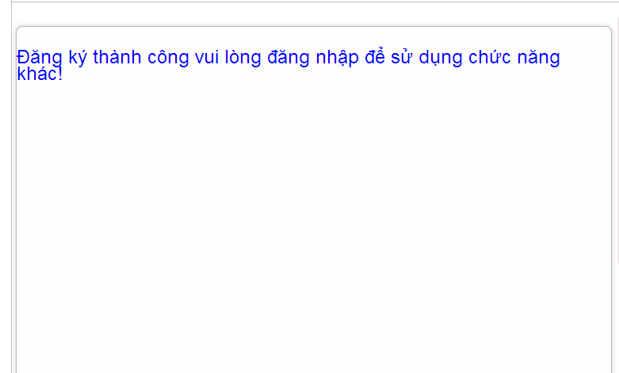

* If it unsuitable, error message will notify. You must be trying again.

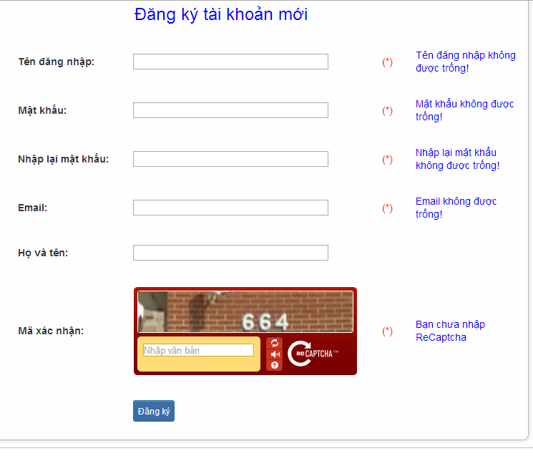

#### Edit profile

To use edit profile function on website, the users do the steps below:

Step 1: Login with Facebook account or registered account

Step 2:

* Method 1: Click “username” link.

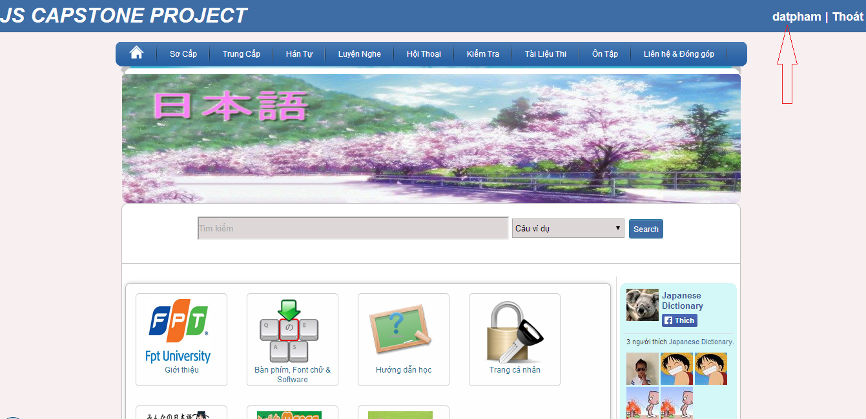

* Method 2:

+ Click “Trang cá nhân” link.

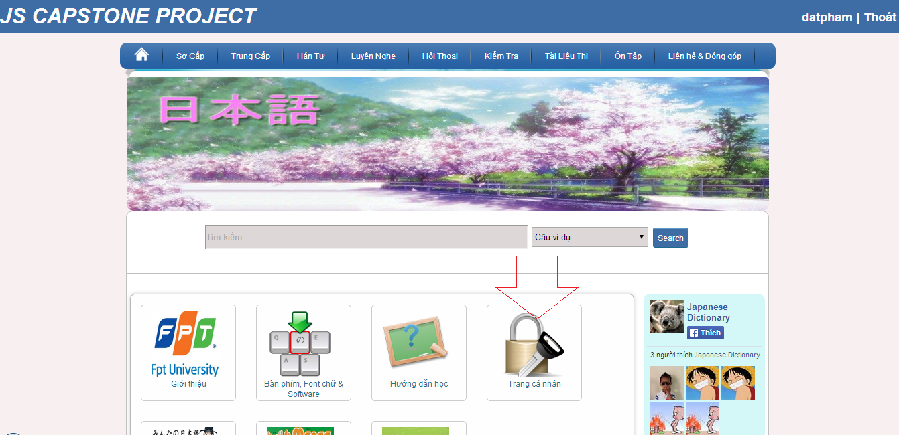

+ Click “Thay đổi thông tin” button

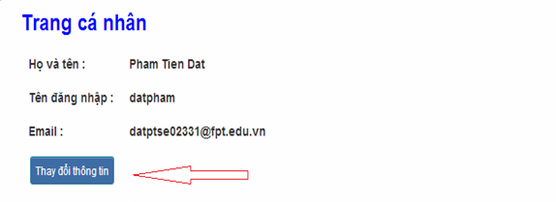

Step 3: Input correct information that you want change (email, họ tên, mật khẩu).

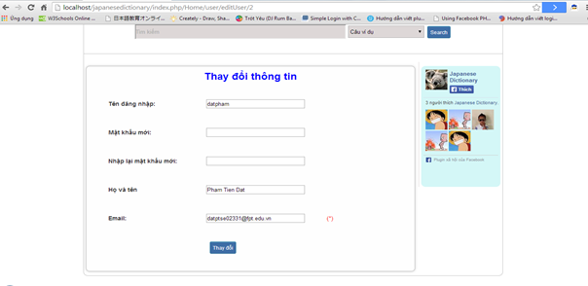Step 4: Click “Thay đổi” button.

* Success: System redirect to homepage

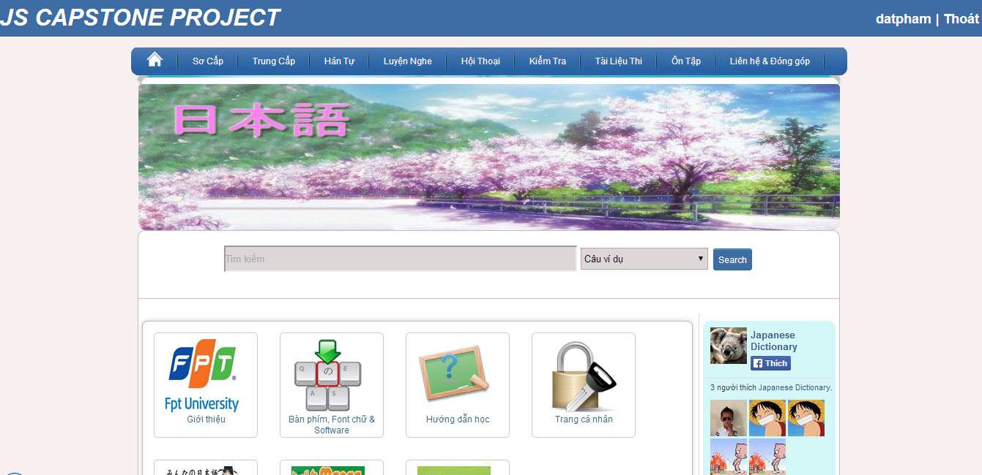

* Fails: Error message will notify. You must be try again.

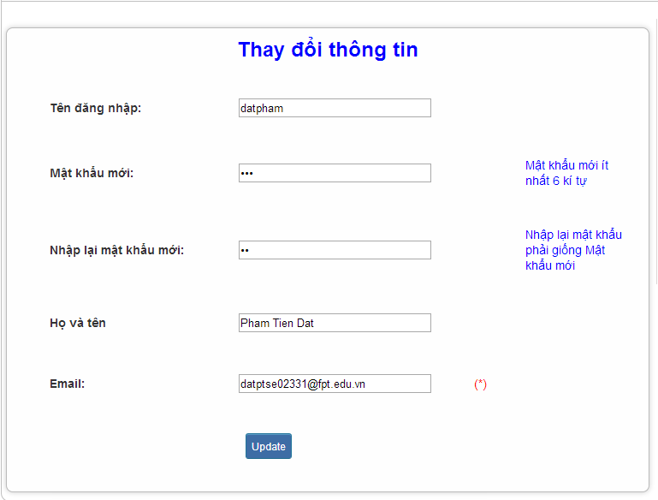

#### Forgot Password

To use forgot password function on website, the users do the steps below:

Step 1: Go to homepage.

Step 2: Click “Quên thông tin” link.

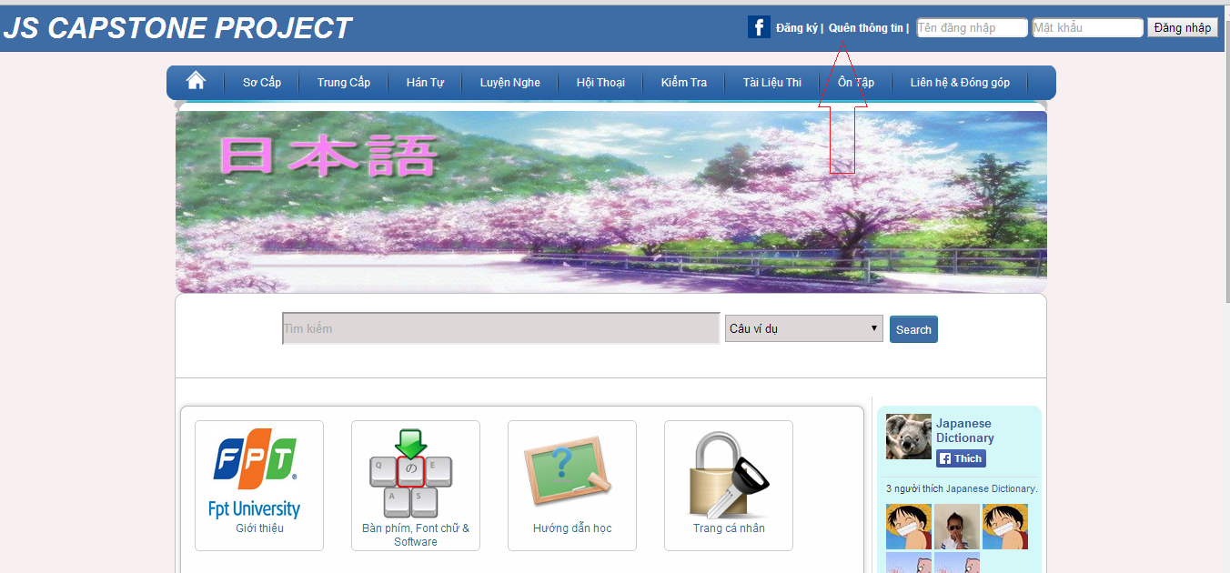

Step 3: Input email that use to register your account.

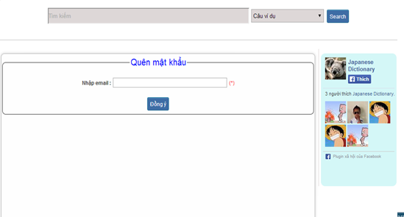

Step 4: Click “Đồng ý” button

* Success: Password will reset and send to your email

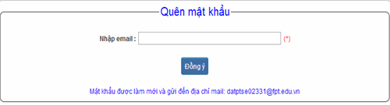

* Fails: Error message will notify. You must be try again.

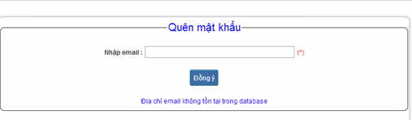

#### Contribute content

To use contribute content function on website, the users do the steps below:

Step 1**:** Go to homepage.

Step 2**:** Hover on “Liên hệ & Đóng góp” and click “Đóng góp database”.

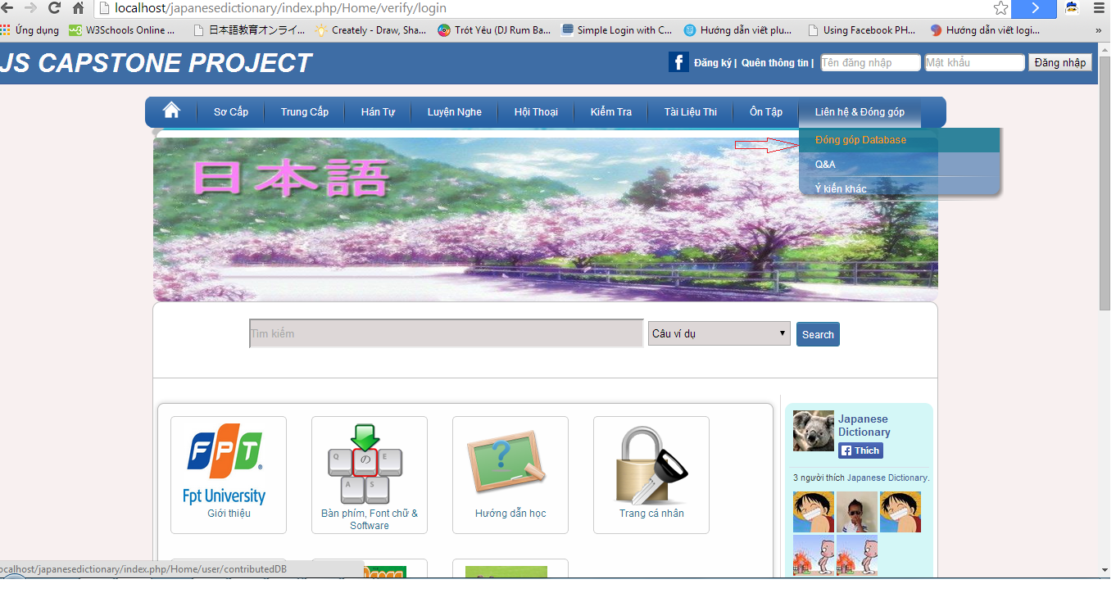

Step 3**:** Choose 1 of 3 type contribute

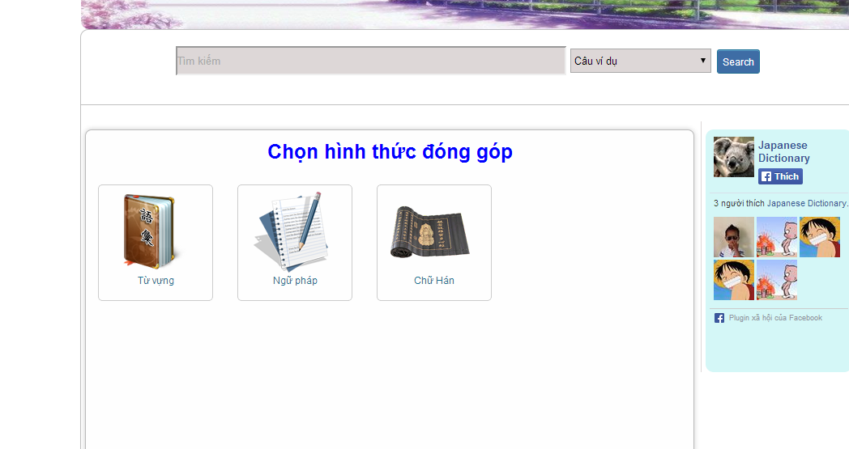

Step 4**:** Input correct information that you want contributed.

* Option 1: Contributing vocabulary

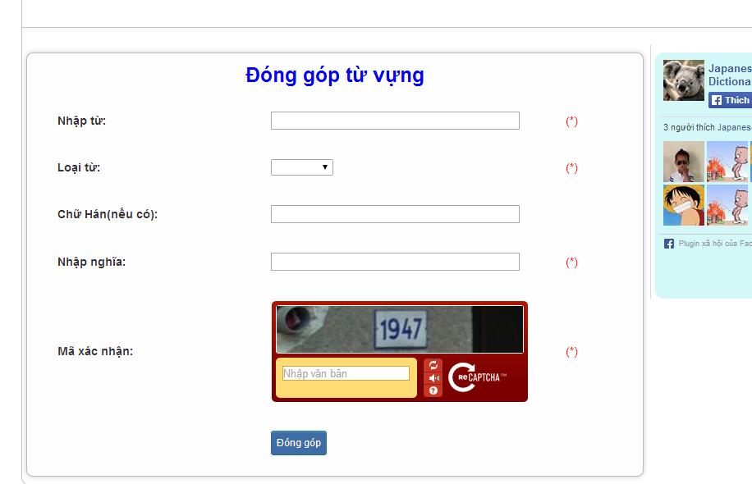

* Option 2: Contributing grammar

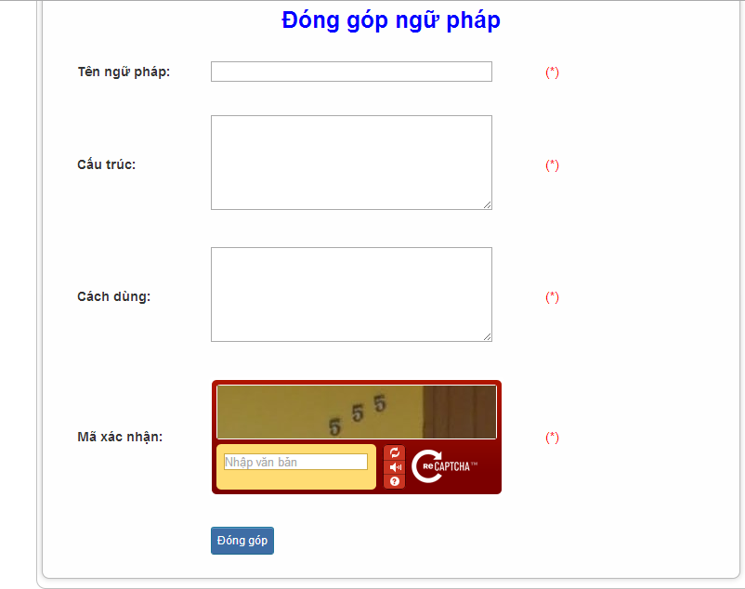

* Option 3: Contributing kanji

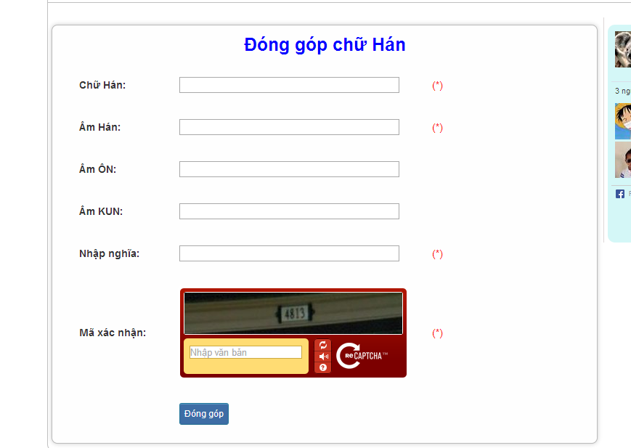

Step 5: Click “Đóng góp” button

* Success:

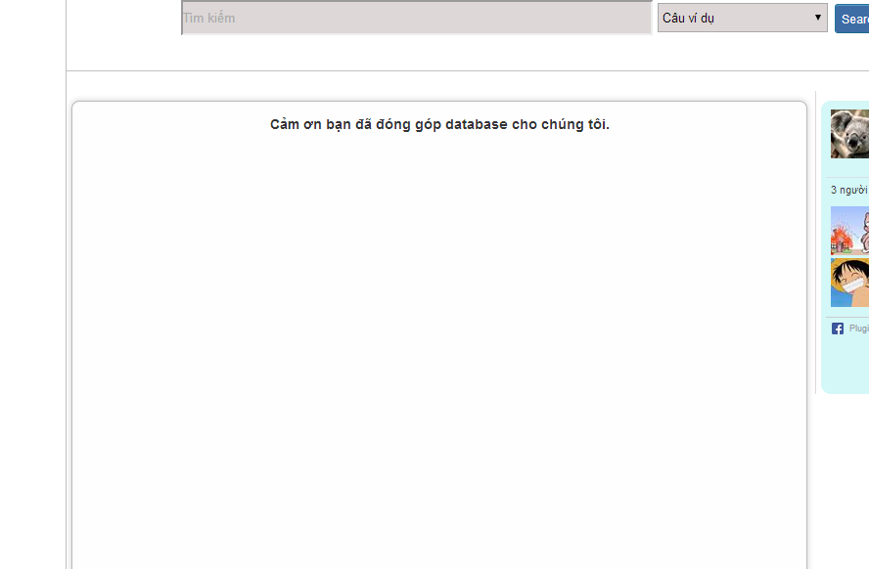

* Fails: Error message will notify. You must be try again.

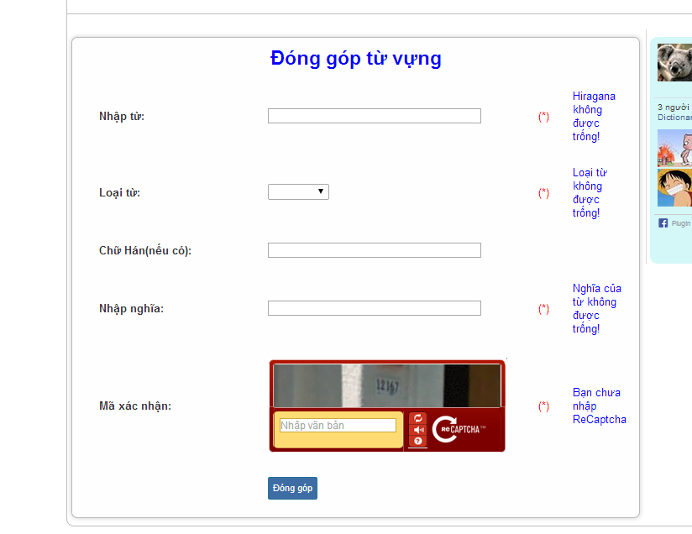

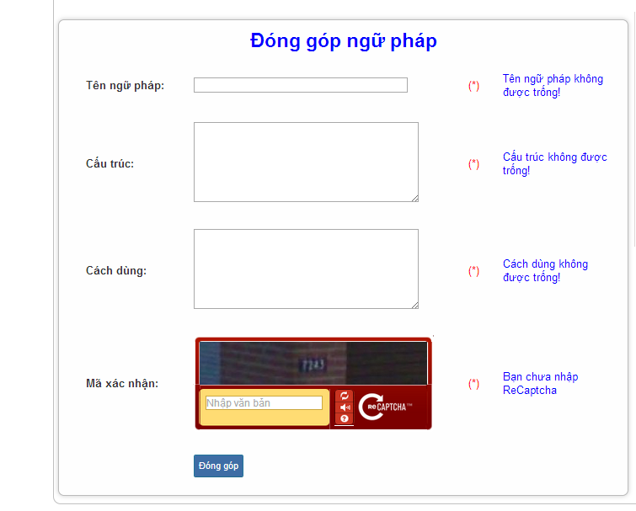

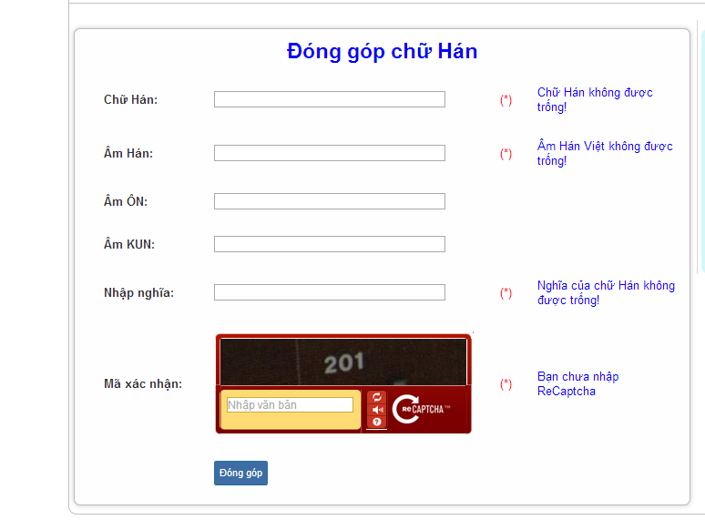

#### Contribute opinion

To use contribute opinion function on website, the users do the steps below:

Step 1**:** Go to homepage.

Step 2**:** Hover on “Liên hệ & Đóng góp” and click “Ý kiến khác”.

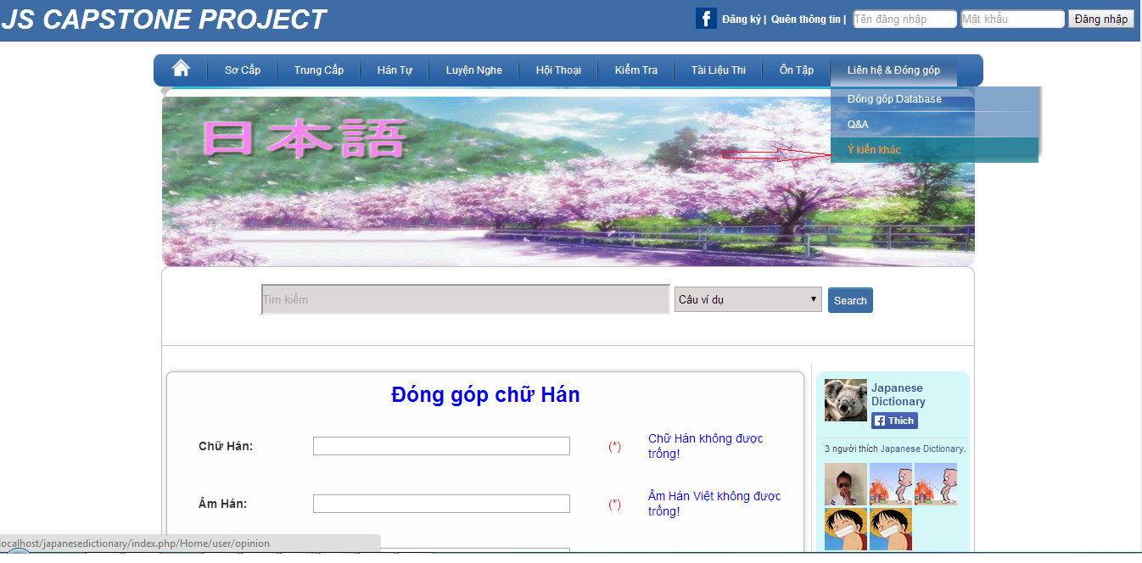

Step 3: Input correct opinion’s information that you want contributed.

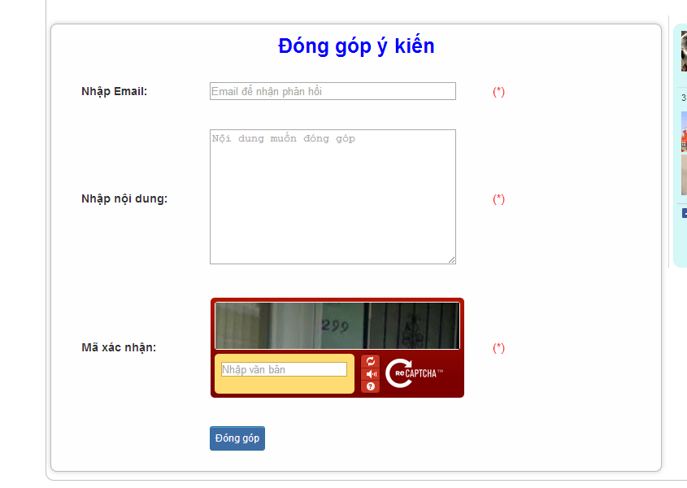

Step 4: Click “Đóng góp” button

* Success :

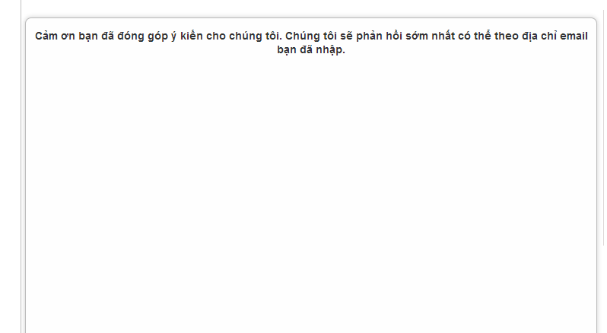

* Fails: Error message will notify. You must try again.

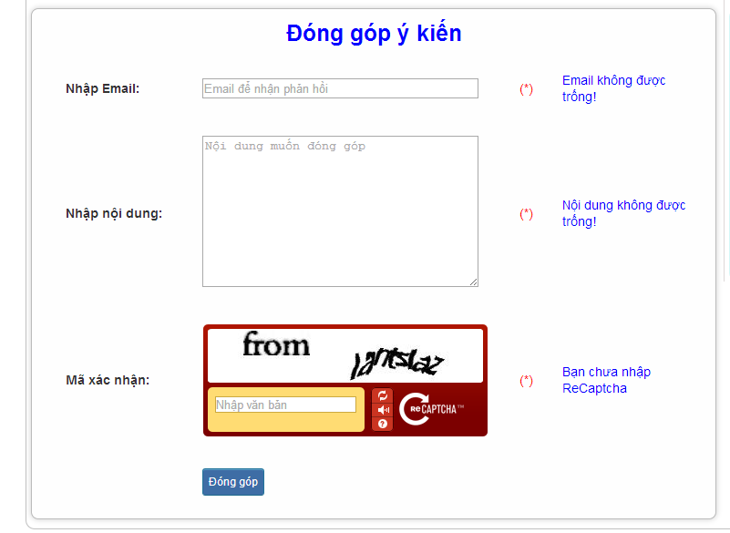

#### Send Q & A

To use Send Q&A function on website, the users do the steps below:

Step 1**:** Go to homepage.

Step 2**:** Hover on “Liên hệ & Đóng góp” and click “Q&A”.

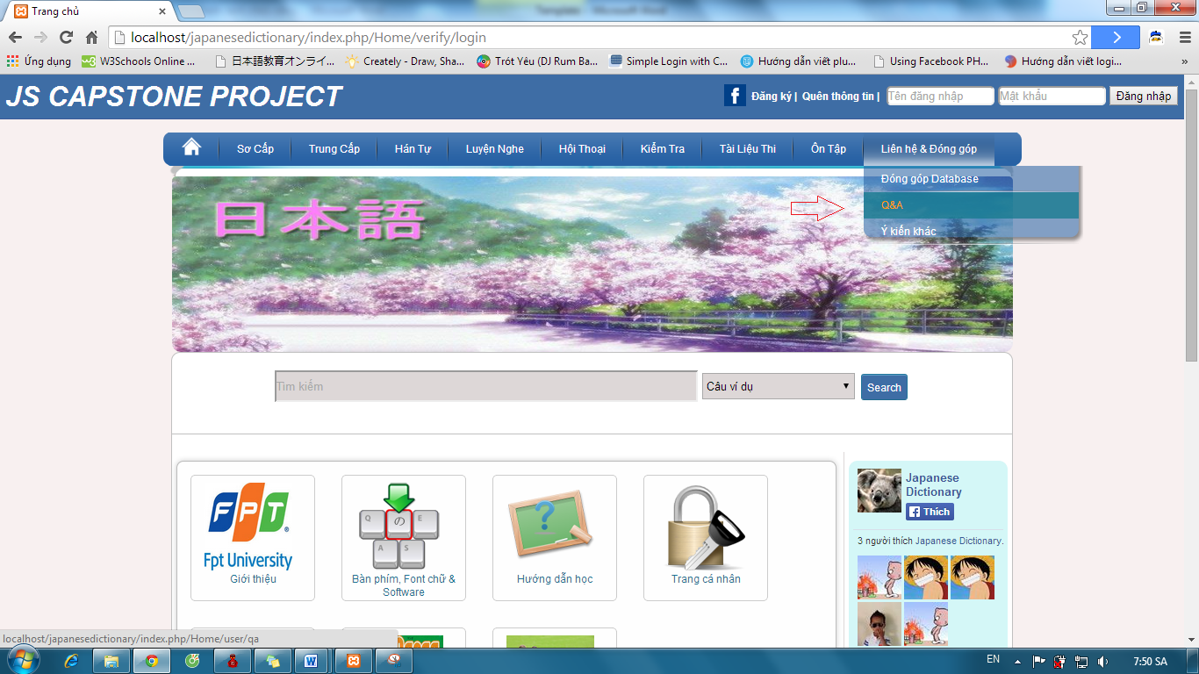

Step 3: Input correct opinion’s information that you want contributed.



Step 4: Click “Đóng góp” button

* Success :



* Fails: Error message will notify. You must be try again.



#### Test

To use test function on website, the users do the steps below:

Step 1: Login with facebook account or registered account as 4.2.6

Step 2:Hover on “Kiểm tra” and click 1 of 3 level to test.

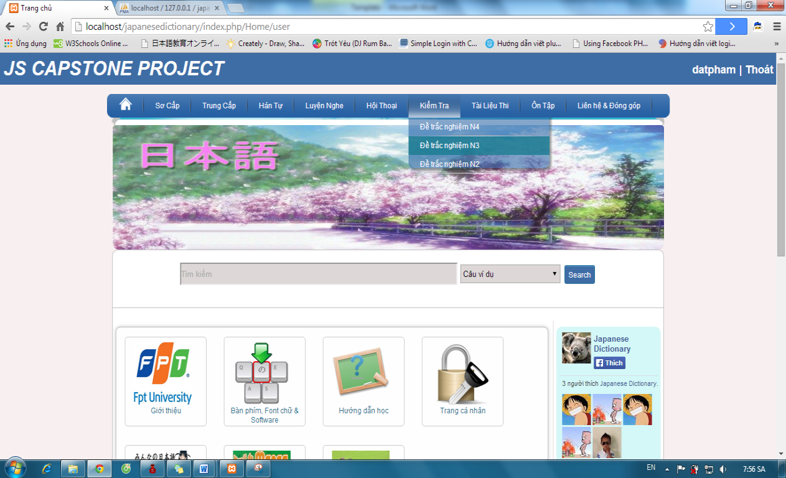

Step 3:Click one of the test link

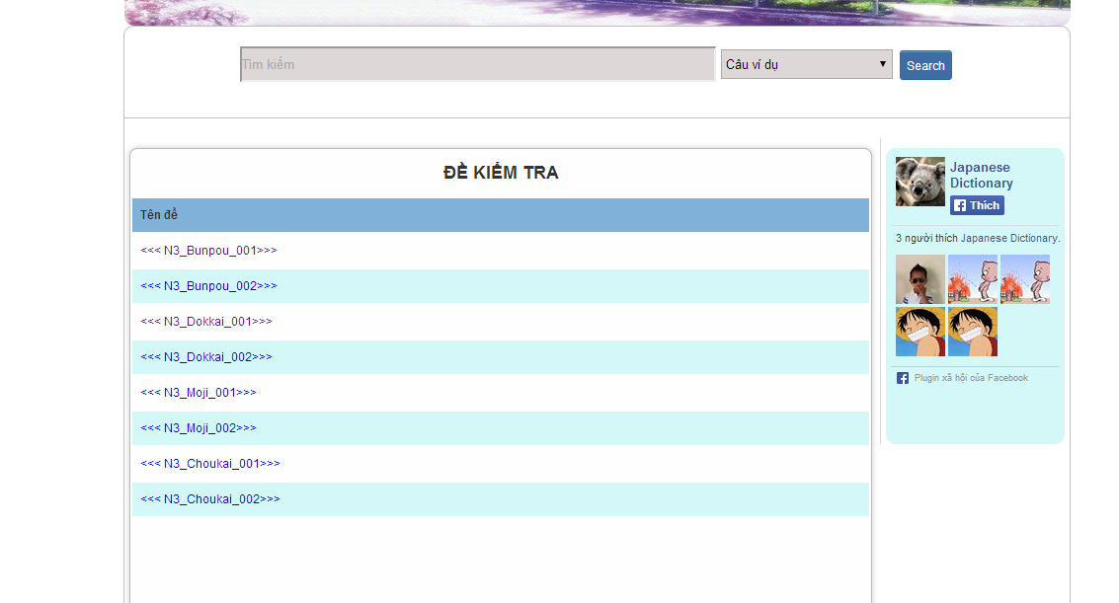

Step 4: Tick on your answer and click “Hoàn thành” button

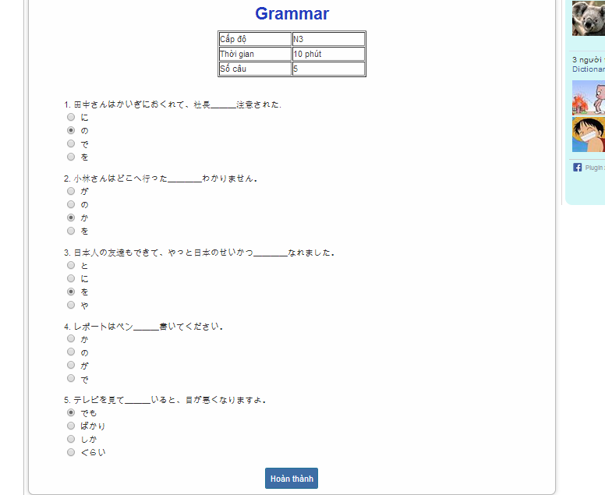

Step 5: Click “đây” link to view correct answer

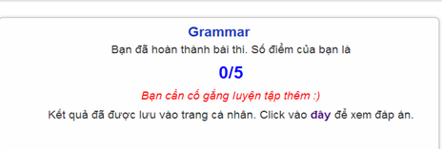

Step 6: Click “Quay lại” button after view correct answer

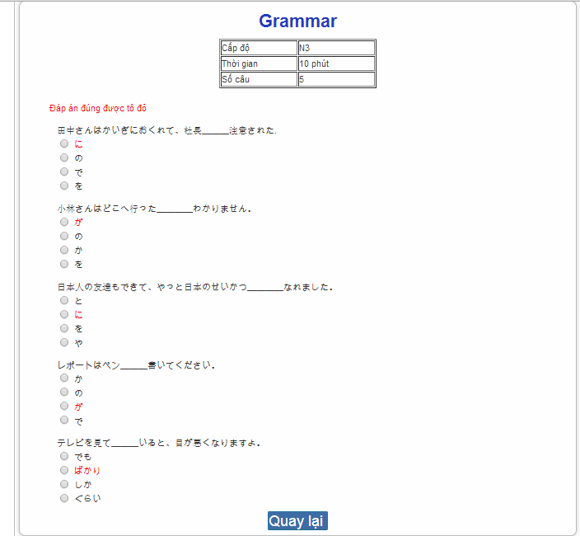

#### Tracking mark

To use tracking mark function on website, the users do the steps below:

Step 1: Login with Facebook account or registered account

Step 2: Click “Trang cá nhân” link on homepage



Step 3: View your mark.

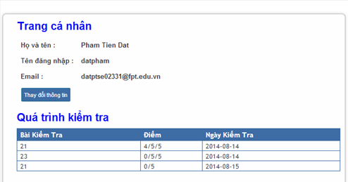

#### Training Listening

To use training listening function on website, the users do the steps below:

Step 1: Go to homepage

Step 2: Hover on “Luyện nghe” and click 1 of 2 levels to listen.

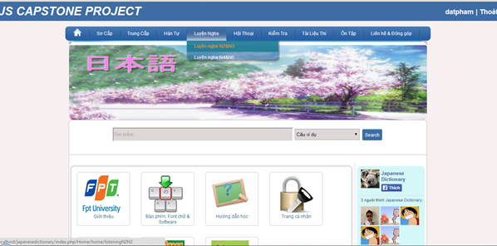

Step 3: Click one of the lesson listening links.

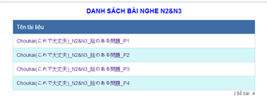

Step 4: Click play button to listen and click “Dịch&Đáp án” to view listening’s detail.

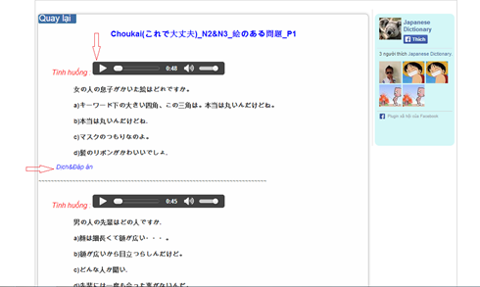

Step 5: Click “Quay lại” button after view listening’s detail.

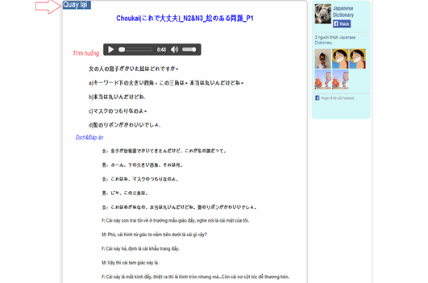

#### Listening conversation

To use listening conversation function on website, the users do the steps below:

Step 1: Go to homepage

Step 2: Hover on “Hội thoại” and click 1 of 3 levels to listening conversation.

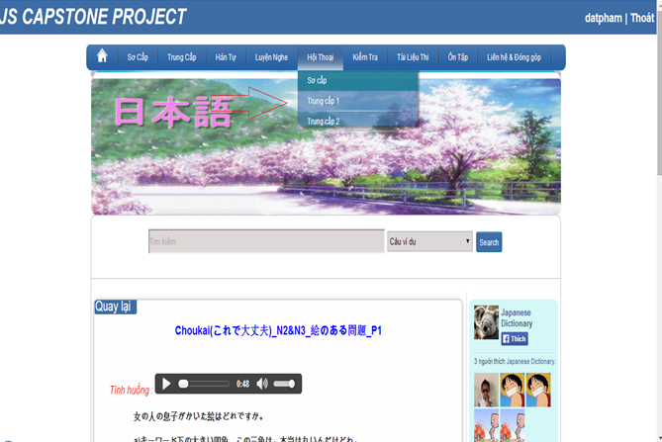

Step 3: Click one of the lesson of conversation links.

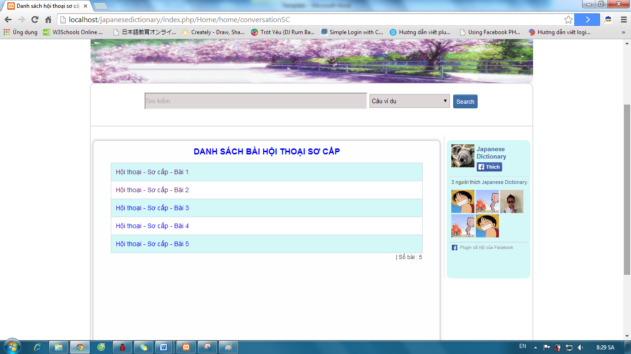

Step 4: Click play button to listen and click “Dịch” to view conversation’s content.

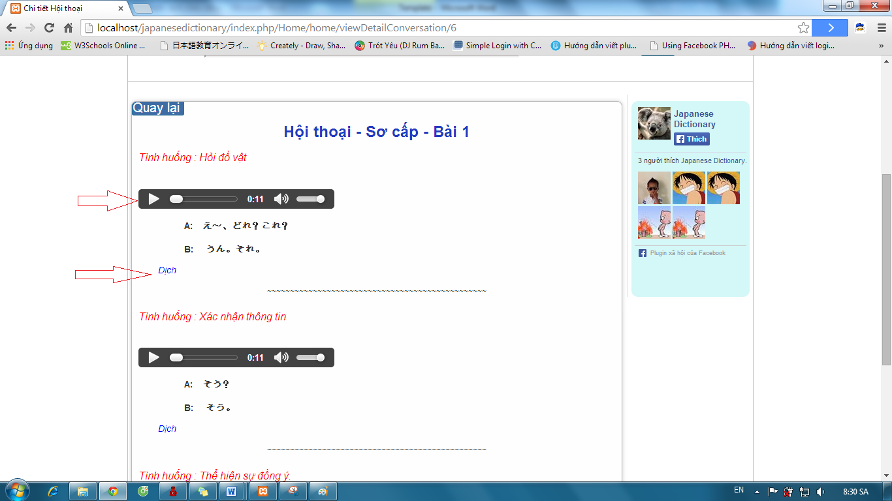

Step 5: Click “Quay lại” button after view conversation’s content

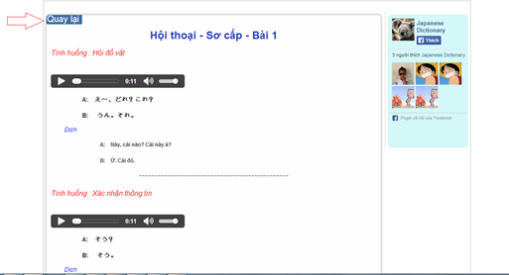

#### Reading Document

To use reading document function on website, the users do the steps below:

##### View alphabet

Step 1: Go to homepage

Step 2: Hover on “Sơ cấp” and click “Hiragana & Katakana” to view alphabet.

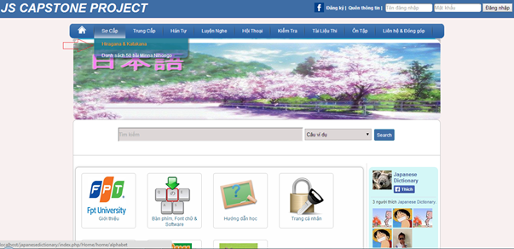

Step 3: Click “Bảng chữ cái Hiragana” link or “Bảng chữ cái Katakana” link to view alphabet.

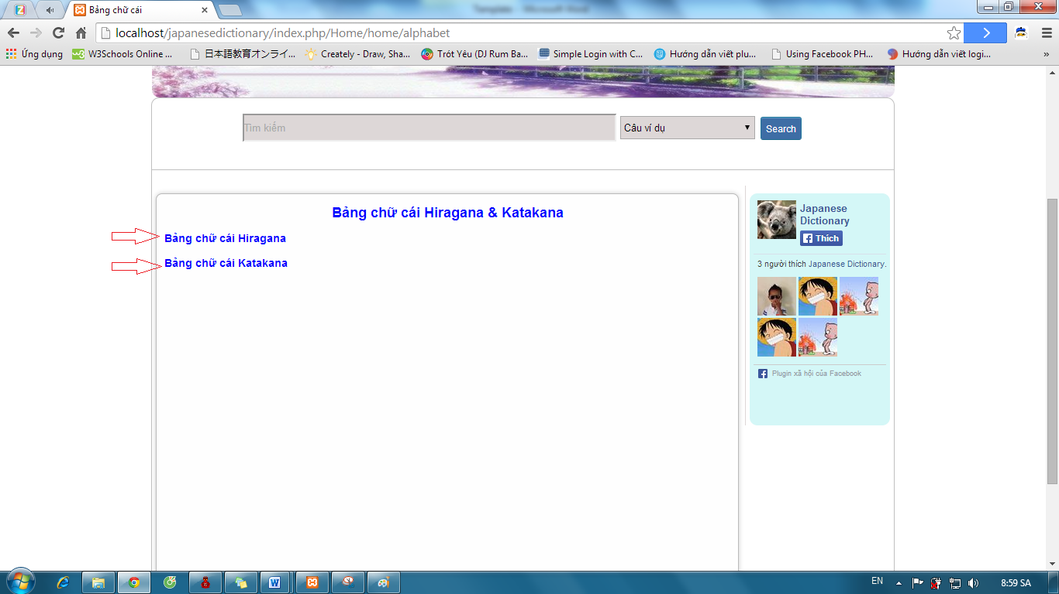

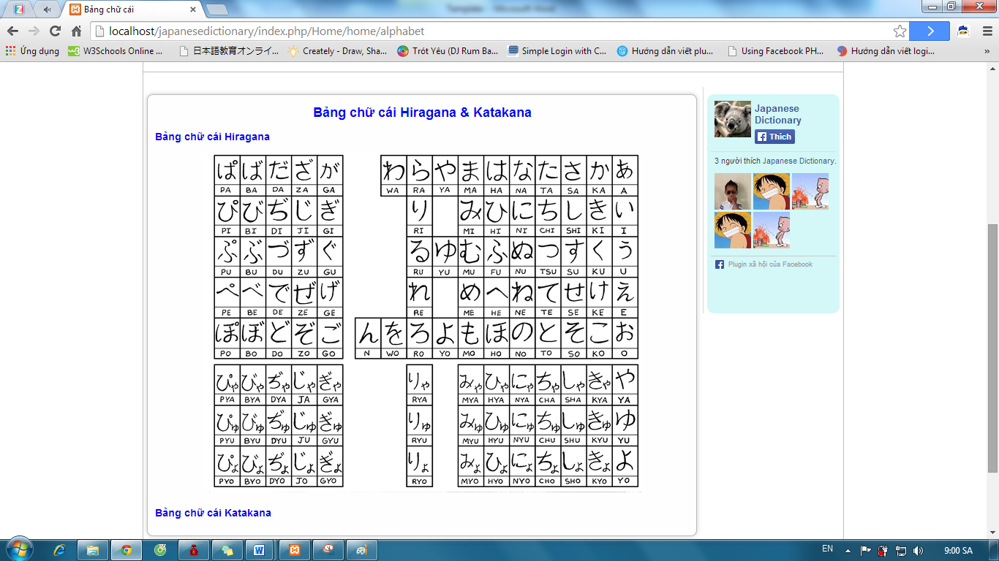

##### View document level Minna

Step 1: Go to homepage

Step 2: Hover on “Sơ cấp” and click “Danh sách 50 bài Minna Nihongo” link.

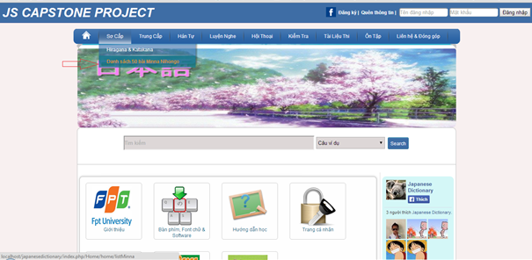

Step 3: Click one of the lessons.

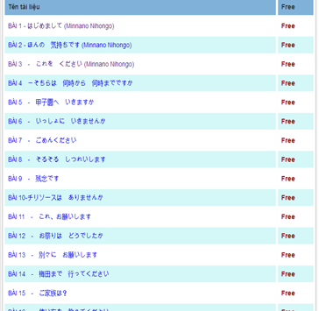

Step 4: Click one of the lesson’s content.

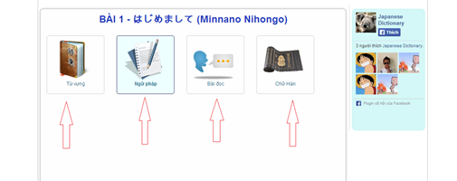

Step 5: Click “Quay lại” button after view content of lesson.

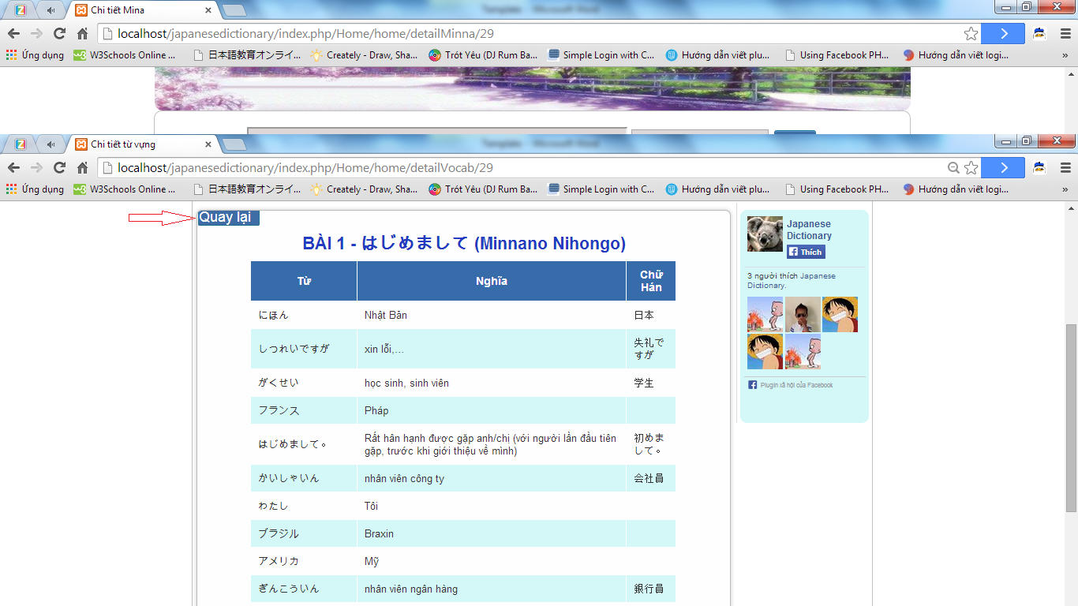

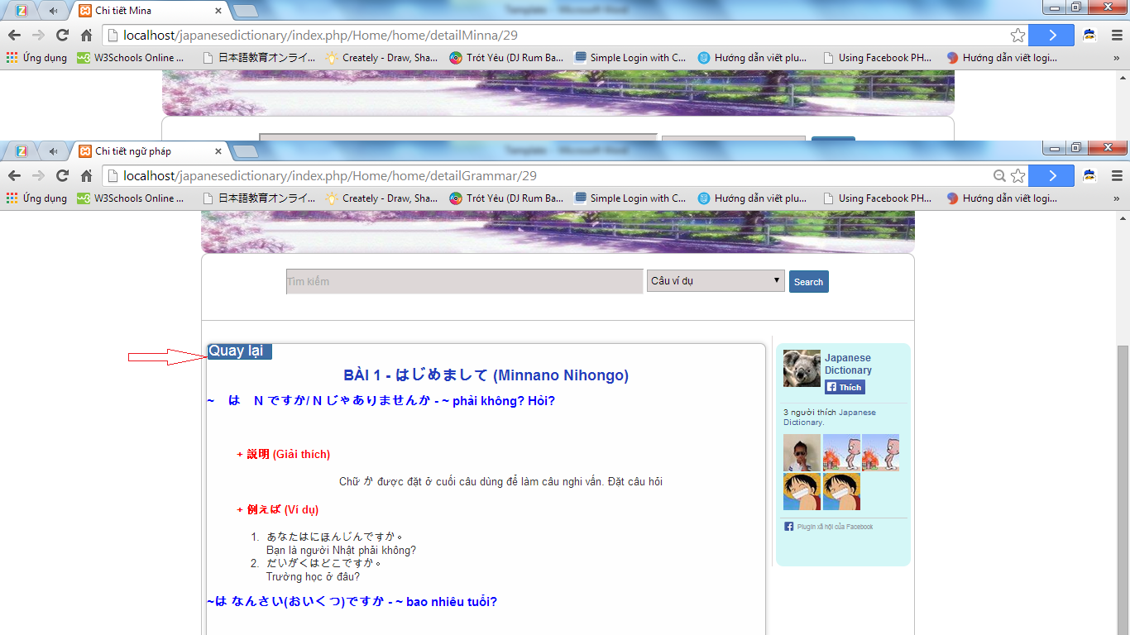

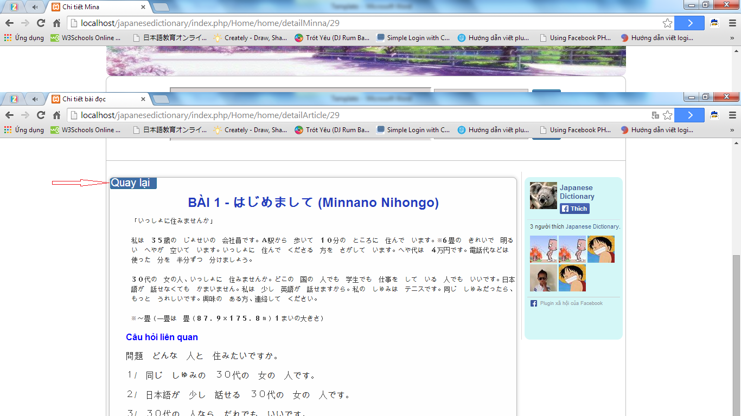

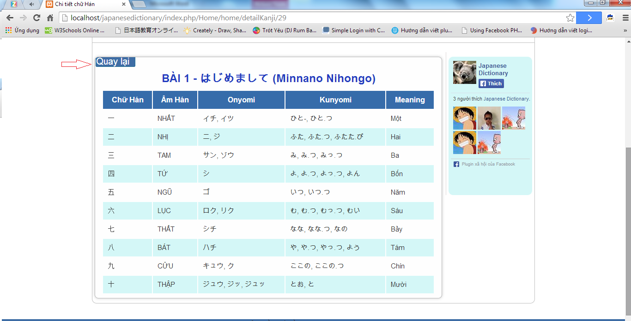

##### View document level intermediate

Step 1: Go to homepage

Step 2: Hover on “Trung cấp” and click one of the level links.

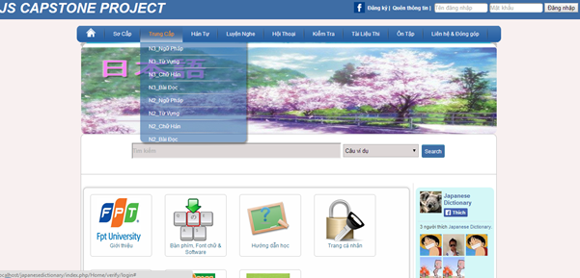

Step 3: Click one of the lesson links.

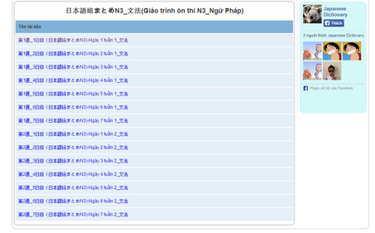

Step 4: Click “Quay lại” button after view lesson’s content.

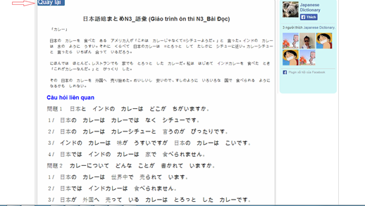

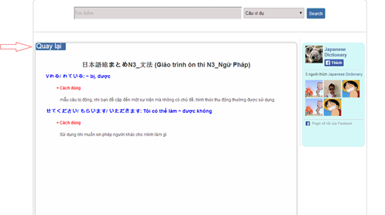

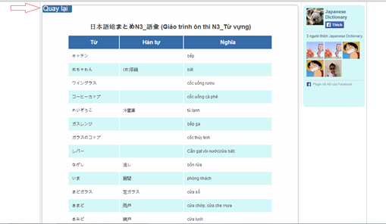

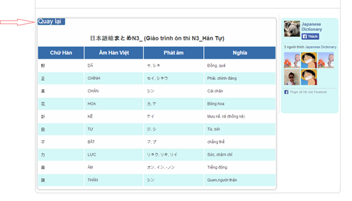

#### Login with admin account

To use login with admin account function on website, the users do the steps below:

Step 1: Go to link http://localhost/japanesedictionary/index.php/admin/verify/login

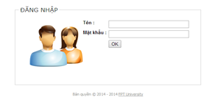

Step 2: Input correct username and password and click “OK” button.

* Success: Redirect to homepage admin.

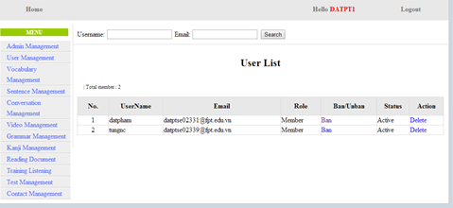

* Fails: Error message will notify. You must try again.

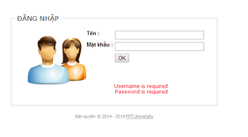

#### Admin’s account management

##### Add new Admin

To use add new admin function on website, the users do the steps below:

Step 1: Login with supper admin account.

Step 2: Click “Admin Management” link.

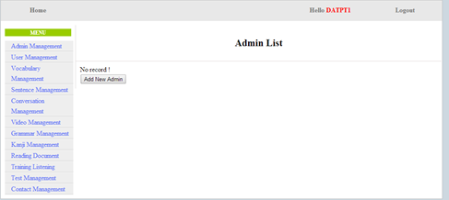

Step 3: Click “Add New Admin” button and input correct information that you want use to create a new account.

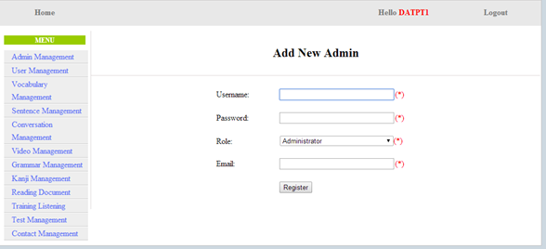

Step 4: Click “Register”

* Success: A new admin was created and system display admin list

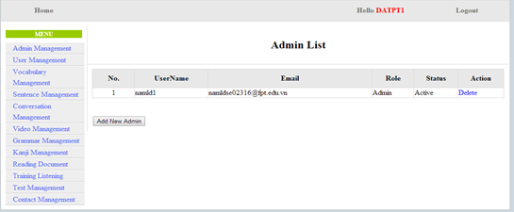

* Fails: Error message will notify. You must try again.

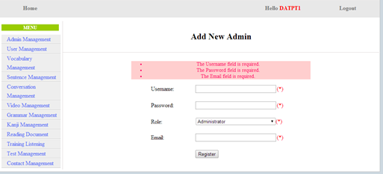

##### Edit profile

To use edit profile function on website, the users do the steps below:

Step 1: Login with admin account.

Step 2: Click “username” link.

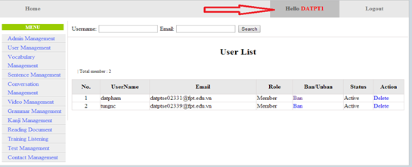

Step 3: Input correct information that you want change and click “Update” button.

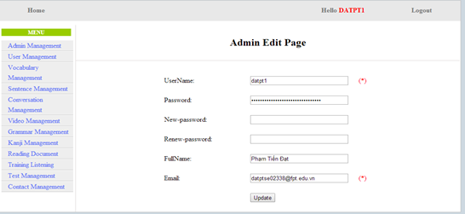

* Success: Redirect to homepage admin

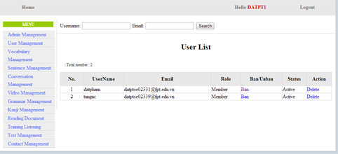

* Fails: Error message will notify. You must try again.

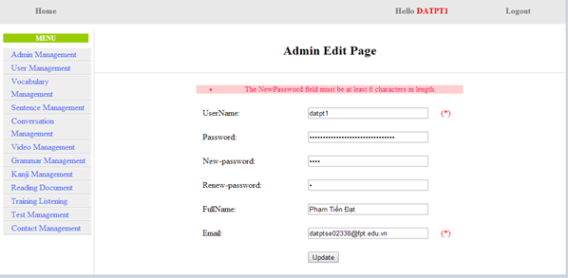

##### Delete Admin

To use delete admin function on website, the users do the steps below:

Step 1: Login with supper admin account.

Step 2: Click “Admin Management” link. System will display list admin.

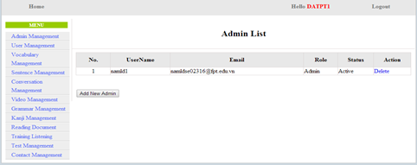

Step 3: Click “Delete” link. System will display list admin after delete an admin account.

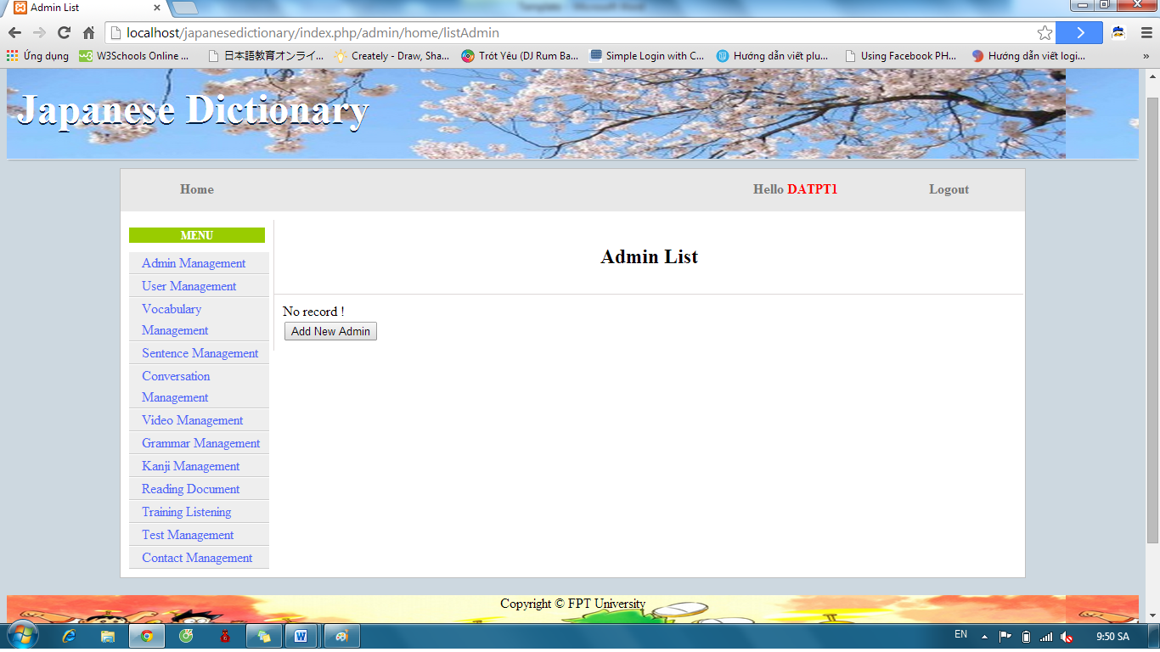

#### Management Member’s account

##### Search member

To use search member function on website, the users do the steps below:

Step 1: Login with admin account. System will display list User.

Step 2: Input username or email that you want find. Click “Search” button.

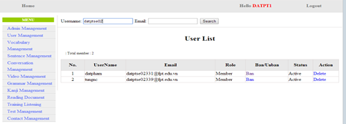

Step 3: View results found.

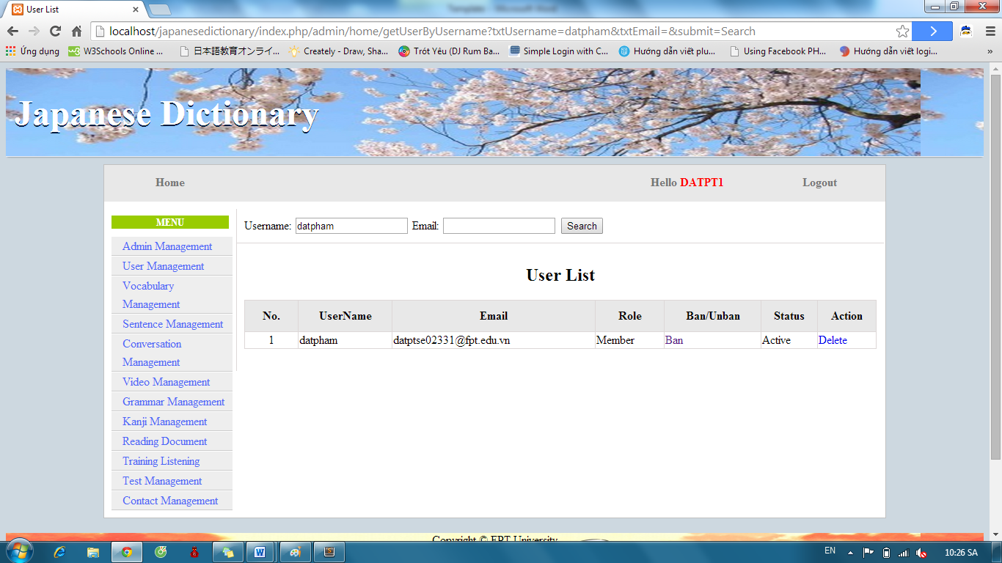

##### Ban/Unban member’s account.

To use ban/unban member’s account function on website, the users do the steps below:

Step 1: Login with admin account. System will display list User.

Step 2: Click “Ban” or “Unban” link.

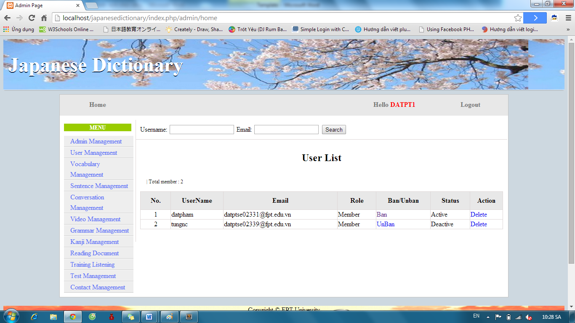

##### Delete member

To use delete member function on website, the users do the steps below:

Step 1: Login with admin account. System will display list User.

Step 2: Click “Delete” link.



#### Vocabulary Management

##### Search Vocabulary

To use search vocabulary function on website, the users do the steps below:

Step 1: Login with admin account. System will display list User.

Step 2: Click “Vocabulary management” link. System will display list Vocabulary.

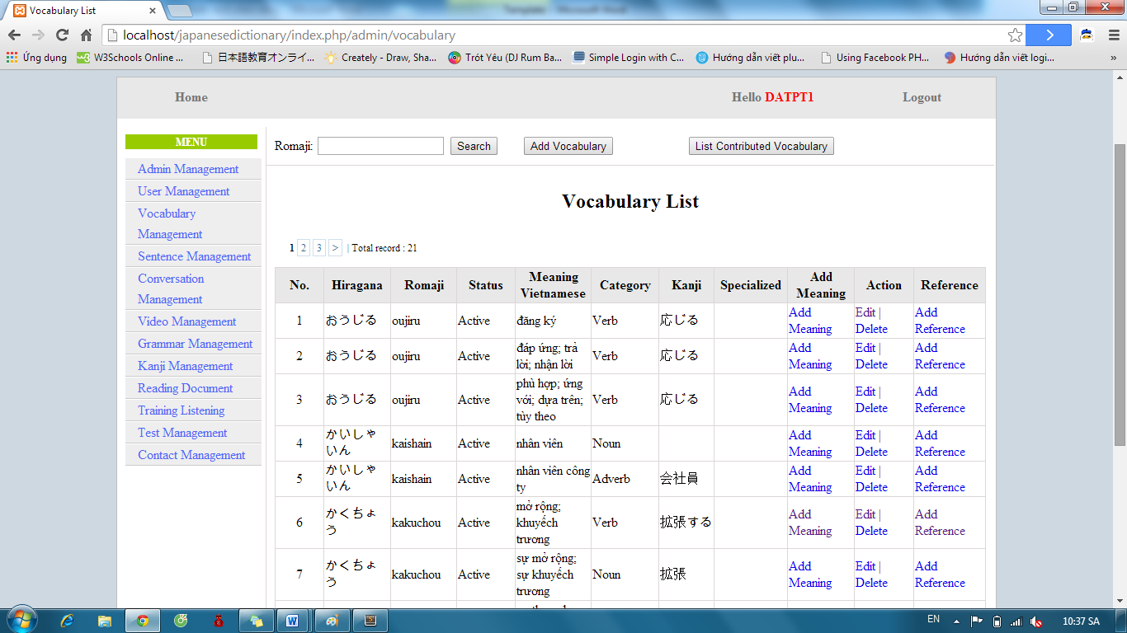

Step 3: Input vocabulary’s romaji and click “Search” button. Display results found.

* If exist : Display result

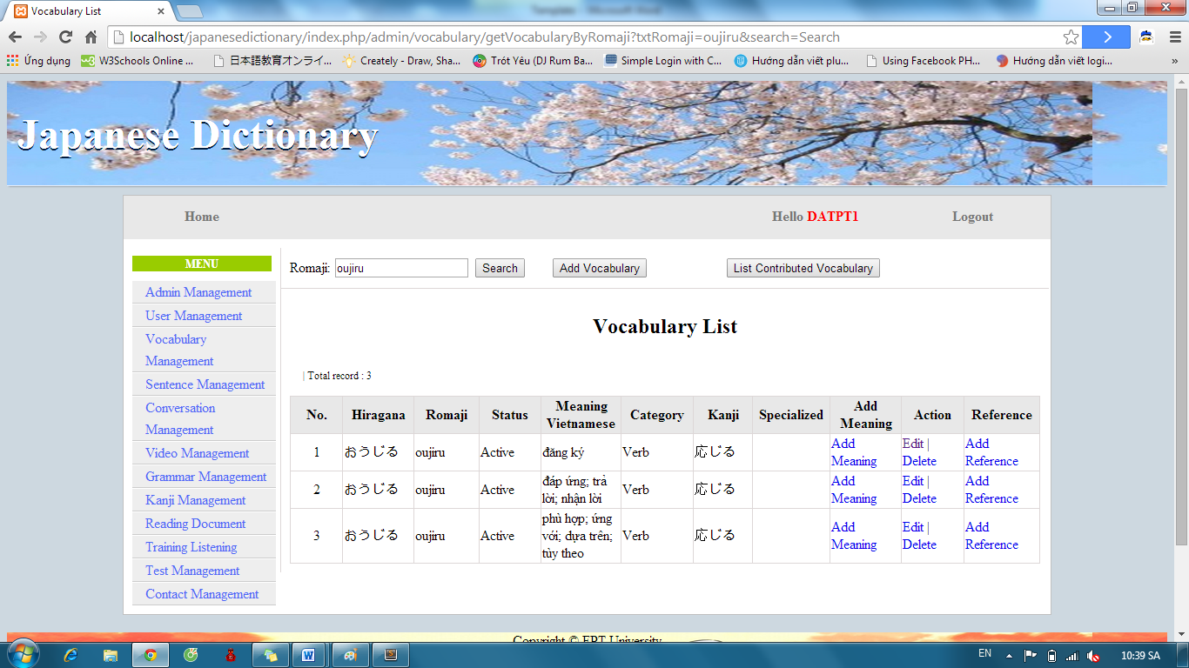

* If don’t exist : Display no record

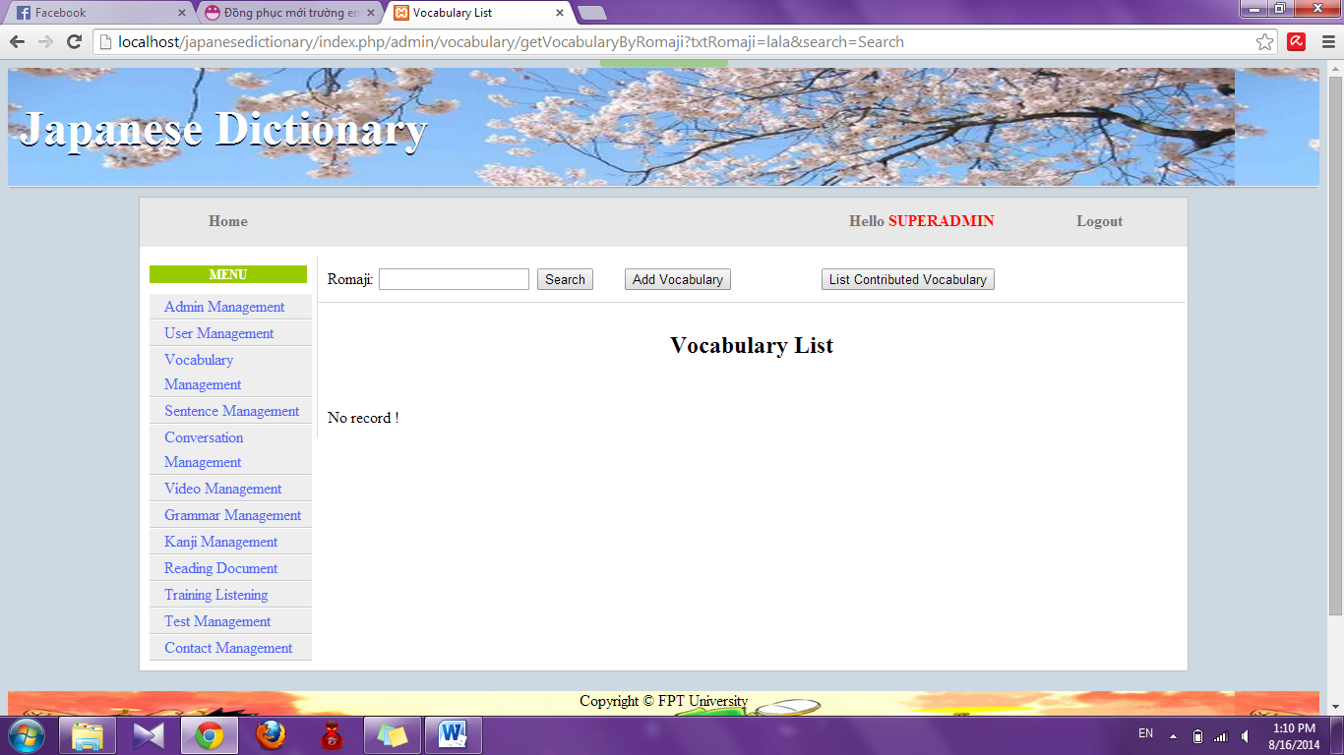

##### Add Vocabulary

To use add vocabulary function on website, the users do the steps below:

Step 1: Login with admin account. System will display list User.

Step 2: Click “Vocabulary management” link. System will display list Vocabulary.



Step 3: Click “Add Vocabulary” button and input correct information of vocabulary that you want add.

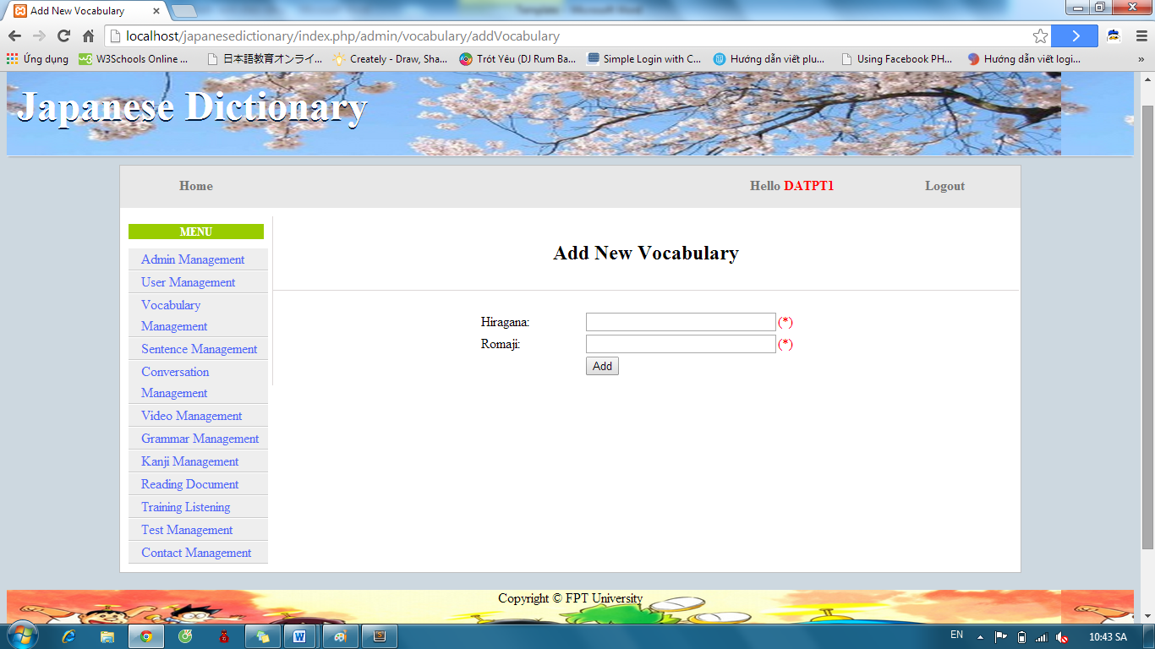

Step 4: After input, click “Add” button.

* Success: System display list Vocabulary with new vocabulary



* Fails: Error message will notify. You must try again.

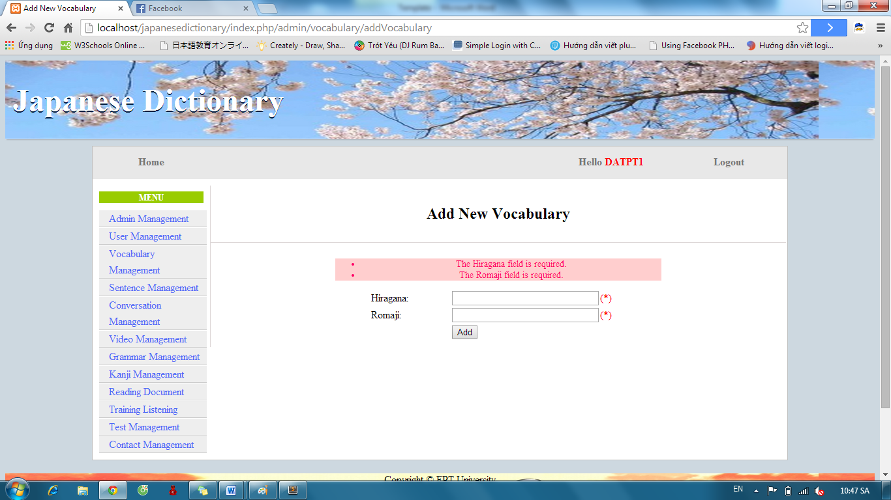

Step 5: After add vocabulary successful, click “Add Meaning” of corresponding Vocabulary.

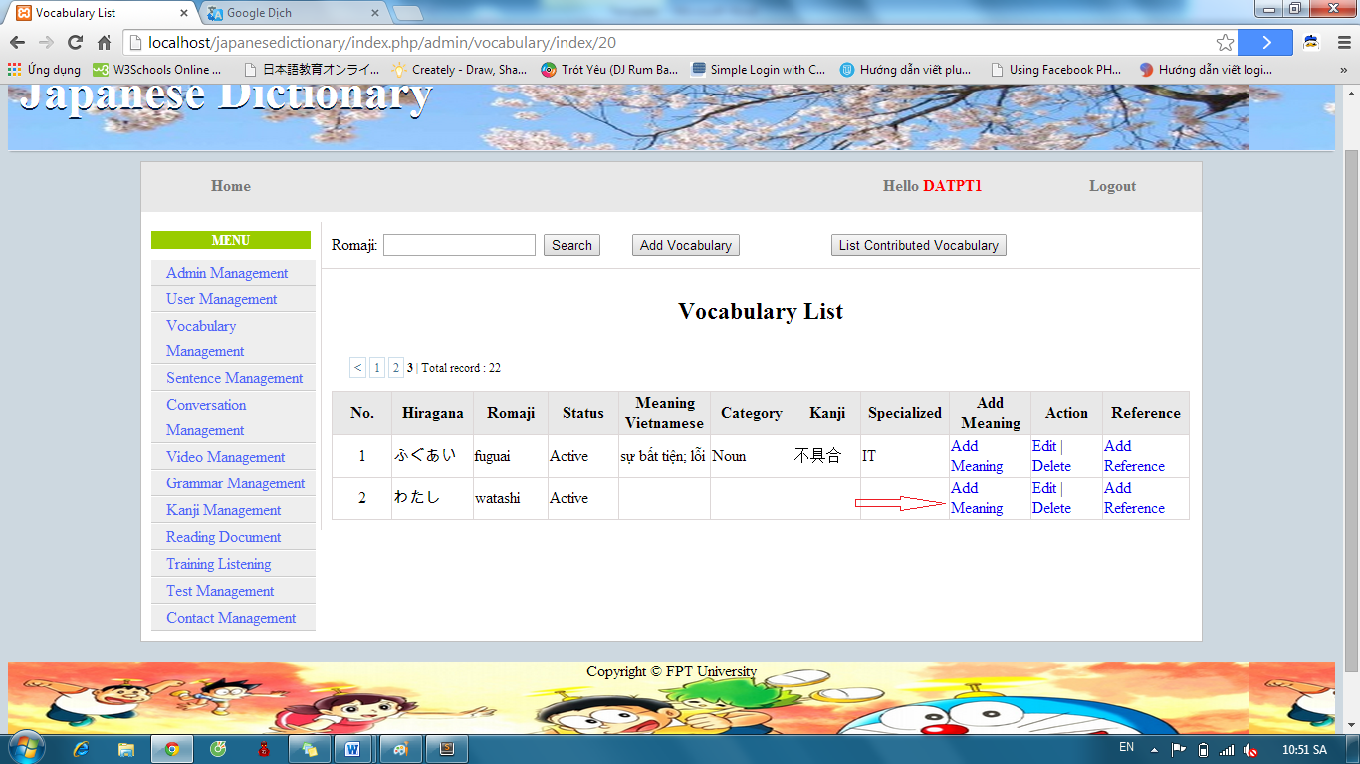

Step 6: Input correct information of vocabulary and click “Add” button

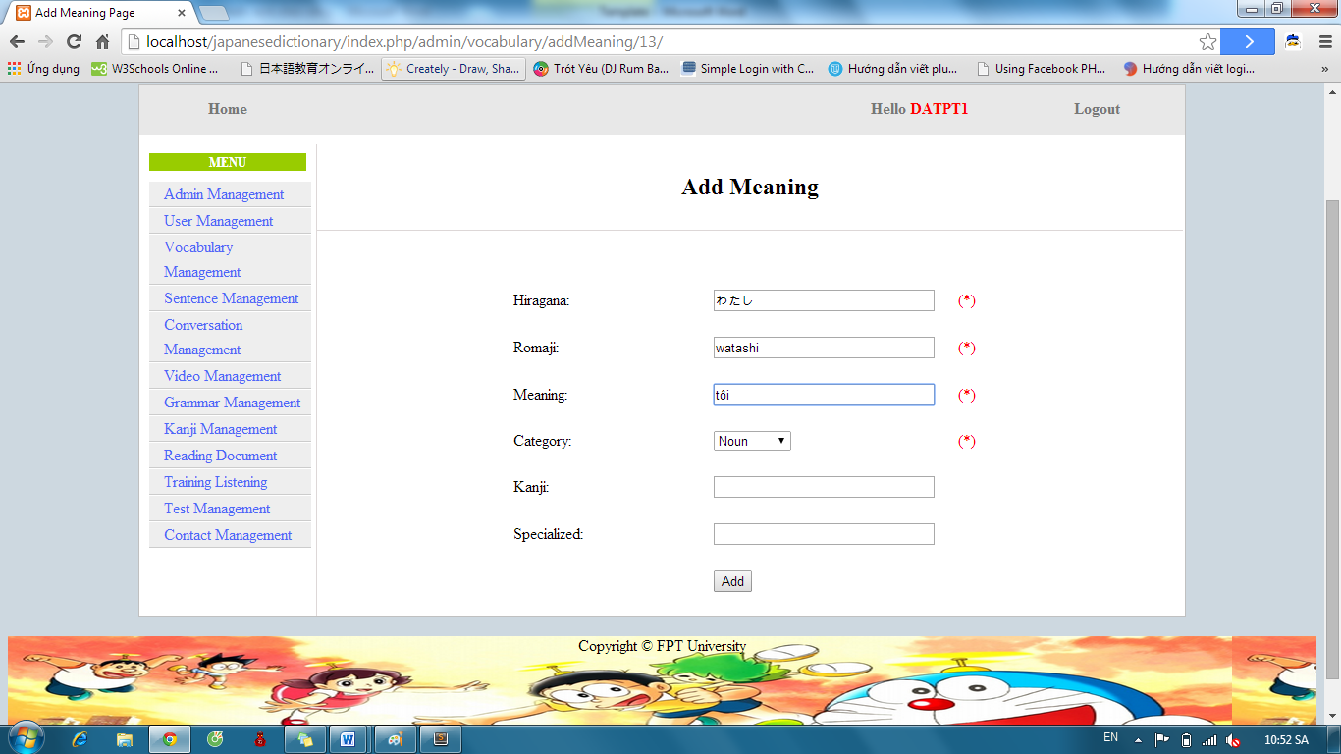

* Success : Display list Vocabulary



* Fails: Error message will notify. You must try again.

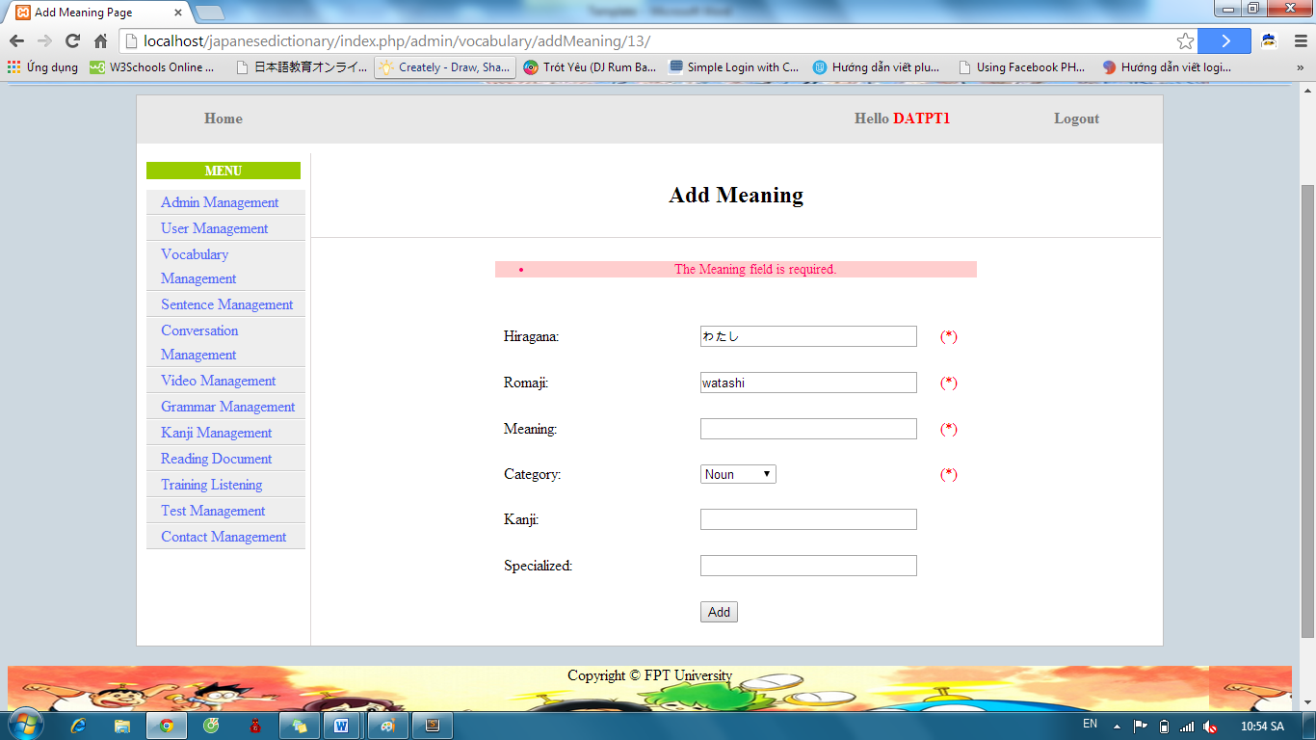

##### Edit Vocabulary

To use edit vocabulary function on website, the users do the steps below:

Step 1: Login with admin account. System will display list User.

Step 2: Click “Vocabulary management” link. System will display list Vocabulary. After that, click “Edit” link.



Step 3: Input correct information of vocabulary that you want change and click “Edit” button.

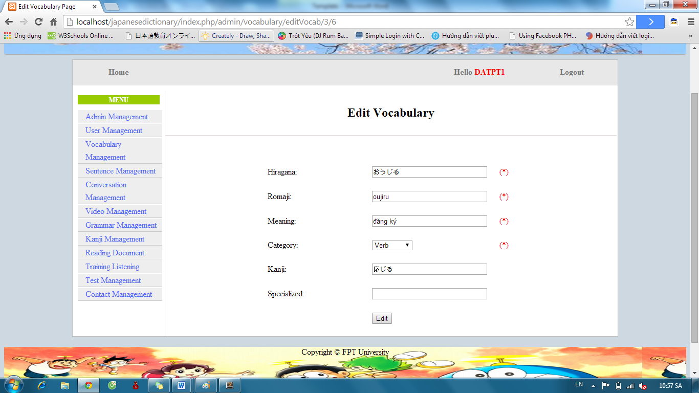

* Success : Display list vocabulary



* Fails: Error message will notify. You must try again.

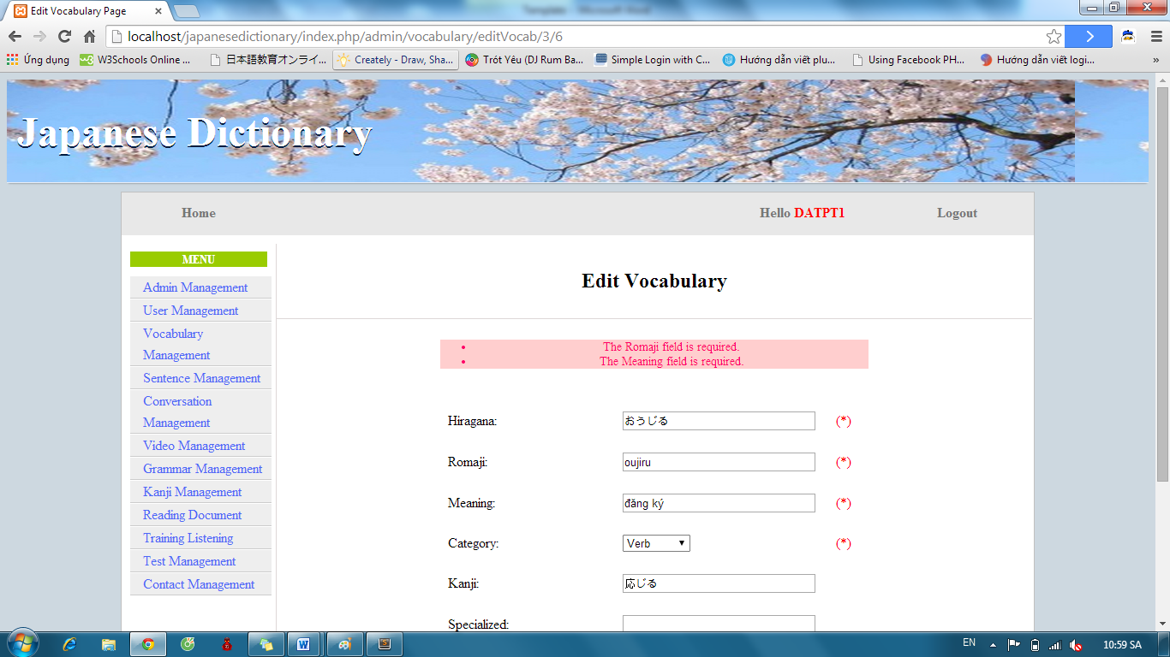

##### Delete Vocabulary

To use delete vocabulary function on website, the users do the steps below:

Step 1: Login with admin account. System will display list User.

Step 2: Click “Vocabulary management” link. System will display list Vocabulary. After that, click “Delete” link.



If vocabulary has one meaning, it deleted. If vocabulary has many meaning, corresponding meaning with “Delete” link deleted.

##### Approve Vocabulary

To use approve vocabulary function on website, the user do the steps below:

Step 1: Login with admin account. System will display list User

Step 2: Click “Vocabulary management” link. System will display list Vocabulary.



Step 3: Click “List contribute vocabulary” button. List vocabulary contribute will display

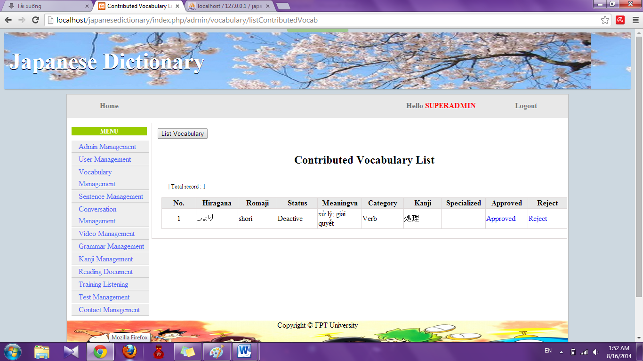

Step 4: Click “Approve” link. System will display approve page

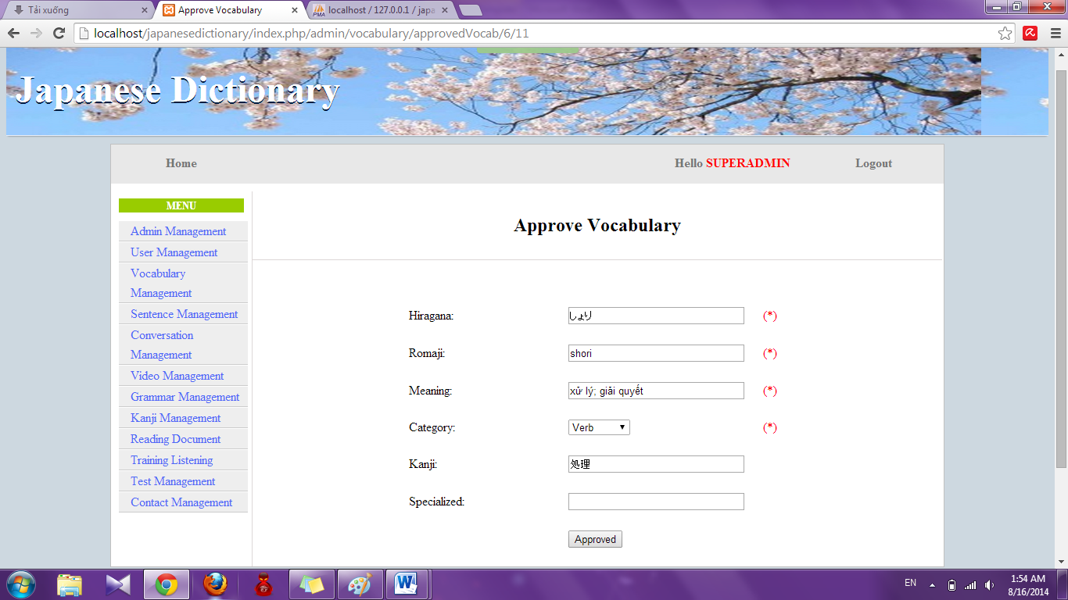

Step 5: Edit information (if need) and click “Approved” button

* Success : Redirect to Contribute Vocabulary list
* Fail: Error message will notify. You must try again.

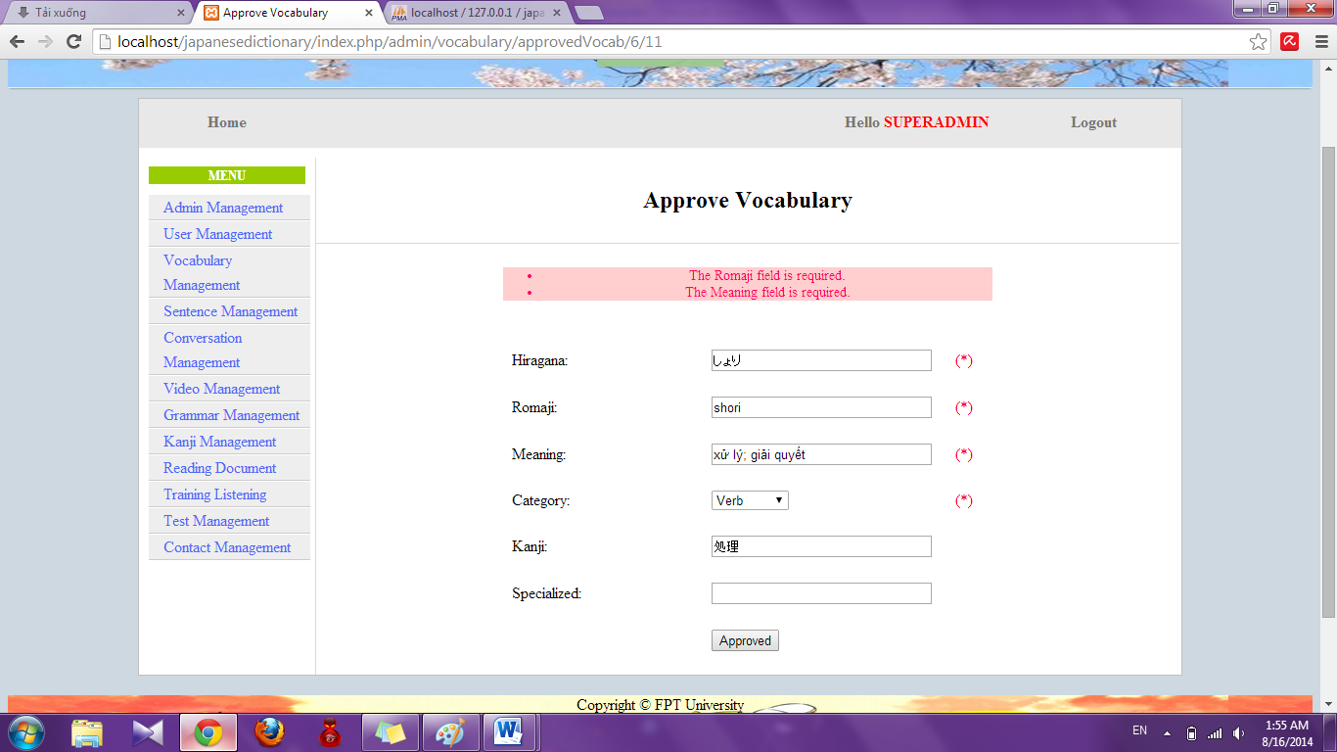

##### Reject Vocabulary

To use reject vocabulary function on website, the user do the steps below:

Step 1: Login with admin account. System will display list User

Step 2: Click “Vocabulary management” link. System will display list Vocabulary.



Step 3: Click “List contribute vocabulary” button. List vocabulary contribute will display.



Step 4: Click “Reject” link. System will reject that contribute

#### Grammar Management

##### Search grammar

To use search grammar function on website, the users do the steps below:

Step 1: Login with admin account. System will display list User.

Step 2: Click “Grammar management” link. System will display list Grammar.

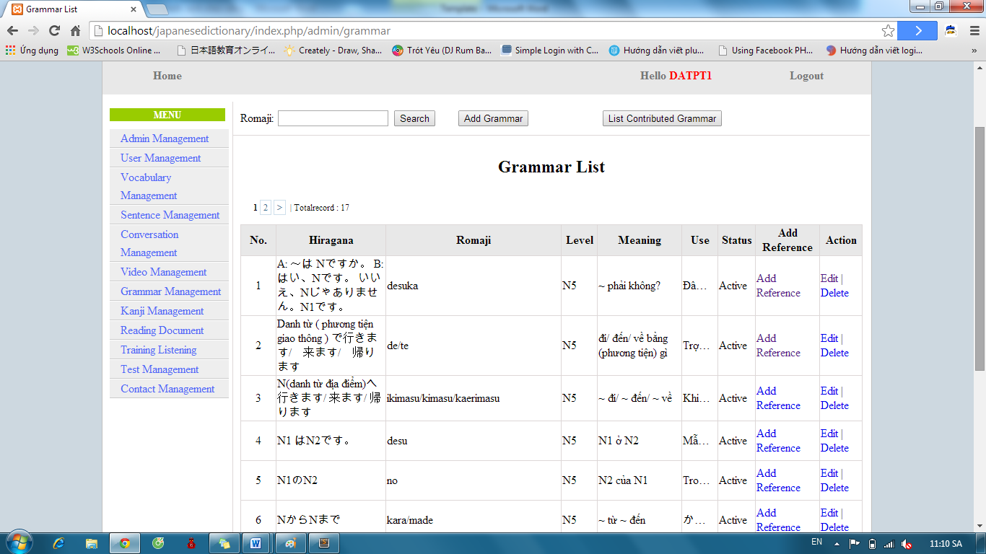

Step 3: Input grammar’s romaji and click “Search” button. Display results found.

* If exist : display result

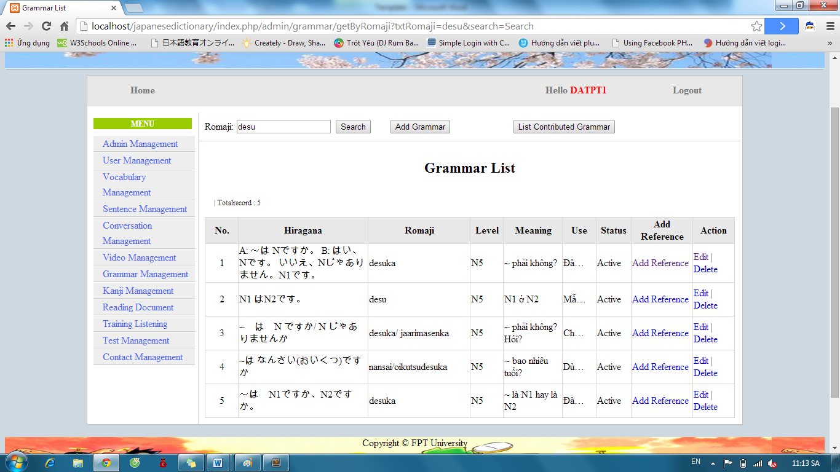

* If don’t exist : Display no record

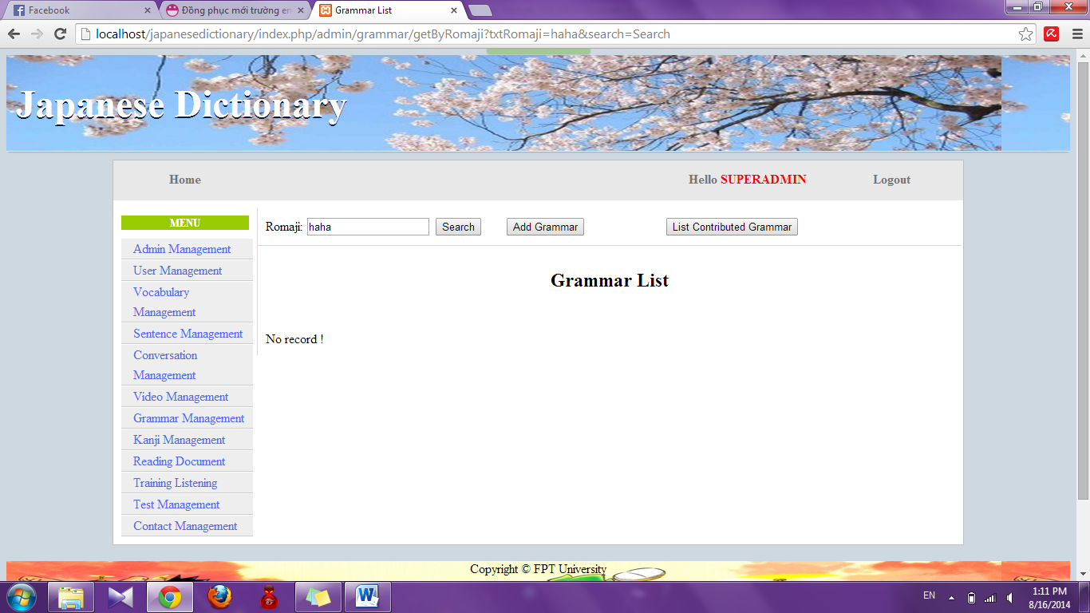

##### Add Grammar

To use add grammar function on website, the users do the steps below:

Step 1: Login with admin account. System will display list User.

Step 2: Click “Grammar management” link. System will display list Grammar.



Step 3: Click “Add Grammar” button and input correct information of grammar that you want add.

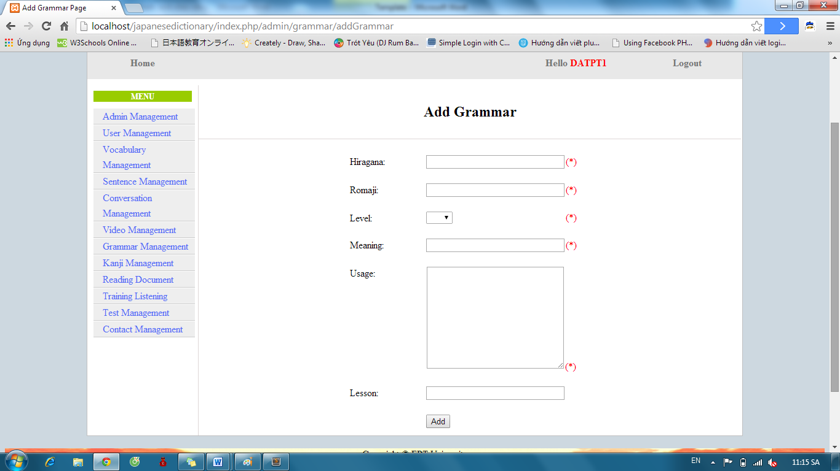

Step 4: After input, click “Add” button.

* Success: System display list Grammar with new grammar



* Fails: Error message will notify. You must try again.

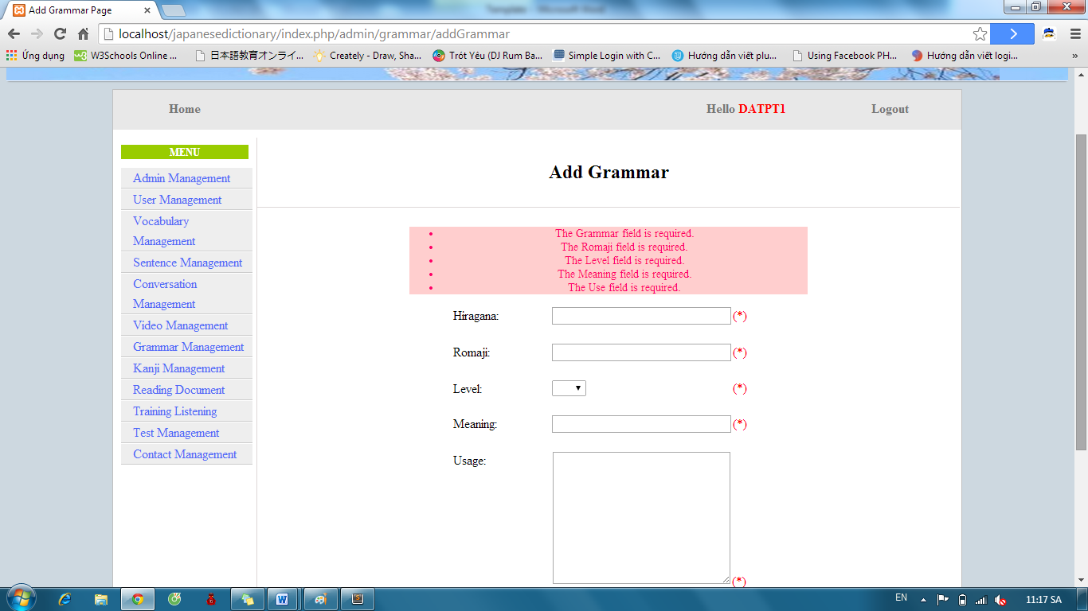

##### Edit Grammar

To use edit grammar function on website, the users do the steps below:

Step 1: Login with admin account. System will display list User.

Step 2: Click “Grammar management” link. System will display list Grammar. After that, click “Edit” link.



Step 3: Input correct information of grammar that you want change and click “Edit” button.

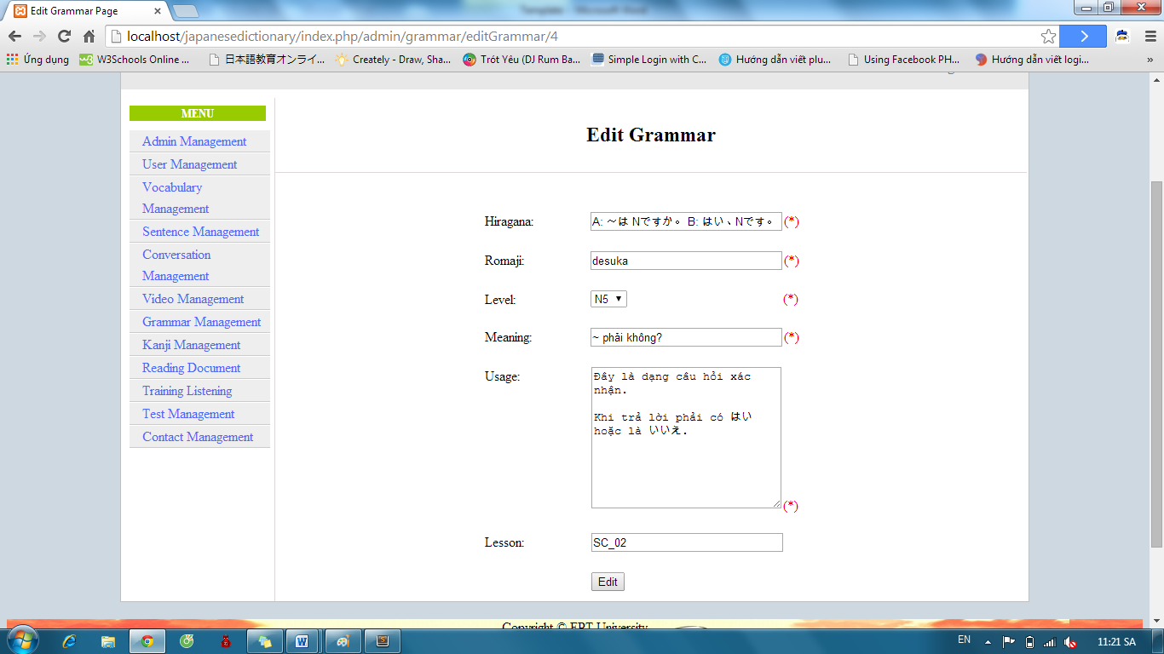

* Success: Display list Grammar.



* Fails: Error message will notify. You must try again.

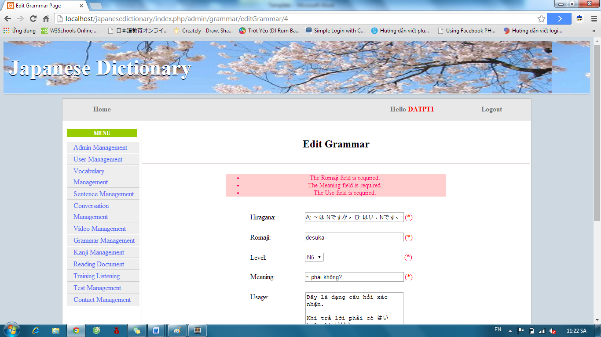

##### Delete Grammar

To use delete grammar function on website, the users do the steps below:

Step 1: Login with admin account. System will display list User.

Step 2: Click “Grammar management” link. System will display list Vocabulary.



Step 3: Click “Delete” link with corresponding grammar.

##### Approve grammar contribute

To use approve grammar function on website, the users do the steps below:

Step 1: Login with admin account. System will display list User.

Step 2: Click “Grammar management” link. System will display list Vocabulary.



Step 3: Click “List contributed grammar” button. System will display list contribute grammar

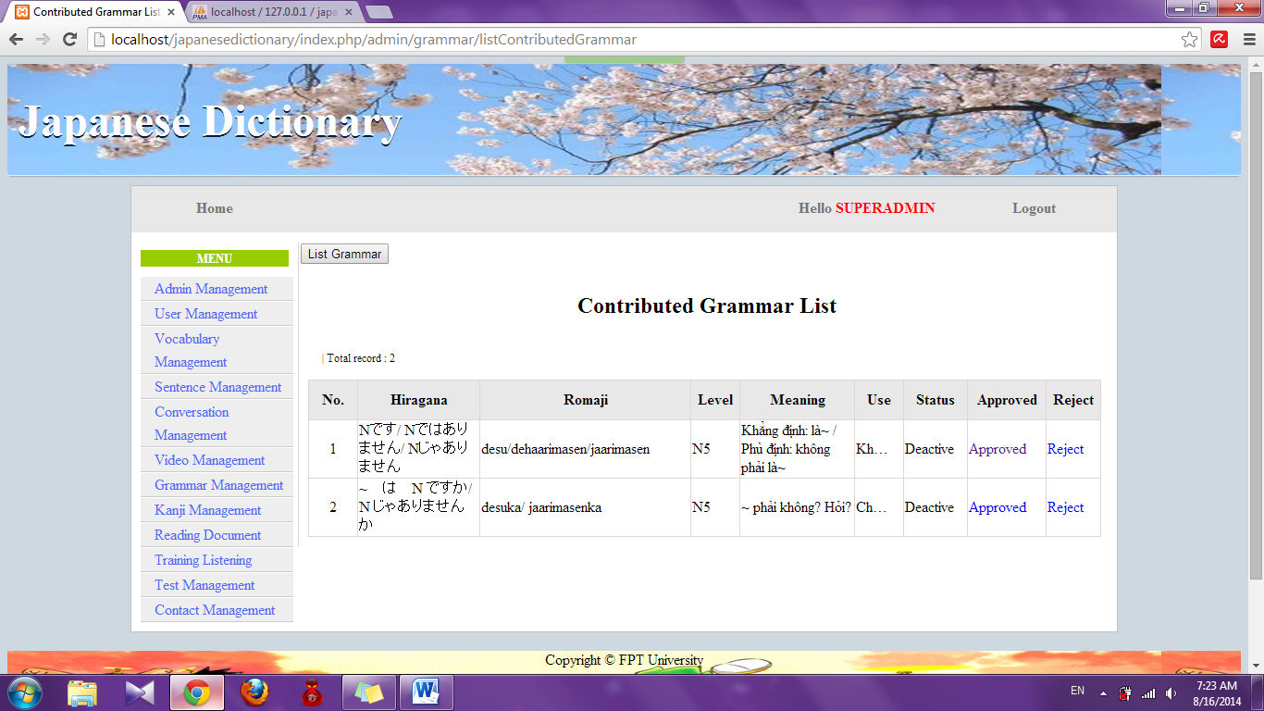

Step 4: Click “Approved” link. System will display approve page

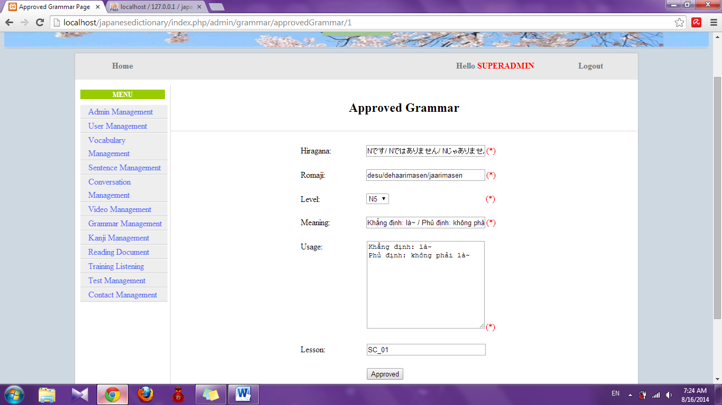

Step 5: Edit information (if need) and click “Approved” button

* Success : Redirect to list grammar contribute and display with new grammar
* Fail: Error message will notify. You must try again.

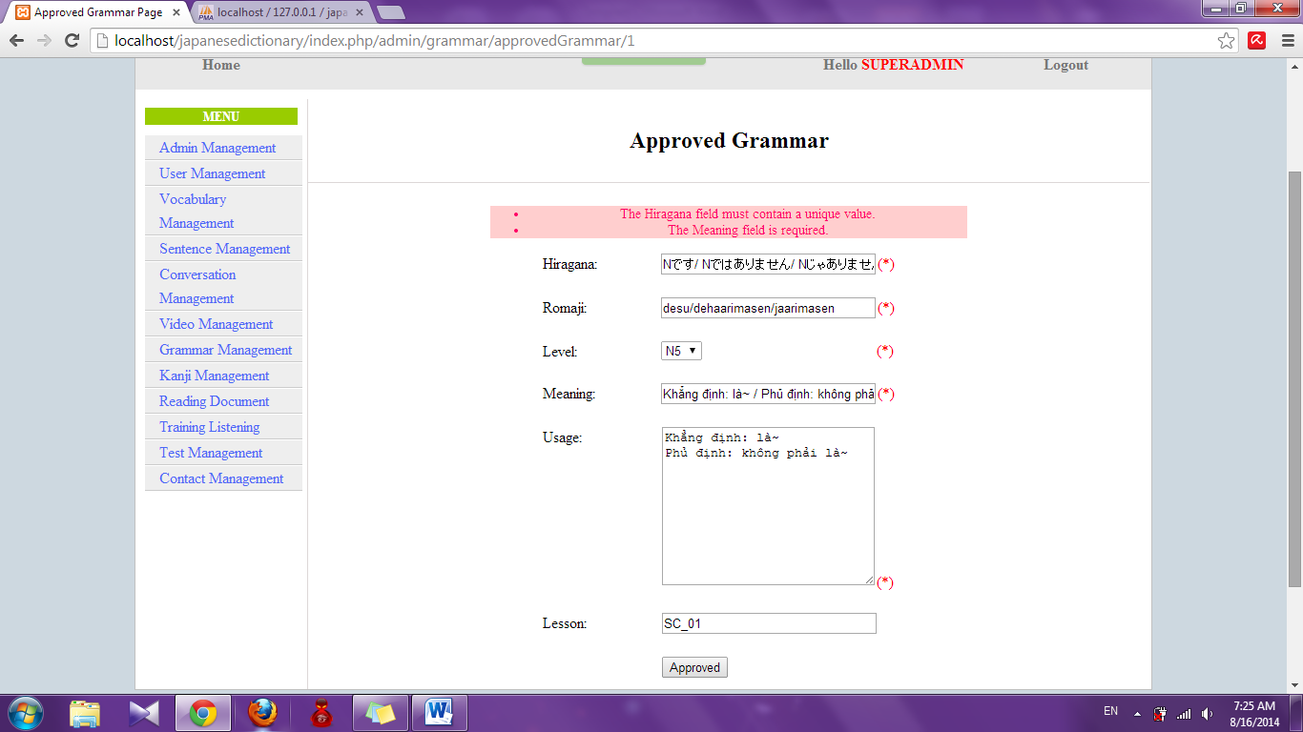

##### Reject grammar contribute

To use reject grammar function on website, the users do the steps below:

Step 1: Login with admin account. System will display list User.

Step 2: Click “Grammar management” link. System will display list Vocabulary.



Step 3: Click “List contribute grammar” button. List grammar contribute will display.

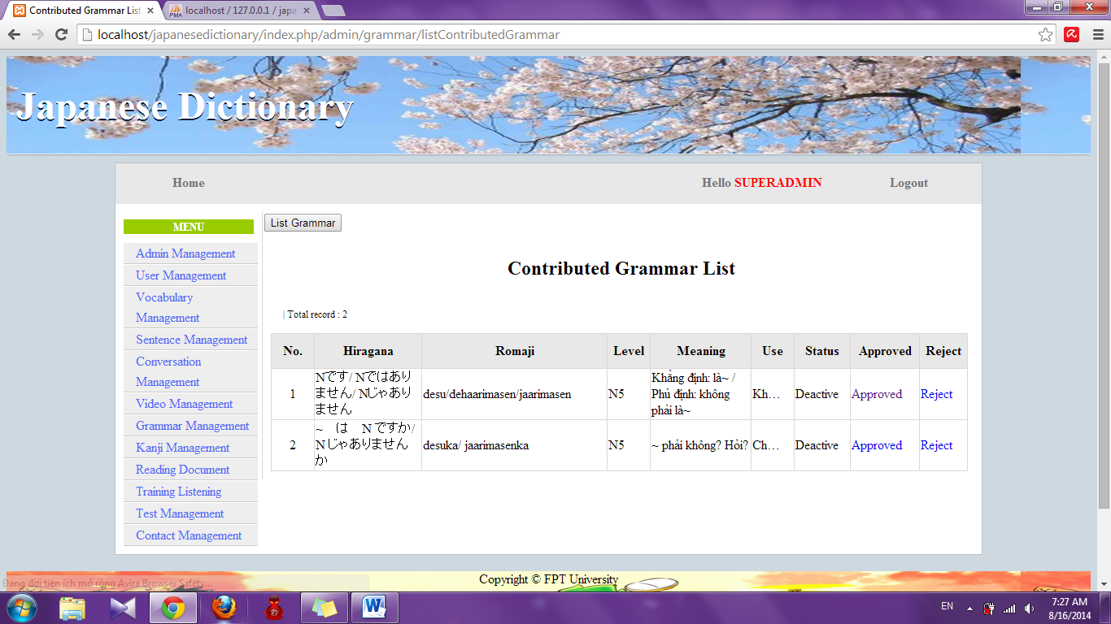

Step 4: Click “Reject” link. System will reject that contribute

#### Conversation management

##### Search Conversation

To use search conversation function on website, the users do the steps below:

Step 1: Login with admin account. System will display list User.

Step 2: Click “Conversation management” link. System will display list Conversation.

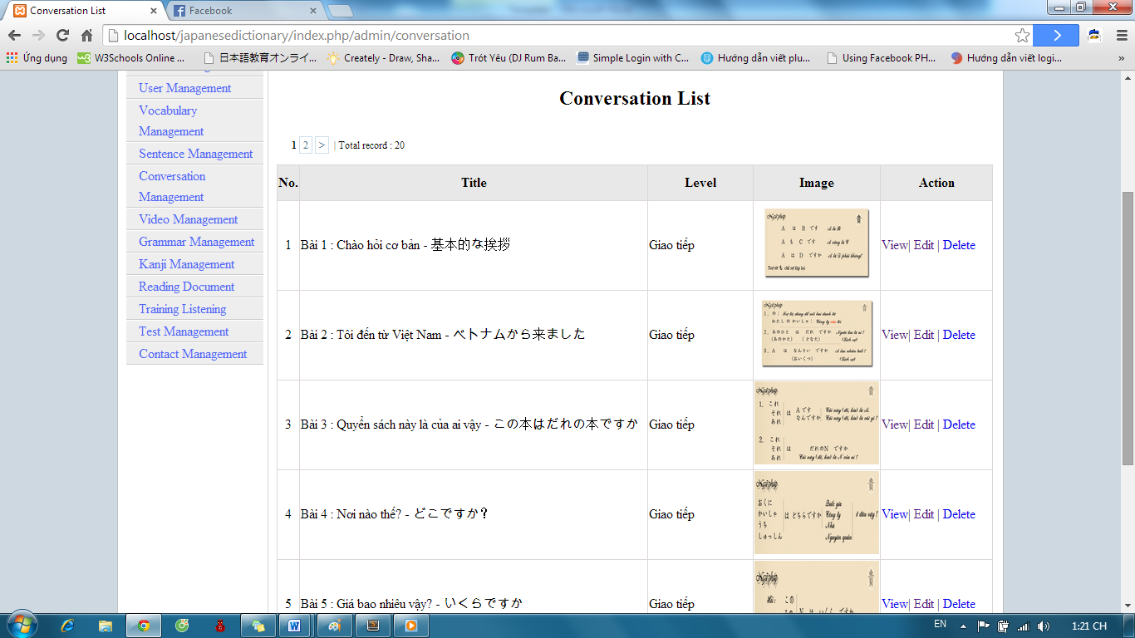

Step 3: Select option search and click “Search” button. Results search will be displayed.

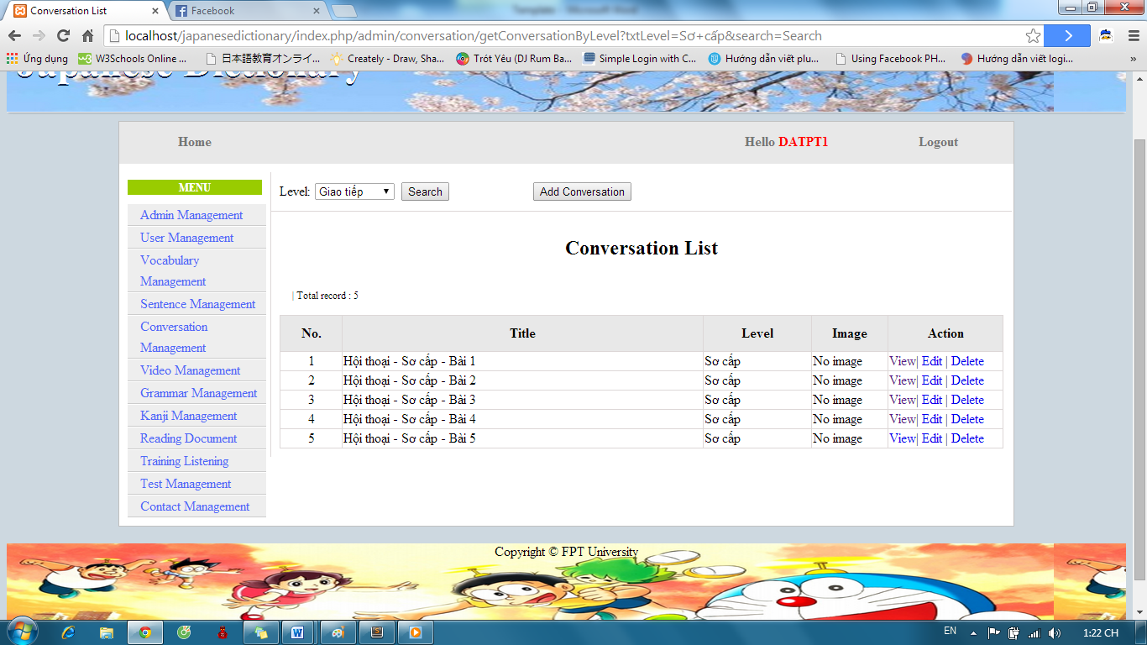

##### Add Conversation

To use add conversation function on website, the users do the steps below:

Step 1: Login with admin account. System will display list User.

Step 2: Click “Conversation management” link. System will display list Conversation.

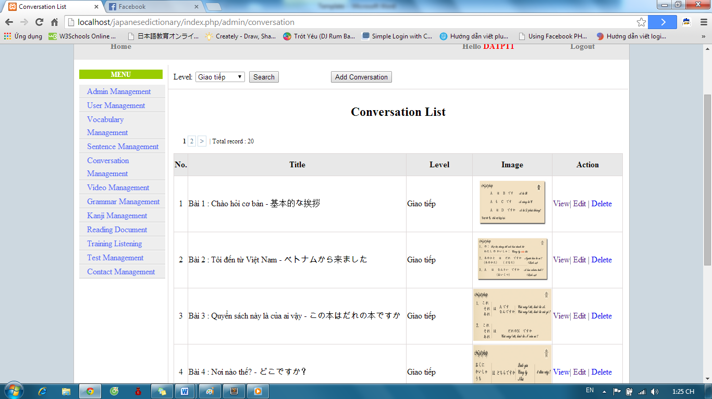

Step 3: Click “Add Conversation” button and input correct information of conversation that you want add.

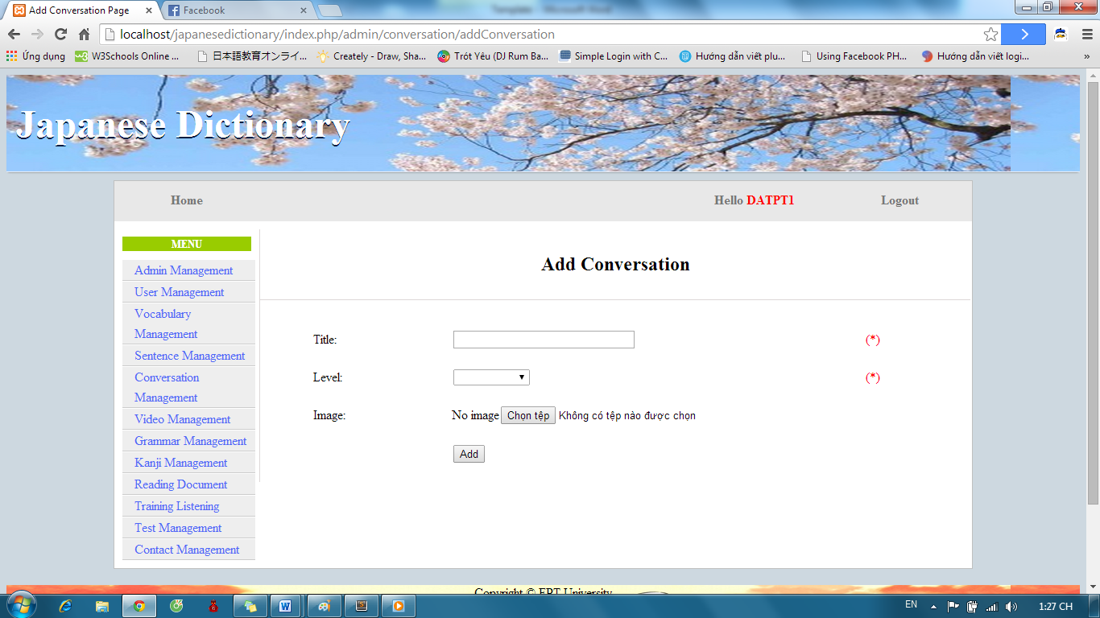

Step 4: After input, click “Add” button.

* Success: Display list conversation with new conversation



* Fails: Error message will notify. You must try again.

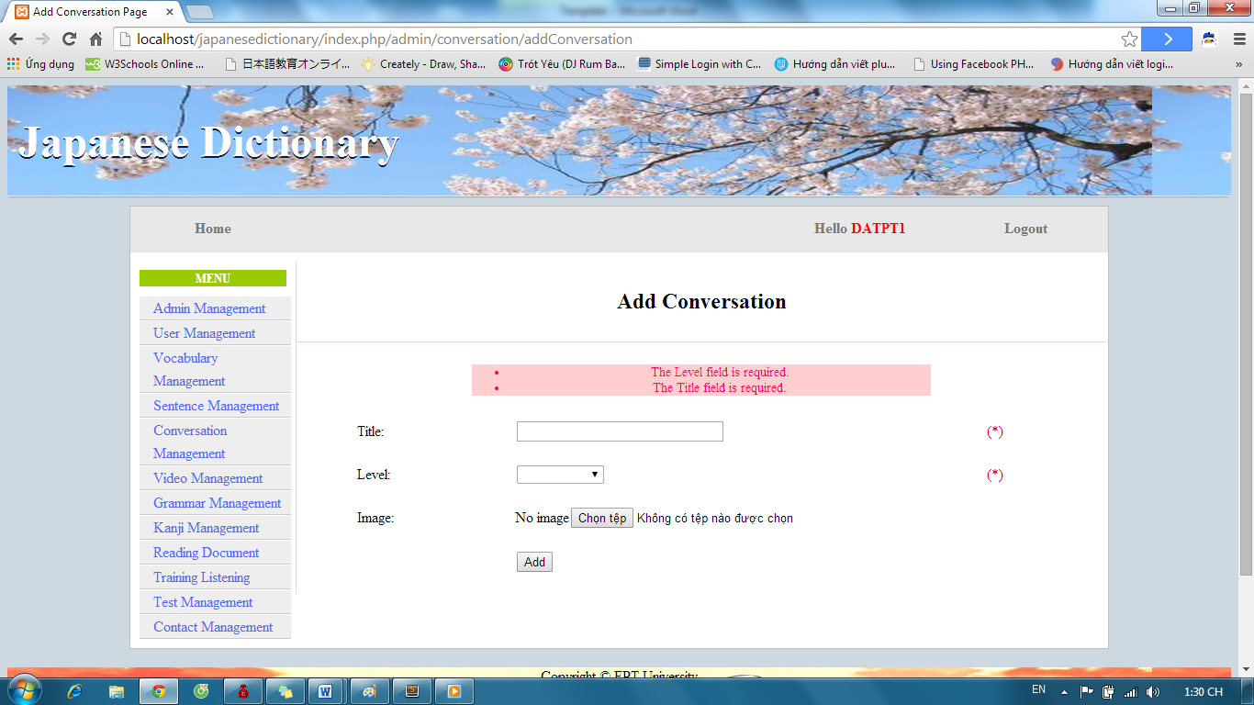

##### Add Content Conversation

To use add content conversation function on website, the users do the steps below:

Step 1: Login with admin account. System will display list User.

Step 2: Click “Conversation management” link. System will display list Conversation.



Step 3: If you want add content for a conversation, click “View” link with corresponding conversation.

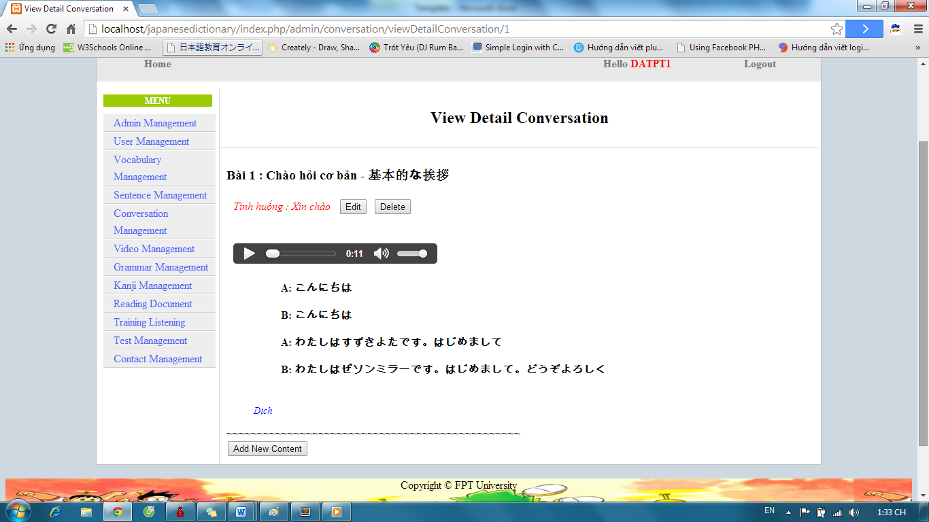

Step 4: Click “Add New Content” button and input correct information of conversation’s content.

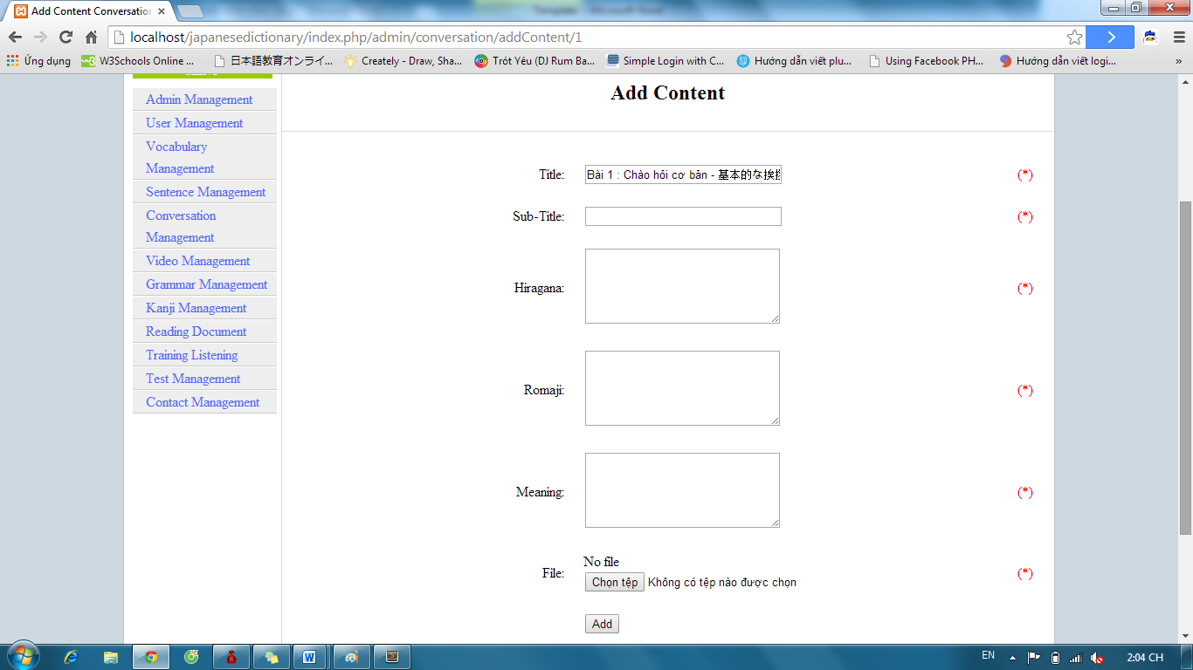

Step 5: Click “Add” button.

* Success : Display details conversation
* Fail : Display error message

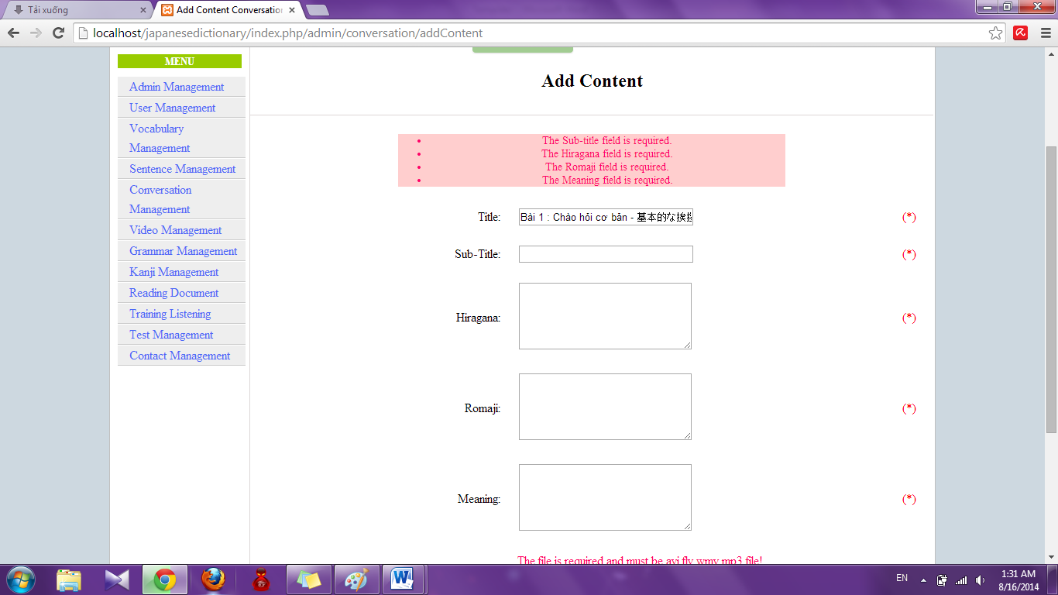

##### Edit Conversation

To use edit conversation function on website, the users do the steps below:

Step 1: Login with admin account. System will display list User.

Step 2: Click “Conversation management” link. System will display list Conversation.



Step 3: Click to “Edit” link with corresponding conversation.

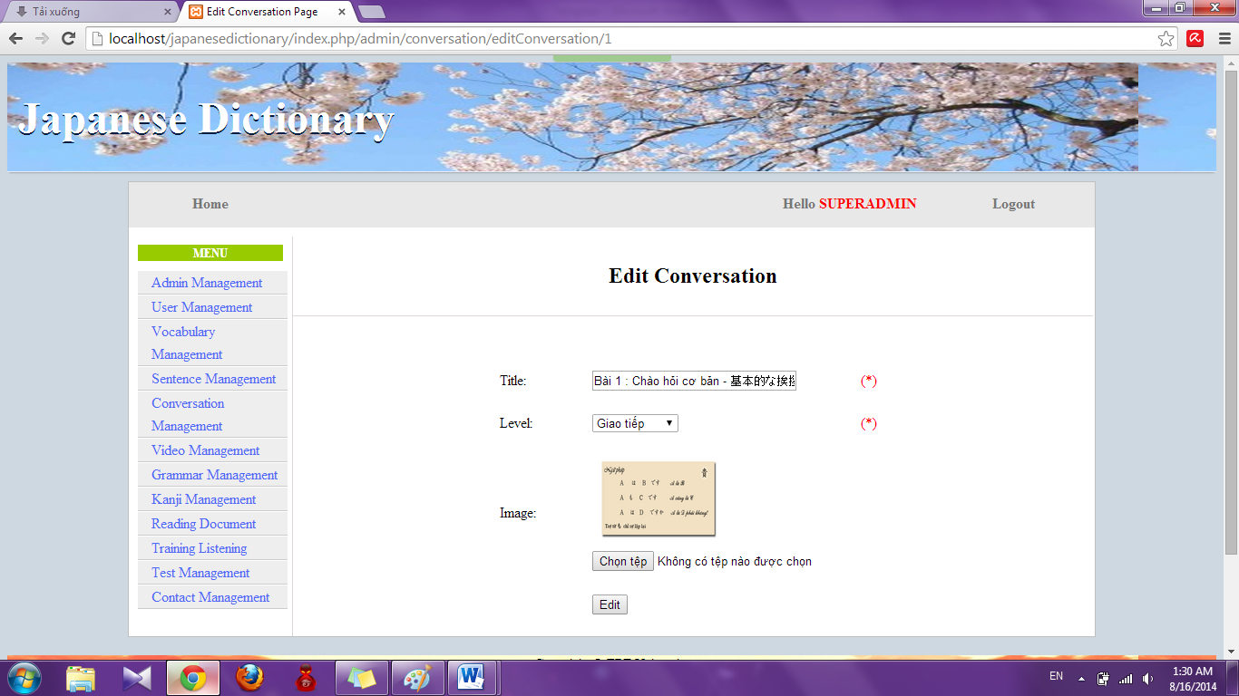

Step 4: Input information that you want to edit and click “Edit”

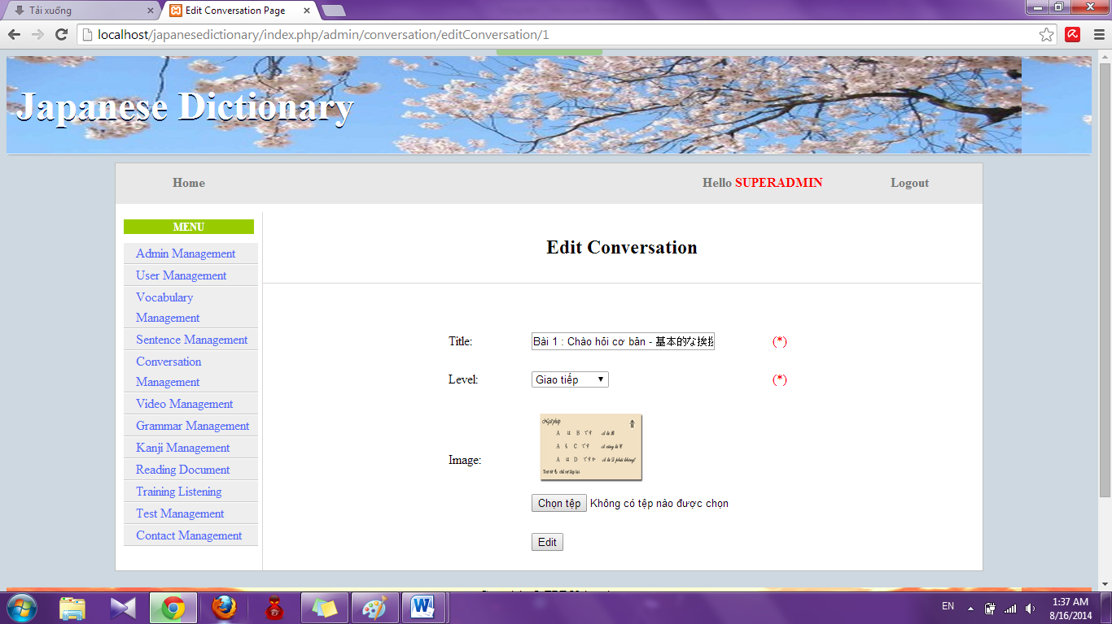

* Success : Redirect to conversation list

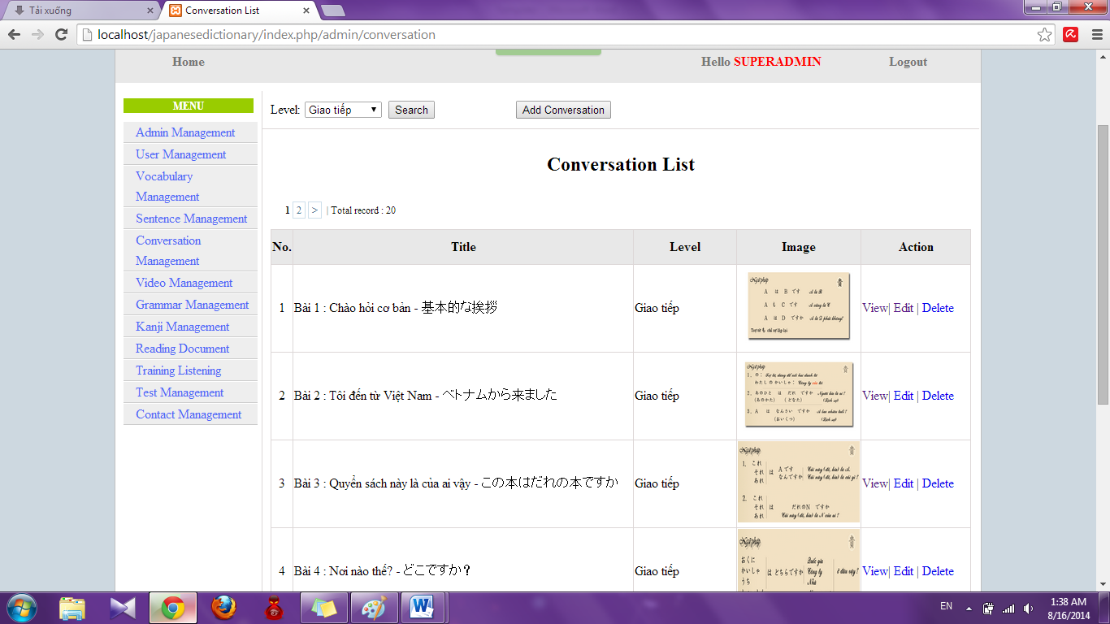

* Fail: Error message will notify. You must try again.

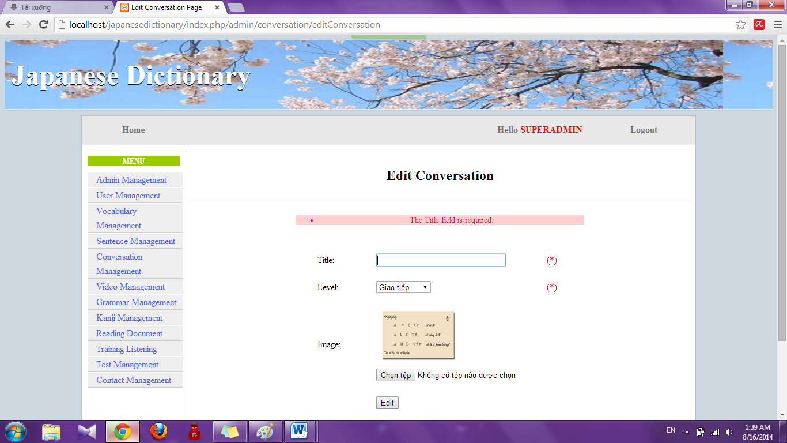

##### Edit Content

To use edit content conversation function on website, the users do the steps below:

Step 1: Login with admin account. System will display list User.

Step 2: Click “Conversation management” link. System will display list Conversation.



Step 3: Click “View” link. System will display view of conversation

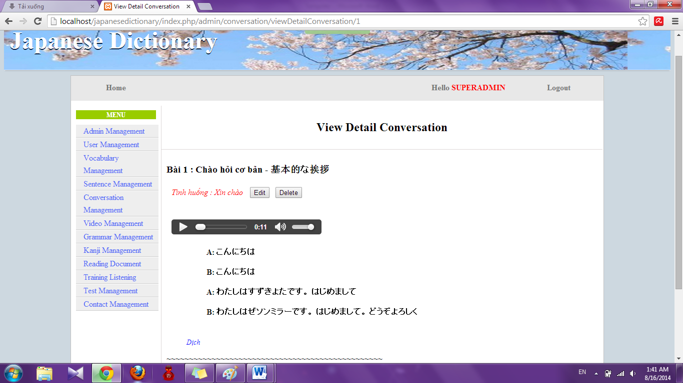

Step 4: Click “Edit” button. System will display Edit page

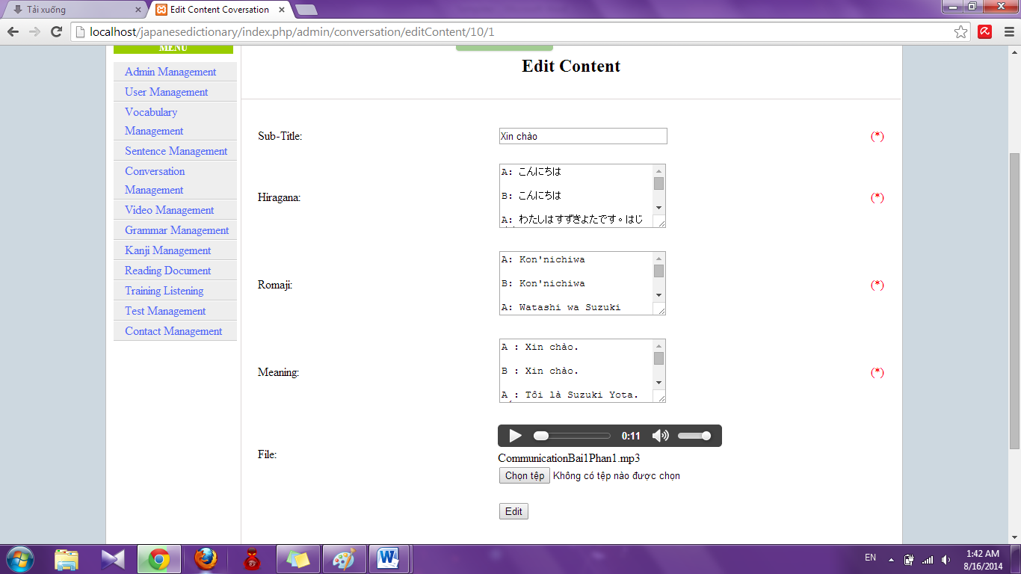

Step 5: Input information that you want to edit and click “Edit”

* Success : Display View details of conversation like Step 3
* Fails: Error message will notify. You must try again.

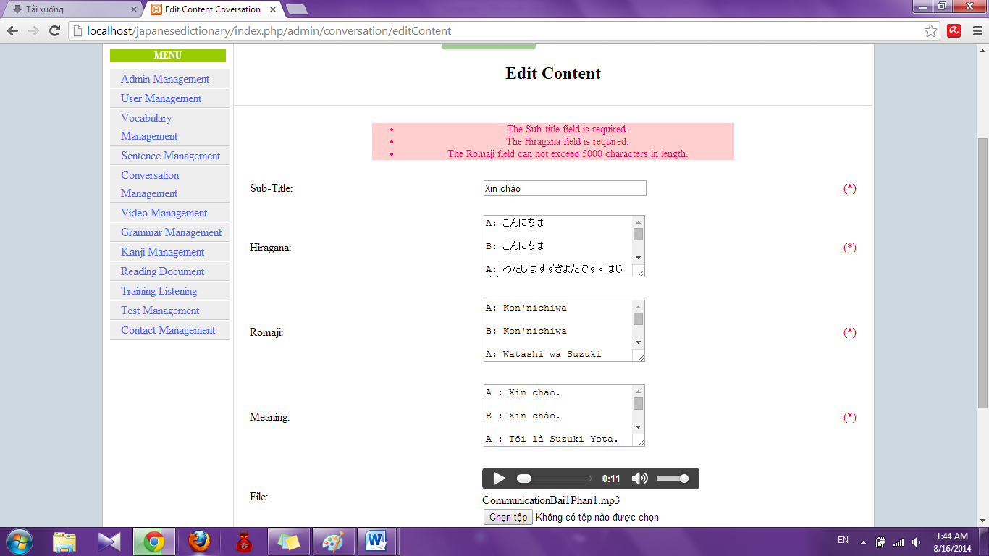

##### Delete Conversation

To use delete conversation function on website, the users do the steps below:

Step 1: Login with admin account. System will display list User.

Step 2: Click “Conversation management” link. System will display list Conversation.



Step 3: Click “Delete” link with corresponding conversation

##### Delete content

To use edit content conversation function on website, the users do the steps below:

Step 1: Login with admin account. System will display list User.

Step 2: Click “Conversation management” link. System will display list Conversation.



Step 3: Click “View” link. System will display view of conversation.



Step 4: Click “Delete” button. System will delete that content

#### Reading document management

##### Search reading document

To use search reading document function on the website, the users do the steps below:

Step 1: Login with admin account. System will display list User.

Step 2: Click “Reading document management” link. System will display list Reading document.

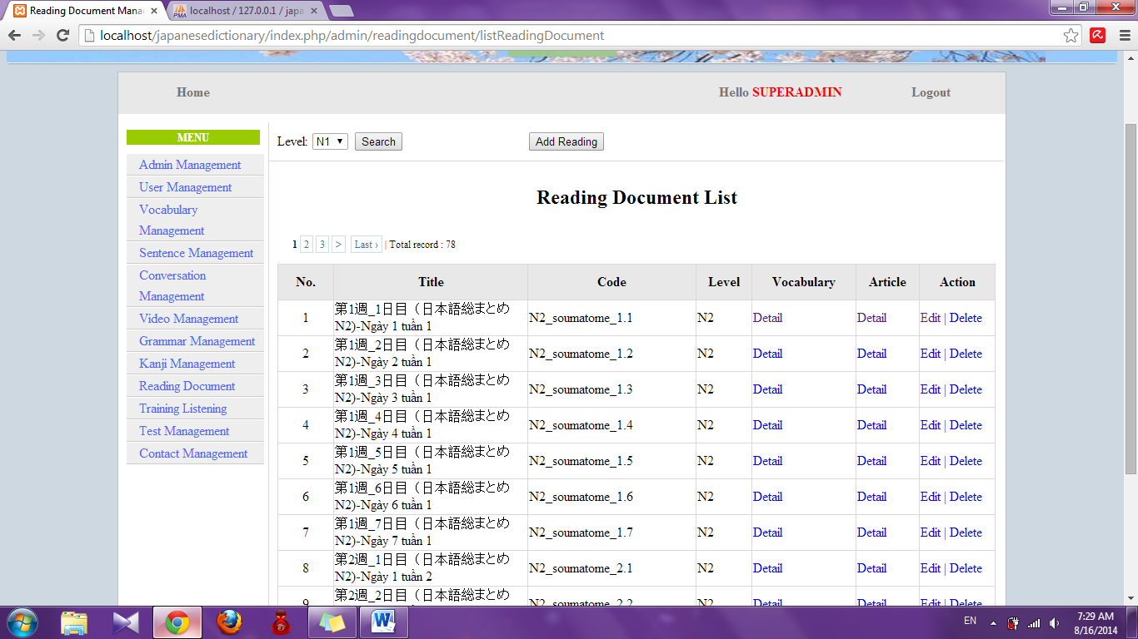

Step 3: Select option search and click “Search” button. Results search will be displayed

* If exist : display result of search

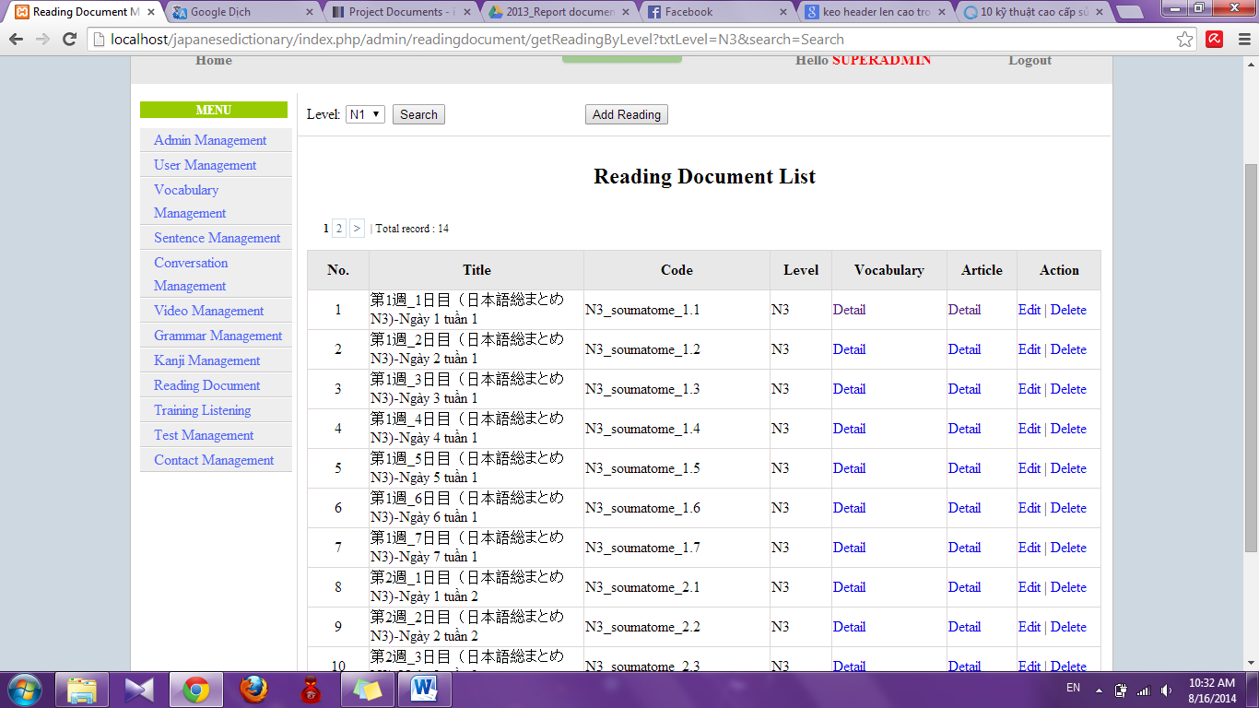

* If don’t exist : Display no record

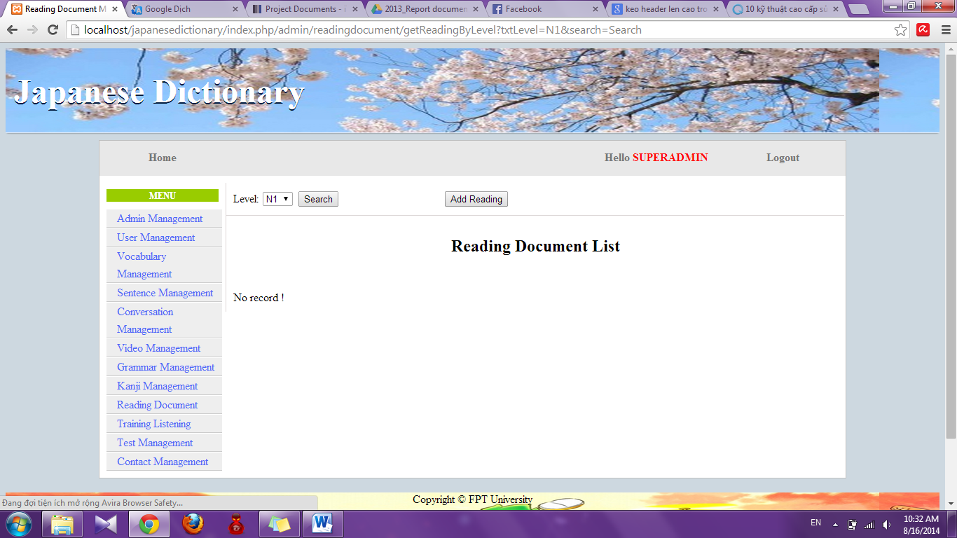

##### Add reading document

To use add reading document function on the website, the users do the steps below:

Step 1: Login with admin account. System will display list User.

Step 2: Click “Reading document management” link. System will display list Reading document.



Step 3: Click “Add reading” button. System will display Add reading page

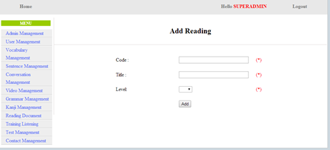

Step 4: Input correct information of conversation that you want add and click “Add” button

* Success : Display list reading document with new reading document
* Fail: Error message will notify. You must try again.

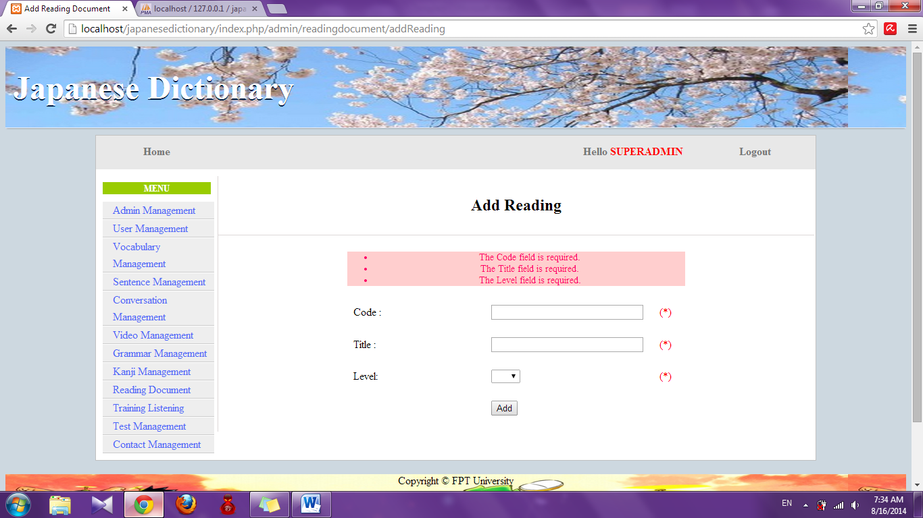

##### Add vocabulary of reading document

To use add vocabulary of reading document function on the website, the users do the steps below:

Step 1: Login with admin account. System will display list User.

Step 2: Click “Reading document management” link. System will display list Reading document.



Step 3: Click “Detail” link of Vocabulary. System will display details of vocabulary

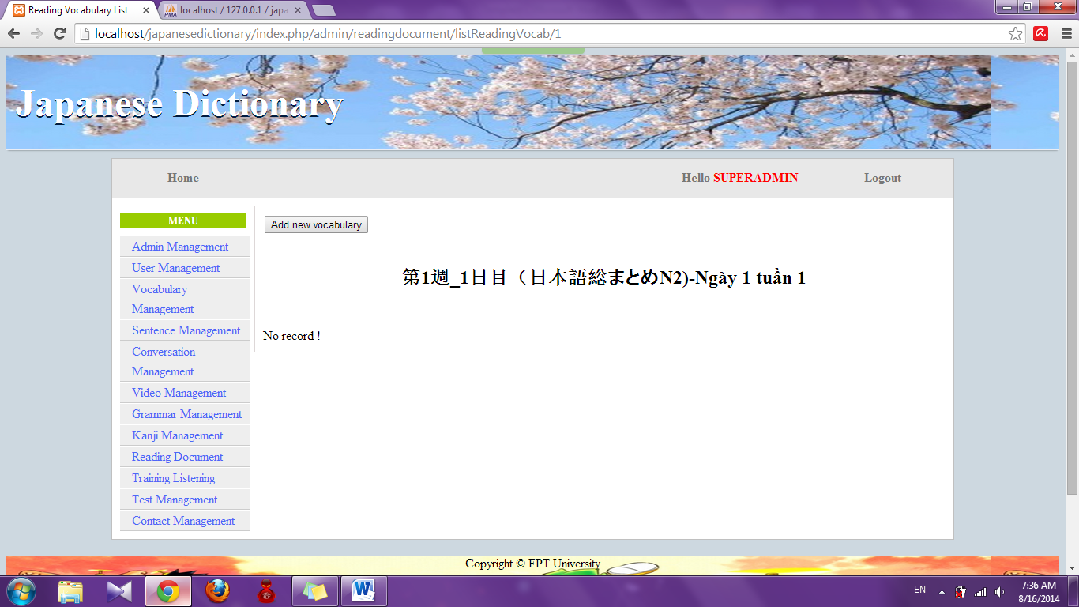

Step 4: Click “Add new vocabulary” button. System will display add vocabulary page

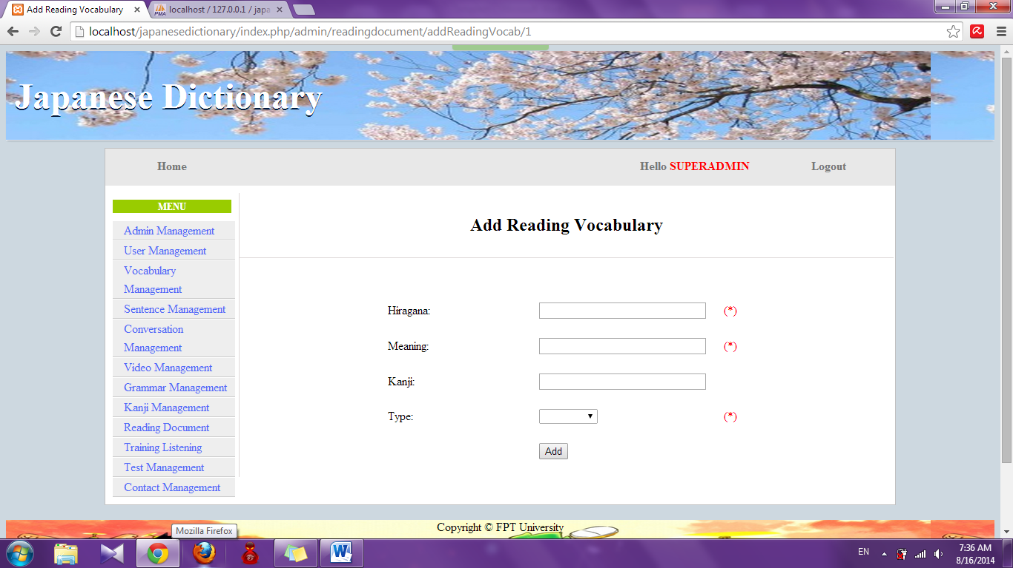

Step 5: Input information that you want to add and click “Add” button

* Success : Display list vocabulary of reading document
* Fail: Error message will notify. You must try again.

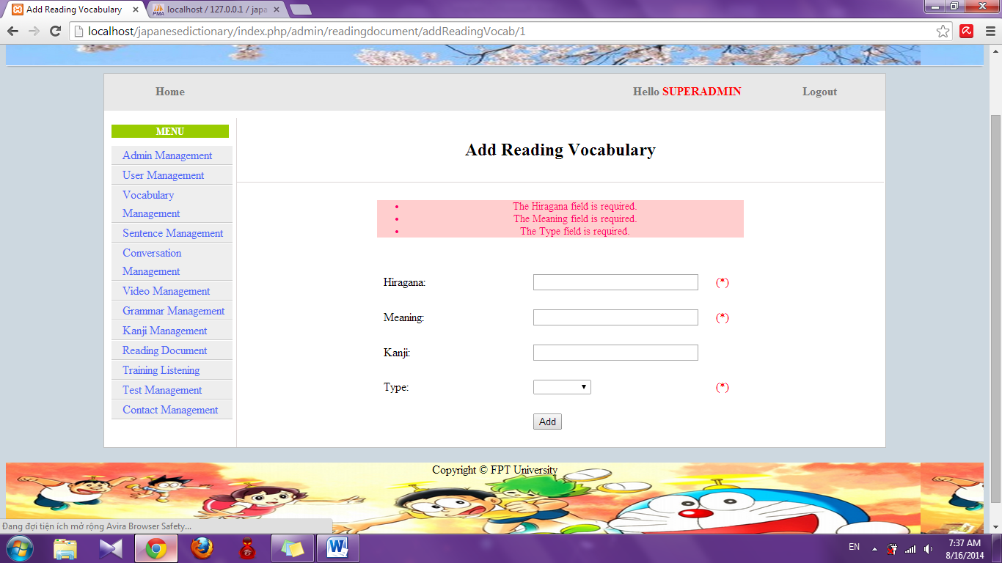

##### Add article of reading document

To use add article of reading document function on the website, the users do the steps below:

Step 1: Login with admin account. System will display list User.

Step 2: Click “Reading document management” link. System will display list Reading document.



Step 3: Click “Detail” link of Article. System will display details of article

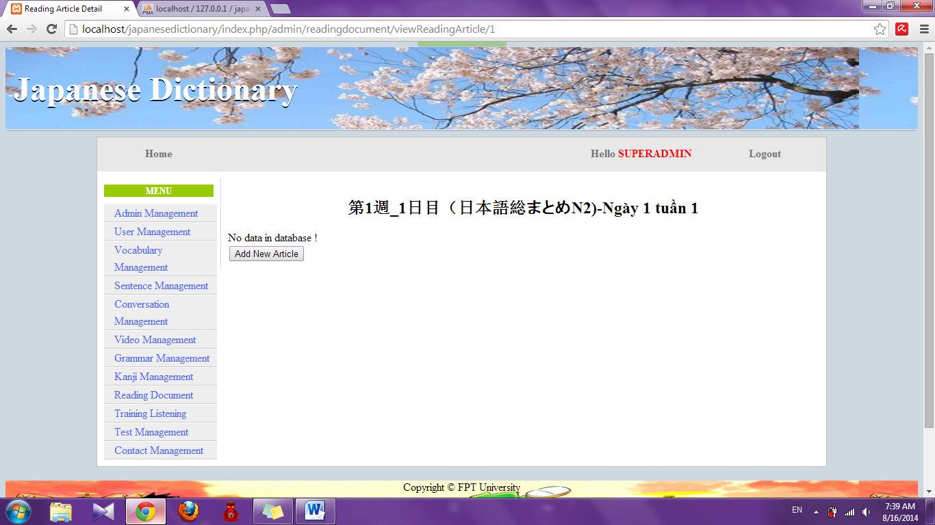

Step 4: Click “Add new article” button. System will display add new article page

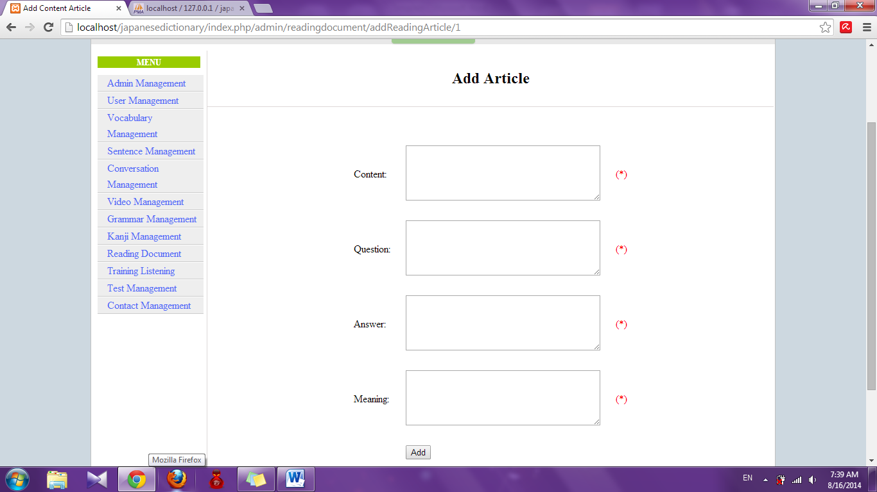

Step 5: Input information that you want to add and click “Add” button

* Success : Display detail of article page with new article
* Fail: Error message will notify. You must try again.

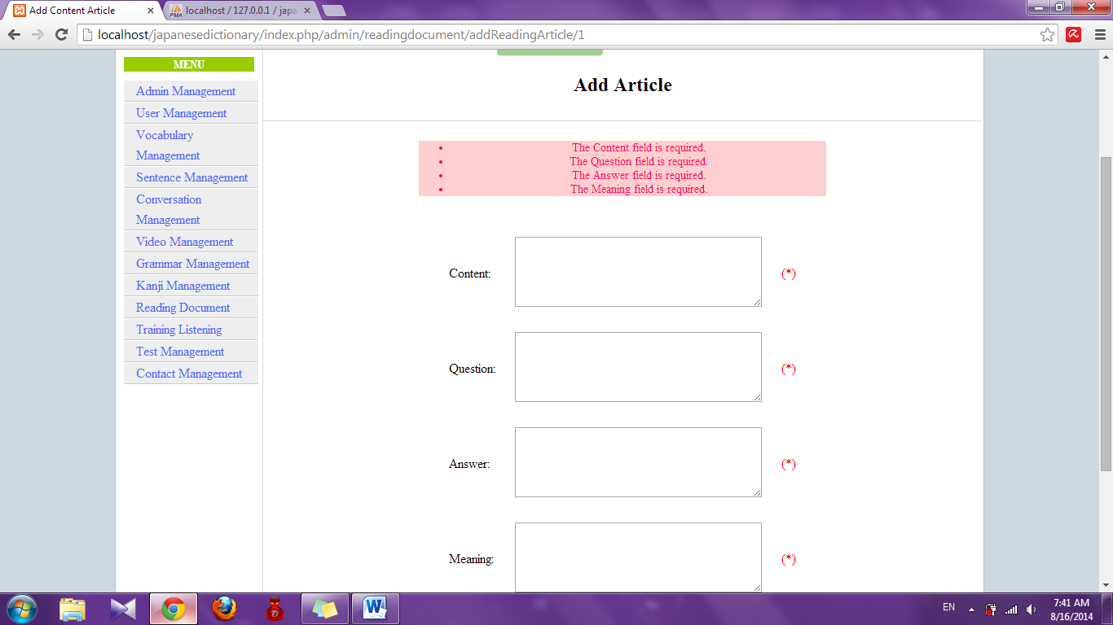

##### Edit reading document

To use edit reading document function on the website, the users do the steps below:

Step 1: Login with admin account. System will display list User.

Step 2: Click “Reading document management” link. System will display list Reading document.



Step 3: Click “Edit” link. System will display edit reading document page

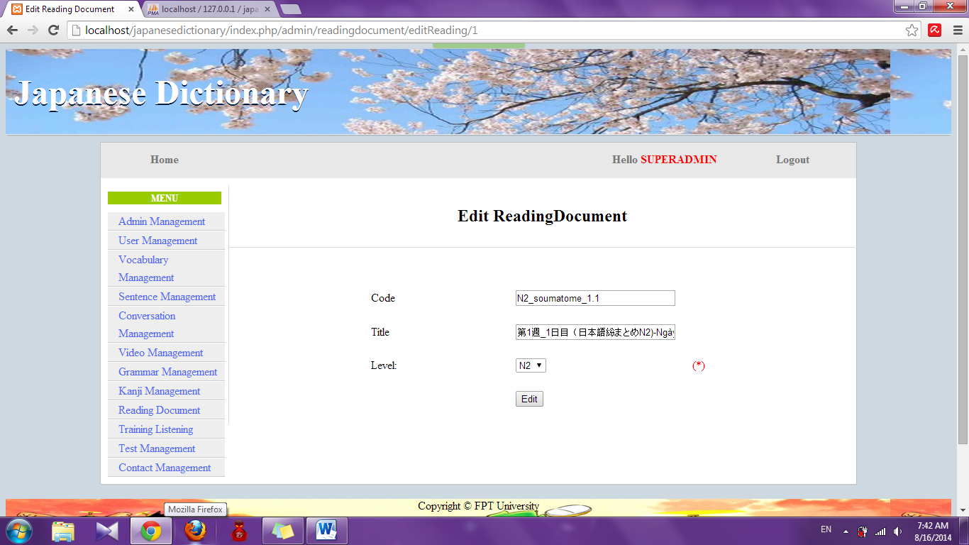

Step 4: Edit information and click “Edit” button

* Success: Display list reading document
* Fail : Error message will notify, you must try again

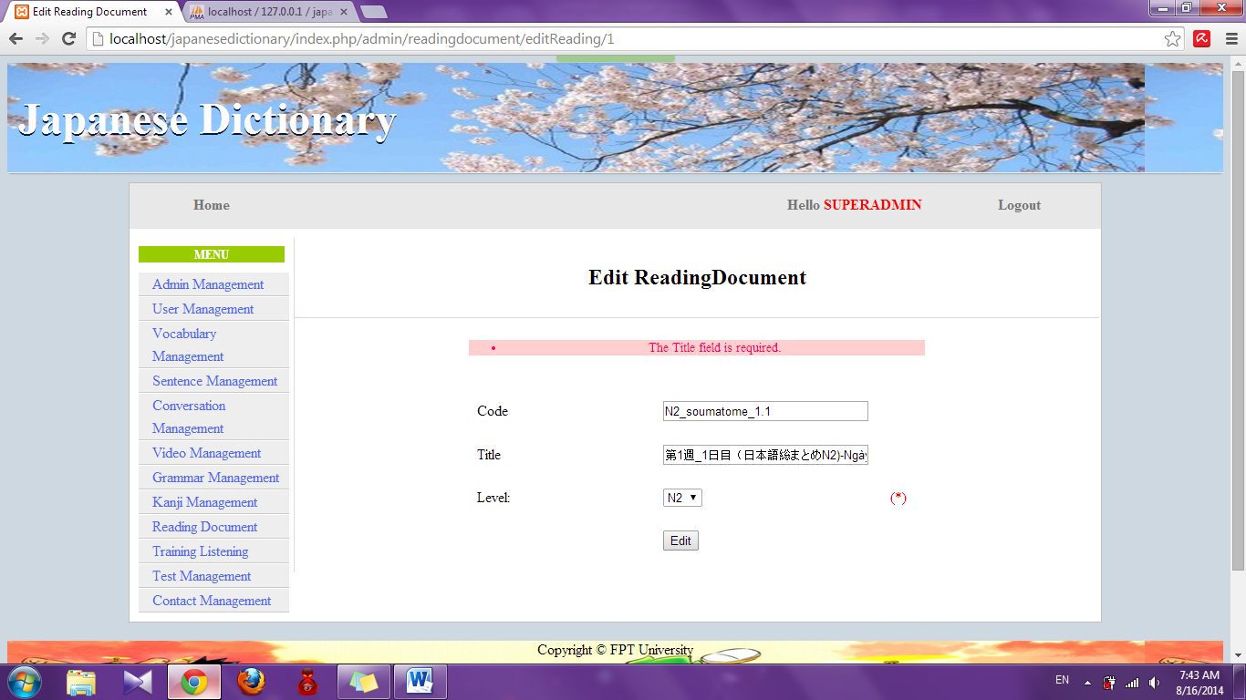

##### Edit vocabulary of reading document

To use edit vocabulary of reading document function on the website, the users do the steps below:

Step 1: Login with admin account. System will display list User.

Step 2: Click “Reading document management” link. System will display list Reading document.



Step 3: Click “Detail” link of Vocabulary. System will display list vocabulary

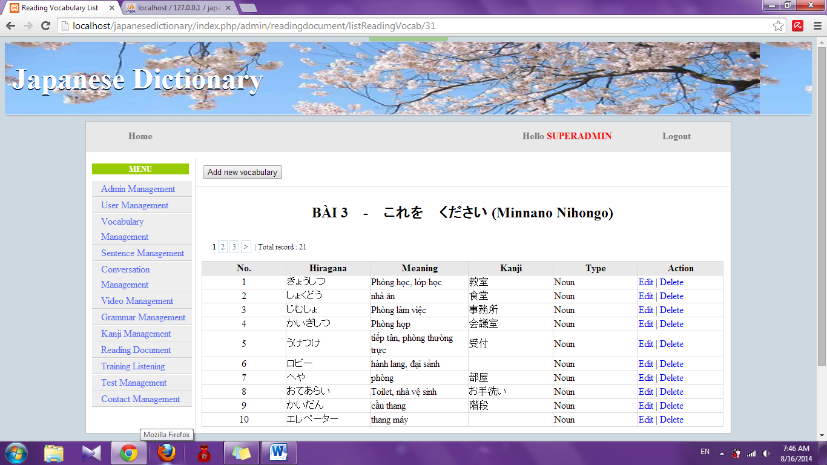

Step 4: Click “Edit” link. System will display edit vocabulary page

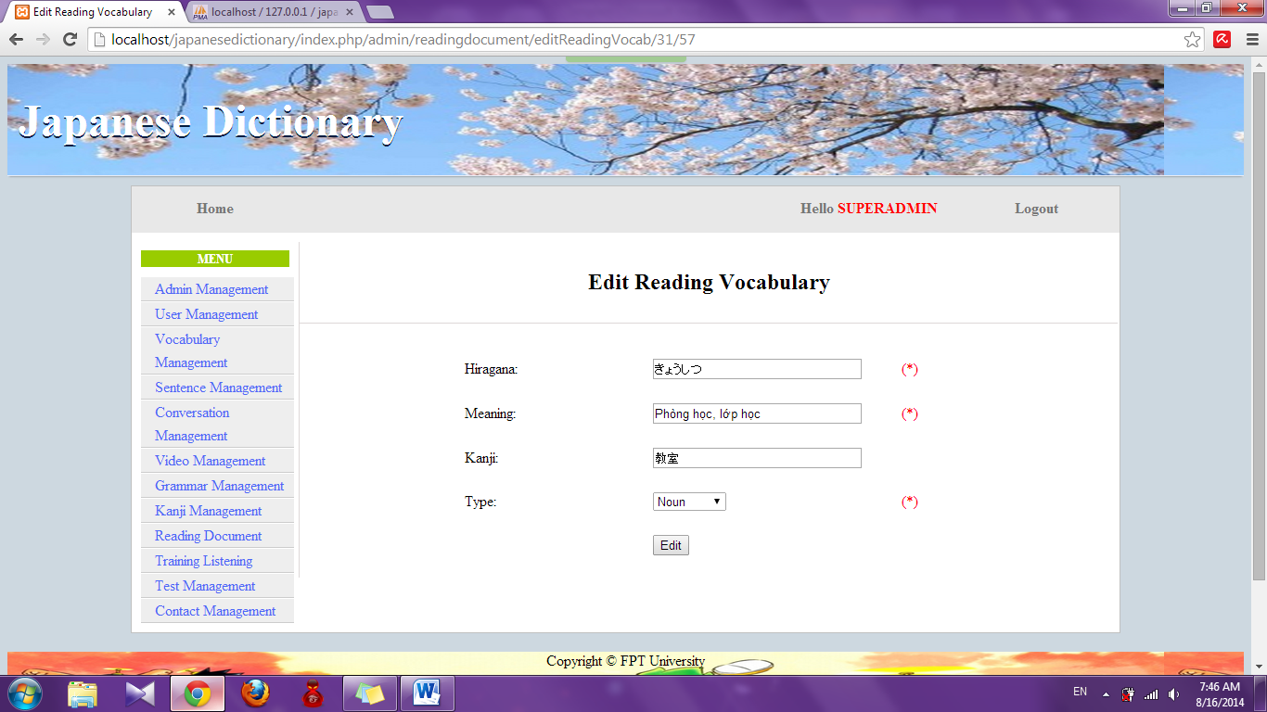

Step 5: Edit information and click “Edit” button

* Success : Display list vocabulary
* Fail : Error message will notify, you must try again

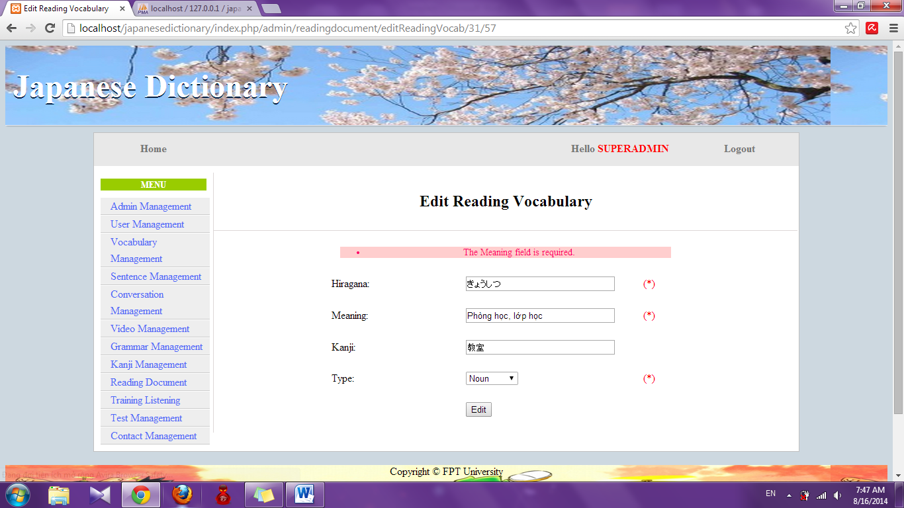

##### Edit article of reading document

To use edit article of reading document function on the website, the users do the steps below:

Step 1: Login with admin account. System will display list User.

Step 2: Click “Reading document management” link. System will display list Reading document.



Step 3: Click “Detail” link of Article. System will display list article

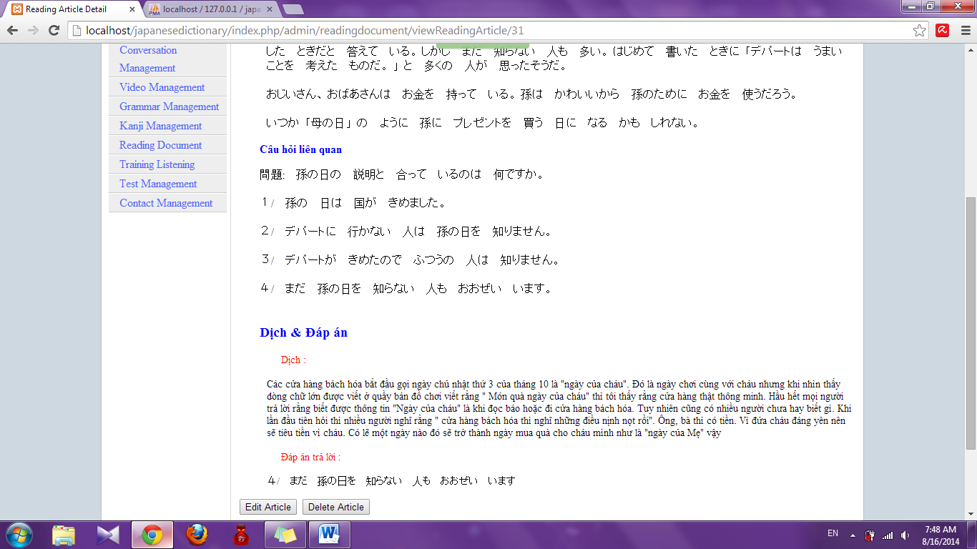

Step 4: Click “Edit article” button. System will display edit article page

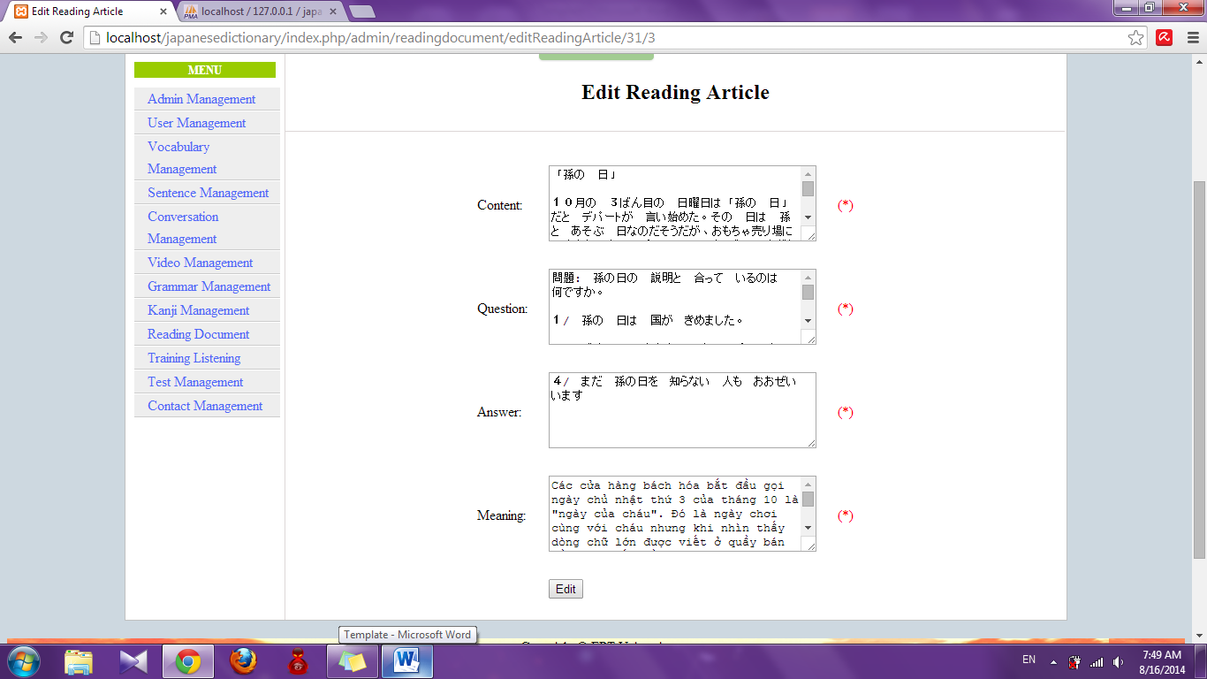

Step 5: Edit information and click “Edit” button

* Success : Display detail of reading article page
* Fail : Error message will notify, you must try again

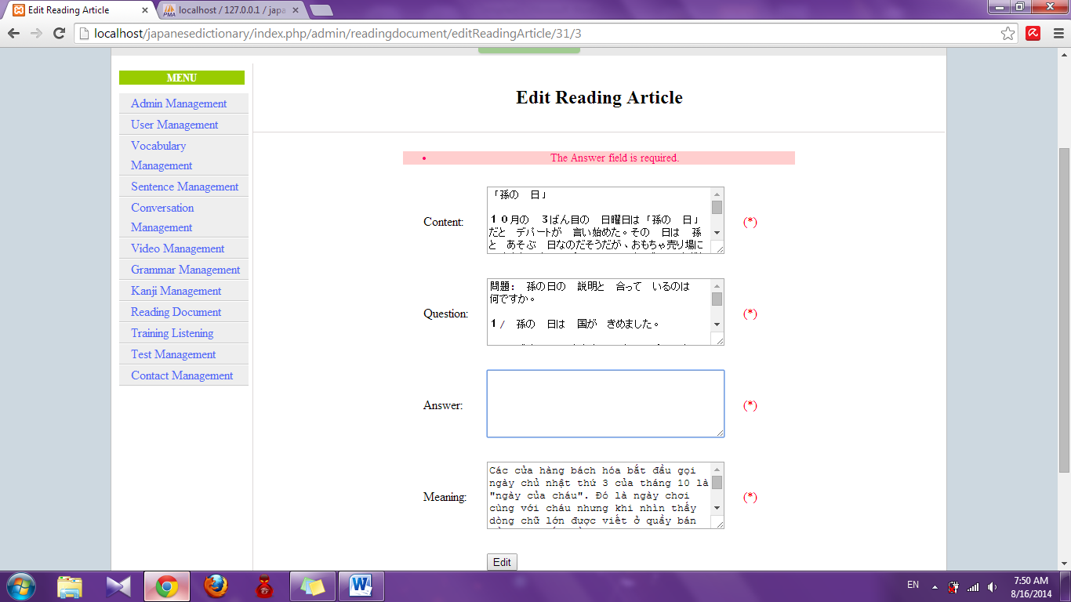

##### Delete reading document

To use detele reading document function on the website, the users do the steps below:

Step 1: Login with admin account. System will display list User.

Step 2: Click “Reading document management” link. System will display list Reading document.

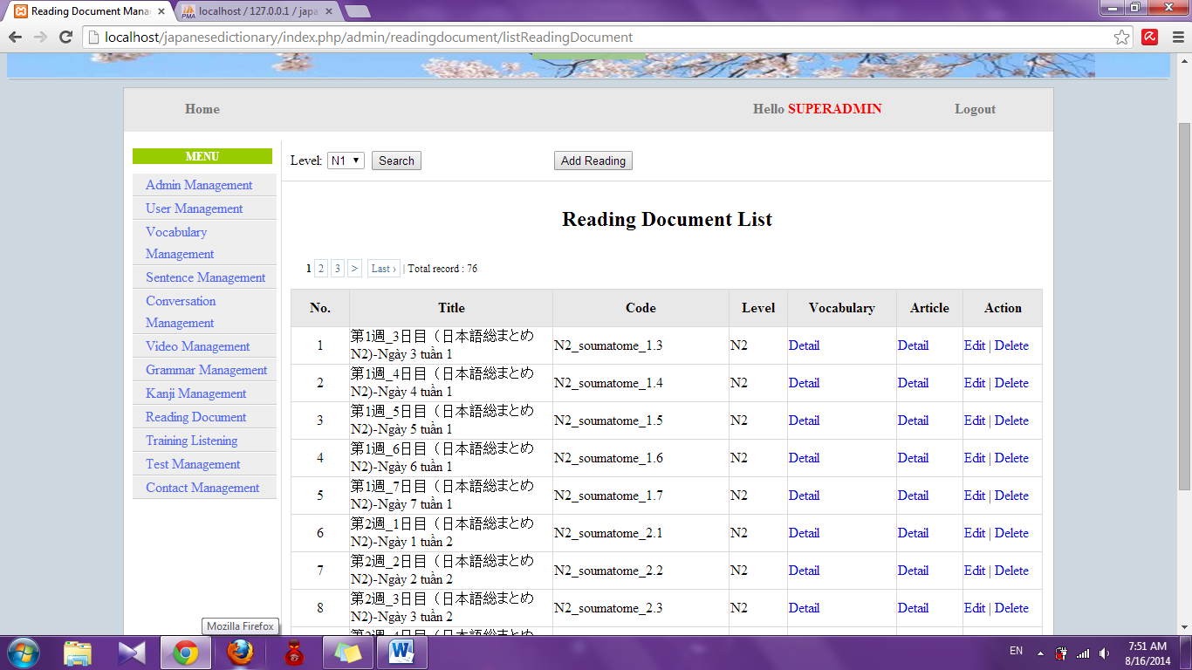

Step 3: Click “Delete” link. System will delete this document

##### Delete vocabulary of reading document

To use delete vocabulary of reading document function on the website, the users do the steps below:

Step 1: Login with admin account. System will display list User.

Step 2: Click “Reading document management” link. System will display list Reading document.



Step 3: Click “Detail” link of Vocabulary. System will display list vocabulary.



Step 4: Click “Delete” link. System will delete this vocabulary

##### Delete article of reading document

To use edit article of reading document function on the website, the users do the steps below:

Step 1: Login with admin account. System will display list User.

Step 2: Click “Reading document management” link. System will display list Reading document. 

Step 3: Click “Detail” link of Article. System will display list article.



Step 4: Click “Delete article” button. System will delete that article

#### Video management

##### Search video

To use search video function on the website, the users do the steps below:

Step 1: Login with admin account. System will display list User.

Step 2: Click “Video management” link. System will display list Video

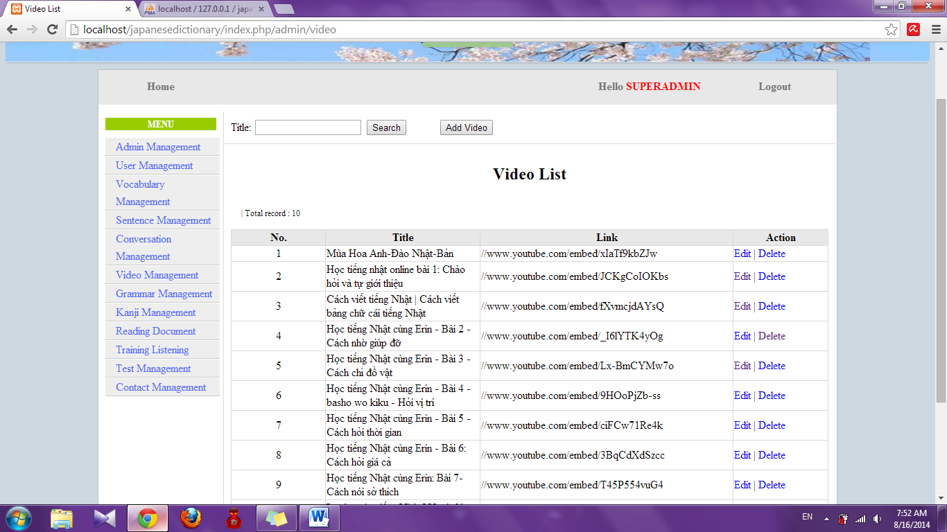

Step 3: Input title and click “Search”. System will display result

* If exist : display list video contain keyword you input

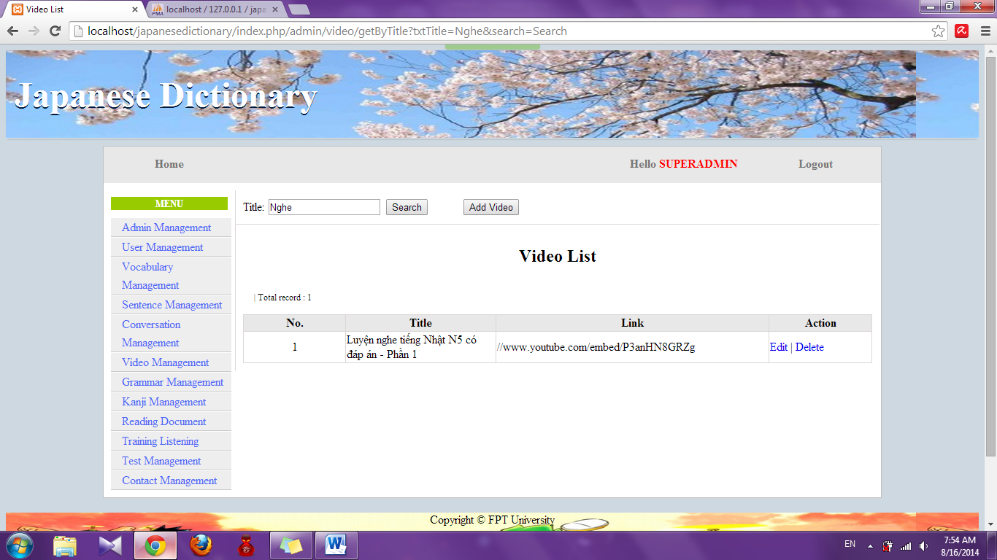

* If don’t exist : Display no record

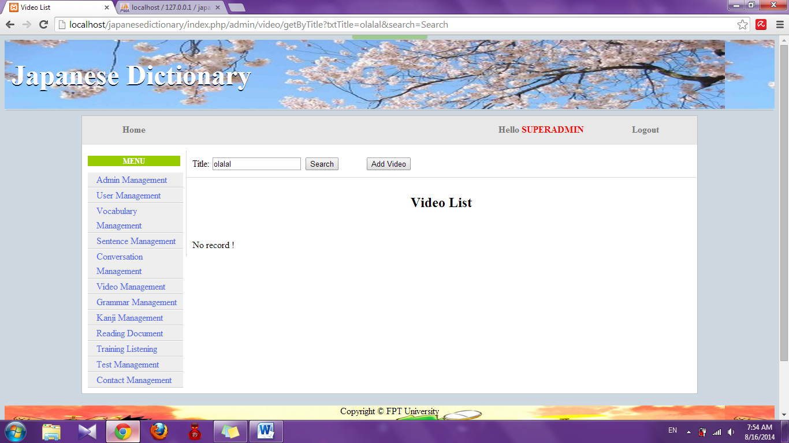

##### Add video

To use add video function on the website, the users do the steps below:

Step 1: Login with admin account. System will display list User.

Step 2: Click “Video management” link. System will display list Video



Step 3: Click “Add video” button. System will display add video page

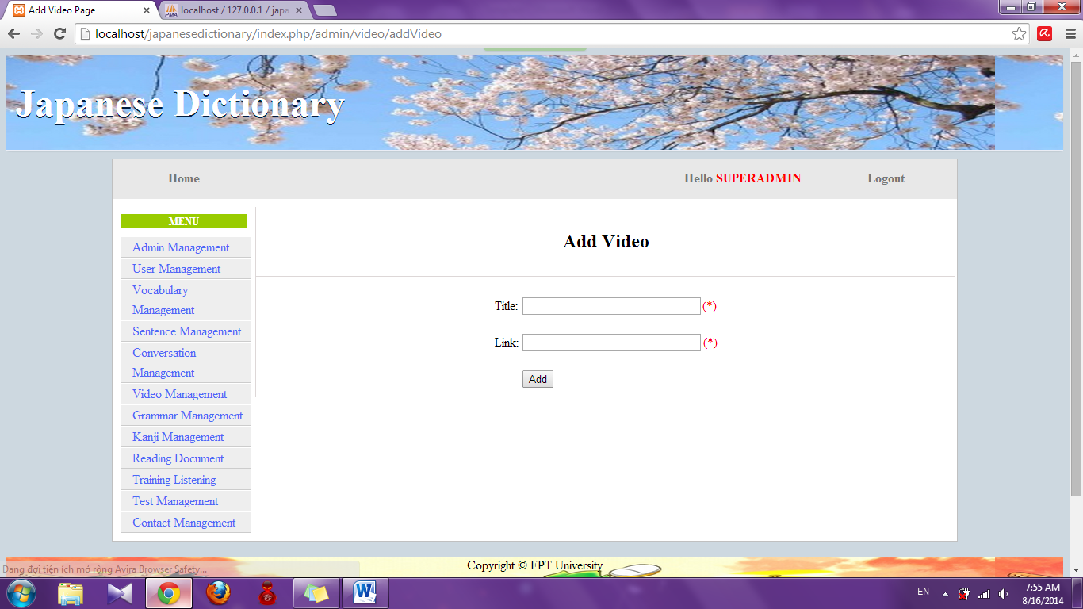

Step 4: Input information that you want to add and click “Add” button

* Success : Display list video with new video
* Fail : Error message will notify, you must try again

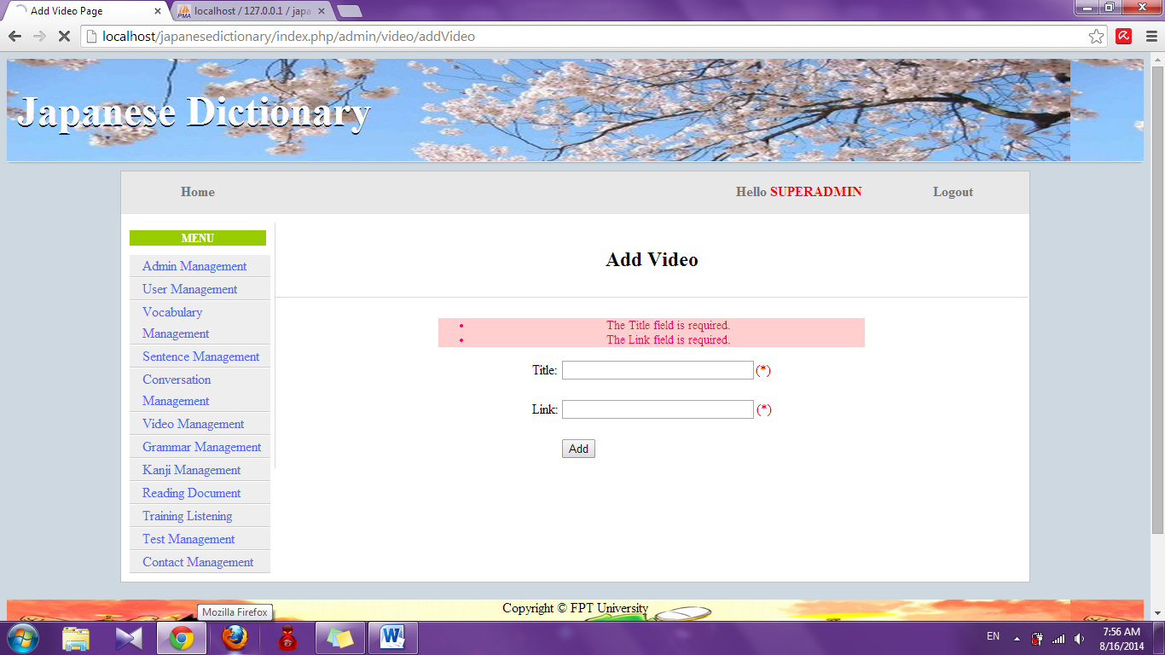

##### Edit video

To use edit video function on the website, the users do the steps below:

Step 1: Login with admin account. System will display list User.

Step 2: Click “Video management” link. System will display list Video



Step 3: Click “Edit” link. System will display edit video page

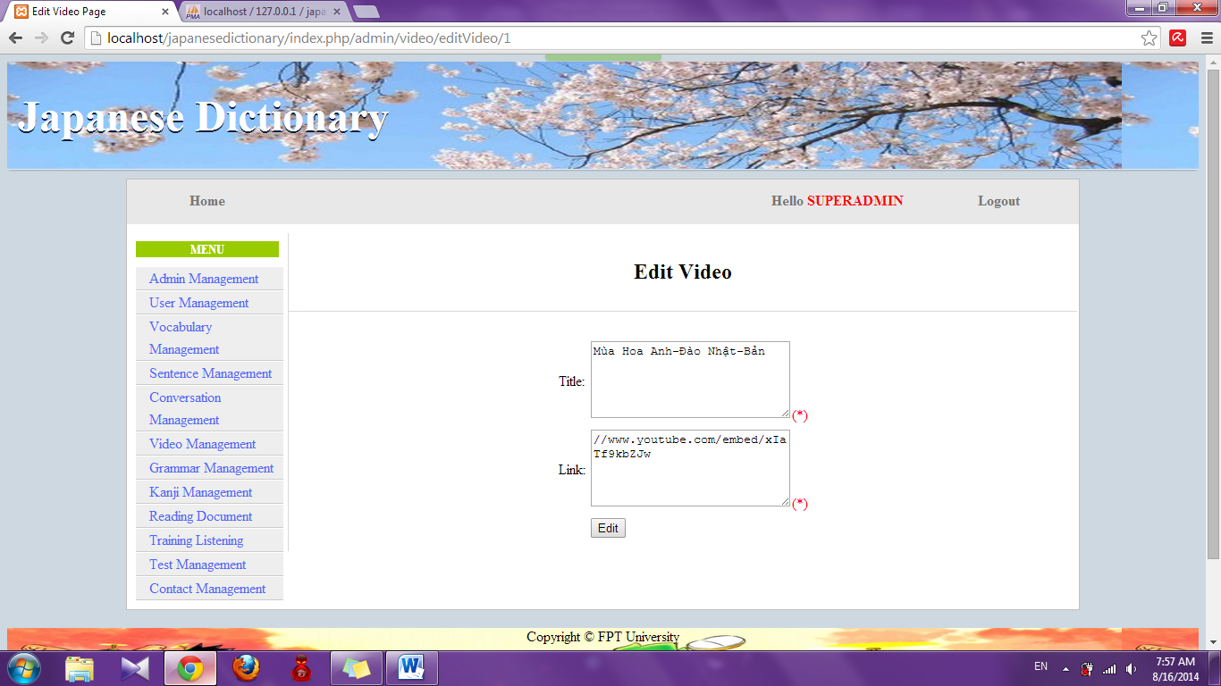

Step 4: Edit information and click “Edit” button

* Success : Display list video
* Fail : Error message will notify, you must try again

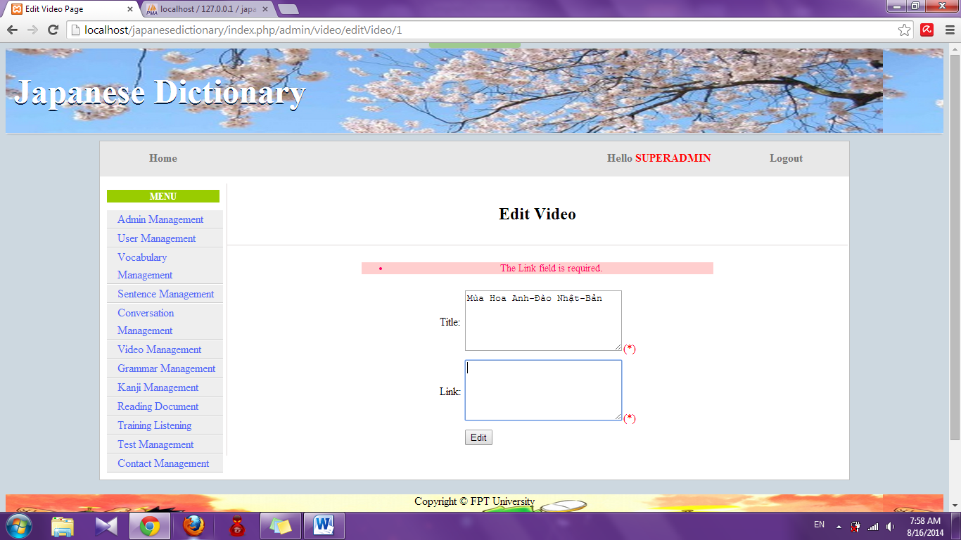

##### Delete video

To use edit video function on the website, the users do the steps below:

Step 1: Login with admin account. System will display list User.

Step 2: Click “Video management” link. System will display list Video.



Step 3: Click “Delete” link. System will delete that video

#### Training listening management

##### Search listening

To use search training listening function on the website, the users do the steps below:

Step 1: Login with admin account. System will display list User.

Step 2: Click “Training listening management” link. System will display list listening

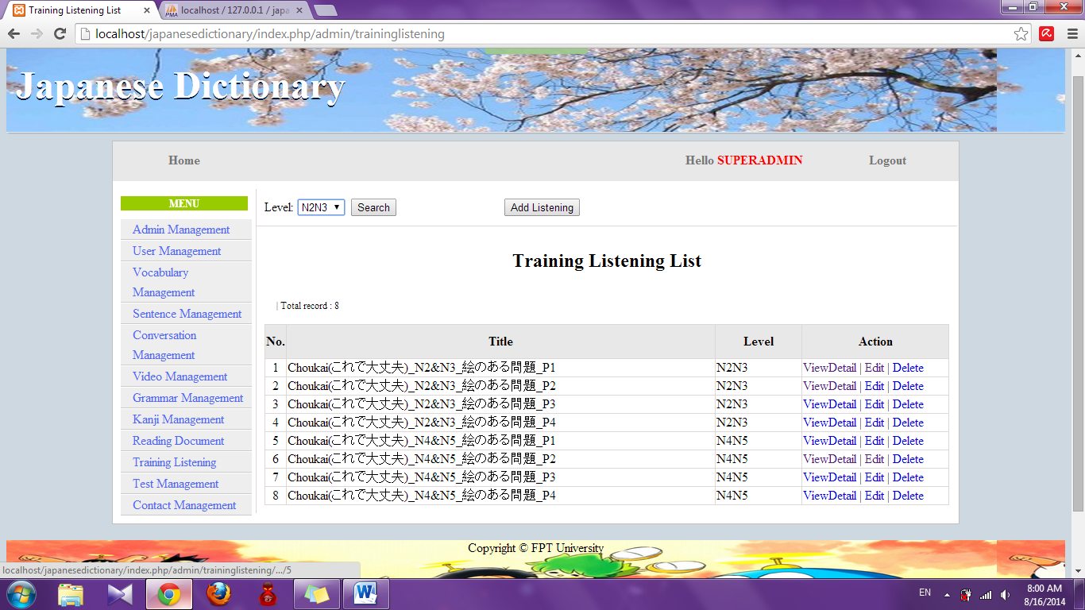

Step 3: Choose option search and click “Search” button. System will display result of search (If exist)

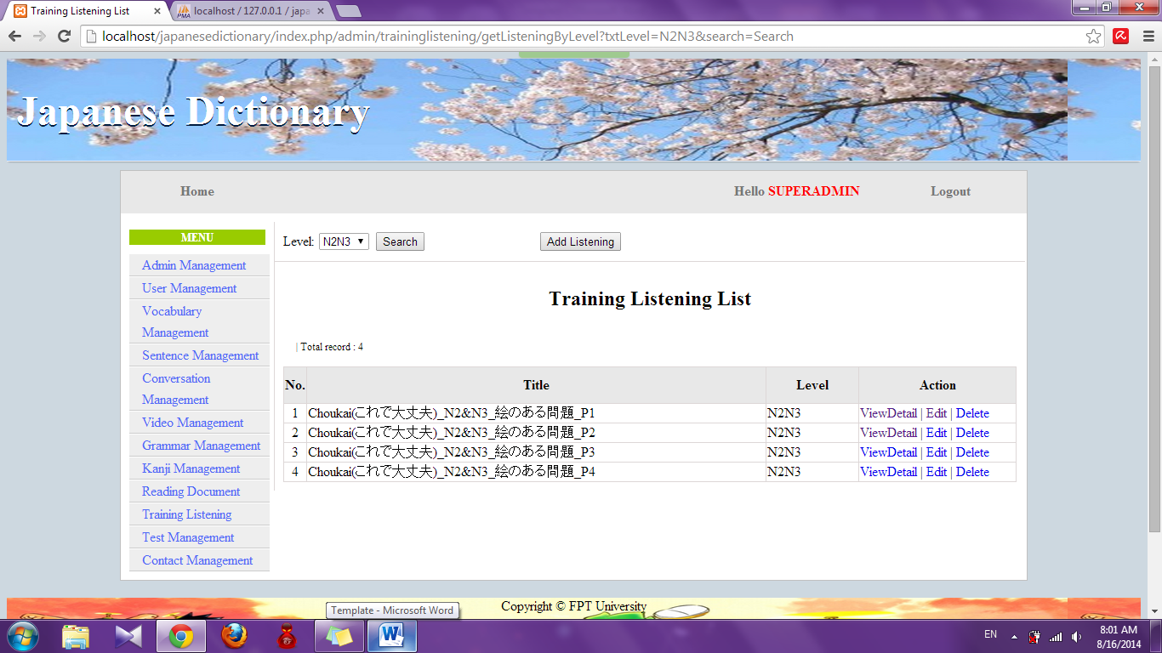

##### Add listening

To use add training listening function on the website, the users do the steps below:

Step 1: Login with admin account. System will display list User.

Step 2: Click “Training listening management” link. System will display list listening



Step 3: Click “Add listening” button. System will display add listening page

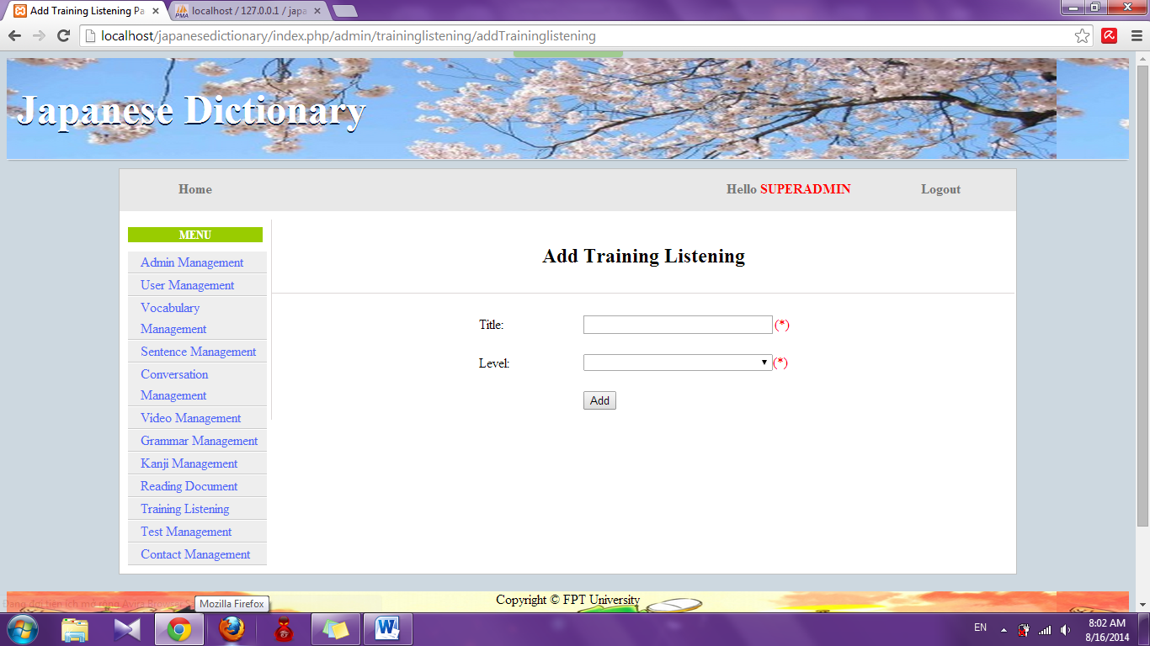

Step 4: Input information that you want to add and click “Add” button

* Success : Display list training listening with new listening
* Fail : Error message will notify, you must try again

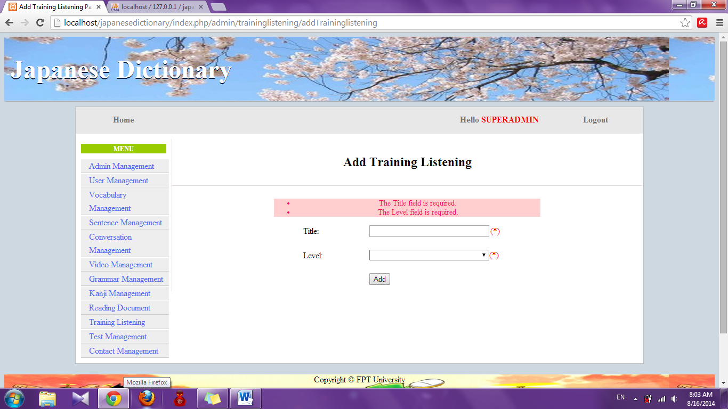

##### Add new source file

To use add new source file of training listening function on the website, the users do the steps below:

Step 1: Login with admin account. System will display list User.

Step 2: Click “Training listening management” link. System will display list listening



Step 3: Click “View Detail” link. System will display detail of listening

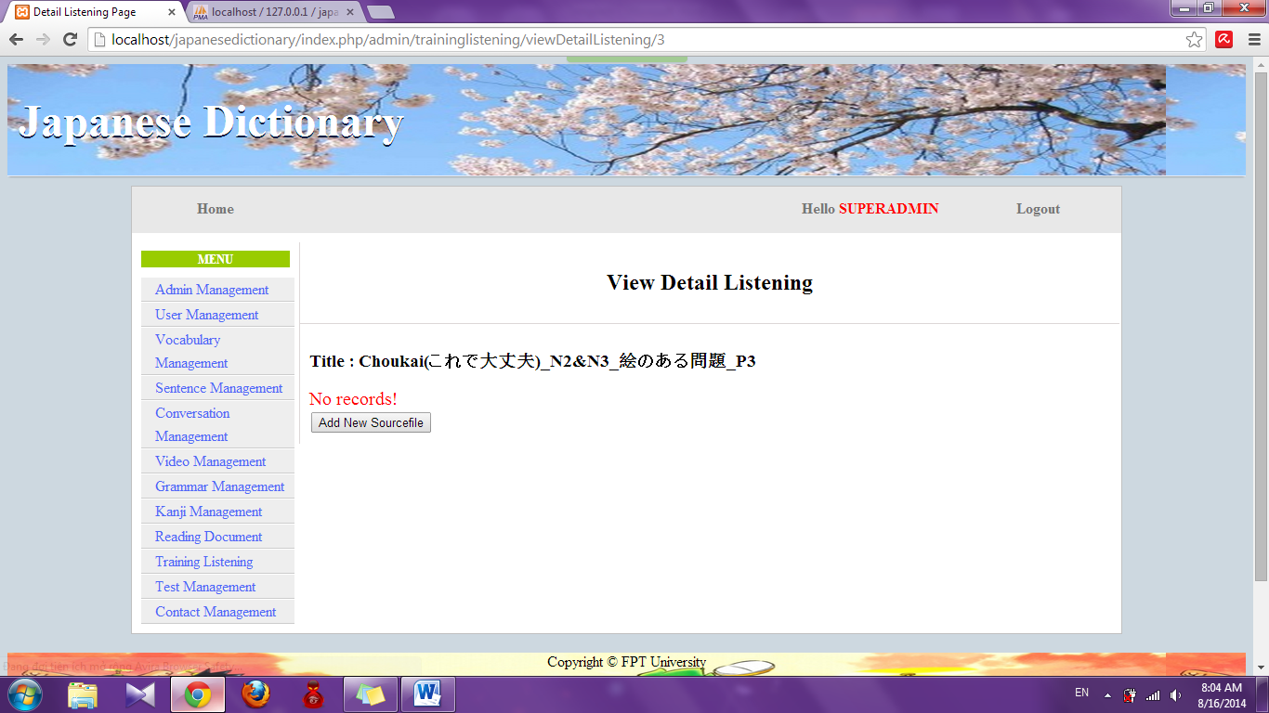

Step 4: Click “Add new sourcefile” button. System will display add new source file page

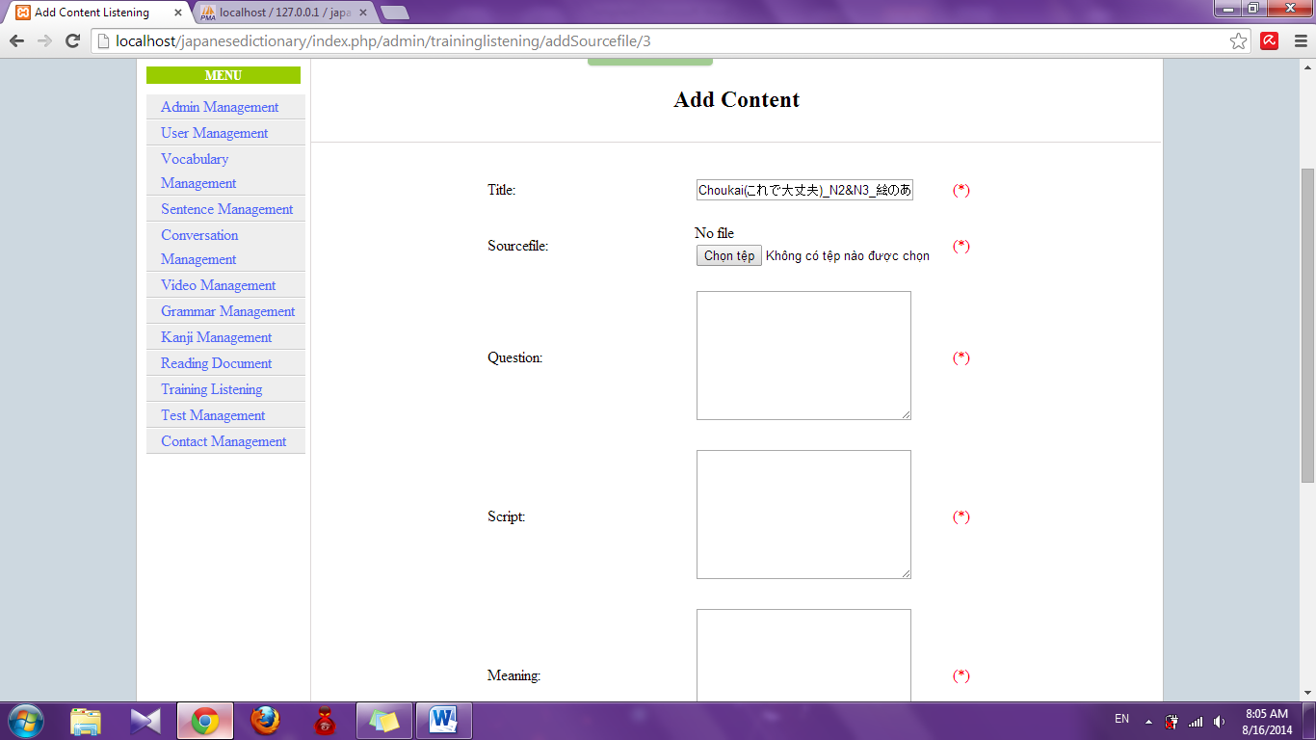

Step 5: Input information and click “Add” button

* Success : Display detail of listening

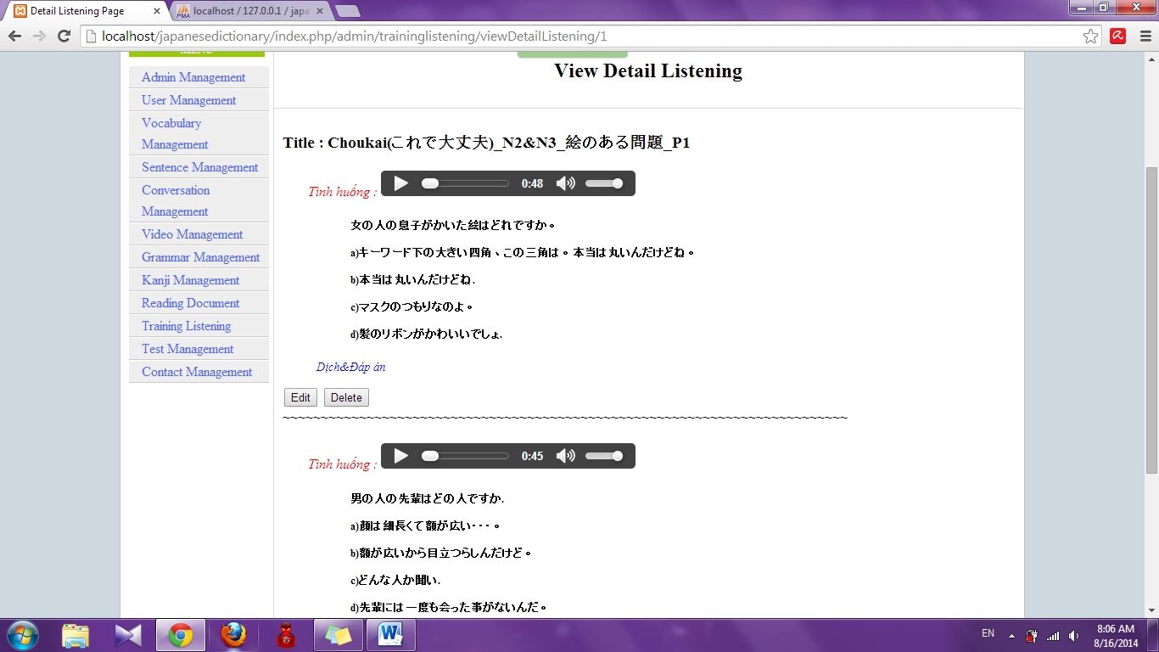

* Fail : Error message will notify, you must try again

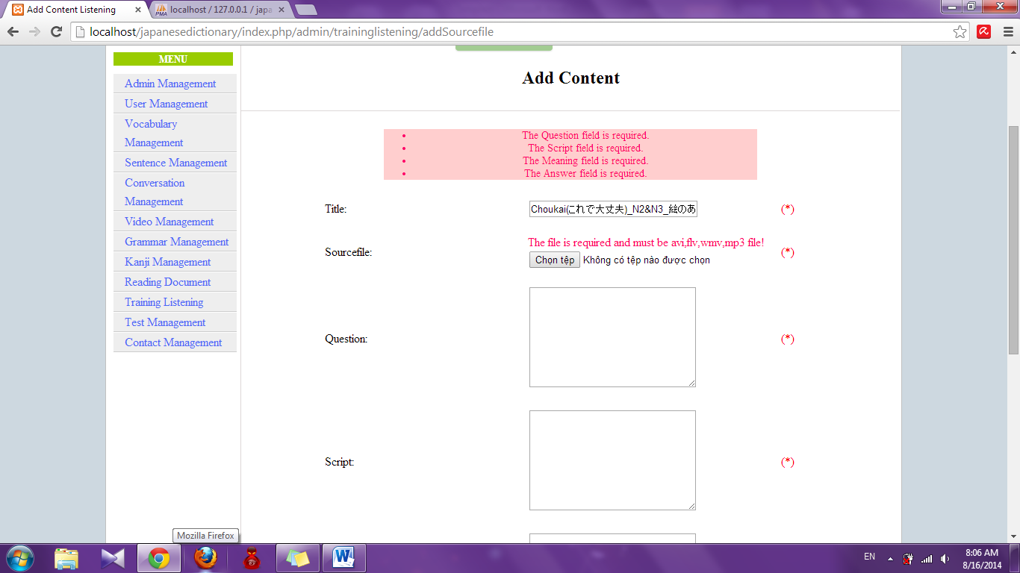

##### Edit listening

To use add edit training listening function on the website, the users do the steps below:

Step 1: Login with admin account. System will display list User.

Step 2: Click “Training listening management” link. System will display list listening



Step 3: Click “Edit” link. System will display edit listening page

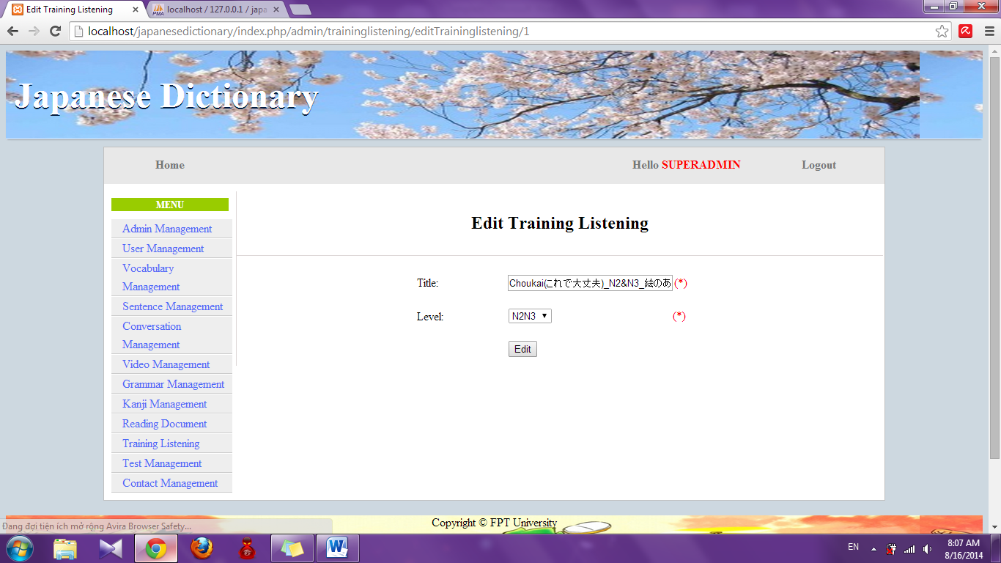

Step 4: Edit information and click “Edit” button

* Success : Display list listening
* Fail : Error message will notify, you must try again

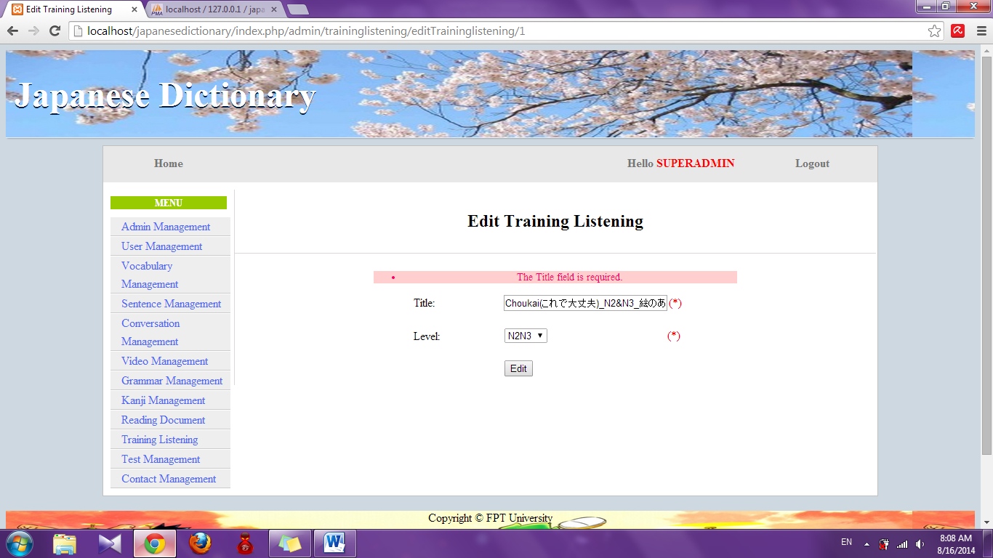

##### Edit source file

To use edit source file of training listening function on the website, the users do the steps below:

Step 1: Login with admin account. System will display list User.

Step 2: Click “Training listening management” link. System will display list listening



Step 3: Click “View Detail” link. System will display detail of listening

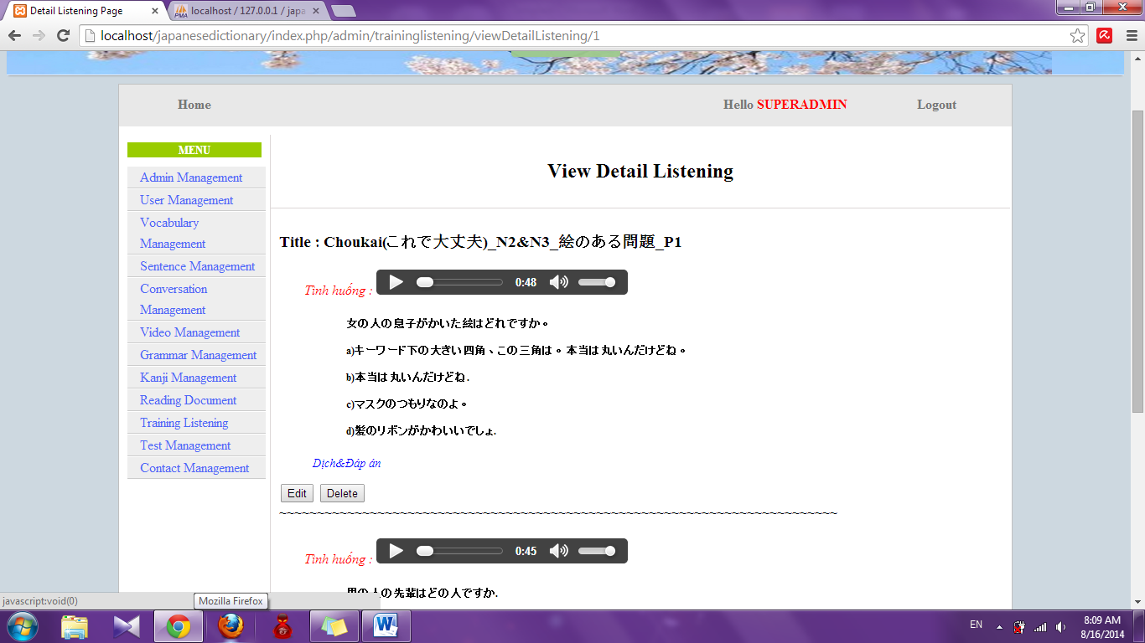

Step 4: Click “Edit” button. System will display edit source file page

Step 5: Edit information and click “Edit” button

* Success : Display detail of listening
* Fail : Error message will notify, you must try again

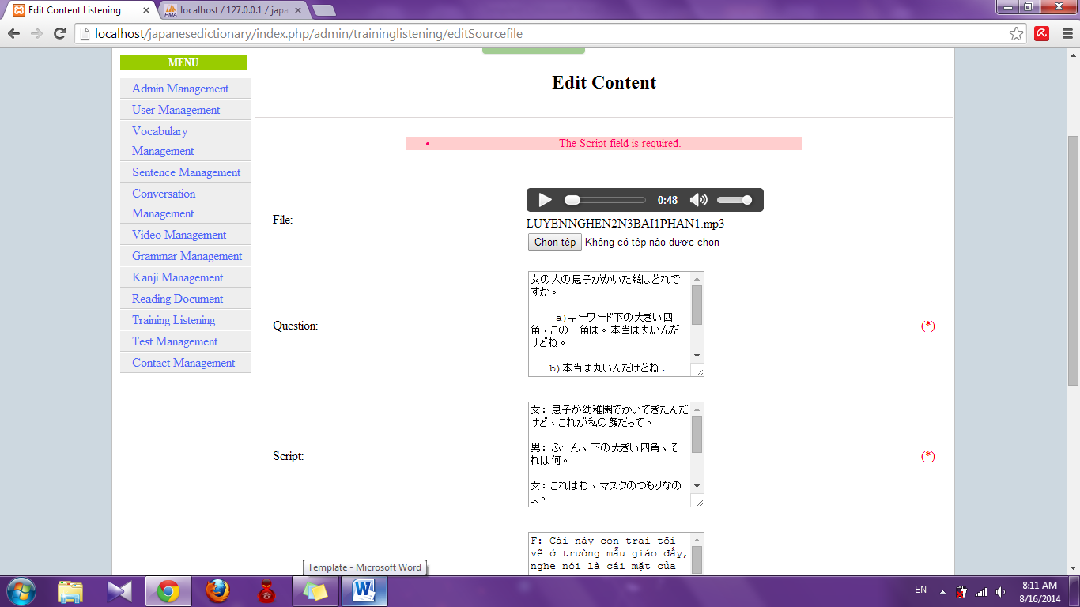

##### Delete source file

To use delete source file of training listening function on the website, the users do the steps below:

Step 1: Login with admin account. System will display list User.Step 2: Click “Training listening management” link. System will display list listening



Step 3: Click “View Detail” link. System will display detail of listening.



Step 4: Click “Delete” button. System will delete that source file

##### Delete listening

To use delete training listening function on the website, the users do the steps below:

Step 2: Click “Training listening management” link. System will display list listening. 

Step 3: Click “Delete” link. System will delete that listening

#### Test management

##### Search test

To use search test function on the website, the users do the steps below:

Step 1: Login with admin account. System will display list User.

Step 2: Click “Test management” link. System will display list test

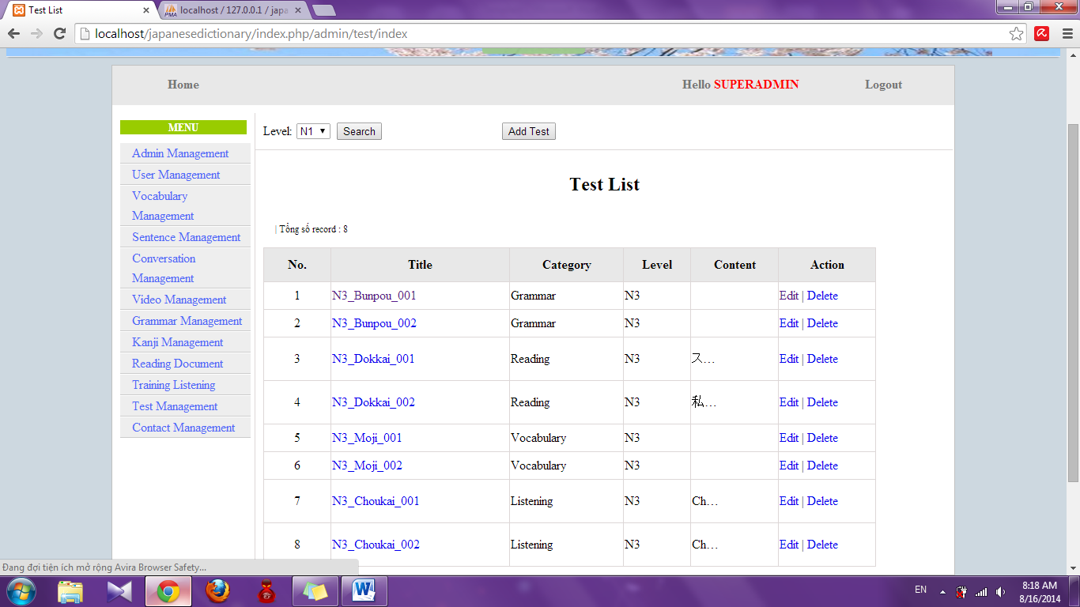

Step 3: Choose option search and click “Search” button. System will display result

* If exist : display result of search

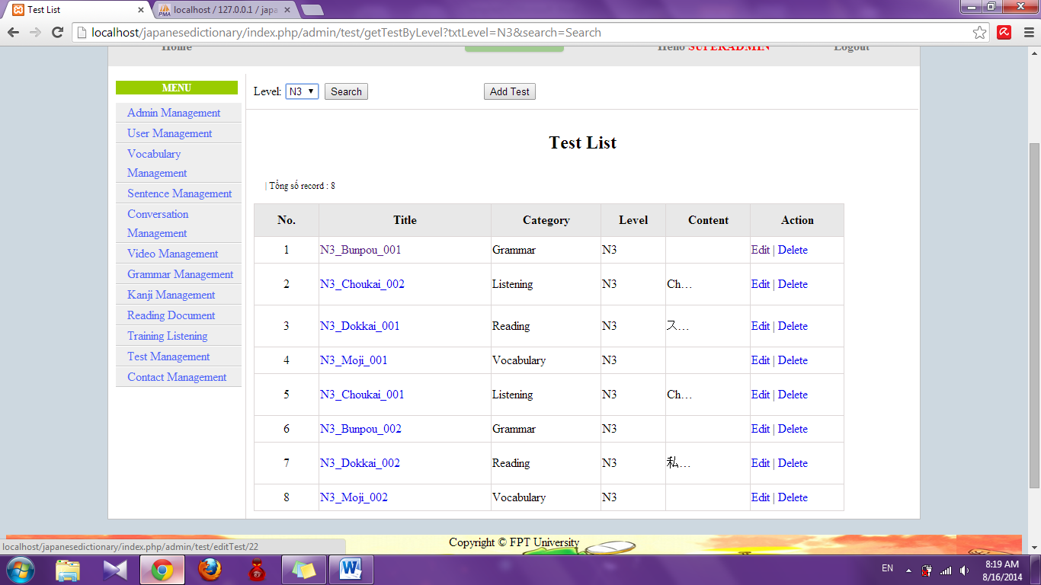

* If don’t exist : Display no record

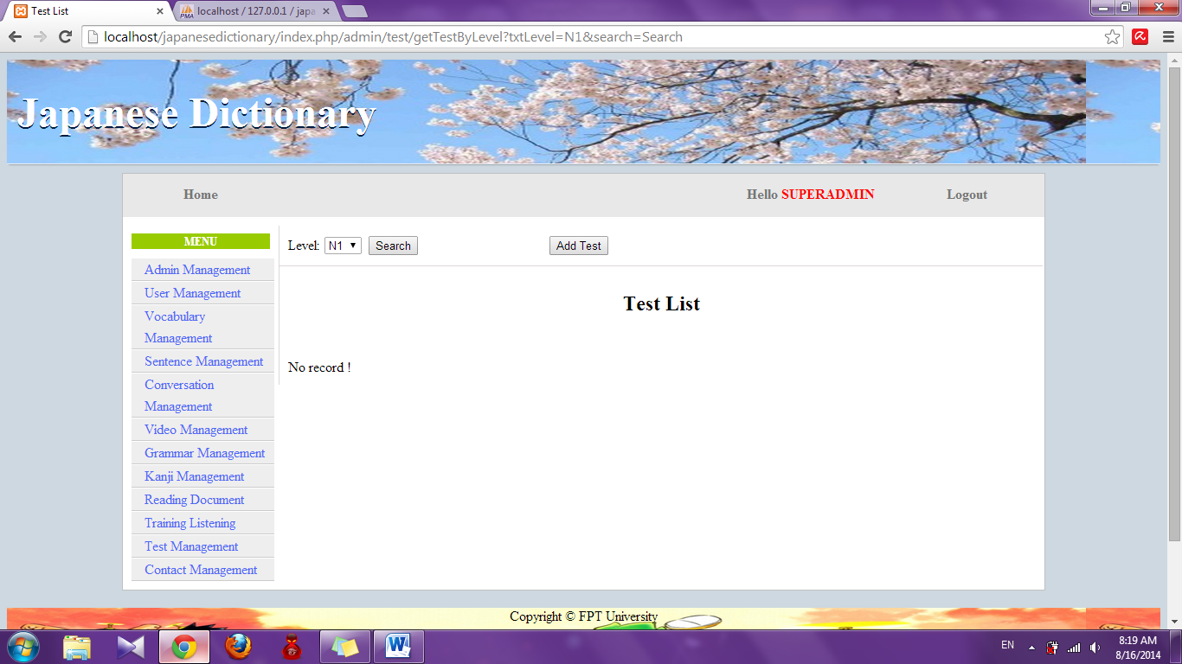

##### Add test

To use add test function on the website, the users do the steps below:

Step 1: Login with admin account. System will display list User.

Step 2: Click “Test management” link. System will display list test



Step 3: Click “Add test” button. System will display add test page.

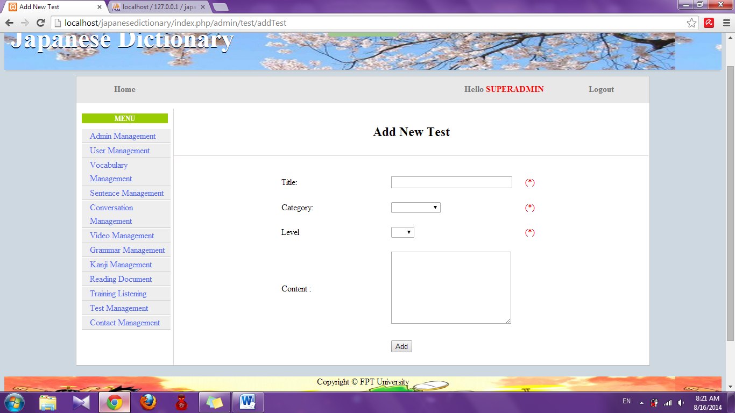

Step 4: Input information that you want to add and click “Add” button

* Success : Display list test with new test
* Fail : Error message will notify, you must try again

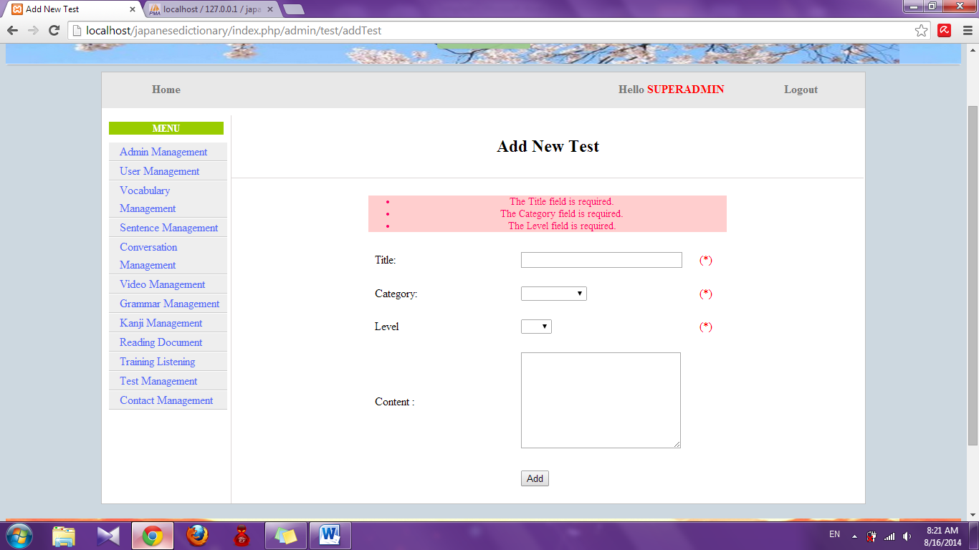

##### Add new question

To use add new question function on the website, the users do the steps below:

Step 1: Login with admin account. System will display list User.

Step 2: Click “Test management” link. System will display list test



Step 3: Click title of test. System will display detail of test

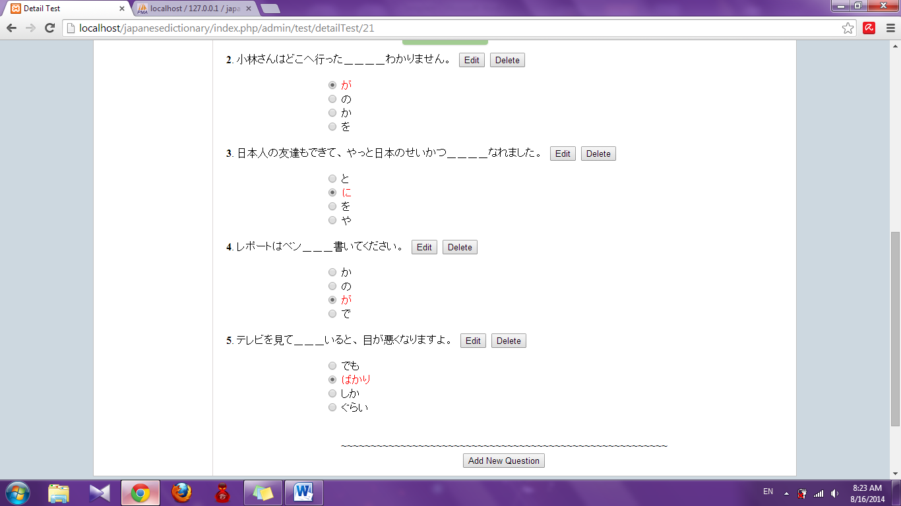

Step 4: Click “Add new question” button. System will display add new question page

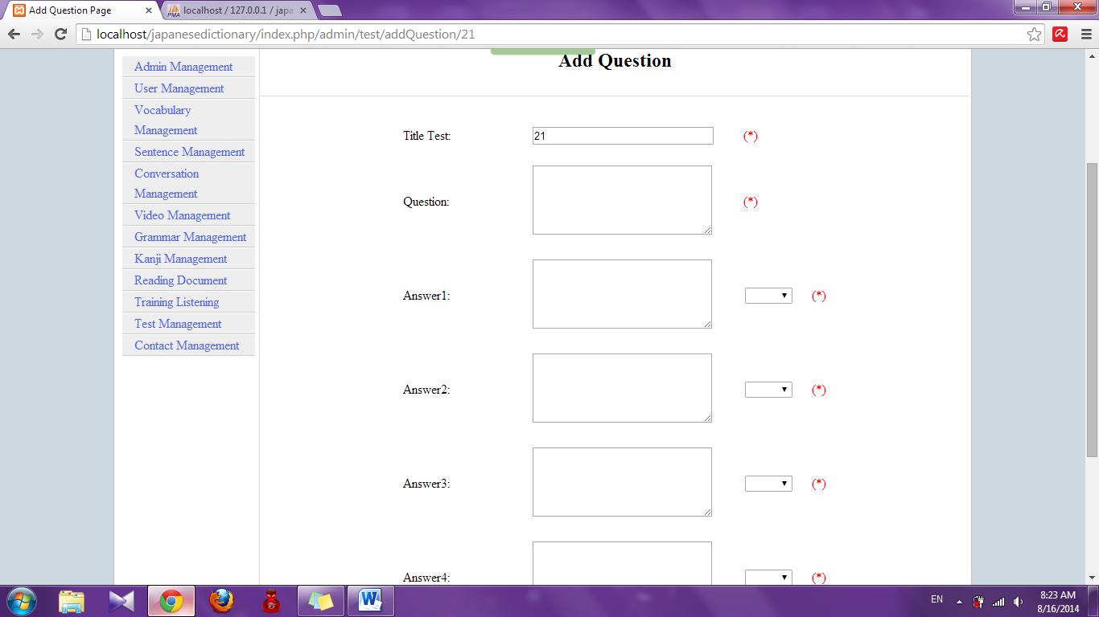

Step 5: Input information and click “Add” button

* Success : Display detail of test
* Fail : Error message will notify, you must try again

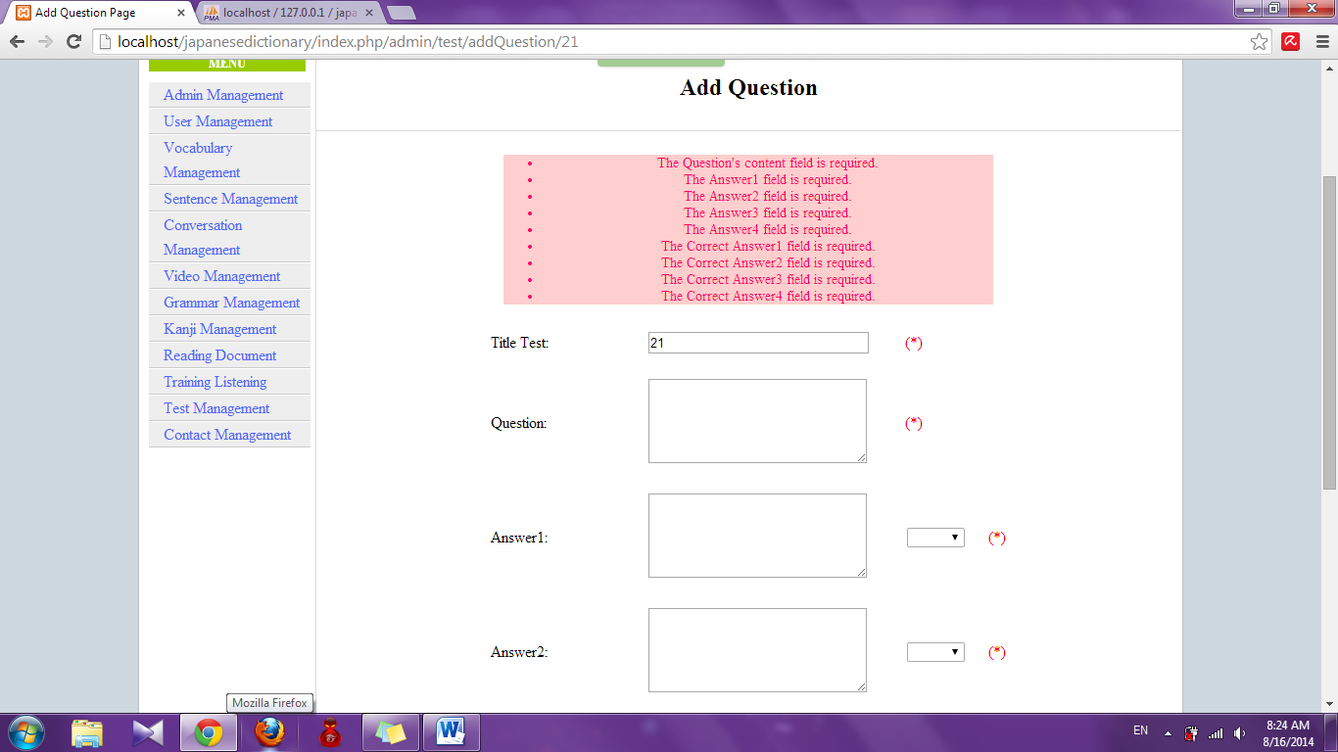

##### Edit test

To use edit test function on the website, the users do the steps below:

Step 1: Login with admin account. System will display list User.

Step 2: Click “Test management” link. System will display list test



Step 3: Click “Edit” link. System will display edit test page

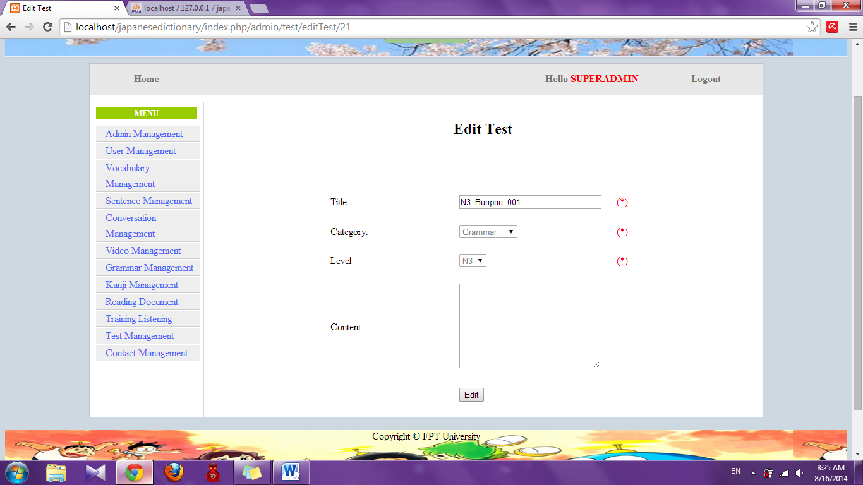

Step 4: Edit information and click “Edit”. System will display list test with edited test

##### Edit question

To use edit question function on the website, the users do the steps below:

Step 1: Login with admin account. System will display list User.

Step 2: Click “Test management” link. System will display list test



Step 3: Click title of test. System will display detail of test



Step 4: Click “Edit” button. System will display edit question page

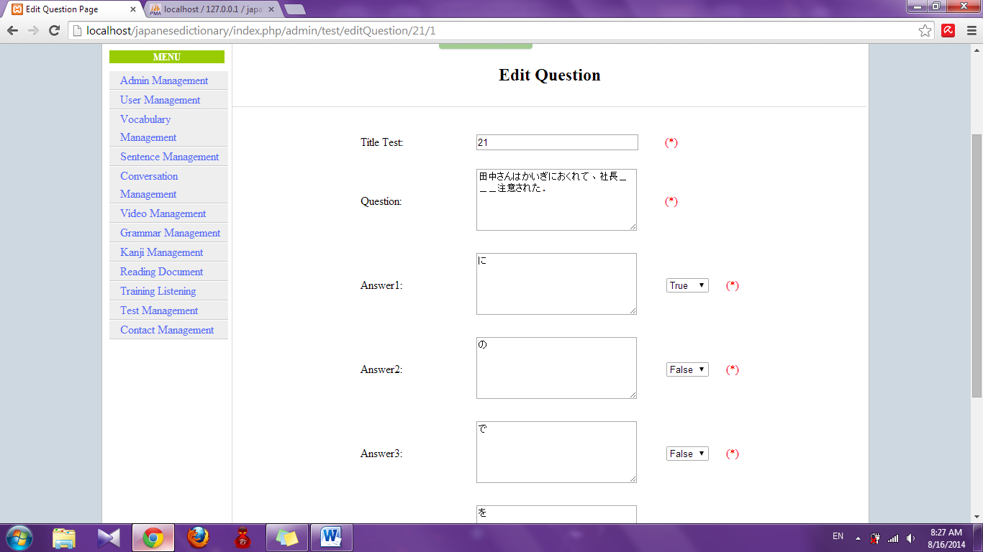

Step 5: Edit information and click “Edit” button

* Success: Display detail of test
* Fail : Error message will notify, you must try again

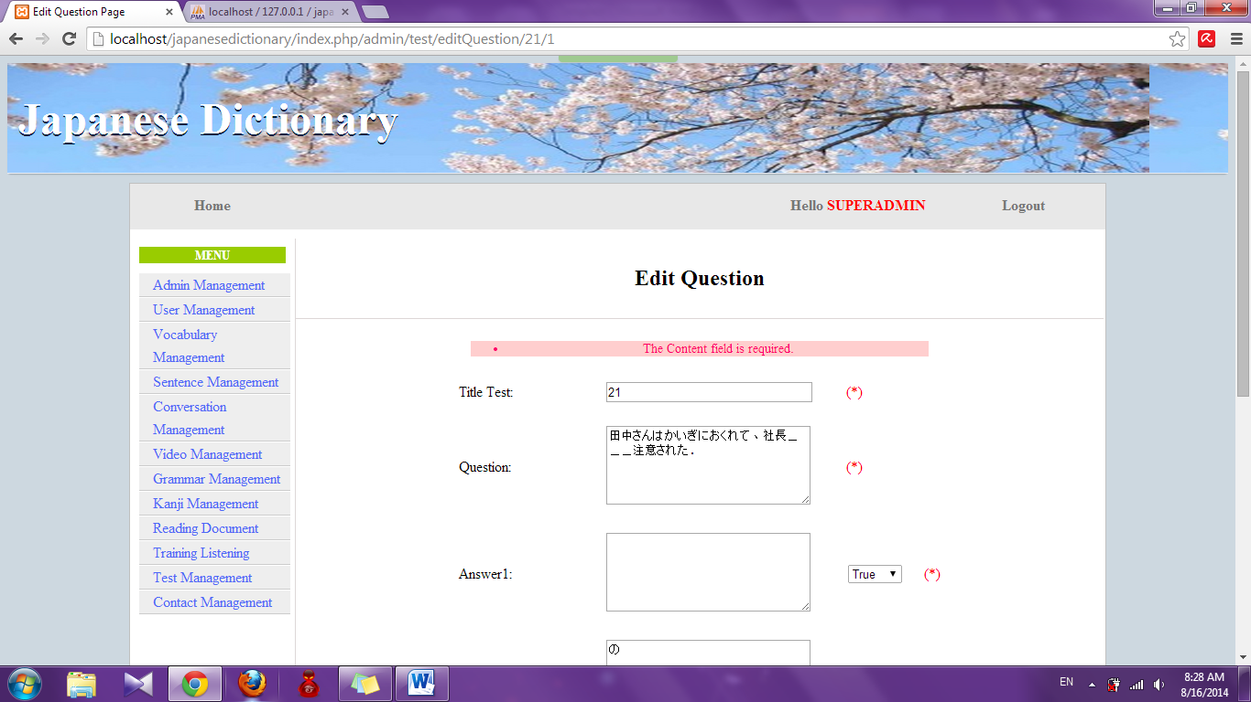

##### Delete question

To use delete question function on the website, the users do the steps below:

Step 1: Login with admin account. System will display list User.

Step 2: Click “Test management” link. System will display list test



Step 3: Click title of test. System will display detail of test.



Step 4: Click “Delete” button. System will delete that question

##### Delete test

To use add test function on the website, the users do the steps below:

Step 1: Login with admin account. System will display list User.

Step 2: Click “Test management” link. System will display list test.



Step 3: Click “Delete” link. System will delete that test

#### Contact management

##### Search contact

To use search contact function on the website, the users do the steps below:

Step 1: Login with admin account. System will display list User.

Step 2: Click “Contact management” link. System will display list contact

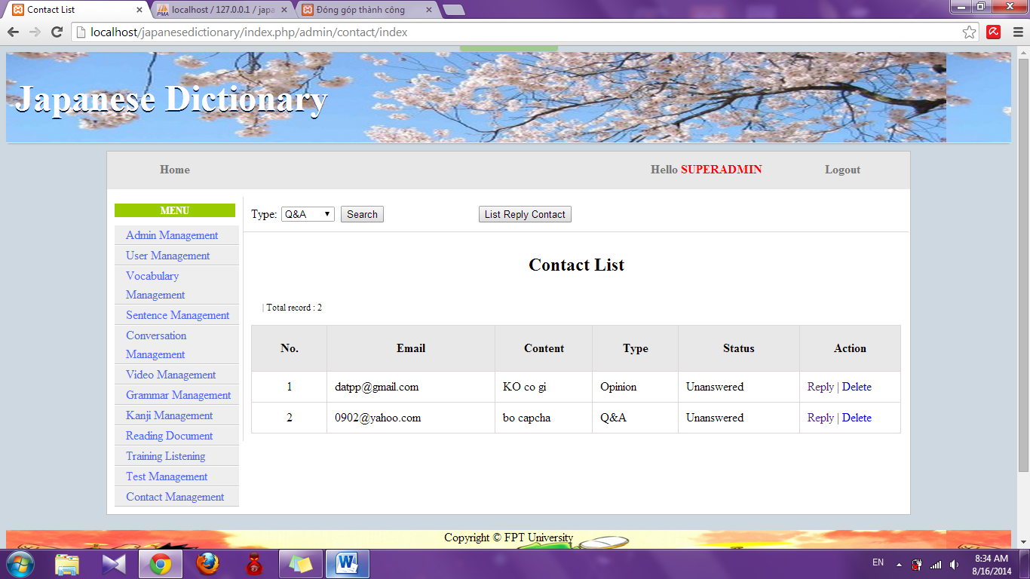

Step 3: Choose option search and click “Search” button. System will display result

* If exist : Display list results

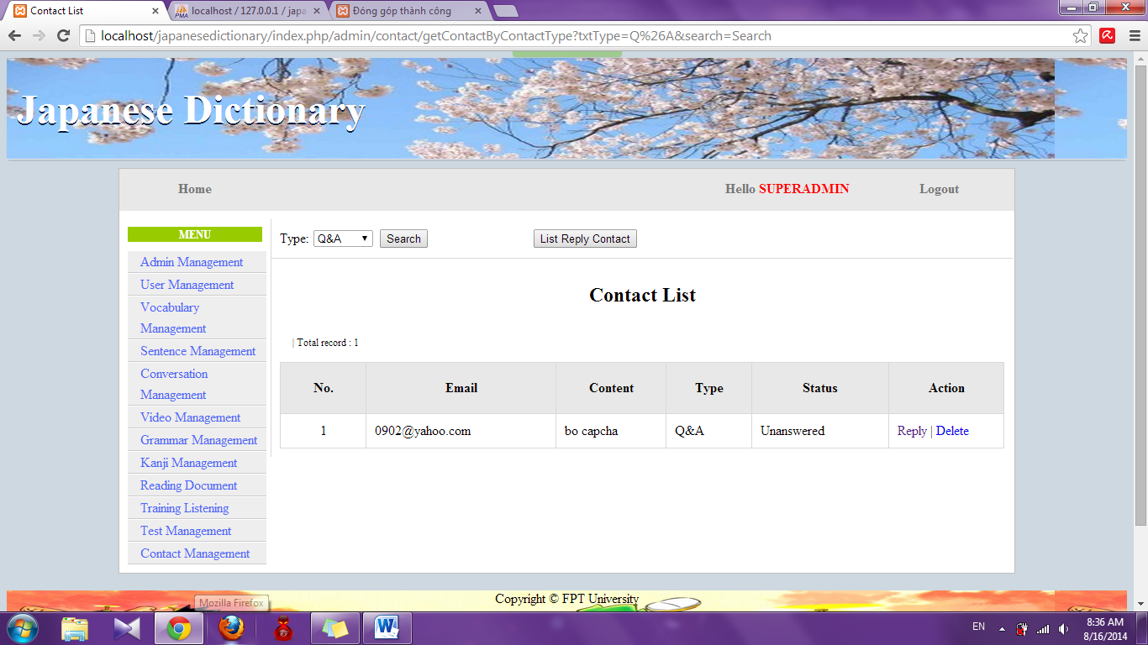

* If don’t exist : Display no record

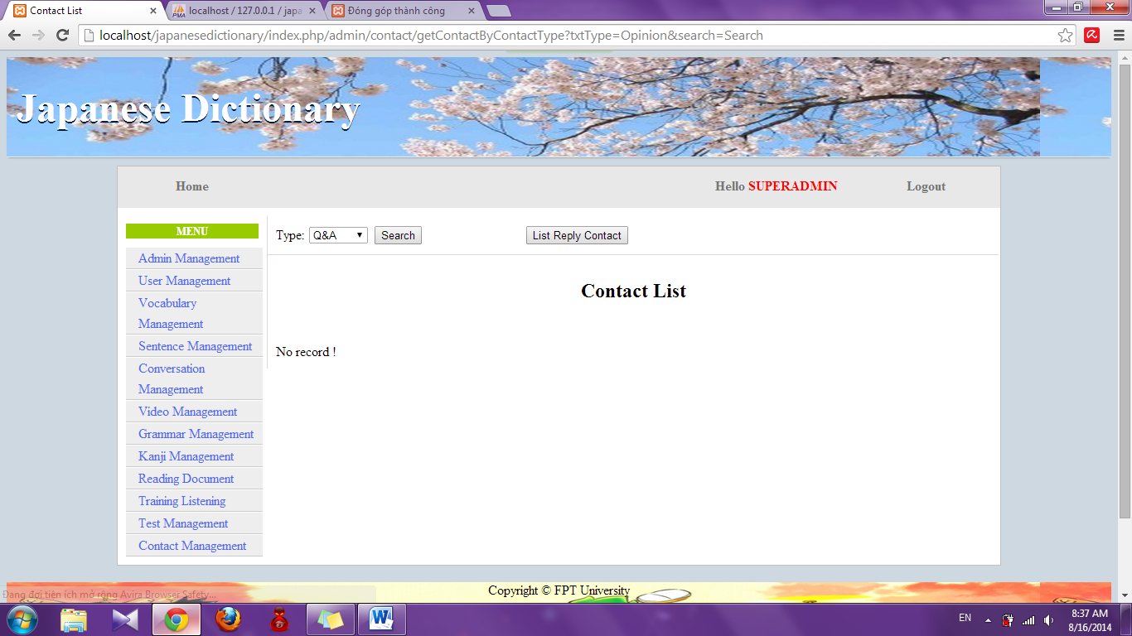

##### Reply contact

To use reply contact function on the website, the users do the steps below:

Step 1: Login with admin account. System will display list User.

Step 2: Click “Contact management” link. System will display list contact



Step 3: Click “Reply” link. System will display reply page

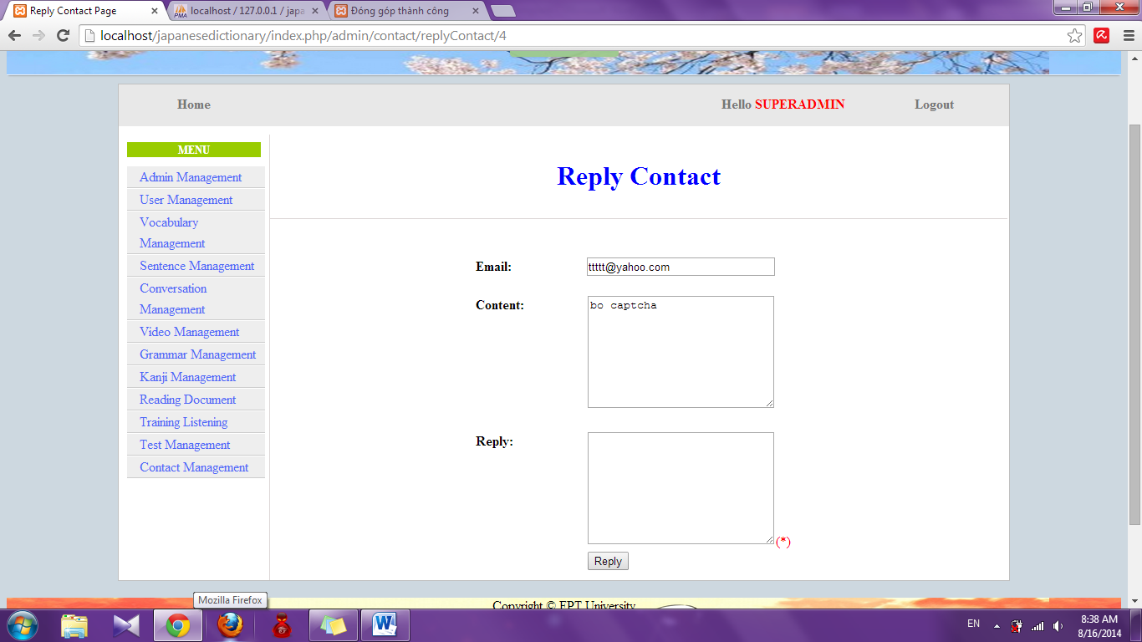

Step 4: Input reply and click “Reply” button. System will display list contact.

##### View list reply contact

To use view list reply contact function on the website, the users do the steps below:

Step 1: Login with admin account. System will display list User.

Step 2: Click “Contact management” link. System will display list contact



Step 3: Click “List reply contact” button. System will display list replied contact.

##### Delete contact

To use delete list reply contact function on the website, the users do the steps below:

Step 1: Login with admin account. System will display list User.

Step 2: Click “Contact management” link. System will display list contact.



Step 3: Click “Delete” link. System will delete that contact.

## PROJECT RESULT REPORT

### Product Judging

#### Advantage of UJD_VN System

The idea of the Useful Japanese dictionary for Vietnamese project is to develop a new website that inherits the advantages and improve issues and learns from other website. And the new website would have the opportunity to add a lot of enhancements.

As the goals that we have set before started the project, the Useful Japanese dictionary for Vietnamese project has been developed in a right direction. And what it provides to users is in the list below:

The user using Useful Japanese dictionary for Vietnamese system will save time, save money but can learn Japanese most convenient.

• **Guest:**

+ Useful Japanese dictionary for Vietnamese system support guest search and reading document in website fastest.

• **Member:**

+ Useful Japanese dictionary for Vietnamese support doing test that check member knowledge and view learning process.

#### Current Limitations

* GUI and function meet demand of almost of user about searching vocabulary, searching conversation and practicing listening Japanese. However, interface also has some limitations like not support on Mobile version, user interface is not support English.
* Not have money for upload website to host.

#### Expectation in Future

* Upload to host that user easy to use.
* Product can get many attracking from user, who care Japanese.
* Providing more function to user and expect to commercialized product in the future.

### Product Summary

|  |  |  |  |  |
| --- | --- | --- | --- | --- |
| **Project Title** | | **Useful Japanese dictionary for Vietnamese** | | |
| **Project Supervisor** | | Nguyễn Văn Sang | | |
| **Committers (4)** | | | | |
| **1** | **Project Manager** | Lê Đình Nam | [NamLDSE02316@fpt.edu.vn](mailto:XuanLT01913@fpt.edu.vn) | |
| **2** | **Project Technical Leader** | Phạm Tiến Đạt | [DatPTSE02336@fpt.edu.vn](mailto:KhoiPH01888@fpt.edu.vn) | |
| **3** | **Tester** | Phạm Thị Minh | [MinhPTSE02300@fpt.edu.vn](mailto:TuPM01770@fpt.edu.vn) | |
| **4** | **Tester** | Nguyễn Ngọc Tuấn | [TuanNNSE02189@fpt.edu.vn](mailto:HaiPH01727@fpt.edu.vn) | |
| **Main objective** | | Develop a system which will provide to users functionality to search and reading document online and the other users log-in and do the test. | | |
| **Purpose** | | Provide a UJD_VN online on website. | | |
| **Source Repository** | | **https**://[japanesedictionary.googlecode.com/svn/trunk/](http://japanesedictionary.googlecode.com/svn/trunk/) | | |
|  | | **Plan** | | **Actual** |
| **Start Date** | | 12/05/2014 | | 12/05/2014 |
| **End Date** | | 22/08/2014 | | 30/08/2014 |
| **Releases version** | | 1.0 | | 1.0 |
| **Duration** | | 75 | | 81 |
| **Effort (person-day)** | | 2400 | | 2464 |
| **Test cases** | | 2600 | | 2528 |
| **Defects** | | 240-340 | | 24 |
| **Document pages** | | 400 | |  |
| **Lines of code** | | ~20000 | | ~ 24000 |

### Lessons Learnt

* Understand ways of working with Japanese style.
* Putting knowledge into practice.
* Improve skill
* Technical: CSS, JavaScript, PHP Codeigniter, MySQL
* Soft skill: brainstorm, teamwork, research and self-study, plan management, time management.
* Risk and issues management
* Technical:

+ When thinking ideas for project, all member of team decided to develop project by PHP language (user Codeigniter framework) and MySQL. But member haven’t experience about PHP Codeigniter. So before start project about 1 month, two members were assigned training PHP language and MySQL.

+ In process coding, we had a function which not completed on time. And our solution is thanks to the help from people who have some experience about PHP language and researching internet.

+ In process of do document, we have difficulty in manage document. Some document was lost because of we don’t have many experience about SVN. So we were meeting and training about SVN in one day.

* Human resource:

+ Some members are lazy for their task. So at 6.00pm everyday we have meeting to report about task of each member.

+ In process coding, one member was sick about one week and the remaining members can’t cover all function. So after that we have worked over time to ensured completion system.

## Reference

**Software Project Management**

1. Template_Project_Plan, (2010), FPT University, Hanoi, Vietnam.
2. Ian Sommerville, Software Engineering, 8th edition, (2007), USA at FPT University.
3. Kathy Schwalbe, Managing Information Technology Projects, 6th edition, Cengage Learning, (2009), Canada.
4. Rational Unified Process - *Best Practices for Software Development Teams*, Rational Software Corporation (1998), Canada.
5. <http://en.wikipedia.org/wiki/IBM_Rational_Unified_Process>
6. <http://en.wikibooks.org/wiki/RUP_-_IBM_Rational_Unified_Process/Phases>
7. <http://msdn.microsoft.com/en-us/library/ff926074.aspx>

**Software Requirement Specification**

1. Template Software_Requirements_Specification, (2010), FPT Software, Hanoi, Vietnam.

**Software Design Description**

1. Template Software_Design_Template, (2010), FPT Software, Hanoi, Vietnam.
2. Internal_Design_Template, FPT Software, Hanoi, Vietnam.
3. Kai Qian, Software Architecture and Design Illuminated, Jones & Bartlett Learning, (2010), USA.

**Software Test Documentation**

1. Templates for Test case & Defect log, FPT Software, Hanoi, Vietnam.